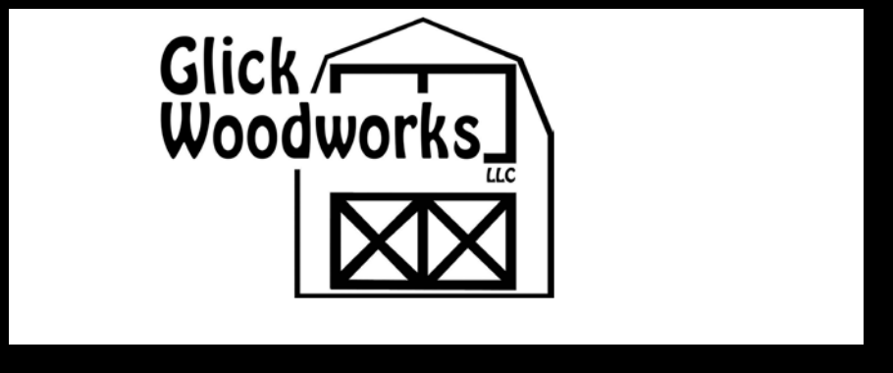

 | 1188 Garfield Road
 | Mount Joy, PA 17552
PA#068100 | 717-653-6523
Storage Sheds | 717-653-6523
Storage Sheds | Fax: 717-653-0307
and Garages | Fax: 717-653-0307
 | www.glicksheds.com

HOURS: Monday - Friday 7 am - 5 pm; Saturday 8 am - 12 noon

See other side for additional sheds & pricing.
Price Sheet
STORAGE SHEDS

Sizes | UTILITY SHEDS
Sizes | T1-11 | Vinyl
4 x 6 | $720 | $810
4 x 8 | $780 | $885

Prices Effective 3/1/15

 |  | MINI BARNS |  |  | A-FRAME |  |  | QUAKER |  |  |  | CLASSIC A-FRAME
Sizes
Sizes |  | T1-11 |  | Vinyl | T1-11 |  | Vinyl | T1-11 |  | Vinyl |  | T1-11 | Vinyl | Sizes
6 x 6 |  | $970 |  | $1,120 |  |  |  |  |  |  |  |  |  | 6 x 6
6 x 8 |  | $1,000 |  | $1,150 | $1,125 |  | $1,275 | $1,165 |  | $1,330 |  |  |  | 6 x 8
8 x 8 |  | $1,070 |  | $1,225 | $1,295 |  | $1,465 | $1,400 |  | $1,600 |  |  |  | 8 x 8
8 x 10 |  | $1,200 |  | $1,345 | $1,440 |  | $1,615 | $1,530 |  | $1,750 |  |  |  | 8 x 10
8 x 12 |  | $1,340 |  | $1,530 | $1,560 |  | $1,765 | $1,685 |  | $1,930 |  | $1,835 | $2,180 | 8 x 12
8 x 14 |  | $1,490 |  | $1,675 | $1,720 |  | $1,950 | $1,825 |  | $2,100 |  | $2,025 | $2,415 | 8 x 14
8 x 16 |  | $1,630 |  | $1,805 | $1,885 |  | $2,135 | $1,930 |  | $2,215 |  | $2,175 | $2,621 | 8 x 16
10 x 10 |  | $1,365 |  | $1,500 | $1,645 |  | $1,865 | $1,730 |  | $1,930 |  |  |  | 10 x 10
10 x 12 |  | $1,480 |  | $1,630 | $1,850 |  | $2,090 | $1,885 |  | $2,180 |  | $2,245 | $2,565 | 10 x 12
10 x 14 |  | $1,585 |  | $1,740 | $1,940 |  | $2,265 | $2,050 |  | $2,355 |  | $2,520 | $2,790 | 10 x 14
10 x 16 |  | $1,705 |  | $1,870 | $2,065 |  | $2,425 | $2,195 |  | $2,520 |  | $2,655 | $2,950 | 10 x 16
10 x 18 |  | $1,825 |  | $2,000 | $2,210 |  | $2,570 | $2,325 |  | $2,670 |  | $2,810 | $3,265 | 10 x 18
10 x 20 |  | $1,945 |  | $2,125 | $2,415 |  | $2,800 | $2,565 |  | $2,950 |  | $2,915 | $3,490 | 10 x 20
12 x 12 |  | $1,705 |  | $1,870 | $2,055 |  | $2,320 | $2,205 |  | $2,530 |  |  |  | 12 x 12
12 x 14 |  | $1,820 |  | $2,000 | $2,175 |  | $2,540 | $2,355 |  | $2,705 |  | $2,660 | $3,215 | 12 x 14
12 x 16 |  | $1,980 |  | $2,220 | $2,345 |  | $2,775 | $2,615 |  | $3,015 |  | $2,885 | $3,520 | 12 x 16
12 x 18 |  | $2,085 |  | $2,295 | $2,530 |  | $2,975 | $2,820 |  | $3,245 |  | $3,080 | $3,770 | 12 x 18
12 x 20 |  | $2,240 |  | $2,465 | $2,735 |  | $3,215 | $3,010 |  | $3,460 |  | $3,315 | $4,055 | 12 x 20
12 x 22 |  | $2,430 |  | $2,670 | $2,940 |  | $3,430 | $3,180 |  | $3,660 |  | $3,570 | $4,315 | 12 x 22
12 x 24 |  | $2,585 |  | $2,840 | $3,145 |  | $3,675 | $3,425 |  | $3,937 |  | $3,765 | $4,630 | 12 x 24
12 x 28 |  | $2,995 |  | $3,185 | $3,415 |  | $4,115 | $4,025 |  | $4,635 |  | $4,190 | $5,070 | 12 x 28
12 x 32 |  | $3,300 |  | $3,635 | $3,750 |  | $4,615 | $4,425 |  | $5,090 |  | $4,745 | $5,535 | 12 x 32
12 x 36 |  | $3,710 |  | $3,985 | $4,180 |  | $5,155 |  |  |  |  | $5,080 | $6,170 | 12 x 36
14 x 16 |  |  |  |  | $2,795 |  | $3,570 |  |  |  |  | $3,415 | $4,040 | 14 x 16
14 x 20 |  |  |  |  | $2,990 |  | $4,045 | Call for pricing |  |  |  | $3,670 | $4,445 | 14 x 20
14 x 24 |  |  |  |  | $3,620 |  | $4,620 | on larger buildings. |  |  |  | $4,235 | $5,305 | 14 x 24
14 x 28 |  |  |  |  | $4,285 |  | $5,140 |  |  |  |  | $4,660 | $6,250 | 14 x 28
14 x 30 |  |  |  |  | $4,590 |  | $5,320 |  |  |  |  | $4,895 | $6,785 | 14 x 30
14 x 32 |  |  |  |  | $4,885 |  | $5,620 |  |  |  |  | $5,190 | $6,985 | 14 x 32
 |  | Mni Barns: |  |  | A-Frame: |  |  | Quaker: |  |  |  | Classic A-Frame:
 |  | 1 Set of Doors |  |  | Double Doors |  |  | Double Doors |  |  |  | Steel or Fiberglass Double
 |  | (1) 18” x 24” Window |  |  | (2) 18” x 24” Windows |  |  | (2) 18” x 24” Windows |  |  |  | Doors on Vinyl Shed
 |  |  |  |  |  |  |  |  |  |  |  | (2) 18” x 24” or 24” x 36”
 |  |  |  |  | with Shutters |  |  | with Shutters
 |  |  |  |  |  |  |  |  |  |  |  | Windows with Shutters
 |  |  |  |  |  |  |  |  |  |  |  | 8/12 Pitch Roof
 |  |  |  |  |  |  |  |  |  |  |  |  |  | Standard
Custom |  |  |  |  |  |  |  |  |  |  |  |  |  | Door Width:
 |  |  |  |  |  |  |  |  |  |  |  |  |  | 6’ w = 3’ Single
designs
 |  |  |  |  |  |  |  |  |  |  |  |  |  | 8’ w = 4’ Double
available.
 |  |  |  |  |  |  |  |  |  |  |  |  |  | 10’ w = 5’ Double
 |  |  |  |  |  |  |  |  |  |  |  |  |  | 12’ w = 6’ Double
 |  |  |  |  |  |  |  |  |  |  |  |  |  | 14’ w = 6’ Double
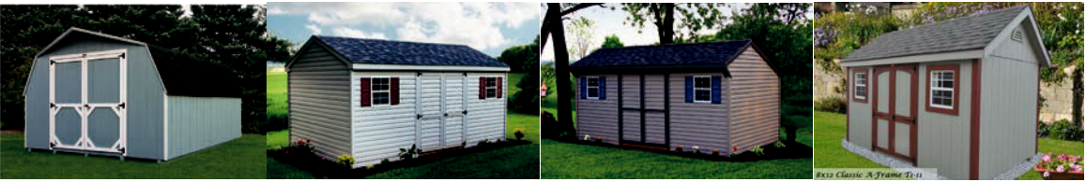

 | 1188 Garfield Road
 | Mount Joy, PA 17552
PA#068100 | 717-653-6523
Storage Sheds | 717-653-6523
Storage Sheds | Fax: 717-653-0307
and Garages | Fax: 717-653-0307
and Garages | www.glicksheds.com

HOURS: Monday - Friday 7 am - 5 pm; Saturday 8 am - 12 noon
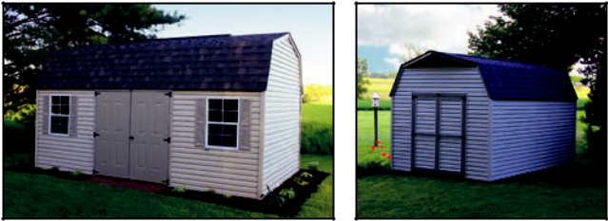
Price Sheet
STORAGE SHEDS

Call for pricing on larger buildings.

See other side for additional sheds.

Prices Effective 3/1/15
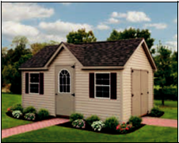

 |  | DUTCH BARNS |  | HIGH WALL BARNS |  | VICTORIAN
Sizes |  | T1-11 | Vinyl | T1-11 | Vinyl | T1-11 |  | Vinyl |  | Sizes
8 x 8 |  |  |  | $1,230 | $1,345 |  |  |  |  | 8 x 8
8 x 10 |  |  |  | $1,370 | $1,500 |  |  |  |  | 8 x 10
8 x 12 |  | $1,815 | $2,115 | $1,490 | $1,630 | $2,345 |  | $2,690 |  | 8 x 12
8 x 14 |  | $1,965 | $2,285 | $1,635 | $1,800 | $2,535 |  | $2,925 |  | 8 x 14
8 x 16 |  | $ 2,120 | $2,465 | $1,785 | $1,980 | $2,685 |  | $3,130 |  | 8 x 16
10 x 10 |  |  |  | $1,570 | $1,725 |  |  |  |  | 10 x 10
10 x 12 |  | $2,000 | $2,325 | $1,785 | $1,970 | $2,755 |  | $3,075 |  | 10 x 12
10 x 14 |  | $2,140 | $2,485 | $1,945 | $2,125 | $3,030 |  | $3,300 |  | 10 x 14
10 x 16 |  | $2,325 | $2,685 | $2,110 | $2,325 | $3,165 |  | $3,455 |  | 10 x 16
10 x 18 |  | $2,510 | $2,875 | $2,280 | $2,520 | $3,320 |  | $3,775 |  | 10 x 18
10 x 20 |  | $2,700 | $3,095 | $2,460 | $2,705 | $3,430 |  | $4,000 |  | 10 x 20
12 x 12 |  |  |  | $1,985 | $2,185 |  |  |  |  | 12 x 12
12 x 14 |  | $2,420 | $2,785 | $2,125 | $2,345 | $3,170 |  | $3,725 |  | 12 x 14
12 x 16 |  | $2,625 | $3,010 | $2,345 | $2,575 | $3,395 |  | $4,030 |  | 12 x 16
12 x 18 |  | $2,856 | $3,270 | $2,555 | $2,805 | $3,590 |  | $4,280 |  | 12 x 18
12 x 20 |  | $2,975 | $3,500 | $2,725 | $3,005 | $3,825 |  | $4,565 |  | 12 x 20
12 x 22 |  | $3,255 | $3,690 | $2,890 | $3,180 | $4,080 |  | $4,825 |  | 12 x 22
12 x 24 |  | $3,405 | $3,860 | $3,160 | $3,475 | $4,275 |  | $5,140 |  | 12 x 24
12 x 28 |  | $3,935 | $4,445 | $3,640 | $4,005 | $4,700 |  | $5,580 |  | 12 x 28
12 x 32 |  | $4,325 | $4,875 | $4,085 | $4,490 | $5,255 |  | $6,045 |  | 12 x 32
12 x 36 |  | $5,200 | $4,565 | $5,020 |  | $5,590 |  | $6,680 |  | 12 x 36
14 x 16 |  | $3,280 | $3,730 | $3,180 | $3,320 |  |  |  |  | 14 x 16
14 x 20 |  | $3,765 | $4,260 | $3,665 | $3,870 |  |  |  |  | 14 x 20
14 x 24 |  | $4,270 | $4,820 | $4,165 | $4,415 |  |  |  |  | 14 x 24
14 x 28 |  | $4,765 | $5,355 | $4,656 | $4,905 |  |  |  |  | 14 x 28
14 x 30 |  | $5,000 | $5,620 | $5,140 | $5,130 |  |  |  |  | 14 x 30
14 x 32 |  | $5,240 | $5,890 | $5,340 | $5,360 |  |  |  |  | 14 x 32
 |  | Dutch Barns: |  | High Wall Barns: |  | Victorian Standard Features:
 |  | Steel or Fiberglass Doors |  | Double Doors |  | (2) 18” x 24” or 24” x 36”
 |  | on Vinyl Shed |  | (1) 18” x 24” Window |  | Windows with Shutters
 |  | (2) 18” x 24” or 24” x 36” |  |  |  | (1) 36” Wide Passage Door with
 |  | Windows with Shutters |  |  |  | 11-lite Glass
 |  |  |  |  |  | Steel or Fiberglass Double Doors on
 |  | (2) 4’ Wide Lofts in Gable
 |  |  |  |  |  | Vinyl Shed
 |  | Ends
 |  | Ends |  |  |  | 6” Gable Overhangs

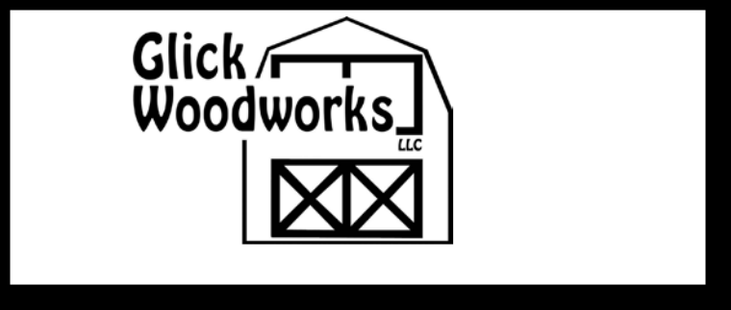
 | 1188 Garfield Road
PA#068100 | Mount Joy, PA 17552
PA#068100 | 717-653-6523
Storage Sheds | 717-653-6523
and Garages | Fax: 717-653-0307
 | www.glicksheds.com

HOURS: Monday - Friday 7 am - 5 pm; Saturday 8 am - 12 noon
Price Sheet

ELITE SHEDS & GARAGES

Prices Effective 3/1/15

 |  |  | ELITE SHEDS |  |  |  |  | ELITE GARAGES
 | Sizes |  |  |  | Loft | 2nd Flr |  |  | Loft |  |  | 2nd Flr |  | Sizes
 | Sizes |  |  |  | add | add |  |  | add |  |  | add |  | Sizes
 | Sizes | T1-11 | Vinyl |  | add | add | T1-11 | Vinyl |  |  |  | add |  | Sizes
 | 10 x 16 | $3,580 | $3,970 | $360 |  | $560 |  |  |  |  |  |  |  | 10 x 16
 | 10 x 20 | $3,935 | $4,355 | $450 |  | $700 |  |  |  |  |  |  |  | 10 x 20
 | 12 x 14 | $3,570 | $4,305 | $378 |  | $588 |  |  |  |  |  |  |  | 12 x 14
 | 12 x 16 | $3,750 | $4,515 | $430 |  | $675 |  |  |  |  |  |  |  | 12 x 16
 | 12 x 18 | $4,095 | $4,725 | $485 |  | $755 | $4,500 | $5,200 | $485 |  |  | $755 |  | 12 x 18
 | 12 x 20 | $4,225 | $4,965 | $540 |  | $840 | $4,750 | $5,500 | $540 |  |  | $840 |  | 12 x 20
 | 12 x 22 | $4,535 | $5,230 | $580 |  | $925 |  |  |  |  |  |  |  | 12 x 22
 | 12 x 24 | $4,775 | $5,615 | $620 |  | $1,005 | $5,400 | $6,280 | $620 |  |  | $1,005 |  | 12 x 24
 | 12 x 26 | $5,300 | $6,165 | $700 |  | $1,090 | $5,700 | $6,650 | $700 |  |  | $1,090 |  | 12 x 26
 | 12 x 28 | $5,460 | $6,350 | $750 |  | $1,175 | $5,950 | $6,990 | $750 |  |  | $1,175 |  | 12 x 28
 | 12 x 30 | $5,805 | $6,720 | $810 |  | $1,260 |  |  |  |  |  |  |  | 12 x 30
 | 12 x 32 | $6,090 | $7,140 | $865 |  | $1,340 | $6,600 | $7,750 | $865 |  |  | $1,340 |  | 12 x 32
 | 12 x 36 | $6,720 | $8,085 | $972 |  | $1,510 | $7,500 | $8,550 | $972 |  |  | $1,510 |  | 12 x 36
 | 14 x 20 | $5,460 | $6,280 | $630 |  | $980 | $5,800 | $6,900 | $630 |  |  | $980 |  | 14 x 20
 | 14 x 22 | $5,775 | $6,980 | $690 |  | $1,075 |  |  |  |  |  |  |  | 14 x 22
 | 14 x 24 | $6,195 | $7,505 | $755 |  | $1,175 | $6,800 | $7,690 | $755 |  |  | $1,175 |  | 14 x 24
 | 14 x 28 | $6,905 | $8,505 | $880 |  | $1,375 | $7,380 | $8,660 | $880 |  |  | $1,375 |  | 14 x 28
 | 14 x 30 | $7,330 | $8,925 | $945 |  | $1,470 |  |  |  |  |  |  |  | 14 x 30
 | 14 x 32 | $7,700 | $9,285 | $1,005 |  | $1,568 | $8,300 | $9,600 | $1,005 |  |  | $1,568 |  | 14 x 32
 | 14 x 36 | $8,925 | $10,365 | $1,135 |  | $1,764 | $9,300 | $10,650 | $1,135 |  |  | $1,764 |  | 14 x 36
 | 14 x 40 | $9,755 | $11,340 | $1,260 |  | $1,960 | $9,950 | $11,530 | $1,260 |  |  | $1,960 |  | 14 x 40
 |  |  |  |  | Loft is | Full |  |  | Loft is |  |  | Full
 |  |  |  |  | 1/2 of 1st | second floor |  |  | 1/2 of 1st |  |  | second floor
 |  |  |  |  | floor size | with pull |  |  | floor size |  |  | with pull
 |  |  |  |  | with pull | down stairs. |  |  | with pull |  |  | down stairs.
 |  |  |  |  | down stairs |  |  |  | down stairs
 | ELITE SHEDS FEATURE: |  |  |  |  |  | ELITE GARAGES FEATURE:
 | 8’ Walls |  |  |  |  |  | 8’ Walls
 | (2) 24” x 36” Windows with Shutters |  |  |  |  |  | Floor Joist 12” o/c
 | T1-11 has Full Trim Package including Z Style Shutter |  |  |  |  |  | 2 Layers 5/8” Plywood Floor
 | Double Transom Windows in both Gables |  |  |  |  |  | 9 x 7 Overhead Door
 | 10/12 Pitch Roof |  |  |  |  |  | 3’ Entry Door
 | 10” Gable Overhangs |  |  |  |  |  | (2) 30” x 36” Windows with Trim around Windows & Shutters
 | Trim around Windows |  |  |  |  |  | T1-11 has Full Trim Package including Z Style Shutter
 | Steel or Fiberglass Double Doors on Vinyl Shed |  |  |  |  |  | Double Transom Windows in both Gables
 |  |  |  |  |  |  | 10/12 Pitch Roof
 |  |  |  |  |  |  | 10” Gable Overhangs
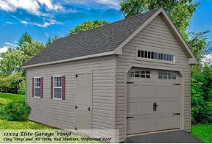

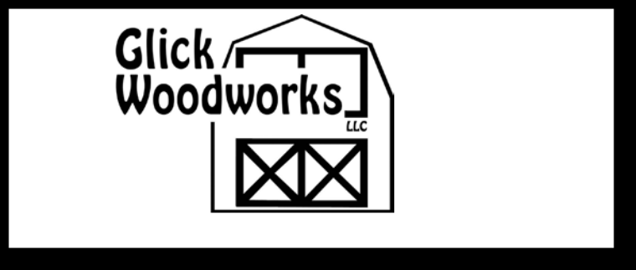
 | 1188 Garfield Road
PA#068100 | Mount Joy, PA 17552
PA#068100 | 717-653-6523
Storage Sheds | 717-653-6523
and Garages | Fax: 717-653-0307
 | www.glicksheds.com

HOURS: Monday - Friday 7 am - 5 pm; Saturday 8 am - 12 noon

See other side for options.
Price Sheet
GARAGES

Prices Effective 3/1/15

 | HIGH WALL GARAGE |  | A-FRAME GARAGE |  |  |  |  |  | CLASSIC A-FRAME GAR. |  |  |  | ELITE GARAGE |  |  |  |  | Loft | 2nd Flr
Sizes | T1-11 | Vinyl | T1-11 |  | Vinyl |  |  |  |  | T1-11 |  | Vinyl | T1-11 |  |  |  | Vinyl | add | add |  | Sizes
12 x 18 | $3,190 | $3,575 | $3,065 |  | $3,685 |  |  |  | $3,345 |  |  | $3,740 | $4,500 |  |  |  | $5,200 | $485 | $755 |  | 12 x 18
12 x 20 | $3,370 | $3,780 | $3,295 |  | $3,865 |  |  |  | $3,565 |  |  | $3,965 | $4,750 |  |  |  | $5,500 | $540 | $840 |  | 12 x 20
12 x 22 | $3,615 | $4,055 | $3,530 |  | $4,145 |  |  |  | $3,840 |  |  | $4,250 |  |  |  |  |  |  |  |  | 12 x 22
12 x 24 | $3,825 | $4,295 | $3,735 |  | $4,385 |  |  |  | $4,045 |  |  | $4,505 | $5,400 |  |  |  | $6,280 | $620 | $1,005 |  | 12 x 24
12 x 26 | $4,030 | $4,530 | $3,935 |  | $4,610 |  |  |  | $4,315 |  |  | $4,740 | $5,700 |  |  |  | $6,650 | $700 | $1,090 |  | 12 x 26
12 x 28 | $4,380 | $4,905 | $4,105 |  | $5,005 |  |  |  | $4,670 |  |  | $5,150 | $5,950 |  |  |  | $6,990 | $750 | $1,175 |  | 12 x 28
12 x 30 | $4,620 | $5,190 | $4,300 |  | $5,150 |  |  |  | $4,945 |  |  | $5,450 |  |  |  |  |  |  |  |  | 12 x 30
12 x 32 | $4,800 | $5,475 | $4,565 |  | $5,400 |  |  |  | $5,220 |  |  | $5,745 | $6,600 |  |  |  | $7,750 | $865 | $1,340 |  | 12 x 32
12 x 36 |  |  |  |  |  |  |  |  |  |  |  |  | $7,500 |  |  |  | $8,550 | $972 | $1,510 |  | 12 x 36
14 x 20 | $3,900 | $4,700 | $3,780 |  | $4,400 |  |  |  | $4,545 |  |  | $5,025 | $5,800 |  |  |  | $6,900 | $630 | $980 |  | 14 x 20
14 x 22 |  |  |  |  |  |  |  |  |  |  |  |  |  |  |  |  |  |  |  |  | 14 x 22
14 x 24 | $4,500 | $5,320 | $4,300 |  | $5,220 |  |  |  | $5,065 |  |  | $5,580 | $6,800 |  |  |  | $7,690 | $755 | $1,175 |  | 14 x 24
14 x 28 | $5,100 | $5,720 | $4,900 |  | $5,940 |  |  |  | $5,455 |  |  | $6,000 | $7,380 |  |  |  | $8,660 | $880 | $1,375 |  | 14 x 28
14 x 30 | $5,540 | $6,105 | $5,200 |  | $6,345 |  |  |  | $5,835 |  |  | $6,410 |  |  |  |  |  |  |  |  | 14 x 30
14 x 32 | $5,870 | $6,455 | $5,600 |  | $6,690 |  |  |  | $6,285 |  |  | $6,775 | $8,300 |  |  |  | $9,600 | $1,005 | $1,568 |  | 14 x 32
14 x 36 | $6,300 | $6,935 | $6,100 |  | $7,185 |  |  |  | $6,650 |  |  | $7,280 | $9,300 |  |  |  | $10,650 | $1,135 | $1,764 |  | 14 x 36
14 x 40 | $6,740 | $7,410 | $6,695 |  | $7,675 |  |  |  | $7,115 |  |  | $7,780 | $9,950 |  |  |  | $11,530 | $1,260 | $1,960 |  | 14 x 40
 |  |  |  |  |  |  |  |  |  |  |  |  |  |  |  |  |  | Loft is | Full
 | T1-11 SIDING |  | VINYL SIDING |  |  |  |  |  |  | Classic A-Frame includes: |  |  |  |  |  |  |  | 1/2 of | second
 |  |  |  |  |  |  |  |  |  |  |  |  |  |  |  |  |  | 1st floor | floor with
 | 4/12 Roof | 6/12 Roof | 4/12 Roof | 6/12 Roof |  |  |  |  |  | 6” Gable Overhangs |  |  |  |  |  |  |  | 1st floor
 |  |  |  |  |  |  |  |  |  |  |  |  |  |  |  |  |  | size with | pull down
20 x 20 | $5,930 | $7,095 | $6,655 |  | $8,035 |  |  |  |  | 6/12 Pitch Roof |  |  |  |  |  |  |  | pull down | stairs.
 |  |  |  |  | $8,035 |  |  |  |  | 14’ Wide has 4/12 Pitch |  |  |  |  |  |  |  | pull down
 |  |  |  |  |  |  |  |  |  |  |  |  |  |  |  |  |  | stairs
20 x 24 | $6,395 | $7,730 | $7,655 |  | $9,160 |  |  |  |  |  |  |  |  |  |  |  |  | stairs
 |  |  |  |  | $9,160 |  |  |  |  | Roof due to Hauling
 |  |  |  |  | $9,160 |  |  |  |  |  |  |  | ELITE FEATURES: 8’ Walls
20 x 28 | $6,960 | $8,370 | $8,700 |  | $10,335 |  |  |  |  | Height Restrictions.
 |  |  |  |  | $10,335 |  |  |  |  |  |  |  | Floor Joist 12” o/c
20 x 30 | $7,310 | $8,755 | $9,220 |  | $10,910
 |  |  |  |  | $10,910 |  |  |  |  |  |  |  | 2 Layers 5/8” Plywood Floor
20 x 32 | $7,875 | $9,395 | $9,755 |  | $11,525
 |  |  |  |  | $11,525 |  |  |  |  |  |  |  | 9 x 7 Overhead Door
20 x 36 | $8,490 | $10,030 | $10,670 |  | $12,540 |  |  |  |  |  |  |  | 3’ Entry Door
20 x 40 | $9,015 | $10,670 | $11,725 |  | $13,710 |  |  |  |  |  |  |  | (2) 30” x 36” Windows with Trim around Windows
 |  |  |  |  |  |  |  |  |  |  |  |  | & Shutters
24 x 24 | $7,010 | $8,420 | $8,505 |  | $10,305
 |  |  |  |  | $10,305 |  |  |  |  | More Custom Design |  |  | T1-11 has Full Trim Package including Z Style Shutter
24 x 28 | $8,065 | $9,605 | $9,870 |  | $11,640
 |  |  |  |  | $11,640 |  |  |  |  |  |  |  | Double Transom Windows in both Gables
24 x 30 | $8,695 | $10,305 | $10,290 |  | $12,355 |  |  |  |  | Options Available |  |  | 10/12 Pitch Roof
24 x 32 | $9,160 | $10,915 | $11,045 |  | $13,145 |  |  |  |  | Ask Us! |  |  | 10” Gable Overhangs
24 x 36 | $10,295 | $12,220 | $12,285 |  | $14,700
24 x 40 | $11,320 | $13,500 | $13,230 |  | $15,435
 | Garage Standard Features: |  | Double Wide Garages:
 | Floor Joist 12” o/c |  | 2 Overhead Doors
 | 2 Layers 5/8 Flooring |  | 1 Passage Door
 | Plywood |  | (3) 24” x 36” Windows
 | 9’ Wide Overhead Door |  | with Shutters
 | 3’ Entry Door |  | No Center Wall on
 | (2) 24” x 36” Windows |  | Buildings 28’ or less.
 | with Shutters |  | Over 28’, 4’ Wall in Either
 |  |  | End.
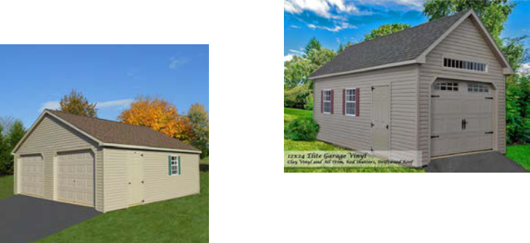

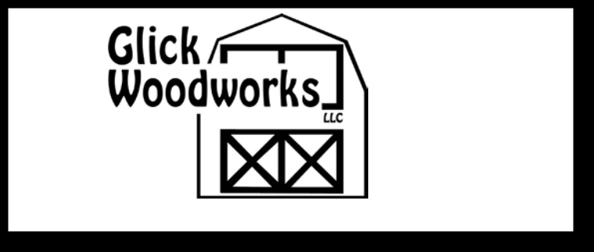
 | 1188 Garfield Road
PA#068100 | Mount Joy, PA 17552
PA#068100 | 717-653-6523
Storage Sheds | 717-653-6523
and Garages | Fax: 717-653-0307
 | www.glicksheds.com

HOURS: Monday - Friday 7 am - 5 pm; Saturday 8 am - 12 noon
Price Sheet

2-STORY SINGLE & DOUBLE-WIDE GARAGES

Prices Effective 3/1/15

 |  |  | 2-STORY SINGLE-WIDE |  |  |  |  |  |  | 2-STORY DOUBLE-WIDE
 |  |  |  |  | Gambrel |  | Gambrel |  |  |  |  | Gambrel |  | Gambrel
 | Sizes |  | Smartside | Vinyl | Smartside |  | Vinyl | Sizes |  | Smartside | Vinyl | Smartside |  | Vinyl
 | 12 x 16 |  | $5,300 | $6,350 | $5,720 |  | $6,650 | 20 x 20 |  | $10,200 | $12,350 | $11,100 |  | $13,150
 | 12 x 18 |  | $5,500 | $6,600 | $5,940 |  | $7,040 | 20 x 24 |  | $11,700 | $13,250 | $12,760 |  | $14,295
 | 12 x 20 |  | $5,800 | $6,900 | $6,250 |  | $7,450 | 20 x 28 |  | $13,400 | $16,200 | $14,600 |  | $17,400
 | 12 x 24 |  | $6,500 | $7,900 | $7,100 |  | $8,500 | 20 x 32 |  | $15,200 | $18,300 | $16,500 |  | $19,600
 | 12 x 28 |  | $7,400 | $8,650 | $8,010 |  | $9,400
 | 12 x 32 |  | $8,100 | $9,650 | $8,850 |  | $10,400 | 24 x 24 |  | $12,800 | $15,400 | $13,945 |  | $16,555
 | 12 x 36 |  | $9,100 | $10,875 | $9,930 |  | $11,700 | 24 x 28 |  | $14,700 | $17,600 | $15,990 |  | $18,885
 | 12 x 40 |  | $10,400 | $12,525 | $11,450 |  | $13,390 | 24 x 32 |  | $16,300 | $19,600 | $17,700 |  | $21,015
 |  |  |  |  |  |  |  | 24 x 36 |  | $18,300 | $21,950 | $19,900 |  | $23,560
 | 14 x 20 |  | $7,300 | $8,800 | $7,900 |  | $9,500 | 24 x 40 |  | $20,200 | $24,150 | $21,975 |  | $25,930
 | 14 x 24 |  | $8,450 | $10,400 | $9,410 |  | $11,200
 | 14 x 28 |  | $9,300 | $11,200 | $10,100 |  | $12,100 | 28 x 28 |  |  |  | $18,700 |  | $22,500
 | 14 x 32 |  | $10,600 | $12,400 | $11,575 |  | $13,540 | 28 x 32 |  |  |  | $21,400 |  | $24,500
 | 14 x 36 |  | $11,600 | $14,000 | $12,740 |  | $15,255 | 28 x 36 |  |  |  | $23,600 |  | $28,450
 | 14 x 40 |  | $12,600 | $15,200 | $13,800 |  | $16,530 | 28 x 40 |  |  |  | $26,050 |  | $31,150
 | STANDARD FEATURES |  |  |  |  |  |  | STANDARD FEATURES
 | First Floor: |  |  |  |  |  |  | First Floor:
 | Pressure Treated 2x4 Floor Joist 12” o/c |  |  |  |  |  |  | Pressure Treated 2x4 Floor Joist 12” o/c
 | 2 Layers 5/8” Flooring |  |  |  |  |  |  | 2 Layers 5/8” Flooring
 | 2 x 4 Wall Construction 16” o/c |  |  |  |  |  |  | 2 x 4 Wall Construction 16” o/c
 | 1/2” Smartside or 1/2” osb with Vinyl Siding |  |  |  |  |  |  | 1/2” Lp Smartside or 1/2” osb with Vinyl Siding
 | 10’ Wall Height |  |  |  |  |  |  | 10’ Wall Height
 | 36” Wide Prehung House Door (9 light glass) |  |  |  |  |  |  | Center Header with 14’ Opening
 | 9’ x 7’ Garage Door |  |  |  |  |  |  | 36” Prehung House Door (9 light glass)
 | (3) 24” x 36” Windows with Shutters |  |  |  |  |  |  | (2) 9’ x 7’ Garage Doors on 24’ & 28’ wide bldgs (8’ wide on 20’ bldgs)
 | Stairway to 2nd Floor |  |  |  |  |  |  | (4) 24” x 36” Windows with Shutters
 | Second Floor: |  |  |  |  |  |  | Stairway to 2nd Floor
 | 2 x 6 Floor Joist 16” o/c |  |  |  |  |  |  | Second Floor:
 | 5/8” Flooring |  |  |  |  |  |  | 2 x 6 Floor Joist 16” o/c
 | 2 x 6 Rafters 16” o/c |  |  |  |  |  |  | 5/8” Flooring
 | 10/12 Pitch Roof |  |  |  |  |  |  | 2 x 6 Rafters 16” o/c
 | (2) 24” x 36” Windows with Shutters |  |  |  |  |  |  | 8/12 Pitch Roof
 | 8” Gable Overhang |  |  |  |  |  |  | (4) 24” x 36” Windows with Shutters
 | Painted Lp Trim on Eves and Gables on Smartside Building |  |  |  |  |  |  | 8” Gable Overhangs
 | Options: |  |  |  |  |  |  | Lp trim on Eves and Gable of Smartside Building
 | 2 x 8 Floor Joist on 2nd Floor add .45 sq. ft. |  |  |  |  |  |  | Options:
 | 2 x 6 Walls add .50 sq. ft. |  |  |  |  |  |  | 2 x 8 Floor Joist on 2nd Floor add .45 sq. ft.
 | Shed Dormers $90 per ft. |  |  |  |  |  |  | 2 x 6 Walls add .50 sq. ft.
 | Includes 1 Window per 8’ Section |  |  |  |  |  |  | Shed Dormers includes 1 Window per 8’ Section $90 per ft.
 | 8’ Wide Hinged Overhang includes LVL Header $65 per ft. |  |  |  |  |  |  | 4’ Return Dormer (includes 1 window) $1,100 each
 | Arched Top Garage Door Top $125 each |  |  |  |  |  |  | 6’ Return Dormer (includes 1 window ) $1,325 each
 |  |  |  |  |  |  |  | 8’ Wide Hinged Overhang includes LVL Header $65 per ft.
 |  |  |  |  |  |  |  | Arched Top Garage Door Top $125 each

OPTIONS

8” o/c Floor Joist from 12” o/c Garage................................... | $0.25 / sq. ft.
8” o/c Floor Joist from 16” o/c............................................... | $0.55 / sq. ft.
12” o/c Floor Joist.................................................................. | $0.25 / sq. ft.
Double Plywood Floor (DPF)................................................... | $0.80 / sq. ft.
Upgrade to Pressure Treated Plywood Floor........................... | $0.75 sq. ft.
7’ High Walls (7HW)........................................................................ | $10 / ft.

 | 1188 Garfield Road
PA#068100 | Mount Joy, PA 17552
PA#068100 | 717-653-6523
Storage Sheds | 717-653-6523
and Garages | Fax: 717-653-0307
 | www.glicksheds.com
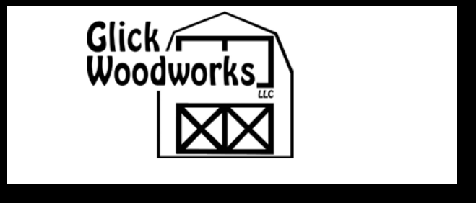

HOURS: Monday - Friday 7 am - 5 pm; Saturday 8 am - 12 noon

1/2” Plywood Sheathing (PS)....................................... |  | 5% Vinyl - 3% T1-11
Silver Crest Sheathing................................... | Vinyl add 9% - T1-11 add 6%
(Helps keep shed cool; keeps shed brighter inside)
Dormer (Shed Style or Return Dormer)........................................... |  | $400 extra
10’ Long Ridge Vents (RV10).................................................................. |  | $50
12” x 12” Gable Vents................................................................ |  | $40 per pr
Extra 18” x 24” Window (SW)......................................................... |  | add $40
24” x 36” Window Upgrade from 18” x 24” (BWUG)...................... |  | add $25
Extra 24” x 36” Window........................................................................ |  | $65
Pair Shutters 24” or 36”........................................................................ |  | $30
Vinyl Flower Boxes (VFB)................................................................ |  | $30 each
Vinyl 24” x 36” House Window (VHW)................................................. |  | $150
36” Pre-hung Door (Solid) (PDS)........................................................... |  | $250
36” Pre-hung Door (with Glass) (PDG)................................................... |  | $275
6” Decorative Hinge............................................. | add $20 per set of doors
Upgrade from T1-11 Door to Fiberglass or Steel Doors............. |  | $60 per door
Steel or Fiberglass 36” Slab Door........................................................ |  | $125
Add Glass to Above Door...................................................................... |  | $50
Standard Colors for Steel Doors: Tan, Clay, Almond, White, Light Gray Fiberglass Door Colors Match Vinyl Siding Colors
Double Slab Doors................................................................... $210 per set
Custom Color Painted Door (CPD).................................... add $25 per door
 | Trim Package (T1-11 includes 4” trim on doors with arch top trim, larger windows with
 | Z style shutter, 6” trim on gables & eves, 6” gable overhang.) (Vinyl includes
 | steel or fiberglass doors upgrade, 6” gable overhang & larger windows.)
 |  |  | 8’ w add $210......................... |  | 10’ w add $230
 |  |  | 12’ w add $260........................ |  | 14’ w add $330
 | Arched Top Garage Door Opening..................................................... |  |  |  | $125
 | Overhead Door 9’ x 7’ Steel (OSD).............................................. |  |  |  |  | $450 extra
 | Insulated Overhead Door (OISD)........................................... |  |  |  | $100 per door
 | Window in Overhead Door (WOD).......................................... |  |  |  | $60 per door
 | Overhead Door Homestead Style Upgrade (ODHS)............................. |  |  |  | $325
 | 16” Wide Shelving (SWS) |  | .................................................................. |  |  | $3 / ft.
 | 32” Wide Shelving (LWS)................................................................... |  |  |  |  | $4 / ft.
 | 48” Wide Lofts (LLS).......................................................................... |  |  |  |  | $6 / ft.
 | Partitions in Building, Wall Height (PB)........................................... |  |  |  |  | $12 / ft.
 | Partitions in Building, Full Height................................................... |  |  |  |  | $15 / ft.
 | 4 x 4 Ramp (LR)...................................................................................... |  |  |  | $60
 | 4 x 5 Ramp............................................................................................ |  |  |  | $75
 | 4 x 6 Ramp............................................................................................ |  |  |  | $90
 | 4 x 9 Ramp.......................................................................................... |  |  |  | $135
 | Diamond Plate Door Sill Protector (DPDS)........................................ |  |  |  |  | $5 / ft.
 | Pegboard (PBD)....................................................................... |  |  |  | $1.25 / sq. ft.
 | Workbench 30” x 5’.............................................................................. |  |  |  | $45
 |  | 6” Gable Overhangs (A-Frames and Quakers)
6’ Wide (6GO).......................... |  |  | $75 | 12’ Wide (12GO)................... | $135
 | 8’ Wide (8GO).......................... |  | $85 | 14’ Wide (14GO)................... | $160
 | 10’ Wide (10GO).................... |  | $110

7’ Walls
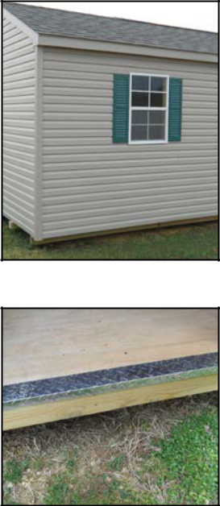

Diamond Plate
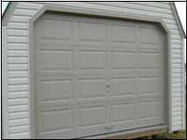

Overhead Door
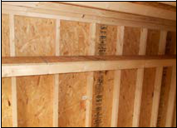

Shelving
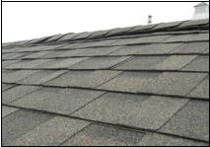

Ridge Vent

Prices Effective 3/1/15
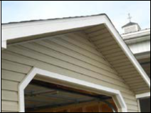

Gable Overhang
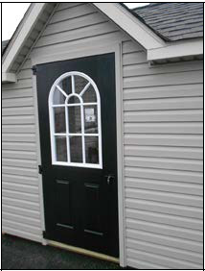

Fiberglass Door w/Glass
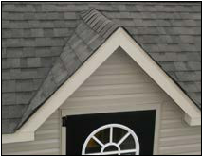

Reverse Dormer
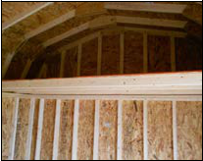

Loft
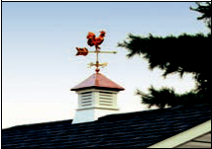

Cupola

 |  | Roofing Upgrades
Cedar Shakes.............. | $5.25 / sq. ft. |  | Metal Roof.............. |  | $2.25 / sq. ft.
 | Porches (includes 36” door)
4 x 4 ..................................... | $375 |  | 4 x 8..................................... |  | $575

 |  | Cupolas
Azek 18” Gulfport (A8G)............................................. |  |  |  | $150
Azek 18” Monterey Coppertop (A8MC)...................... |  |  |  | $200
12/12 Base Extension (12BE)........................................ |  |  |  | $25

