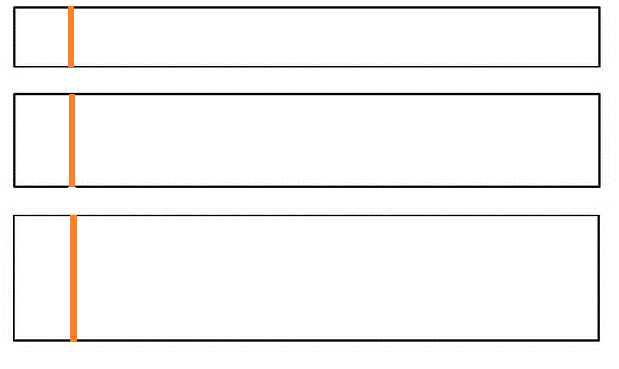

Notebook Title

Notebook Title

Notebook Title