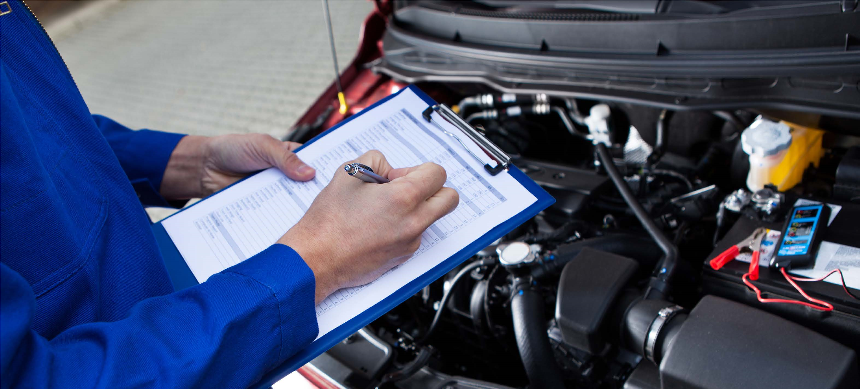

Track your ongoing upkeep with the
VEHICLE MAINTENANCE LOG
TABLE OF CONTENTS
6
MO
3
YR
click on the icons to
jump between sections
5,000 Miles or 6 Month Interval Maintenance 3
30,000 Miles or 3 Year Interval Maintenance 4
Dealer Maintenance Log 5

TABLE OF CONTENTS
5,000 MILES OR 6 MONTH INTERVALS
Perform specific inspection, maintenance and lubrication procedures.
6-Month Dealer Maintenance Checklist
Check off each service appointment listed below and ensure your dealer completes the following checkpoints.
Inspect ramp access door system operation Inspect undercarriage and ground effects and alignment; clean and lube system
Inspect ramp system operation; Inspect and maintain wheelchair tiedowns
clean and lube systemand occupant restraints
Inspect kneel system operation; 30,000 mile or 3 year intervals: perform specified clean and lube system (if applicable)maintenance and service procedures
Inspect electronic control system for current software (if applicable)

 | 1 |  | 2 |  | 3 |  | 4 |  | 5 |  | 6 |  | 7 |  | 8 |  | 9 |  | 10 |  | 11 |  | 12 |  | 13 |  | 14 |  | 15
5,000 | 10,000 | 15,000 | 20,000 | 25,000 | 30,000 | 35,000 | 40,000 | 45,000 | 50,000 | 55,000 | 60,000 | 65,000 | 70,000 | 75,000 | 80,000 | 85,000 | 90,000 | 95,000 | 100,000 | 105,000 | 110,000 | 115,000 | 120,000 | 125,000 | 130,000 | 135,000 | 140,000 | 145,000 | 150,000

5,000 MILES OR 6 MONTH INTERVAL MAINTENANCE
30,000 MILES OR 3 YEAR INTERVALS
Perform specific inspection, maintenance and lubrication procedures.
3-Year Dealer Maintenance Checklist
Check off each service appointment listed below and ensure your dealer completes the following checkpoints.
Door Rollers (if applicable): 5,000 or 6 month intervals:
inspect and replace as necessary perform specified inspection, maintenance and lubrication procedures.
Kneel Chain (if applicable):
inspect and replace as necessary *Infloor ramp motor and drive components are
accessible only by removing the top cover. Refer
Foldout Ramp Chain (if applicable): to applicable service manual.
inspect and replace as necessary
*Infloor Ramp Belt and Rollers (if applicable):
Inspect and replace as necessary

1 2 3 4 5 6 7 8 9 10 11 12 13 14 15
5,000 | 10,000 | 15,000 | 20,000 | 25,000 | 30,000 | 35,000 | 40,000 | 45,000 | 50,000 | 55,000 | 60,000 | 65,000 | 70,000 | 75,000 | 80,000 | 85,000 | 90,000 | 95,000 | 100,000 | 105,000 | 110,000 | 115,000 | 120,000 | 125,000 | 130,000 | 135,000 | 140,000 | 145,000 | 150,000

30,000 MILES OR 3 YEAR INTERVAL MAINTENANCE

Service Center:
Date:
Technician:
Mileage:
Maintenance / Service Description and Notes:
1
5,000
Service Center:
Date:
Technician:
Mileage:
Maintenance / Service Description and Notes:
2
10,000
Service Center:
Date:
Technician:
Mileage:
Maintenance / Service Description and Notes:
3
15,000
Service Center:
Date:
Technician:
Mileage:
Maintenance / Service Description and Notes:
4
20,000
Service Center:
Date:
Technician:
Mileage:
Maintenance / Service Description and Notes:
5
25,000
Service Center:
Date:
Technician:
Mileage:
Maintenance / Service Description and Notes:
6
30,000
Service Center:
Date:
Technician:
Mileage:
Maintenance / Service Description and Notes:
7
35,000
Service Center:
Date:
Technician:
Mileage:
Maintenance / Service Description and Notes:
8
40,000
Service Center:
Date:
Technician:
Mileage:
Maintenance / Service Description and Notes:
9
45,000
Service Center:
Date:
Technician:
Mileage:
Maintenance / Service Description and Notes:
10
50,000
Service Center:
Date:
Technician:
Mileage:
Maintenance / Service Description and Notes:
11
55,000
Service Center:
Date:
Technician:
Mileage:
Maintenance / Service Description and Notes:
12
60,000
Service Center:
Date:
Technician:
Mileage:
Maintenance / Service Description and Notes:
13
65,000
Service Center:
Date:
Technician:
Mileage:
Maintenance / Service Description and Notes:
14
70,000
Service Center:
Date:
Technician:
Mileage:
Maintenance / Service Description and Notes:
15
75,000
Service Center:
Date:
Technician:
Mileage:
Maintenance / Service Description and Notes:
16
80,000
Service Center:
Date:
Technician:
Mileage:
Maintenance / Service Description and Notes:
17
85,000
Service Center:
Date:
Technician:
Mileage:
Maintenance / Service Description and Notes:
18
90,000
Service Center:
Date:
Technician:
Mileage:
Maintenance / Service Description and Notes:
19
95,000
Service Center:
Date:
Technician:
Mileage:
Maintenance / Service Description and Notes:
20
100,000
Service Center:
Date:
Technician:
Mileage:
Maintenance / Service Description and Notes:
21
105,000
Service Center:
Date:
Technician:
Mileage:
Maintenance / Service Description and Notes:
22
110,000
Service Center:
Date:
Technician:
Mileage:
Maintenance / Service Description and Notes:
23
115,000
Service Center:
Date:
Technician:
Mileage:
Maintenance / Service Description and Notes:
24
120,000
Service Center:
Date:
Technician:
Mileage:
Maintenance / Service Description and Notes:
25
125,000
Service Center:
Date:
Technician:
Mileage:
Maintenance / Service Description and Notes:
26
130,000
Service Center:
Date:
Technician:
Mileage:
Maintenance / Service Description and Notes:
27
135,000
Service Center:
Date:
Technician:
Mileage:
Maintenance / Service Description and Notes:
28
140,000
Service Center:
Date:
Technician:
Mileage:
Maintenance / Service Description and Notes:
29
145,000
Service Center:
Date:
Technician:
Mileage:
Maintenance / Service Description and Notes:
30
150,000

Vehicle Maintenance Log

