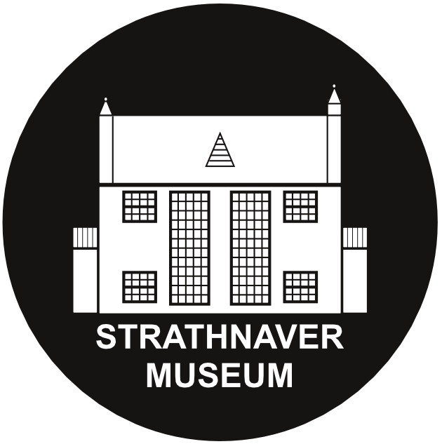

Volunteer Application Form

1 | PERSONAL DETAILS
 | Name:
 | Address:
 | Date of birth: |  |  | Gender:
 | Contact telephone no:
 | Email address:
 | Do you belong to any of the following groups:  BME  Under 25 years  Disabled  50 years plus |  | Unemployed  A migrant worker  Other – please specify:  Prefer not to say

2 | SKILLS AND INTERESTS
 | Reason / motivation for volunteering?
 | Existing skills, qualifications or interests:
 | What skills and experience are you looking to develop?

3 | BARRIERS TO VOLUNTEERING
 | Do you have any barriers to volunteering, e.g. days of the week which aren’t suitable, any health issues or transport difficulties or any projects which you wouldn’t want to volunteer with?

4 | VOLUNTEER POSITION
 | Which volunteer position(s) are you interested in applying for?
 | Front of House  Maintenance  Admin Assistant | PR and Media  Activities / Events  Research Assistant
Your idea or suggestion:
________________________________________________________________________
________________________________________________________________________
________________________________________________________________________

5 | TIME COMMITMENT
 | Would you like to be a: | Regular volunteer?  Occasional volunteer?
 | Total hours per week:
 | Availability: | Mornings Afternoons Evenings  Weekdays Weekends

6 | DECLARATION
Data protection: This application form will be kept in a paper based filing system and details from it may be recorded on computer. The purpose of this is to have a record of contact details for everyone and also to produce statistics on client volunteering for our Board of Trustees and Funders. You may have access to your personal records on request at any time.

I accept that information contained in this form may be used as described above and I confirm that the information given in this application is correct.

Signature: Date:

Please give your completed form to:

Fiona Mackenzie – Development Manager

Strathnaver Museum, Clachan, Bettyhill, KW14 7SS

info@strathnavermuseum.org.uk

01641 521 418

