Market Analysis of Bird-Based Tourism:

A Focus on the U.S. Market to Latin America and the Caribbean Including Fact Sheets on The Bahamas, Belize, Guatemala, Paraguay

Bird-based tourism is growing rapidly, including to developing countries. According to one study, “Bird watching is reported as being the fastest growing outdoor activity in America,”¹ while another notes, “An increasing number of birdwatchers are traveling to long haul destinations to spot new birds that cannot be seen in their own country or region.”² To capitalize on this growing market, however, developing countries have to offer what birdwatchers require, including safety, accessibility, infrastructure, quality of birdlife, and knowledgeable guides. This document looks at global trends in bird tourism (with a particular focus on the US market) and concludes with fact sheets on four countries: The Bahamas, Belize, Guatemala, and Paraguay, currently the locations of an initiative of the Multilateral Investment Fund of the Inter-American Development Bank (IDB/MIF) together with the U.S.’ largest bird conservation organization, The National Audubon Society.

Size and Strength of the Bird-Based Tourism Market

In the United States, approximately 46.7 million people observed birds around the home and on trips in 2011, according to the U.S. Fish and Wildlife Service (FWS) national survey. A large majority, 88% (41.3 million), observed wild birds around their homes, while 38% (17.8 million) took birding trips away from home. Birders averaged a startling 110 days of birding in 2011.

Away-from-home birders averaged 13 days.³

Another study citing USDA Forest Service studies contains roughly similar findings, particularly in terms of bird watchers who travel: some 80 million Americans – 35% of the adult population – viewed, identified, or photographed birds between 2005

and 2009. Of these, 42% or nearly 20 million people took birding trips away from home. On average they spent 14 days away

from home observing birds.⁴ The USDA Forest Service’s National Survey found that bird viewing and photography is “the most steadily growing [recreational] activity in the United States,” growing 287% from 1982 to 2009.⁵ In the UK, as well, bird watching has become the number one hobby according to a 2013 survey, making the UK, along with the Netherlands, Denmark, France, Sweden,
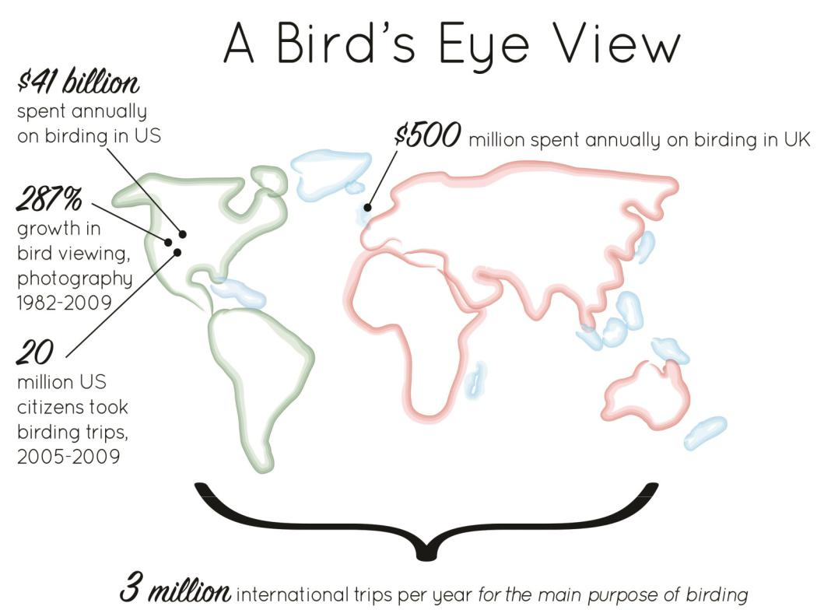

important European bird tourism providers to developing countries.⁶

“There can be no doubt that bird watching has the potential to be a significant tourism market segment,” concludes a recent study by the Caribbean Tourism Organizations (CTO), adding that “growth is expected to be strong over the next 10 years.” This CTO report estimates that 3 million

international trips (worldwide) are taken each year for the main purpose of bird watching,

and many more trips combine birding with other activities.⁷

1
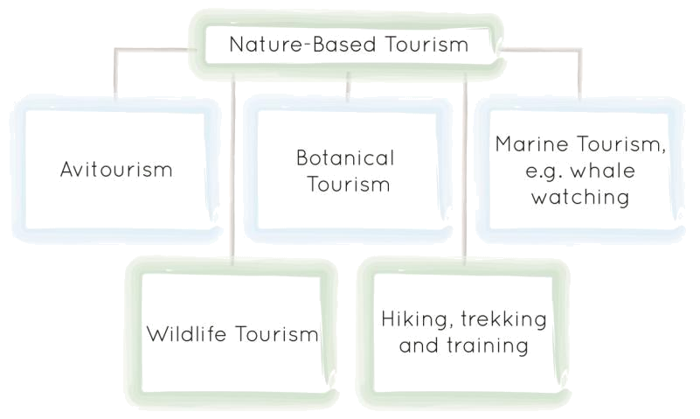
Birdwatching as a Market Segment

Bird-based tourism or Avitourism is considered a sub -category or “niche market” of nature-based

tourism. According to the CTO, bird watching and other tourism niche markets “are good for diversifying the product, minimizing the effects of seasonality, and reducing pressure on ‘honey pot’ areas by distributing tourists to lesser-visited places.”⁸

While historically restricted to an elite, bird watching has “grown into [a] highly popular pastime for the non-professional in the U.S.” and elsewhere.⁹ A

number of factors contribute to the growing popularity of bird watching and bird tourism. These include a drop in price of birding equipment such as binoculars and telescopes, the growing number of TV documentaries on birds and other wildlife, and the increasingly sophisticated techniques for filming birds close up and in flight. There is also a growing number of field guides dedicated to birding, as well as an array of beautiful ‘coffee table’ bird books. Further, the number of festivals featuring birds has grown exponentially. In 2004, there were over 200 festivals in the US and Canada. Internationally, the World Migratory Bird Day is now celebrated in some 70 countries and includes festivals, education programs, presentations, film screenings and bird watching trips, all run by hundreds of volunteers and organizations.¹⁰ One of the most important reasons for the growth in numbers of bird watchers has been the impressive growth in wildlife photography. According to a recent survey by the U.S. Fish and Wildlife Service, there were 13.9 million wildlife photographers in 2001. By 2011, that number had grown to 25.4 million, an increase of 82%.¹¹
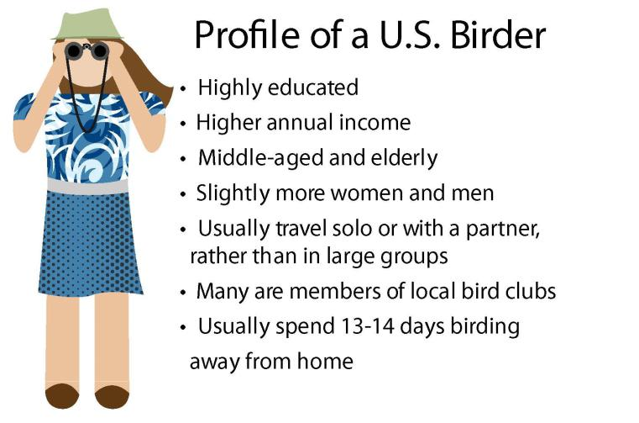

Profile of Consumers

Surveys find that US bird watchers are usually highly educated, affluent, slightly more women (56%) than men, and made up of all age groups, but middle-aged and elderly people represent the largest group (40-70 years of age).

They travel to areas where bird life is abundant and are keen to see as many species as possible in the most cost effective manner. Bird watchers may combine bird viewing with other wildlife viewing. Many enjoy other activities such as gardening, hiking, and photography and are members of local bird or nature clubs. They

generally use bird and nature books, magazines, and organizations, and recommendations from other bird watchers when deciding where to go birdwatching.¹² The 2011 FWS survey of birders in the U.S. found that the five states with the most birders among its residents are Vermont, Wisconsin, West Virginia, Wyoming, and Alaska. The regional breakdown of U.S. birders is more in the South (34%), followed by the Midwest (24%), West (22%) and Northeast (20%).¹³
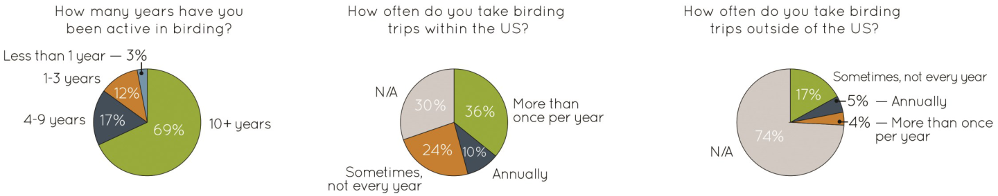

2

Segments within the Birdwatching Market

A British survey describes bird watching travelers as falling into three broad categories: Twitchers, Enthusiastics, and Casuals.¹⁴ The US market roughly parallels these,
describing the 3 categories as named Hard Core Birders,

Enthusiastic Birders, and Casual Birders (Ecotourists).
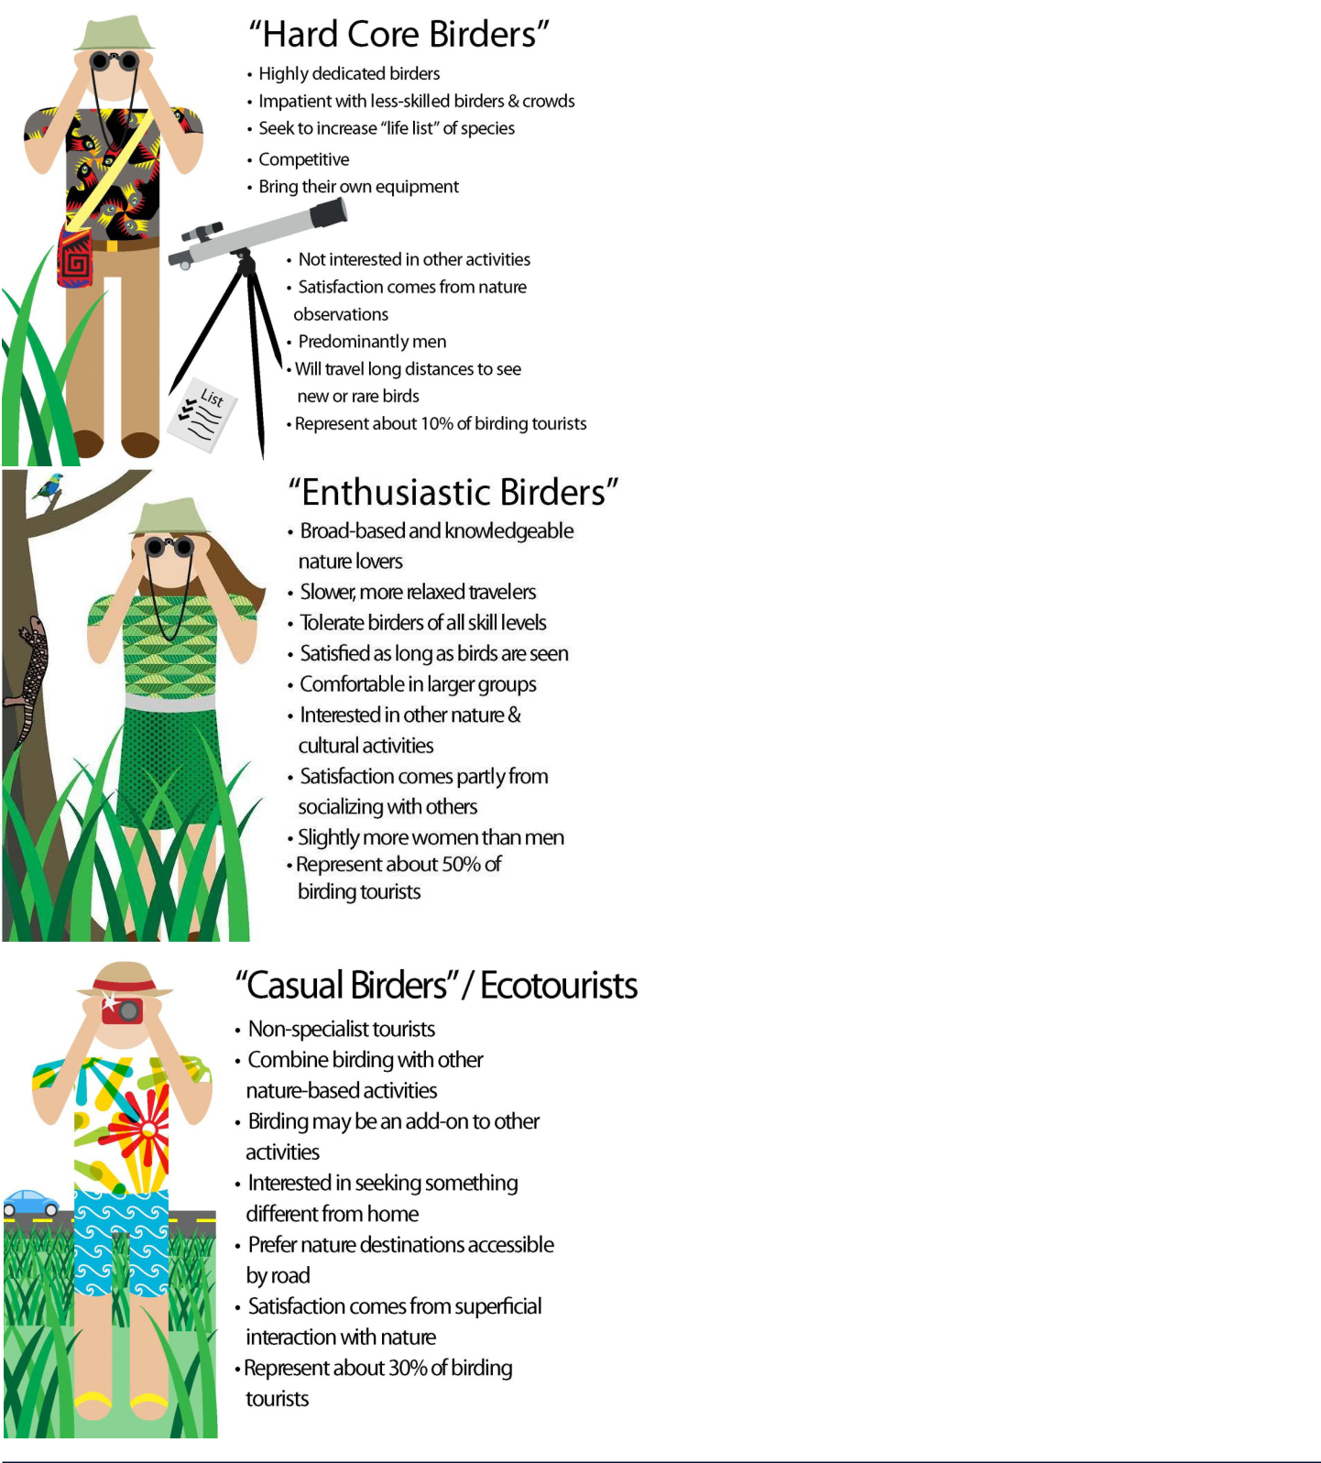
Others refer to the market segments as Hard Birding for Hard Core Birders) and Soft Birding (for the latter 2). Each segment differs in objectives and means to achieve satisfaction. This, in turn, may well have implications for how best to organize birding tours. Marketing and catering
to each segment may lead to higher client satisfaction. ¹⁵

Many birders focus on identifying the greatest number of species possible from a given location. The increase in a birder’s ‘life list’ of species is often an important element in the outcomes from birding activities. In some circumstances, competitive bird watching occurs amongst birders (sometimes on a lifetime/region basis, sometimes during a specified period). Achievement in these activities may take considerable skills and technical support and, depending on the geographic scope, may be expensive.

The Hard Core Birders are highly dedicated, frequently impatient with the presence of lesser-skilled individuals and desire small group size with comparable experience base. Satisfaction comes almost entirely from nature observations, or related activities, not from interaction with other birders or locals. While this segment may invest more on certain aspects in a trip, it is the smallest market of the three. Marketing to Hard Core Birders may be less

attractive for some countries or tour operators, because their decision making is difficult to influence and it is a smaller market segment.

By contrast, the second category of Enthusiastic Birders are more broad-based nature lovers, are not focused simply on birds and are comfortable with a larger group (up to 15) and individuals of varying ability in birding. Satisfaction comes both from observing birds and from social interactions. Despite needing some comforts, this segment also desires a large and diverse bird list. This group makes up a larger part of the birding market than the hard core birders.

Finally, Casual Birders/Ecotourists typically make up the highest proportion of visitors to nature destinations. Satisfaction for this group comes mainly from the superficial interaction with nature and the sense of discovery associated with it. This group prefers visiting areas accessible by road and viewing colorful and emblematic species with less effort and more comfort.

Based on the above findings, developing countries should focus primarily on marketing to the non-hard core bird watchers that represent larger segments in the overall birding market and have broader interests.¹⁶

3
Preferred Bird Settings and Species

According to the 2011 FWS Survey, the most common settings for bird watching are woods, followed by lakes and stream sides, brush covered areas and fields; ocean areas were less favored. The kinds of birds watched to some extent reflect this environmental preference. Waterfowl and songbirds were the most common groups, followed by birds of prey and shorebirds. The FWS study found that for birding away from home (in the US), waterfowl and birds of prey are most popular, followed by songbirds.¹⁷
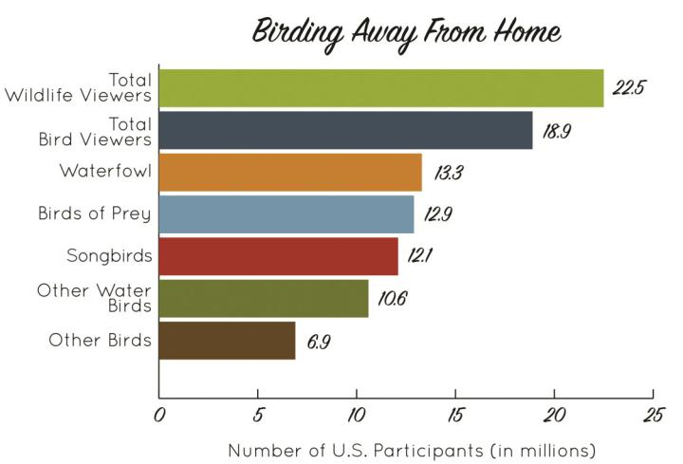

Preferred International Destinations

In order to capture international bird-based tourism, a country must offer “safety, quality of birdlife, birding accessibility and infrastructure, and knowledgeable guides.”¹⁸ High quality lodges and parks/protected areas can be major features of a destination and serve as drivers of birding travel.

U.S. bird watchers prefer visiting places to which indigenous American birds migrate, particularly Mexico and Colombia, followed by Venezuela, Costa Rica and Panama.¹⁹

A 2013 study in Europe found that “an increasing number of bird watchers are travelling to long haul destinations to spot new birds that cannot be seen in their own country or region” and, in addition to the traditional birdwatching destinations, are visiting less traditional countries.²⁰

Economic Value and Spending

The 2011 FWS survey estimates that the annual economic value of U.S. bird watching is $15 billion for trip-related and $26 billion for equipment-related expenditures, generating a total of $41 billion and creating a total

industry output (direct, indirect and induced) across the

4

United States of $107 billion.²¹

Bird watching tourism is also increasing in popularity in Europe. As a comparison, in the U.K., birdwatching expenditures are estimated at $500 million per year.²²

Spending by birders varies, of course, depending on whether it is at or near home, within the home country, or international. According to one study, birders and other wildlife specific specialists “spend more money than generalists.”²³ Another study concludes, “ecotourism including bird-watching can be more lucrative for a community than other types of economic activities.”²⁴ The UNEP Green Economy Report shows that global spending on all areas of ecotourism is increasing by about six times the industry-wide rate of growth.²⁵ Thus, birders, as a market

segment, represent an overall higher value to a country’s economy.

Many birders are willing to pay to see particular species, including highly charismatic and emblematic species, for example, Harpy Eagle, Scarlet Macaw, etc. However, few studies have been conducted on the value of a particular species. In Scotland, the Royal Society for the Protection of Birds found that US $8–12 million is spent annually by tourists wishing to see White-tailed Eagles on the Isle of Mull.²⁶ Another study found that seeing new species in the US may cost, on average, $75; whereas, for a visit to Costa Rica—a species-rich country but relatively cheap to travel to and within—seeing a new species may cost about $8–10.²⁷

Finally, another way to calculate the value of this market segment is by understanding the daily expenditure on birding tours. Average spending per day on birding tours ranges from $70-180 in Guatemala, $145 in Belize, and $300-$400 per day in the Bahamas. At a national level, this market segment can represent millions of dollars in tourism revenue. Ministries of Tourism should collect more

information on expenditure habits of birders to calculate a real estimate of the value of this market segment.

Bird Watching and Sustainable Tourism

Birders, like backpackers, are often the first travelers to open up a destination to the international market. Hard core birders are driven and laser focused in their pursuit of new species for their life lists. Given their passion, many are willing to travel to remove and less developed locations. As word spreads about birding in a new destination, the other two categories of birders, Enthusiasts and Casuals, who seek comforts usually associated with a more established destination, also begin to come.

Those involved in bird tourism tend to be interested in sustainable tourism. There is also “a growing trend among bird tour operators to practice sustainable and socially responsible ecotourism” which relies mainly on local goods and services and often involves supporting local conservation projects.²⁸

Therefore, bird watching and other low impact tourism “can provide a financially sustainable means of habitat protection” including for private reserves.²⁹ This provides a real business opportunity for expanding nature-based tourism in developing countries. Businesses that

incorporate protection of both resident and migratory birds can differentiate themselves from their competitors, becoming more attractive to regional and international tourists sensitive to environmental and ecological issues.

Recommendations

To develop and expand bird-based tourism, Ministries of Tourism and tour operators in Latin America and the Caribbean should target birdwatchers, nature travelers/ ecotourists and nature photographers from the US to visit the country.

Ministries can:

- Offer what birdwatchers require, including safety and security, accessibility to habitats, good infrastructure, quality of birdlife, and knowledgeable guides.

- Advertise and promote the country’s or area’s birdlife and top birding sites. Feature charismatic, emblematic bird species in advertising. Highlight country’s best amenities for birders (lodges, national parks, birding towers, trails, etc.).

- Advertise in diverse media, to include not only websites, but also festivals, social media, guidebooks, and printed materials in appropriate languages.
- Target advertising through bird and nature organizations and publications.

- Target higher value overnight tourists rather than day, stopover or cruise tourists who put little into the local economy and may have little or no environmental understanding or conscience about their impact on a country’s natural resources.

- Improve data collection related to this market segment, including number of visitors, number of days per trip, amount spent, etc. to accurately calculate the value of this market segment.

- Collaborate closely with protected area system managers to develop, manage and market parks and their amenities to birders and nature travelers. Take advantage of visitors “willingness to pay” by charging entrance fees to national protected areas.

- Increase environmental awareness through education of school children and the public to build a local constituency to support parks and protected areas as well as bird watching and other types of wildlife tourism.

- Simplify tour guide certification and accreditation processes.

Tour operators can:

- To reach all three market segments described in this document, develop specialized bird tours as well as tours that include bird watching combined with some other wildlife, nature-based, and cultural activities.

- Emphasize the different species of birds that can be seen by destination, especially endemics, regional endemics and charismatic species.

- Ensure there are well trained and knowledgeable guides in each destination and preferably fluent English speaking guides to receive US birders.

- Attend international events, such as the British Bird Fair, to market the country’s bird tourism offerings.

- Focus on marketing to middle-aged and elderly groups of Enthusiastic and Casual bird watchers, as well as families. Specifically target women, because they are most likely to plan family travel.

5

Endnotes


- Acorn Consulting Partnership. (February 2008). “Bird Watching.” Developing a Niche Tourism Market Database for the Caribbean: 20 Niche Market Profiles. Caribbean Tourism

Organisation. p. 10. http://www.onecaribbean.org/wp-content/uploads/ NicheMarketsDatabase.pdf.

- CBI Ministry of Foreign Affairs (2013). CBI Product Fact Sheet: Birdwatching Tourism by EU residents.” http://www.cbi.eu/sites/default/files/study/product -factsheet-birdwatching-tourism-europe-tourism-2013.pdf.

- US Fish and Wildlife (2011). 2011 National Survey of Fishing, Hunting, and Wildlife-Associated Recreation. Revised February 2014. http://www.census.gov/prod/2012pubs/fhw11-nat.pdf.

- Holly R. Robinson (2012). “Building a Framework for Sustainable Tourism in Key Biodiversity Areas in the Dominican Republic and Jamaica: The Caribbean Birding Trail.” Master of Science. thesis Conservation Biology and Sustainable Development. University of Wisconsin-Madison.

- H.K.Cordell, G.T. Green, and C.J. Betz (2009). Long-Term National Trends in Outdoor Recreation Activity Participation. USDA Forest Service.
⁶ CBI Ministry of Foreign Affairs. (2013). CBI Product Fact Sheet.
- Acorn Consulting Partnership. (February 2008). “Bird Watching.” p. 10.

- Ibid. p. 3.

- Sheri L. Glowinski (December 2008). “Bird-Watching, Ecotourism, and Eco-nomic Development: A Review of the Evidence.” Applied Research in Econom-ic Development. vol. 5, issue 3. pp. 67-68.

- “Bird-Watching Can Help Eco-Tourism Fly High in a Green Economy – UNEP Report” (May 11, 2012). Travel Impact Newswire. https://www.travel-impact-newswire.com/2012/05/bird-watching-can-help-eco-tourism-fly-high-in-a-green-economy-unep-report/.

- Caribbean Birding Trail Website. http://www.caribbeanbirdingtrail.org/ about/sustainabletourism/.

- Acorn Consulting Partnership (February 2008). “Bird Watching.” pp. 10-11; Erin Carver (2011). Birding in the United States: A Demographic and Economic Analysis. Addendum to the 2011 National Survey of Fishing, Hunting, and Wildlife-Associated Recreation. U.S. Fish & Wildlife Service. 2011-1.

- Erin Carver (2011). Birding in the United States. pp. 7-8.

- CBI Ministry of Foreign Affairs. (2013). CBI Product Fact Sheet.

- Karen Higginbottom, ed. (2004). Wildlife Tourism: Impacts, Management and Planning. Common Ground and Sustainable Tourism CRC. Common Ground Publishing. Australia. http://crctourism.com.au/wms/upload/images/ disc%20of%20images%20an5d%20pdfs/for%20bookshop/Documents/ FINAL_WildlifeTourism_V006.pdf.
- CBI Ministry of Foreign Affairs. (2013). CBI Product Fact Sheet.

- US Fish and Wildlife (2011). 2011 National Survey.

- CBI Ministry of Foreign Affairs. (2013). CBI Product Fact Sheet.

- Acorn Consulting Patnership. (February 2008). “Bird Watching.” p. 11.

- CBI Ministry of Foreign Affairs. (2013). CBI Product Fact Sheet.

- Erin Carver (2011). Birding in the United States. pp. 13-14.

- Acorn Consulting Partnership. (February 2008). “Bird Watching.” p. 10.

- Karen Higginbottom, ed. (2004). Wildlife Tourism: Impacts, Management and Planning.

- Sheri L. Glowinski (December 2008). “Bird-Watching, Ecotourism, and Eco nomic Development: A Review of the Evidence.” Applied Research in Econom-ic Development. vol. 5. issue 3. p. 74.

- “Bird-Watching Can Help Eco-Tourism Fly High in a Green Economy – UNEP Report.” (2012).

- Ibid.

- Karen Higginbottom, ed., (2004) Wildlife Tourism.

- “Bird-Watching Can Help Eco-Tourism Fly High in a Green Economy – UNEP Report.” (May 11, 2012). .

- Knut Eisermann and Claudia Avendaño (2009). ”Important Bird Areas of the Neotropics: Guatemala.” Neotropical Birding. 5. http://www.cayaya-birding.com/Eisermann_Avendano_2009_IBA_Guatemala.pdf.

6

