MARKET ANALYSIS REPORT

Prepared by: McClain Towery mcclain@towerydevelopment.com

Prepared for: Dr. Jay Mittal

MASTER OF REAL ESTATE DEVELOPMENT – AUBURN UNIVERSITY

November 16, 2012
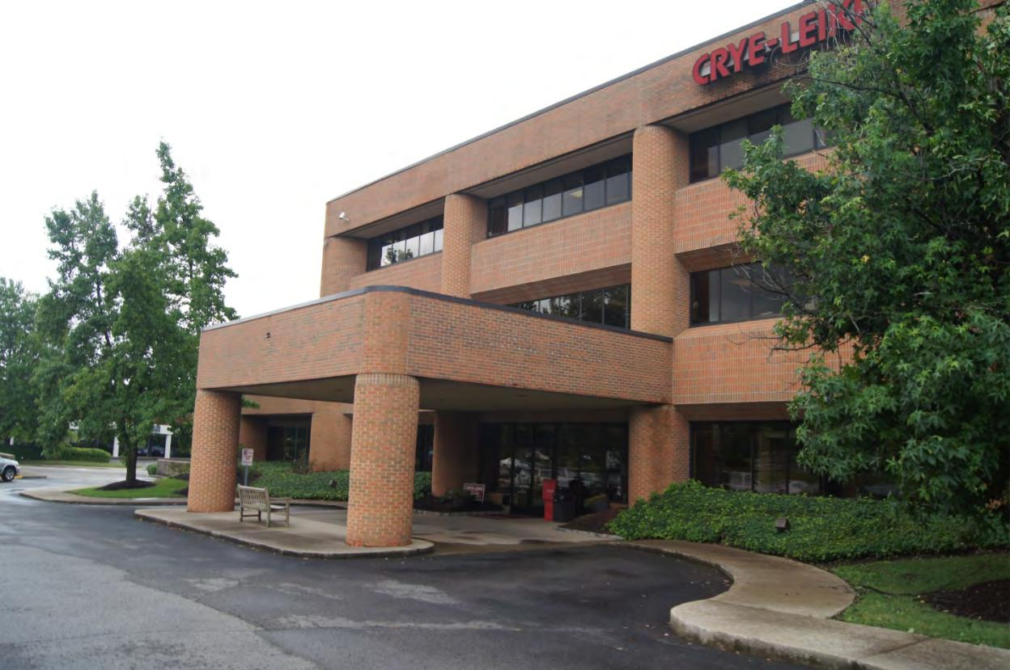

PROFESSIONAL PLAZA BUILIDNG

5111 MARYLAND WAY

BRENTWOOD, TN 37027

PROFESSIONAL PLAZA – MARKET ANALYSIS Page 1

TABLE OF CONTENTS

Executive Summary…………………………………………………………Page #4

Productivity Analysis………………………….…………………………….Page #5

Market Delineation…………. ……………………………………………...Page #10

Forecast Demand Analysis……………..…………………………………Page #11

Supply Analysis……………………………………………………………..Page #12

Equilibrium Analysis………………...……………………………………...Page #14

Forecast Subject Capture……………..……………………………..……Page #15

Conclusions & Recommendations………….………...…………………..Page #17

APPENDIX

Site Location & GIS Maps.…………………………………………………Page #19

Marketing Brochure……...…………………………………………………Page #28

Site & Building Pictures.……………………………………………………Page #33

Comparable Pictures.………………………………………………………Page #42

Final Plat & Deed……………………………………………………………Page #45

Tax Assessment Reports..…………………………………………………Page #54

Tax Breakdown per Suite..…………………………………………………Page #72

Zoning/Parking/FEMA..............……………………………………………Page #74

FDIC Reports.....………….…………………………………………………Page #91

Site-To-Do-Business Reports.…………………………………….………Page #104

PROFESSIONAL PLAZA – MARKET ANALYSIS Page 2

Market Analysis Reports.……………………………………………..……Page #144

Cost-of-Living Data...........…………………………………………………Page #178

Transportation Facilities Data...........……………………..………………Page #185

Williamson County Land Use Data...……………………..………………Page #187

Office Use Standards Analysis.........……………………..………………Page #189

Equilibrium Analysis..........................……………………..………………Page #196

BOMA Office Expense Table.......................……………..………………Page #198

PROFESSIONAL PLAZA – MARKET ANALYSIS Page 3

EXECUTIVE SUMMARY

Presented herein is the market study for the Professional Plaza building. The subject property has great marketability and investment potential located in Maryland Farms office park in the City of Brentwood, TN just south of Nashville. The growing sub-market is home to a diverse industry mix with many major corporate headquarters in a very affluent area.

The 26-year old, Class B subject property is in good condition for its age. The building is a 3 -story brick structure situated on 2.73 acres on a corner lot. The facility offers great visibility and accessibility on Maryland Way, which is the main road servicing Maryland Farms office park. The zoning regulations are very complex and stringent in the City of Brentwood.

Almost 40% of all new jobs in Middle Tennessee (10 counties) were created in Williamson County from 2004 to 2009. The State of Tennessee, the greater Nashville chambers of commerce and the economic development agencies have been aggressively pursuing business relocations through tax incentives and anti-union political philosophies. The cost-of-living is much less relative to comparable cities and the national average with transportation infrastructure that is more than adequate to serve almost any business. This, in part, drives the published growth rate to 2.4% annually. However, as indicated in the conclusions, the predicted growth rate is higher than 2.4%.

The Brentwood/Maryland Farms area is almost completely developed in current commercial zoning districts. Major rezoning measures would be necessary for future large scale commercial projects beyond what is currently planned or under construction. However, the Cool Springs/Franklin area has growth potential. Most of the future competition in the Brentwood/Cool Springs sub-market will be in Cool Springs. The current demand has exhausted the exiting supply with an average submarket vacancy rate of 5%. While there is a substantial amount of planned future supply, the business friendly environment, ideal lifestyle and population growth will generally maintain the stability of the submarket.

The greater Nashville area has a total of approximately 31 million square feet of office space. The Brentwood/Cool Springs submarket represents 31.4% of the total space and 34.3% of the total Class A space, which indicates it’s the preferred submarket. The subject is a Class B property, a class in which the submarket represents 27.7% of the market share. The capture of the site is projected to decrease from 100% to approximately 94% through the first two years and increase to 96% in years 3 through 7.

PROFESSIONAL PLAZA – MARKET ANALYSIS Page 4

Step 1: PRODUCTIVITY ANALYSIS

SUBJECT PROPERTY:

Professional Plaza

5111 Maryland Way

Brentwood, TN 37027
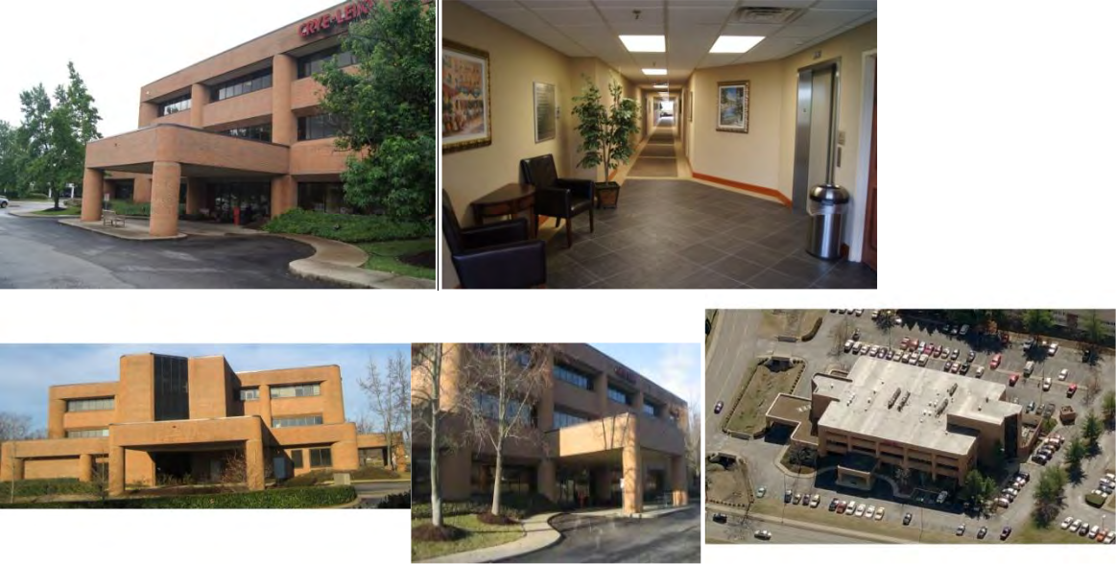

PROPERTY OWNERSHIP (since 6/23/09):

5111 Maryland Way, LLC

5111 Maryland Way, Suite 201

Brentwood, TN 37027

(See attached deed in Appendix)

1.1 Office Type and Tenant Class: The property is a Class B with sound tenant types with good credit ratings. The building includes a total of 7 tenants. A real estate brokerage firm occupies 44% of the building in various suites. There are also 3 medical tenants, which presents a challenge when mixed with typical business tenants.

1.2 SITE & BUILDING ANALYSIS

SITE ANALYSIS:

Land Area: 2.73 acres

Shape: Roughly Square

PROFESSIONAL PLAZA – MARKET ANALYSIS Page 5

Street Frontage: Approximately 320' along Maryland way and approximately 350' along Ward Circle.

Site Access: Both site driveways are accessed from Ward Circle. No site access is provided from Maryland Way. Old Hickory Blvd. just to the north of the site provides easy access to Interstate 65 approximately 1.25 miles to the east of the site.

Topography: The site slopes from the northwest to the southeast at 2% on average with a finished floor elevation of approximately 698.’
Flood Zone Designation: Zone "X"; outside the 500-year floodplain (FEMA Map # 47187C0091F)
Utilities: All necessary utilities are available to the site and all of the office park
including: water/fire mains (building is 100% spriklered), sanitary sewer, storm sewer, gas service, 3-phase electrical service, cable and telephone.

Easements/Encroachments: An existing 10’ public utility and drainage easement is adjacent to the property line on the north, south and west sides. Another 10’ public utility and drainage easement intersects the south portion of the site at an approximate bearing of N65ºW. An existing 50’ drainage easement is adjacent to the property line on the east side. No encroachments were observed during this analysis. (See appendix for the final plat of the property)

Conclusions: The property is on a corner lot on Maryland Way and Ward Circle in the center of Maryland Farms Office Park. The site has great access and visibility with gentle topography. All necessary utilities are available to the property. While there are utility and drainage easements restricting the property, they are essentially confined to the perimeter of the site minimizing the development restrictions. The easements are generally within the building setback; an area which would be otherwise unbuildable. The site is outside of the 500-year flood plain. However, it should be noted that there is an existing large drainage ditch on the east property line in close proximity both vertically and horizontally to the main entrance, which requires bridges to access the site. We recommend an engineering analysis to determine the overflow potential of the drainage ditch. Furthermore, the analysis should address whether or not the building experienced damage in the flood in Middle Tennessee in May of 2010.

BUILDING ANALYSIS:

Year Built: 1985 (suites and common space remodeled at different times)

Number of Stories: 3

Gross Building Area: 54,489 square feet

Rentable Area: 43,492 square feet. Information from on site observation, LoopNet, marketing brochures and County tax records all slightly contradict each other. The County data is very close to site observations and marketing brochures regarding net suite size, and will therefore be used for the purposes of this analysis. This net rental space equates to a fairly high 20% load add-on factor, but not unrealistic. Review of the floor plans (see pictures in Appendix) suggests that a 20% common area space for this building is reasonable.

PROFESSIONAL PLAZA – MARKET ANALYSIS Page 6

Load/Add-on Factor: 20%

Exterior Walls & Roof: The exterior wall are brick façade in good condition. The roof system is a galvanized metal decking with a rubber membrane covered with a layer of aggregate, all of which appeared to be in good condition.

Interior Walls & Floors: The interior common space was is great condition. It was likely renovated within the last 5 years. The floors are a combination of carpet, wood and tile. The walls are painted and wallpapered sheetrock that appeared to be holding up well. All of the suites have all been remodeled at different times since the original building construction.

Mechanical Systems: The mechanical systems are roof mounted in a penthouse that was inaccessible at the time of the site inspection. We recommend a building engineering report to assess the condition of the building infrastructure.

Onsite Parking: 168 spaces

Site Improvements: The property has an asphalt parking lot that is need of repair. It is at the end of its useful life and will require at least a new surface coarse in the near future. The property has site lighting, surveillance/security system, fair landscaping, and two covered vehicular drop-offs.

Conclusions: The property is in good condition overall. The brick structure is well built with 8'-6" ceilings and recently renovated. The 168 on site parking spaces equates to 3.08 spaces per 1,000 sf, which is functionally adequate for an office building (see zoning requirements below). However, the 27-year old structure may have deferred maintenance beyond the asphalt parking lot. We recommend a full inspection report to assess the condition of the entire building.

AD VALOREM TAS ANALYSIS:

Williamson County, TN assess this property by the 17 individual suites; not the property as a whole. This will facilitate tenant tax participation. However, the current building owner owns all of the suites and intends to sell the entire building.

Tax Identification Numbers: 011AC00100C00115011A, 011AC00100C00215011A, 011AC00100C00315011A, 011AC00100C00415011A, 011AC00100C00515011A, 011AC00100C00615011A, 011AC00100C00715011A, 011AC00100C00815011A, 011AC00100C00915011A, 011AC00100C001015011A, 011AC00100C001115011A, 011AC00100C001215011A, 011AC00100C001315011A, 011AC00100C001415011A, 011AC00100C001515011A, 011AC00100C001615011A, 011AC00100C001715011A

Land Lot and Block: Maryland Farms Section 12, Lot 19, Plat Book 8, Page 130

Market Value of the Property: $7,871,600 (all 17 suites combined)

Improvement Value of the Property: $6,741,400 (all 17 suites combined)

Size of the Building: 43,492 SF (all 17 base areas combined, rentable area only)

Assessed Value: $3,148,640 (all 17 suites combined)

Annual Taxes: $85,013.28 (all 17 suites combined, paid by leasee)

(See Appendix for suite breakdown)

PROFESSIONAL PLAZA – MARKET ANALYSIS Page 7

ZONING:

City of Brentwood, TN

Current Zoning Classification: C-2 (Commercial/Retail)

Allowable Development: Commercial and Retail including: general retail, general services, hotels, restaurants, laundry services, commercial recreation, service stations, outdoor/indoor retail, outdoor/indoor services, general office, medical office, postal services, institutional uses, accessory uses. (See Appendix for complete list)

Density Restrictions:

Height Limit: 3 stories or 42’ including mechanical penthouse

Maximum Building Area: 30% of total lot area

Maximum Impervious Coverage: 80%

Building Setbacks: 50’ along Maryland Way, 30’ along Ward Circle, 20’ along side and rear.
(See Appendix for complete list of technical and development standards)

Parking Requirements: “General Office” use requires 1 parking space per 300 square feet of gross building. “Medical Office” use requires 1 parking space per 250 square feet of gross building plus 2 drop-off spaces. Currently, 84% of the building is “General Office” and 16% is “Medical Office.” Therefore, the required parking is 153 spaces for “General Office” and 35 spaces for “Medical Office” totaling 188 spaces. At total of 6 accessible parking spaces are required by code, however, only 4 are currently provided.

Conclusions: The existing parking does not meet the current code minimum based on the existing use of the building. There is a shortfall of 20 spaces. If the medical office components were replaced with general office, there would still be shortfall of 14 spaces. Furthermore, only 4 accessible parking spaces are currently provided; a shortfall of 2 spaces. This may create problems with future additions, major renovations and/or redevelopment. A zoning variance may be necessary to acquire future building permits.

1.3 LOCATION ANALYSIS

Metropolitan Context: The Middle Tennessee market is extremely business friendly, which has played a large role in recruiting business to the greater Nashville area. Tennessee is a “right-to-work” state, which attracts big business. This has created an enormous growth rate that is very highly ranked in various major publications. Forbes has ranked Nashville at #3 in the “Next Big US Boom Town,” one of the “25 Cities Most Likely to have the Country’s Highest Job Growth” and one of the “Best Places for Business and Careers.” Fortune magazine named Nashville as one of the 15 “Best US Cities for Work and Family.” The metropolitan area is booming with business with a very high quality of life with a low cost of living.

PROFESSIONAL PLAZA – MARKET ANALYSIS Page 8
Population & Employment Growth: The population of the Brentwood/Cool Springs sub-market was 149,841 based on the 2010 US Census. It is expected to grow at a rate of 2.4% by 2015 to a population of 168,666. Based on the latest information available from Site To Do Business (STDB), the current employment rate in the sub-market is 92.1% with 7.9% unemployed. This is compared to a national average of 10.8% unemployment. However, it should be noted that as of July 18, 2012, the national unemployment rate has dropped to 8.2%, which likely suggests that the Brentwood/Maryland Farms sub-market has fallen below the 7.9% unemployment rate reported by Site To Do Business. The expected unemployment rate will drop to 5.9% by 2015. "White collar" jobs represent 80.1% of the work force in this sub-market. The direction of affluent urban growth is to the south directly through the I-65 corridor, which includes the Brentwood and Cool Springs submarkets.

Site Location & Accessibility: The Brentwood/Cool Springs sub-market is located just south of Nashville. The subject property is located in the Maryland Farms office park in the heart of the City of Brentwood approximately 8 miles due south of downtown Nashville. Cool Springs is located in the City of Franklin approximately 5 miles due south of Brentwood. The submarket has very convenient access to Interstate 65, which provides easy access to downtown Nashville and most other sub-markets including: Central Business District, Metrocenter, Green Hills/Music Row, Vanderbilt/West End, East Nashville, Airport North, Airport South and Rivergate. A polygon approximately 60 square miles has been drawn around the City of Brentwood, City of Franklin and surrounding residential areas to establish the boundary of the sub-market.

Cost Of Living: According to the Nashville Chamber of Commerce, the Nashville Area scores 88.5 on the cost-of-living index. According to the Williamson County Chamber of Commerce, the Brentwood/Cool Springs are scores a 90.2 on the cost-of -living index. With the national average score at 100, Nashville and Williamson County ranks below average costing less than similar cities such as Atlanta, Raleigh, Indianapolis, Dallas, and Charlotte. (See Appendix for complete list of cost-of-living data)

Transportation Facilities: The Middle Tennessee interstate system serves as a main transportation hub for the Southeast United States with the intersection of I-65, I -40 and I-24 in the heart of Nashville. Truck bypass around downtown and the metro area is provided by I-440 and State Route 840, respectively. The Nashville International Airport is located approximately 10 miles northeast of Brentwood, which is easily accessed by Interstate 65. The airport hosts 9 million passengers annually with 400 daily flights on 14 different carriers. CSX Transportation operates the rail system with 90 daily trains that link 20 states. The Cumberland River winds through Middle Tennessee and downtown Nashville, which is home to the Port of Nashville. The Cumberland River provides access to the Ohio River, the Mississippi River and the Gulf of Mexico. (See Appendix for reference)

PROFESSIONAL PLAZA – MARKET ANALYSIS Page 9

STEP 2: MARKET DELINIATION

Tenant Base: The Maryland Farms Office Park hosts 1.5 million square feet of office and commercial space across 400 acres. The sub-market and immediate surrounding area is anchored by many major employers, some of which include: Healthcare Corporation of America, Community Health System, Nissan of North America, Tractor Supply Company, Healthways, United Health Group, Verizon Wireless, among many others. The Middle Tennessee major market is also well known for industries such as Health Care (252 private Health Care companies), Education (20 colleges and universities), Government (largest metropolitan area in the State; State Capitol, most State Departments, Veterans Affairs, Treasury, Ft. Campbell) and Entertainment (music capitol, professional sports, conventions).

The top industries in the major market (metropolitan) ranked by Location Quotient (LQ) based on the FDIC are: Information = 1.24; Administration & Waste Management = 1.19; Management of Companies = 1.18; Wholesale Trade = 1.13; Educational Services
1.09; Transportation & Public Utilities = 1.04; Health Care and Social Assistance = 1.03 and Leisure and Hospitality Services = 1.03. However, the rankings based on direct employment by industry are: 1) Educational & Health Services = 16.1%; 2) Professional

- Business Services = 14.2%; 3) Government = 13.9%; 5) Leisure & Hospitality (Entertainment) = 10.3%. Other industries impacting the office market include Information, "Other Services," and Financial Services, which collectively comprise 12.9%. (See Appendix for complete list of rankings)

The Data provided by STDB focuses on the Brentwood/Maryland Farms sub-market as opposed to the major market of Middle Tennessee. The sub-market industry leaders
based on 2010 data are: 1) Health Care/Social Assistance = 15.3%; 2) Retail Trade =
10.4%; 3) Educational Services = 10.0%; 4) Finance/Insurance = 9.5%; 5)
Professional/Scientific/Technical Services = 9.3%; 17) Management of
Companies/Enterprises = 0.5%. Other industries impacting the office market include Information, Real Estate Services, Administration and "Other Services," which collectively comprise 19.4%. The growth rate based on STDB for the Brentwood/Maryland Farms sub -market for Management of Companies/Enterprises increased by 15.46% from 2000 to 2010; more than 5 times faster than the second highest industry's growth rate. The growth rates based on the FDIC greater Nashville market increased over the last year by 1.6% for Financial Services, 7.1% for Professional & Business Services, 0.5% for Education/Health Services, and 6.1% for "Other Services." (See Appendix for complete list of industry rankings and growth rates)

Conclusions: Brentwood/Cool Springs is the strongest sub -market in Middle Tennessee. Brentwood and Cool Springs submarket is just south of Nashville along I-65, which allows for convenient access to the CBD and all other major sub -markets. The affluence of the southern I-65 corridor makes the submarket ideal for new big business headquarters. The transportation facilities are more than adequate for a metropolitan area of this size including abundant interstates and highways, rail

PROFESSIONAL PLAZA – MARKET ANALYSIS Page 10

commerce, river access and a convenient international airport. The cost-of-living index of 90.2 is relatively low for a high quality of life. Williamson County continues to lure major corporations to the area through tax incentives and the "right to work" state law that prohibits labor unions. Employment will consequently continue to grow for most industries.

STEP 3: FORECAST DEMAND ANALYSIS

3.1 Trend Analysis (Inferred Methods): A very high historical occupancy rate of 94.5% in the submarket coupled with a very strong local economy that is pulling quickly out of the recession suggests that the future of the submarket is very strong. The submarket should expect similar occupancy rates and high absorption throughout the 7 year analysis period.

3.2 Fundamental Analysis (Segmentation Method): 3.2(1) The total office space demand for the Brentwood/Cool Springs sub-market will be analyzed for the current year, 3-year and 7-year projections; 2012, 2015 and 2019. The demand forecast for the sub-market is based on a total employment of 75,369 in 2012 and 80,477 in 2015 based on the sub-market reports generated from SiteToDoBusiness (STDB). The annual growth rate generated by STDB of 2.4% has been applied to the total employment projections for the 2019 forecast of 88,030 total employment. The growth rate was not applied to the 2015 projections because it was directly stated in the STDB reports. 3.2(2) According to the STDB sub-market reports, 80.1% of the total workforce is considered "white collar." However, further breakdown of industries in the equilibrium analysis (included in the Appendix), suggests that a reduction to 65% should be applied to the percentage occupying office space. A portion of select industries considered "white collar" do not work in a traditional office space. 3.2(3) The percentage of office space representing similar Class A space is 65%. 3.2(4) The rate of total square foot per employee can range from as little as 120 to 330 depending on the building use and region. A factor of 220 square feet per employee was used in the forecast demand calculations for the purpose of this analysis based on a general office use, which is common in the Nashville area and the Brentwood/Cool Springs sub -market. 3.2(5) The demand for Class A office space for 2012, 2015 and 2019 is 7.01 million, 7.48 million and 8.18 million, respectively 3.2(6) A fairly low frictional vacancy of 7% has been applied to account for normal tenant turnover. The total demand forecast for 2012, 2015 and 2019 is 7.54 million, 8.04 million and 8.80 million, respectively. (See Appendix for market surveys and demand analysis)

3.3 Fundamental Analysis (Ratio Method): Based on the analysis above in the segmentation method, the total employment in the submarket is 75,369, 80,477 and 88,030 in 2012, 2015 and 2019, respectively. The total occupied Class A office space has been averaged between three different market survey reports: CBRE, Grubs Ellis, Cassidy Turley and Xcelligent. Based on the rate of 65% of the office space qualifying for Class A product, a total of 7.06 million square feet of office space is available. It

PROFESSIONAL PLAZA – MARKET ANALYSIS Page 11

should be noted that the 4 major real estate firms produced data ranging from 6.5 to 8.3 million square feet, which averages 7.06 million square feet. The ratio of occupied Class A office space per employee is 93.67 for 2012. Applying this ratio to years 2015 and 2019 suggests a total demand for occupied Class A space of 7.54 million square feet and 8.25 million square feet, respectively.

3.4 Forecast Demand (Reconcile): The trend analysis suggests very positive growth rates and historical occupancies. The results from the segmentation method and ratio method were fairly similar, generally within 6 to 7%. Given the similar results, further refinement is not necessary. The segmentation method is generally more accurate because it accounts for more variables. Therefore, the segmentation method results will be used for the purpose of this analysis. The total forecast demand for Class A office space is 7.54 million, 8.04 million and 8.80 million square feet for 2012, 2015
and 2019, respectively.

Conclusion: The incredibly popular Brentwood/Maryland Farms submarket currently has very high demand, which will continue to grow well beyond the 7 year analysis period. This submarket is the highest performing of all of Middle Tennessee with an a very large percentage of Class A properties.

STEP 4: COMPETITIVE SUPPLY:

Competitive Development: The 400-acre Maryland Farms office park home to 1.5 million square feet of office space is very close to full capacity. The total Brentwood area is home to 4.9 million square feet of office space and the Cool Springs area is home to an additional 5.5 million square feet for a total sub-market of 10.4 million square feet according to market studies by Cassidy Turley, CBRE, Grubbs & Ellis, and Xceligent. Currently, a total of 152 office buildings compete with the subject property according the Cassidy Turley market survey. The commercial core of Brentwood is densely populated with office space. The total commercial land in the City of Brentwood is only 5.7%, which is mostly developed. The vast majority of the undeveloped land would have to be rezoned, which would most likely be denied by the City of Brentwood based on historical evidence. The Cool Springs area has appropriate vacant land to accommodate office growth. The future competition growth for the subject property within the sub-market will primarily be in the Cool Springs area.

Under Construction & Planned for Construction: Approximately 516,000 square feet is currently under construction in the sub-market. According to contacts at the City of Brentwood, a new 260,000 square foot office complex is currently seeking permits situated on 55 acres, 24 acres of which will be dedicated as a City park. This property was the subject of a long rezoning battle in 2007. However, the City of Brentwood is essentially out of land suitable for large scale commercial development without extreme rezoning measures. Cool Springs has more supply of land suitable for large scale commercial development. As of last month, a local developer announced plans for a

PROFESSIONAL PLAZA – MARKET ANALYSIS Page 12

71-acre office park that will eventually boast 1.5 million square feet of office space in 6 buildings in Cool Springs. The time frame for this planned construction was not stated. Given the size of the development and high relocation rate to the metropolitan area and particularly the Brentwood/Cool Springs submarket, The construction will probably require 10 years to reach full build-out. The developer will likely build more space with new lease commitments. The supply growth rate applied over the next 7 years will be 2.4% over and above the three large developments currently planned. The forecast supply for 2012, 2015 and 2019 is approximately 7.06 million, 8.42 million and 9.55 million, respectively. (See Appendix for market surveys and supply analysis)

Conclusion: All of the new and planned development will be Class A properties. The absorption rate should remain at historical levels given the high demand, lengthy duration of the planned construction and high relocation rate from businesses to the area. Given that only half of the sub-market can adequately grow with high the planned construction in Cool Springs and this analysis will utilize a relatively moderate growth rate for future supply beyond what is currently under construction or planned for construction equal to approximately 1% annually. Therefore, the submarket should remain strong in the near future, but developers will continue to watch closely and add supply as the market requires.

PROFESSIONAL PLAZA – MARKET ANALYSIS Page 13

STEP 5: EQUILIBRIUM ANALYSIS

The equilibrium analysis (marginal demand analysis) compares the demand forecast and the supply forecast to project the net excess or shortage of office space. The marginal demand is determined by subtracting the projected demand for space from the total available space. Marginal demand cannot be satisfied unless additional space is added to the inventory above and beyond proposed and newly constructed space. The analysis revealed an office supply shortage of 480,000 square feet in 2012, which equates to 6.4%. However, the analysis revealed an office surplus of 380,000 square feet in 2015 and 750,000 square feet in 2019, which equates to 4.5% and 7.9%, respectively.

The total vacant space (314,000) plus the space planned or under construction (776,000 sf) equals the total excess space (1.09 million sf). The demand is projected to increase by 167,000 square feet per year from 2012-2015 and by 190,000 square feet per year from 2015-2019. Based on these projections, the time needed to absorb the existing and proposed space is 6.1 years. The supply is growing at a very fast pace. However, businesses are constantly relocating to the area and the market expectations of growth for population, business and employment is higher than the published growth rates by Site To Do Business. The published growth rates from Site To Do Business were used in this analysis, which represent a conservative approach to future growth.

Another major variable is the future capture rate of the submarket. The overall Class A capture rate of the Brentwood/Cool Springs submarket is 31.4% of the total office space in the greater Nashville area. The Brentwood/Cool Springs submarket accounts for

34.3% of the Class A office space in the greater Nashville area. This speaks volumes to the future of the submarket, even though the subject property is Class B space. The total Class B office space in the submarket is 3.3 million square feet or 27.7% of the total available Class B space. The occupancy rate for Class B properties is approximately 94%. The occupancy rate of the subject property is currently 100%. Therefore, the subject is similar to the other Class B properties in the submarket, but slightly inflated. Furthermore, the CBD capture rate is expected to continue to decline over the projected periods, which will force growth to a few key submarkets, primarily to Brentwood/Cool Springs.

PROFESSIONAL PLAZA – MARKET ANALYSIS Page 14

STEP 6: FORECAST SUBJECT CAPTURE (MARKET PENETRATION)

6.1 Preliminary (Inferred) Estimate of Subject Capture: The current occupancy in the Brentwood/Cool Springs submarket is approximately 95% for Class A and approximately 96% for Class B. Growth trends for the subject are strong. City employment and population are projected to grow at a rate of 2.4% per year according to Site To Do Business. If so, the subject property should remain fairly stable for the remainder of the holding period. The subject should be considered typical of the Class B market, and the subject occupancy is expected to fluctuate at a rate similar to the market rate based on the inferred estimate.

6.2 Subject Capture Rate by Fundamental Rating Analysis: The marginal demand estimate suggests little or no increase in rent should be expected over the next 6 years, which contradicts the inferred. Additionally, the subject occupancy of 100% and the submarket occupancy of 95% cannot realistically increase, which suggests that only the rent rates could increase. Therefore, a more detailed fundamental forecast and capture analysis will be required to reconcile the income forecast.

The average asking rent for Class B properties in the entire Brentwood/Cool Springs sub-market is $19.53/sf/year based on the Xceligent market snapshot. The Professional Plaza is currently 100% occupied, and therefore an asking rent is not provided. Further research into the property revealed that the most recent asking rent for the property was $ 20/square foot/year in May of 2012. Analyzing comparables across the submarket based on asking rents, location, class, lease terms, improvement allowances and expense structures suggests that the Professional Plaza office building market rent of $20/square foot/year is reasonable. Therefore, the rent is price according to market rates, which implies that the high occupancy is not resulting from low rent rates.

The next step is to adjust the pro rata share of the subject property based on its variations compared to the competitive space in the submarket. The site is easily accessible not only within Brentwood, but also to the Interstate 65 corridor. The subject property also has adequate parking as it stands currently, accessibility to all necessary amenities, great visibility and compatibility to adjacent land uses. The appearance is mediocre given the property’s age and compared to the ample supply of Class A space. However, the remodeling efforts on the interior significantly helped its aesthetics. The tenant quality and the management is adequate. The overall rating compared to competitive space in the submarket was slightly below average. Based on the fundamental analysis, the capture rate should reduce slightly based on the below average condition of the property.

PROFESSIONAL PLAZA – MARKET ANALYSIS Page 15

The employment forecast is most likely not consistent with the market expectations. The growth rate of 2.4% stated in the above sections is most likely very conservative and does not accurately account for the growing business relocations to the area. Business growth in the last decade has been unprecedented for the area, which coupled with the recession, would be very difficult to accurately predict. The actual growth rate may be much higher than 2.4% per year. Therefore, based on the rental rates, subject rating analysis and the conservative growth rates, the subjects occupancy level and capture rate should expect a slight decline from its current 100% occupancy before stabilizing again.

Additional considerations for the fundamental analysis should be evaluated such as adequate data available to analyze subject class and sound data used to estimate capture rates. There is adequate data available on the greater Nashville market to analyze all of the submarkets, class breakdowns, occupancy rates, absorption rates, inventory, etc.

6.3 Reconciled Capture Rate (Final Capture Conclusions): The subject’s current capture rate in the Brentwood/Cool Springs market is 1.65% of the total Class B space available, which is as high as currently possible given the subject’s occupancy is 100%. If the subject capture rate were equal to the Class B submarket rate of 94%, it would drop to 1.55%.

There is a significant amount of future supply planned to hit the market. While this may temporarily saturate the market, there is just cause for the new development. The submarket population and business growth coupled with current occupancy rates justifies the new supply. The equilibrium analysis implies a long absorption period of the large amount of new supply. This is may be misleading because of the potentially underestimated growth rates forecasted by Site To Do Business. The submarket is growing much faster than all others with the highest percentage of Class A space by far.

Given all of the variables stated herein, the subject property’s future capture rate is projected to reduce to approximately 95% and remain through the 7-year holding period.

PROFESSIONAL PLAZA – MARKET ANALYSIS Page 16

MARKET/MARKETABILITY STUDY CONCLUSIONS

The Professional Plaza building is very well located in the best sub-market in Middle Tennessee. Given the population, business and employment growth potential of the Brentwood/Cool Springs submarket, the greater Nashville area and Tennessee in general, this study suggests that the growth rates applied herein represent the low to mid-range forecast. The actual growth rates are predicted to represent the occupancy and rents indicated between the mid and high-range forecast listed below. The forecast ranges listed below represent the subject properties reaction to different forecast growth rates.

Low-Range Forecast: The occupancy will drop to approximately 90% in years 2 through 3, then stabilize at 93% in years 4 through 7. The rental rates will drop by 3% in years 2 through 3, then increase at a rate of 3% annually.

Mid-Range Forecast: The occupancy will drop to approximately 94% in years 2 through 3, then stabilize at 95% in years 4 through 7. The rental rates will increase at a rate of 3.5% annually.

High-Range Forecast: The occupancy will drop to approximately 96% in years 2 through 3, then stabilize at 98% in years 4 through 7. The rental rates will increase at a rate of 4% annually.

PROFESSIONAL PLAZA – MARKET ANALYSIS Page 17

APPENDIX

PROFESSIONAL PLAZA – MARKET ANALYSIS Page 18

SITE LOCATION &

GIS MAPS

Tools & Features Demonstration Site

 |  |  |  |  |  |  |  |  |  | 1: 926
0.0 |  | 0 |  | 0.01 |  | 0.0 Miles |  |  | This map is a user generated static output from an Internet mapping site and
 |  |  |  |  |  |  |  |  | is for reference only. Data layers that appear on this map may or may not be
 | NAD_1983_StatePlane_Tennessee_FIPS_4100_Feet |  |  |  |  |  |  |  | accurate, current, or otherwise reliable.
 | © Latitude Geographics Group Ltd. |  |  |  |  |  |  |  | THIS MAP IS NOT TO BE USED FOR NAVIGATION
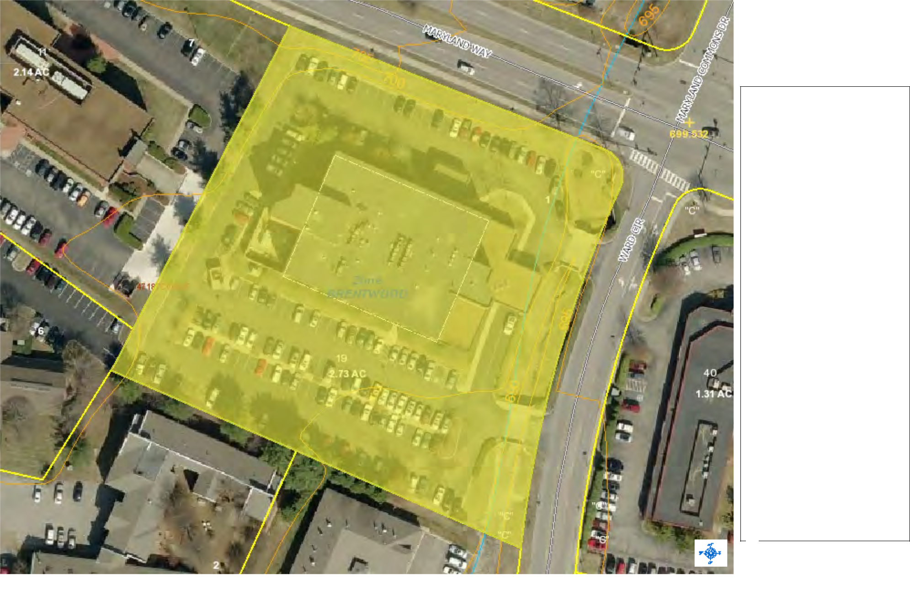

Legend

Proposed Zones

RP- 5 - Rural Preservation - 5

RD- 5 - Rural Development - 5

RP- 1 - Rural Preservation - 1

RD- 1 - Rural Development - 1

SIC - Suburban Infill and Conservat

MGA-1

MGA-5

MGA-H

H - Hamlet

V - Village

College Grove Village

NC - Neighborhood Conservation

NCMH -Neighborhood Conservatio

840C - 840 Center District

Zones

CC

E

IC

NC

NCT

R

S

SE

U

Parcels

Parcel Numbers

Parcel Acreage



Notes


Tools & Features Demonstration Site

 |  |  |  |  |  |  |  |  |  | 1: 29,618
0.9 |  | 0 |  | 0.47 |  | 0.9 Miles |  |  | This map is a user generated static output from an Internet mapping site and
 |  |  |  |  |  |  |  |  | is for reference only. Data layers that appear on this map may or may not be
 | NAD_1983_StatePlane_Tennessee_FIPS_4100_Feet |  |  |  |  |  |  |  | accurate, current, or otherwise reliable.
 | © Latitude Geographics Group Ltd. |  |  |  |  |  |  |  | THIS MAP IS NOT TO BE USED FOR NAVIGATION
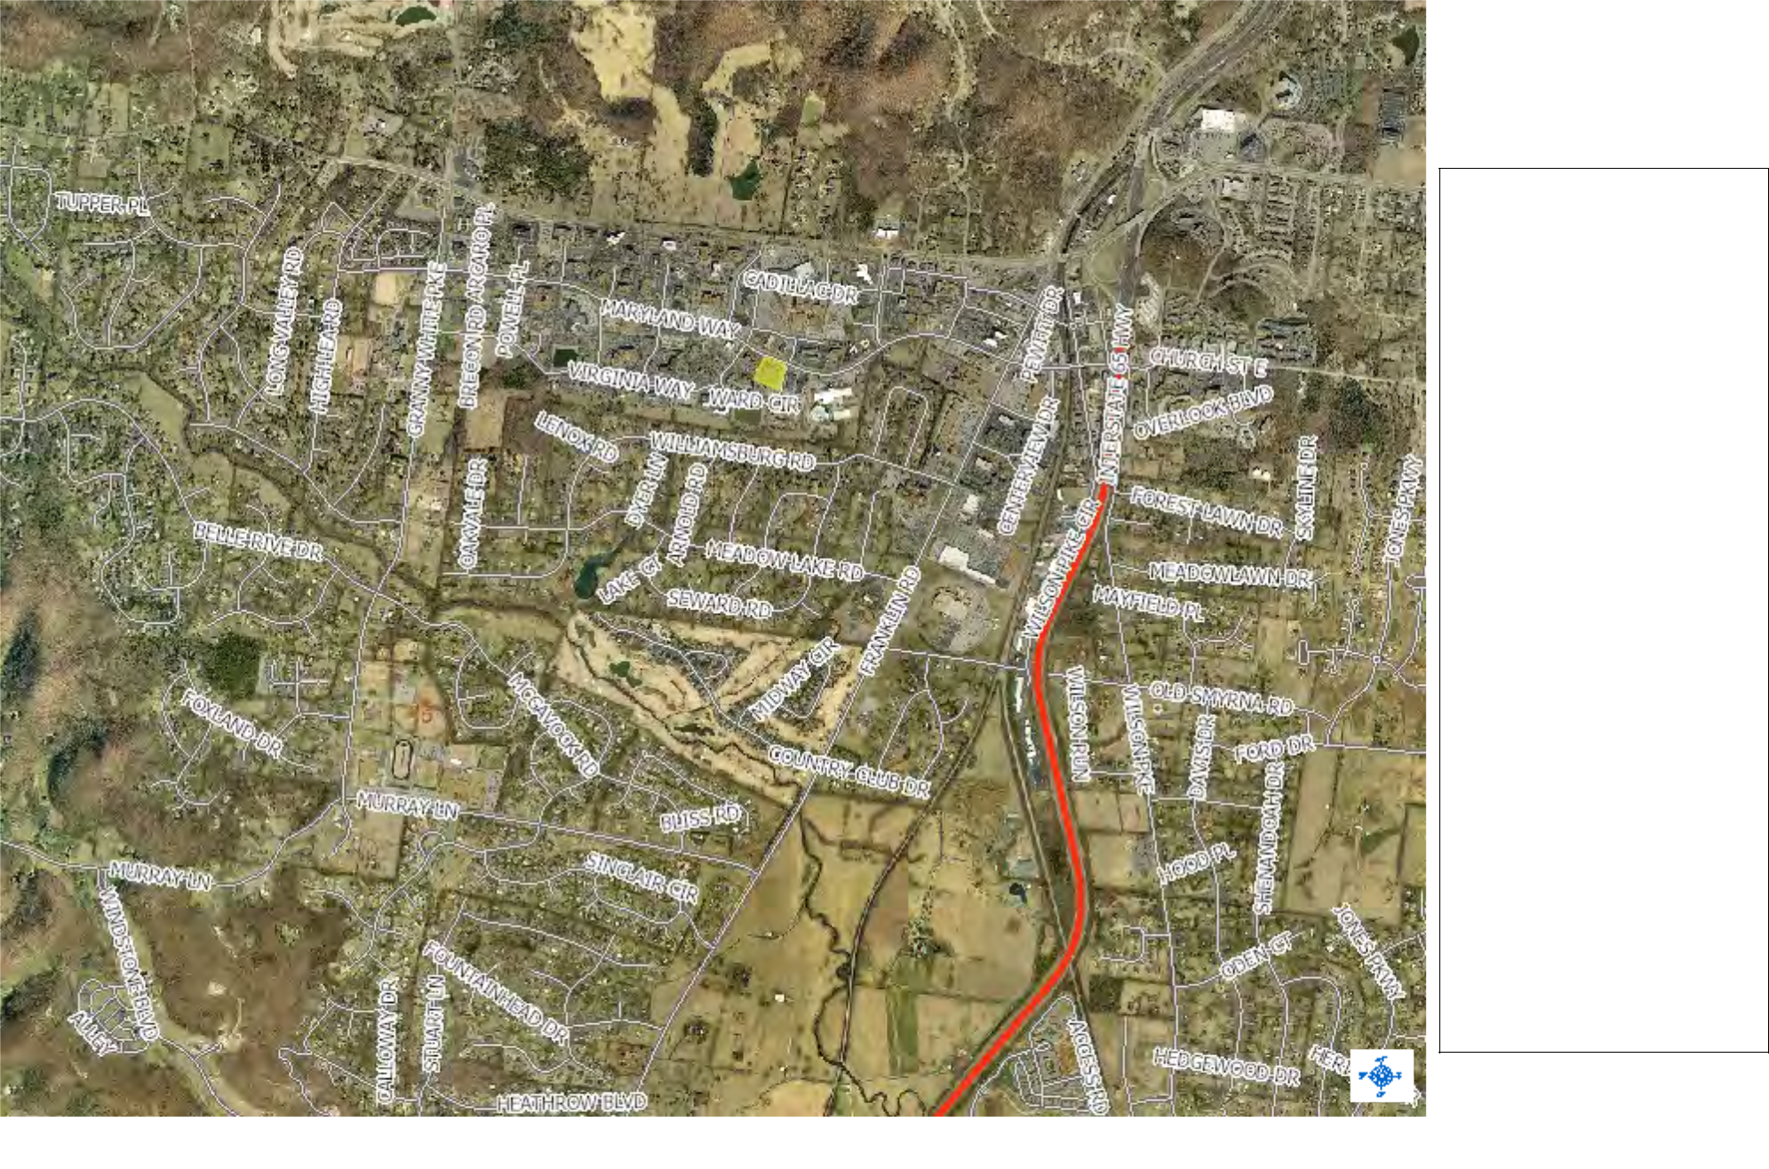

Legend

Centerlines

<all other values>

INTERSTATE

ACCESS

LOCAL STREETS

MAJOR ARTERIAL

MAJOR COLLECTOR

MINOR ARTERIAL

MINOR COLLECTOR

NO NAME

UNCLASSIFIED

PRIVATE

Williamson2009.sid

Red: Band_1

Green: Band_2

Blue: Band_3

Notes

1

2

3

4

5

6
7
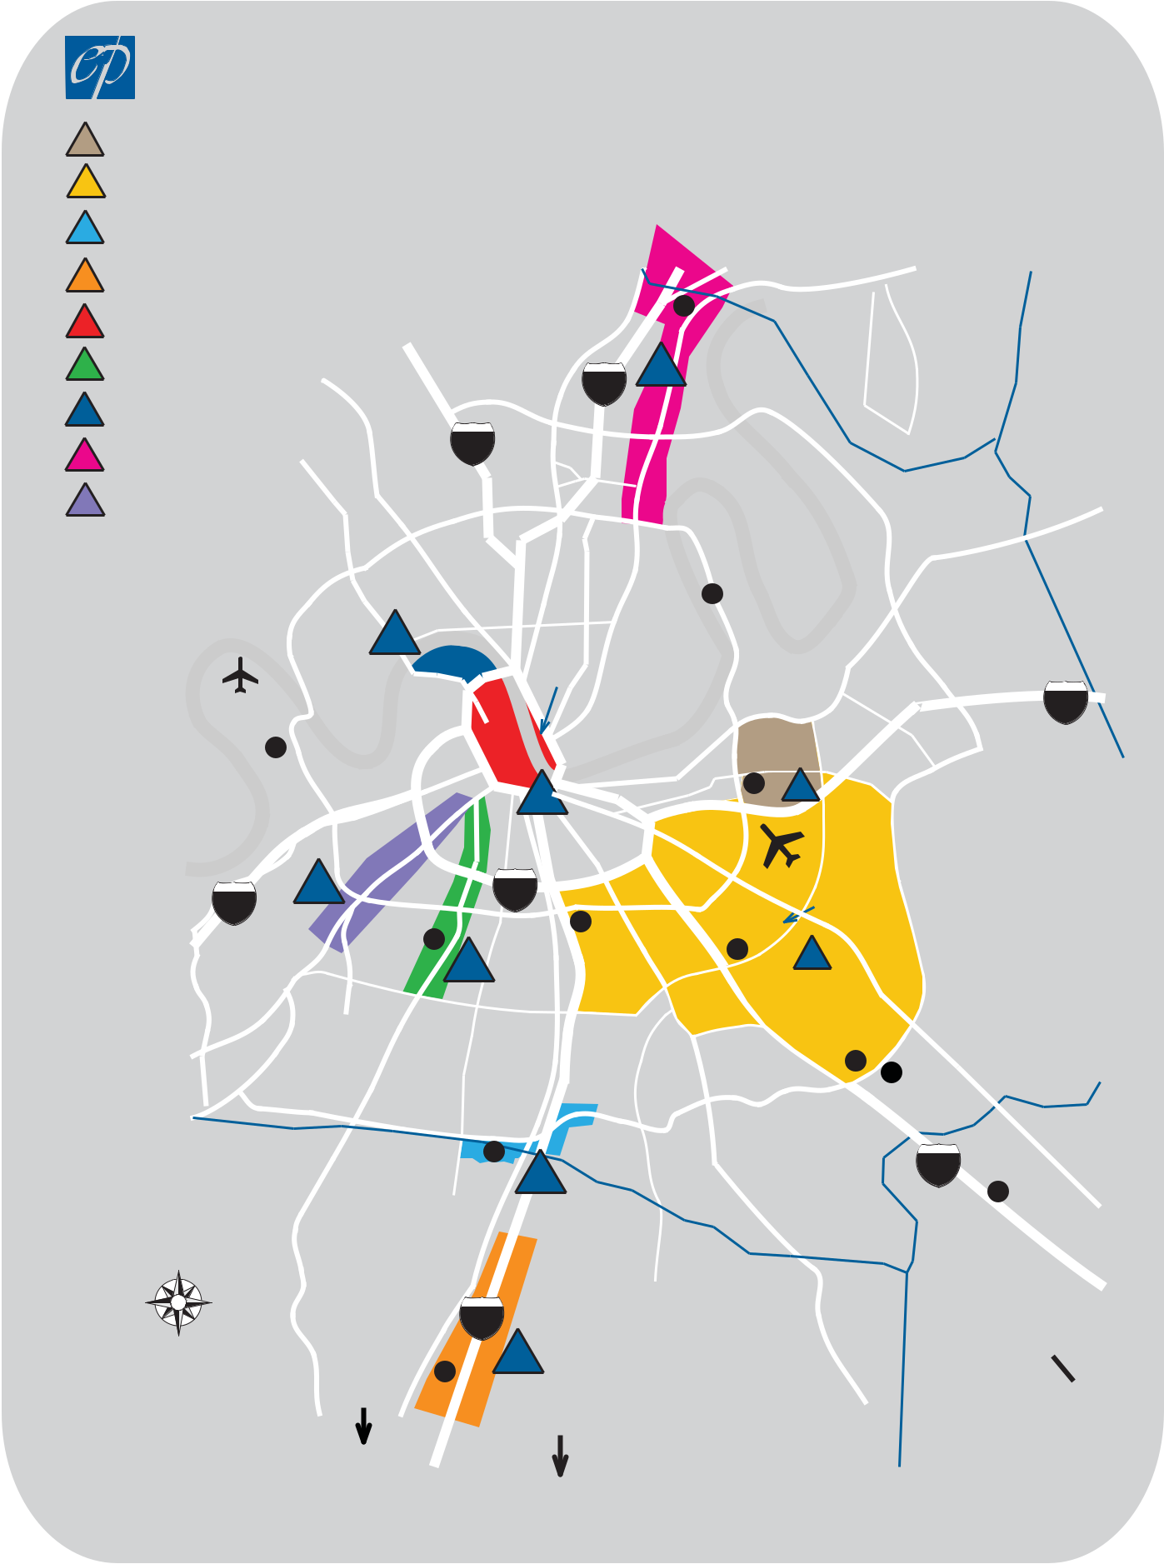

NASHVILLE OFFICE MARKET 2011

NASHVILLE OFFICE MARKET AREA MAP

AIRPORT NORTH

AIRPORT SOUTH

BRENTWOOD

COOL SPRINGS/FRANKLIN

 |  | . |  | Mall
 |  | Pk
 |  |  |  | Rivergate
DOWNTOWN | Dickerson
DAVIDSON |  |  | 8
GREEN HILLS/MUSIC ROW^{COUNTY}
 | 65

7

8

9

METROCENTER | Whites | 24
RIVERGATE | Creek
 |  | .
WEST END | Pk | Pkwy
WEST END | . | Briley

 |  |  |  |  |  |  |  |  | Clarksville
m |  |  |  |  |  |  |  |  | Trinity Ln.
m |  |  | n | d | R | i | v |  | .7
e |  | la |  |  |  | i | v | e | Hwy
b | r |  |  |  |  |  | v | r | Hwy
u
C

Tune Airport
Cockrill Bend
Industial Park

Ellington Pkwy.

Coliseum

Rd .

Gallatin

 | Old
MADISON | Hickory
 | Blvd
Opryland | .
Hotel
&
Opry
Mills
 | Stewarts
 | Pk.
DONELSON

Rd.

Lebanon

HERMITAGE

Ferry | 40

DOWNTOWN
 |  |  | . | 5
 |  | End | Ave
9 | West | End
9 | West |  |  | 440
40

Century City
Highland Ridge
Office Parks
Percy
1 Priest
Lake

 | Nashville
 | Int’l | Old
 | Airport | Old
Space
Park | Dell Computer
South,Metroplex
 |  | Hickory

 |  | GREEN
 |  |  | HILLS
 | .
Harding | Rd | BELLE
 |  | MEADE |  | Rd | .
 |  | Hillsboro |  | Rd
.100
Hwy
 |  | Old
 |  | Hickory |  |  | Blvd.
Woodmont
Blvd.
6

. Harding Pl.

Pk

White

Granny

- Oaks Mall

& Perimeter | .
Off. & Ind. Parks | Pk | Blvd
Donelson | Pk | Blvd
Donelson | 2 | Blvd
Donelson | 2 | .
ANTIOCH
Haywood
Ln. | Hickory Hollow
 | Mall |  | Murfreesboro
 |  | The | Murfreesboro
 |  | Crossings | Murfreesboro
 |  |  | Rd
 |  |  | .

 | Maryland |  |  | 3
BRENTWOOD Farms |  |  |  | 3
 | Office Park
WILLIAMSON |  | Rd | .
COUNTY | Franklin | Rd
N | Franklin

 | 65
Cool Springs | 4
Galleria Mall | 4

To Franklin

.
Pk

Edmondson

Nolensville

Rd
.
24 Interchange City

Industrial Park

LAVERGNE

RUTHERFORD
COUNTY

Murfreesboro

Chattanooga&

Saturn Plant


Site Map on Satellite Imagery - 0.4 Miles Wide

Professional Plaza |  |  | Prepared by William Towery
5111 Maryland Way, Brentwood, TN 37027, United States, 5-mile |  |  | Latitude: 36.032822
Ring: 5 Miles |  |  | Longitude: -86.800423
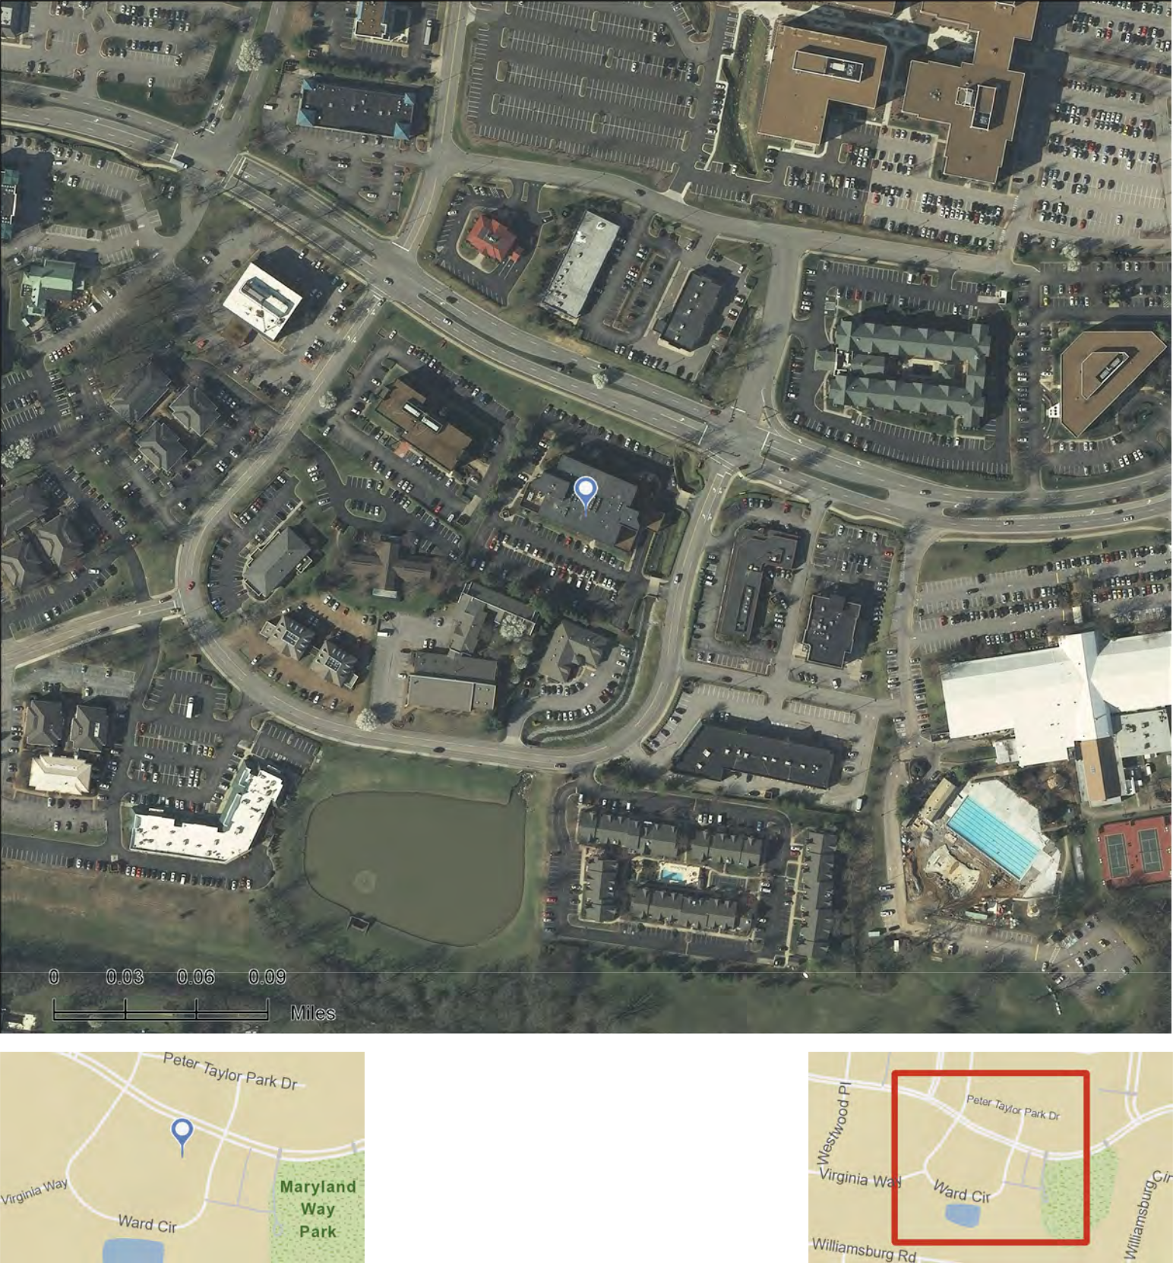

Source: ©i-cubed

July 06, 2012

©2012 Esri

Site Map on Satellite Imagery - 0.8 Miles Wide

Professional Plaza |  |  | Prepared by William Towery
5111 Maryland Way, Brentwood, TN 37027, United States, 5-mile |  |  | Latitude: 36.032822
Ring: 5 Miles |  |  | Longitude: -86.800423
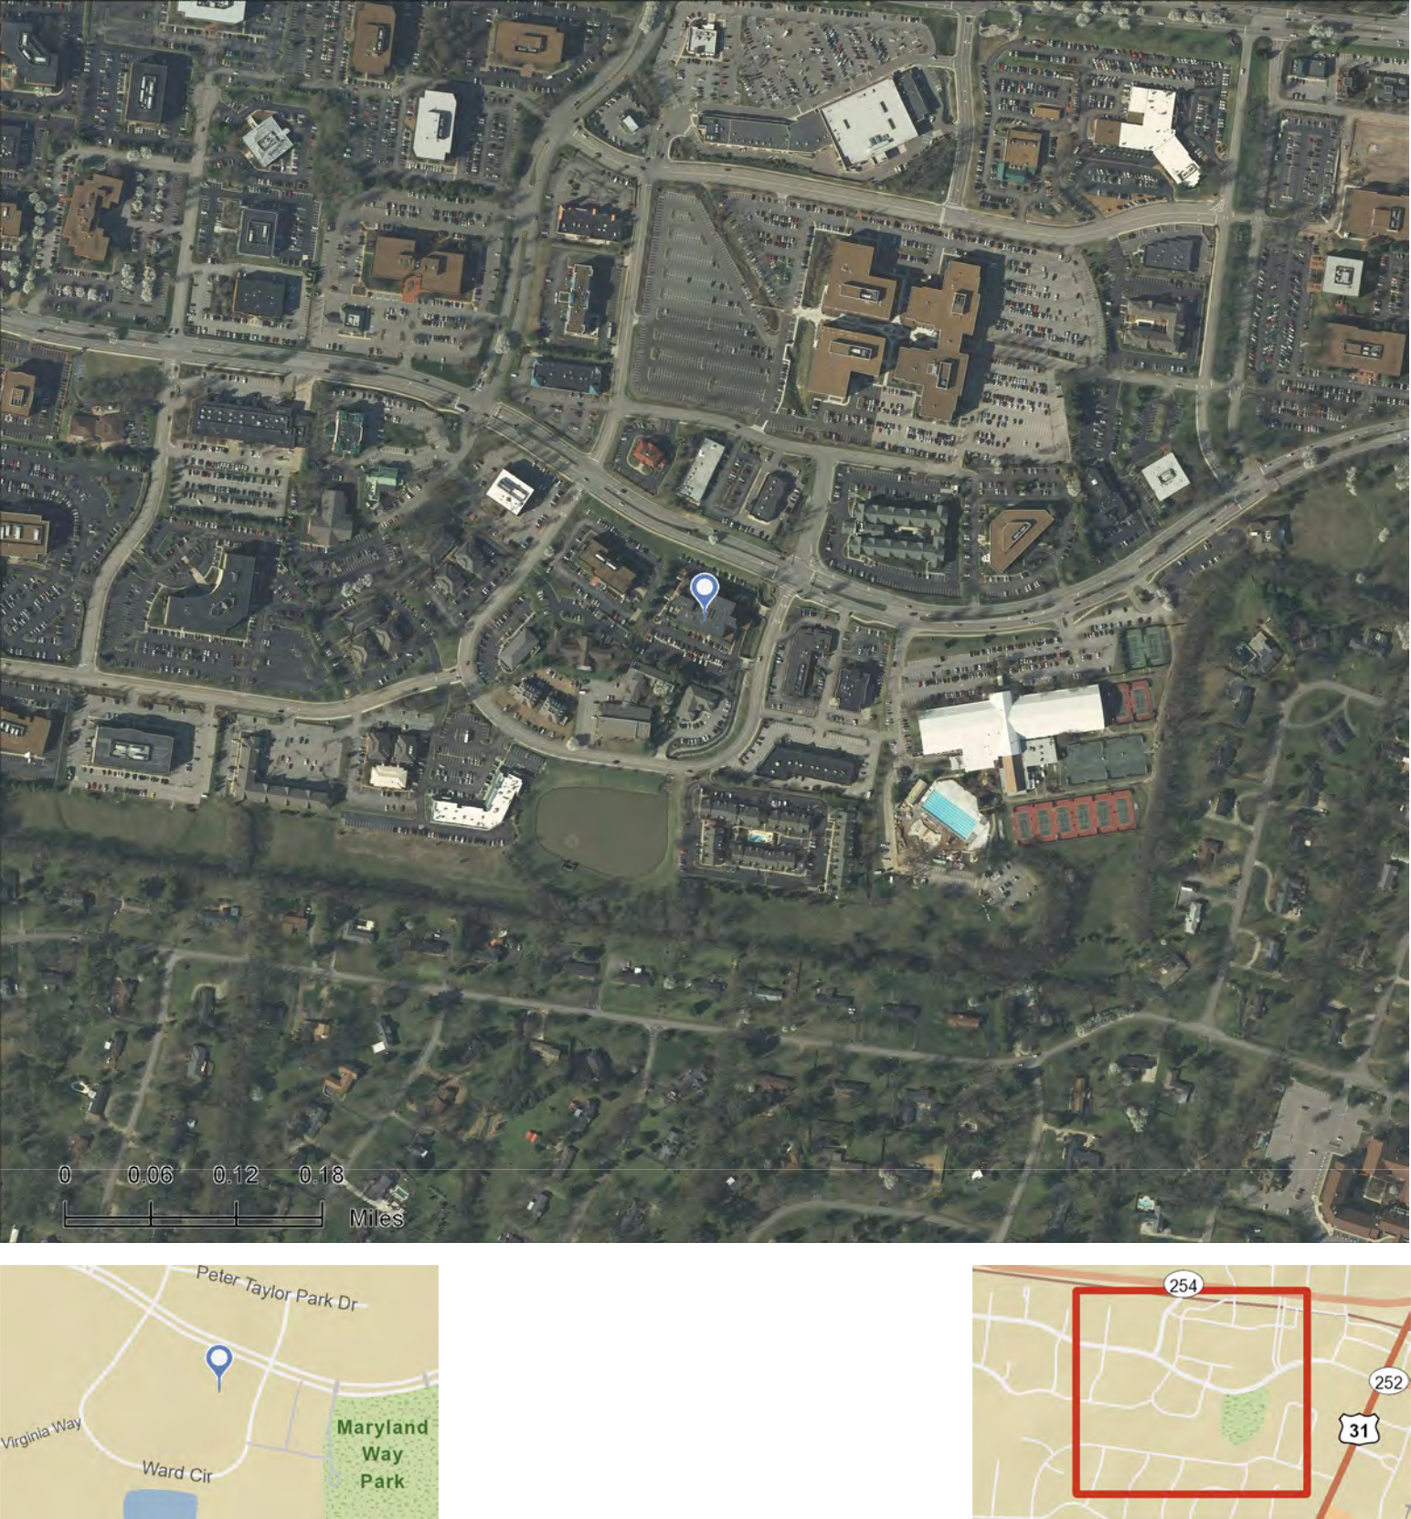

Source: ©i-cubed

July 06, 2012

©2012 Esri

Site Map on Satellite Imagery - 1.6 Miles Wide

Professional Plaza |  |  | Prepared by William Towery
5111 Maryland Way, Brentwood, TN 37027, United States, 5-mile |  |  | Latitude: 36.032822
Ring: 5 Miles |  |  | Longitude: -86.800423
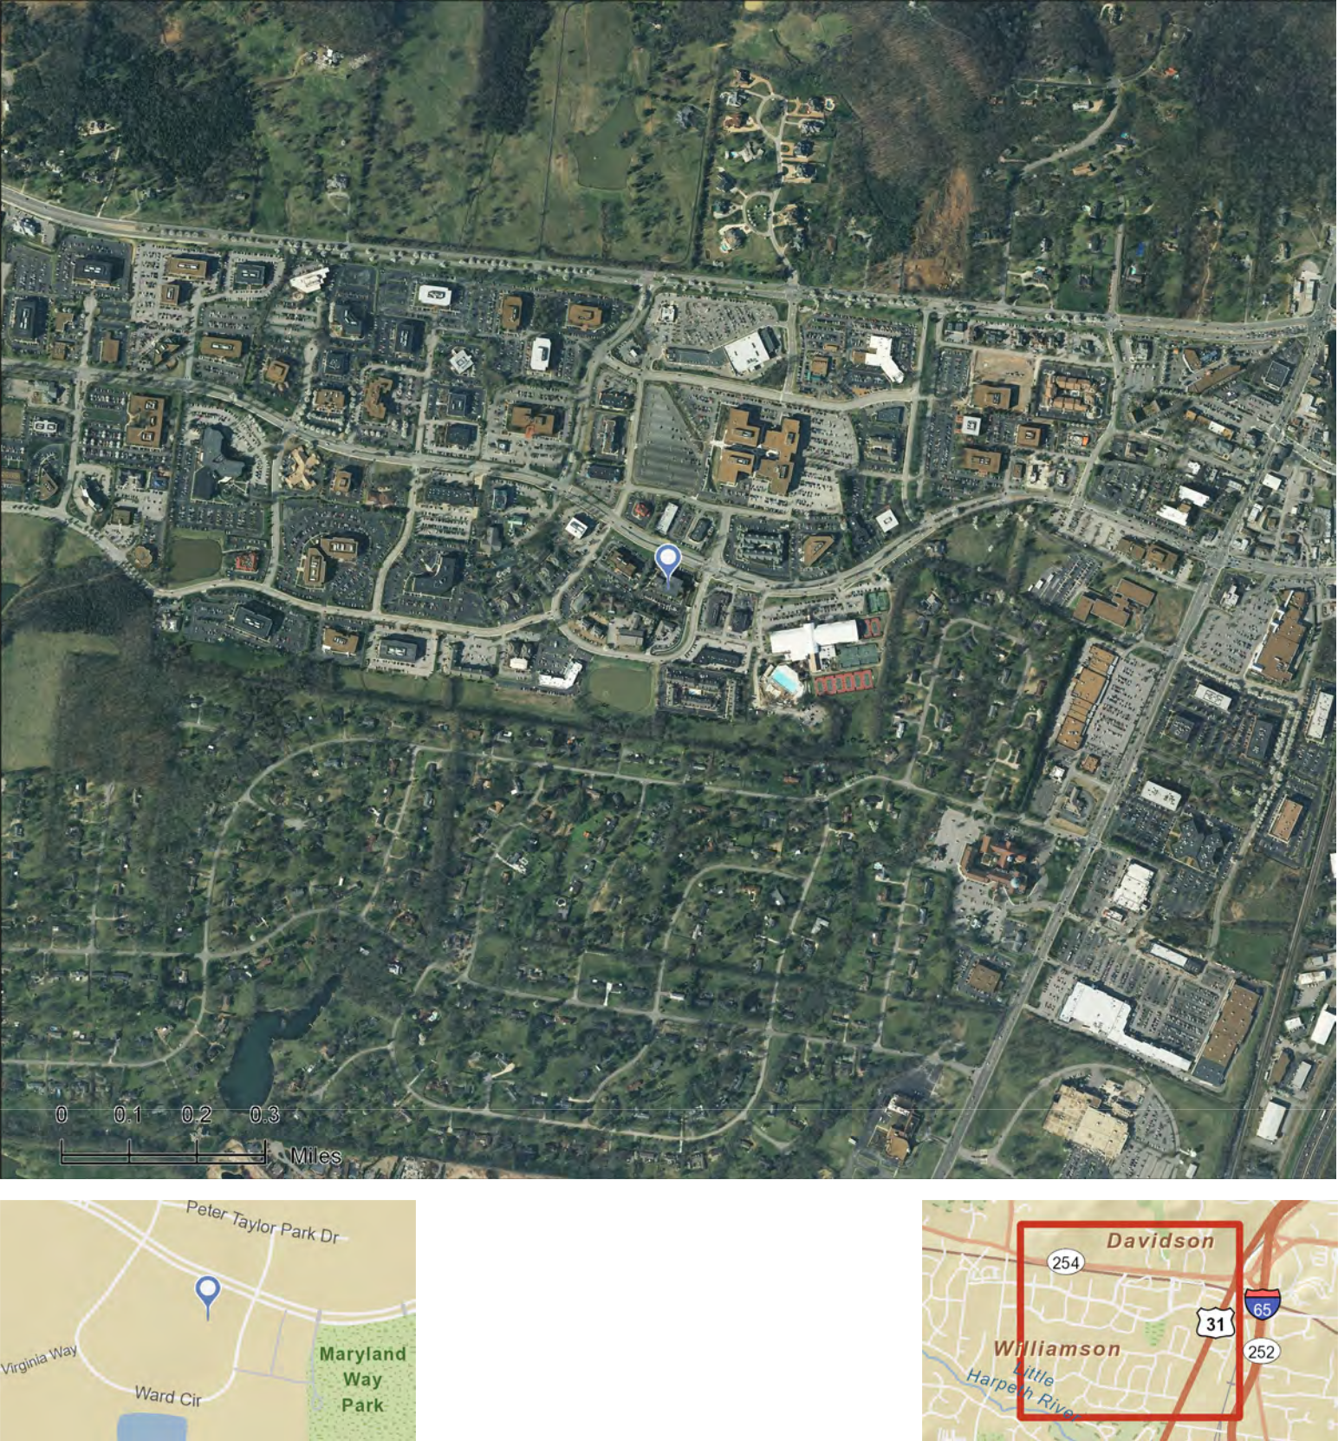

Source: ©i-cubed

July 06, 2012

©2012 Esri

Site Map

Brentwood & CoolSprings Prepared by William Towery polygon sub-market
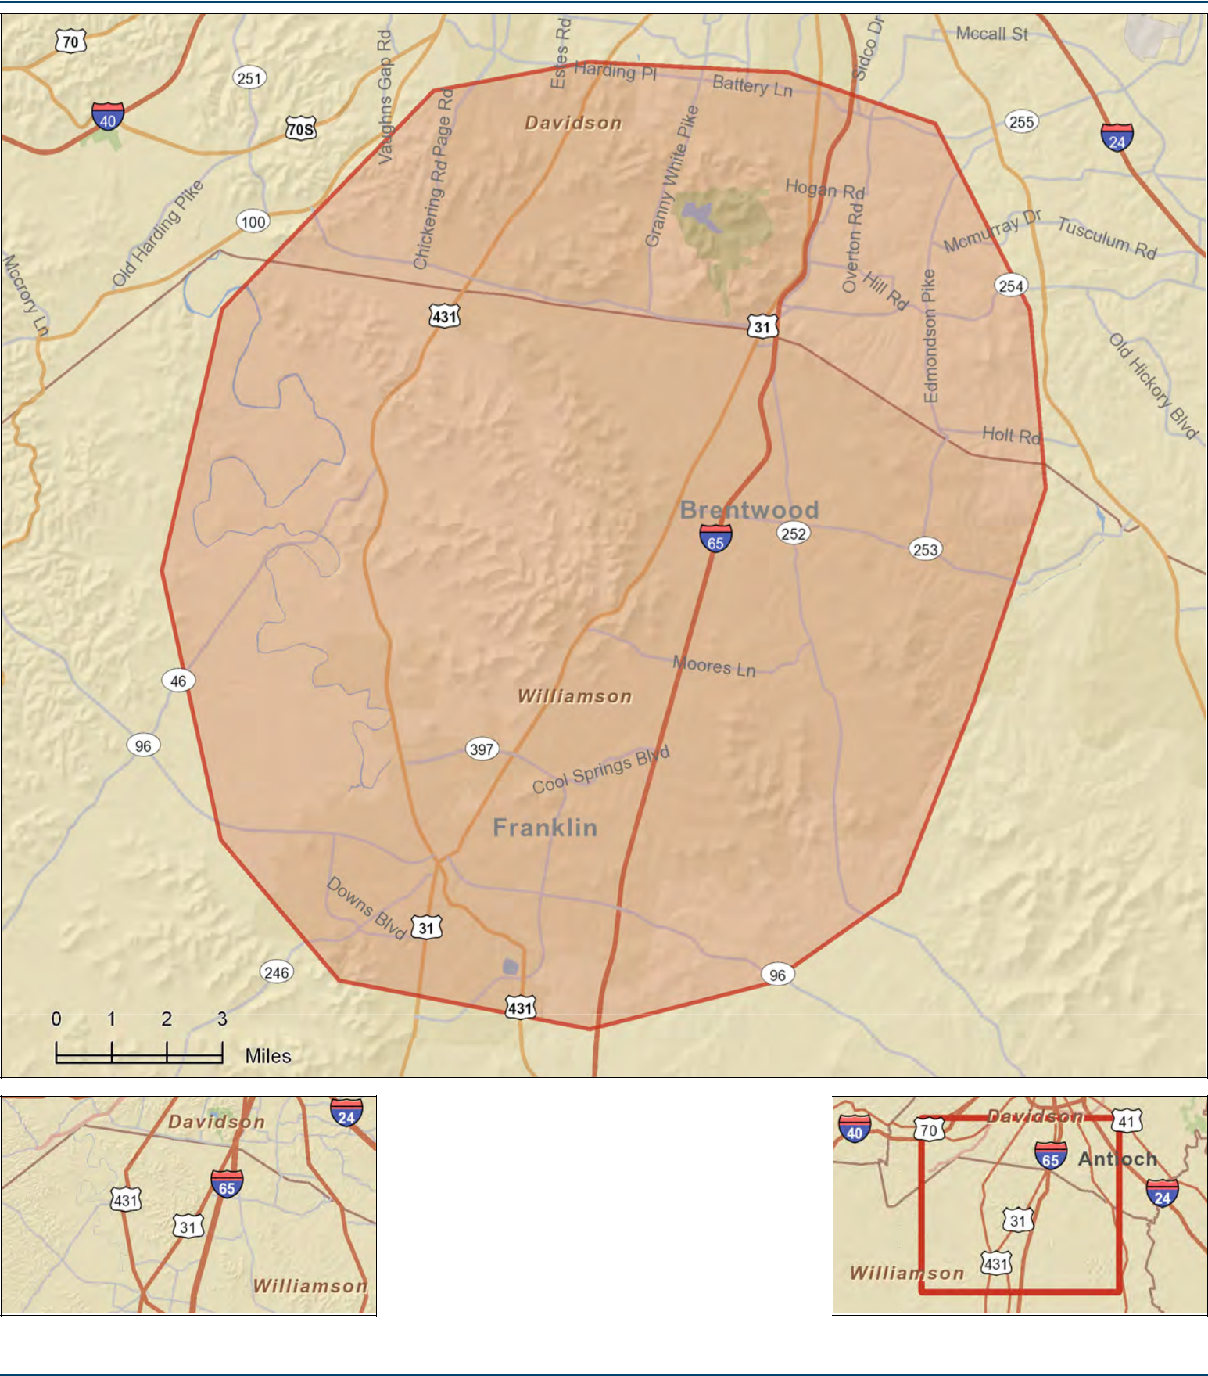

July 19, 2012

©2012 Esri

Site Details Map

Professional Plaza | Prepared by William Towery
5111 Maryland Way, Brentwood, TN 37027, United States, 5-mile | Latitude: 36.032822
Ring: 5 Miles | Longitude: -86.800423
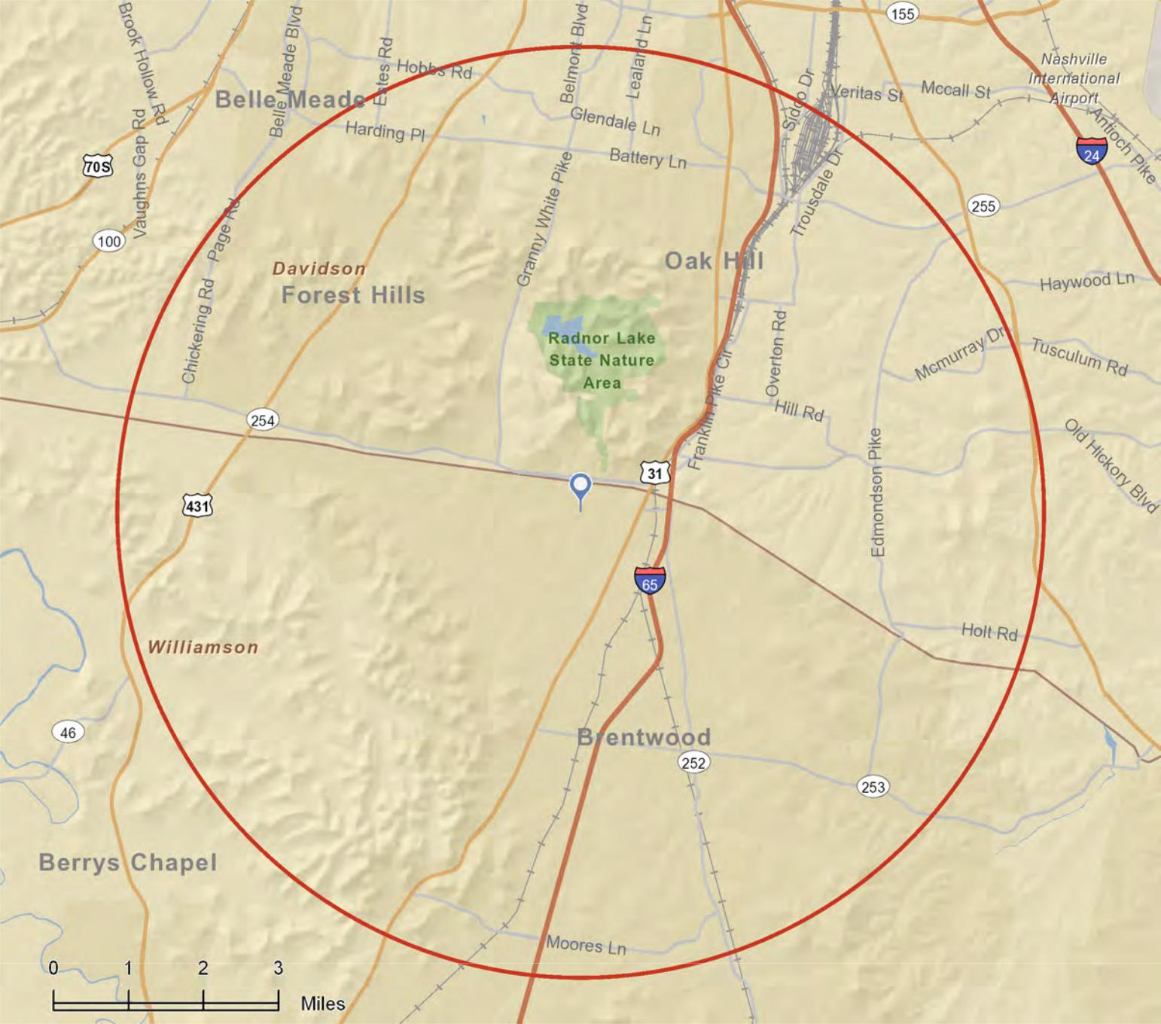

This site is located in:

City: | Brentwood city | County: | Williamson County
State: | Tennessee | Census Tract: | 47187050302
ZIP Code: | 37027 | Census Block | 471870503022

CBSA: Nashville-Davidson--Murfreesboro--Franklin, TN Metropolitan Statistical Area (34980)

July 06, 2012

©2012 Esri

MARKETING BROCHURE
OFFICE

BUILDING

FOR SALE

professional plaza


BRENTWOOD
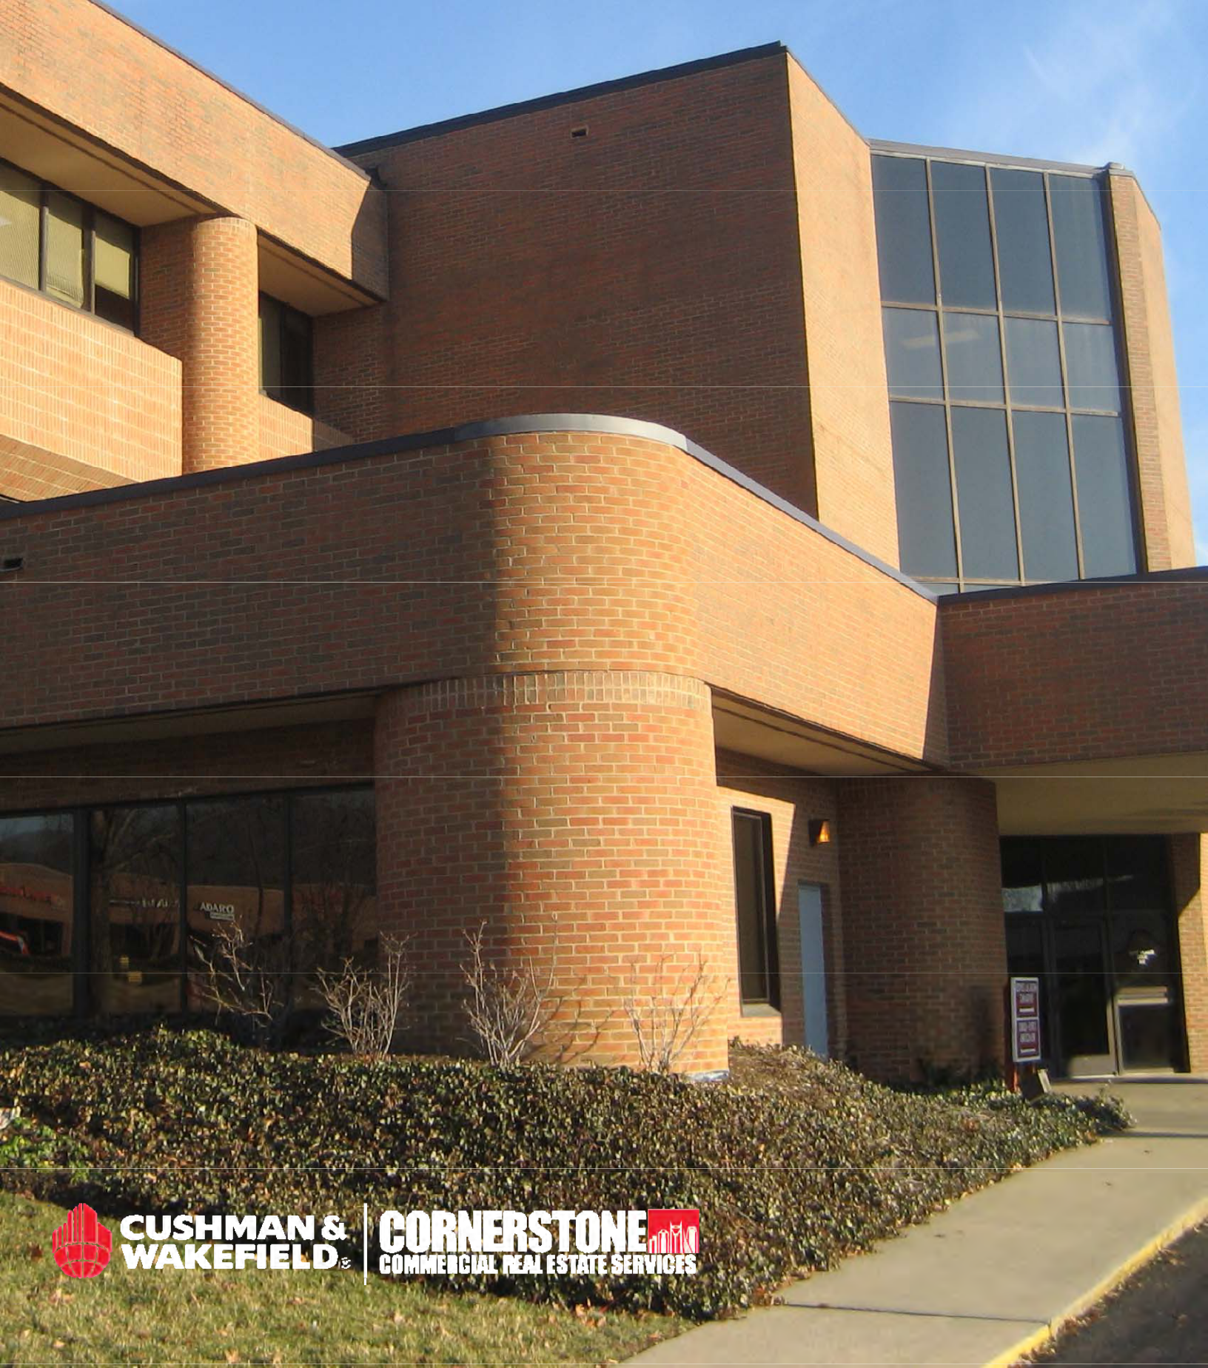

PROFESSIONAL

PLAZA


OFFERING AT A GLANCE

ADDRESS

5111 Maryland Way

Brentwood, TN 37027

SIZE

54,489 SF

NUMBER OF FLOORS 3

YEAR BUILT

1985

OCCUPANCY

100%

ZONING

C-2 (Commercial/Retail)

LAND AREA

2.73 Acres

PARKING

168 Paved Spaces

ELECTRICAL

3 Phase System

LIGHTING

Recessed Fluorescent

CEILING HEIGHT

8’ 6”

FIRE SAFETY

100% Sprinklered

SITE IMPROVEMENTS

Concrete sidewalks; paved asphalt parking; pole lighting; security system;

brick dumpster enclosure; and good quality landscaping

Long Term Credit Tenancy

Diversified Rent Roll


Balanced Lease Expiration Schedule

The Capital Markets Group of Cushman & Wakefield | Cornerstone is pleased to present Professional Plaza Office Building, a class B office asset located in the heart of the Brentwood submarket. This asset’s strong historical occupancy provides a rare opportunity to invest in one of Nashville’s premier office locations. At 100% occupancy, this property offers excellent long-term, stable cash flows in a submarket that has been a top performer when compared to other Nashville submarkets occupancy and absorption.
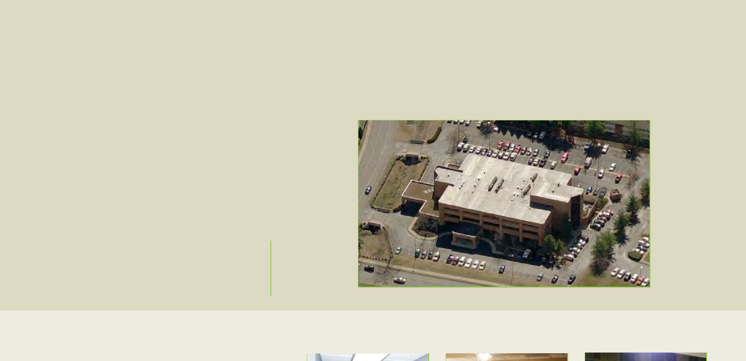

INTERIOR PHOTOS




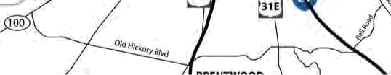

Maryland

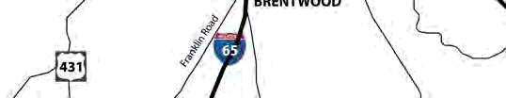
Farms
PROFESSIONAL


PLAZA


EXCELLENT LOCATION

- Professional Plaza Office Building is located at the southwest corner of Maryland Way and Ward Circle in Maryland Farms Office Park, a 400-acre master-planned office and commercial park containing approximately 1.5 million square feet of office space.

- Convenient and ready interstate access is available to I-65 via Old Hickory Blvd. with major traffic arteries in the area including Granny White Pike, Franklin Pike and Hillsboro Pike.

- The Maryland Farms Office Park is packed full of amenities including a variety of restaurants, banks, and retail shops.

- Several major corporations are located in the Brentwood submarket including Tractor Supply, Lifepoint, Comdata, Nissan and Hospital Corporation of America.
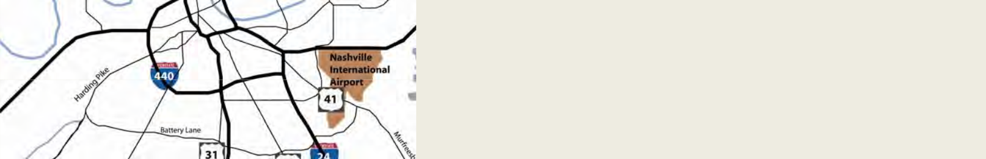
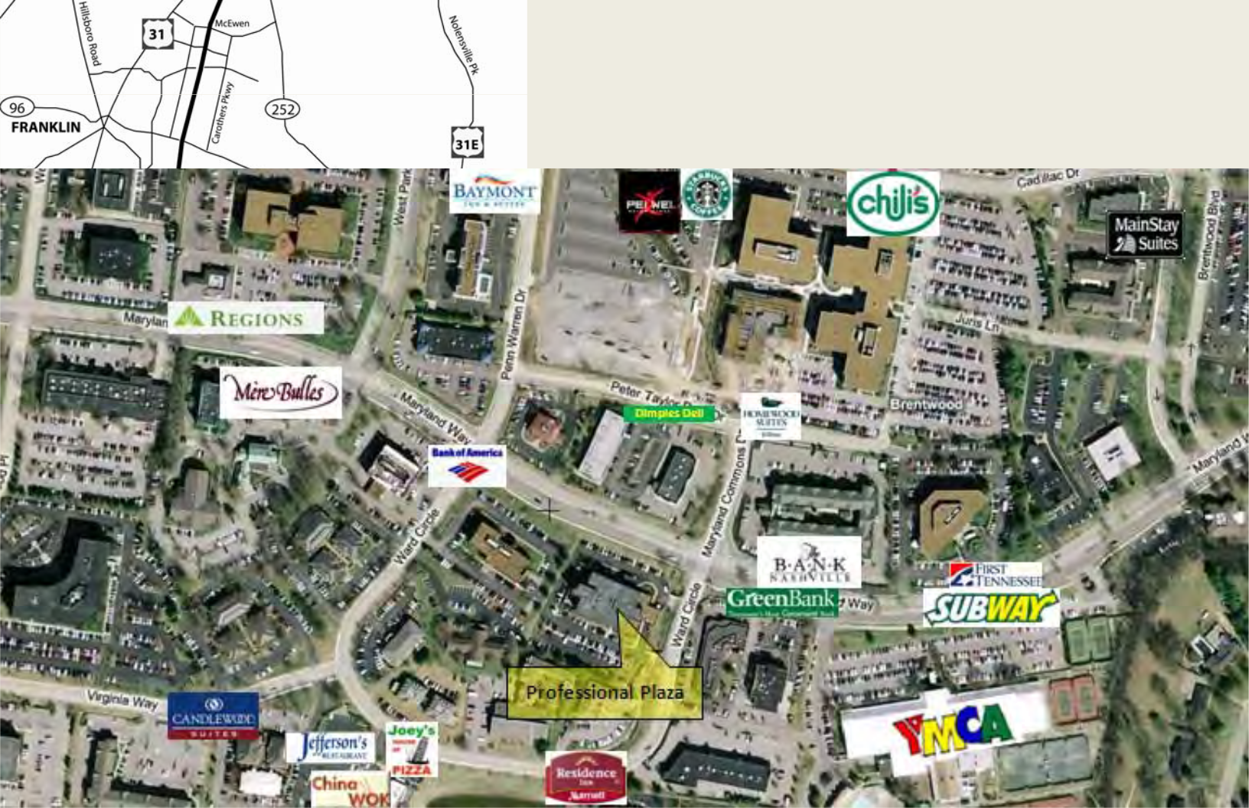

 | for more information |  | for debt and equity assistance,
 | please contact: |  | please contact:
 | INVESTMENT SALES TEAM |  | Todd S. Friedenberg, CCIM
 |  |  | Principal
 | Don Albright |  | Q10 | Vista
 |  |  | 615.279.1631
 | Director, Capital Markets |  | 615.279.1631
 |  |  | tfriedenberg@vistacmg.com
 | Cornerstone | Cushman & Wakefield Alliance
615.727.7407
 | dalbright@cornerstonecres.com
 | Mike Jacobs
 | Sr. Investments Specialist
 | Cornerstone | Cushman & Wakefield Alliance
615.727.7415
 | mjacobs@cornerstonecres.com
 | Cyndi B. Cushman
 | Market Research & Marketing Specialist
 | Cornerstone | Cushman & Wakefield Alliance
615.727.7423
 | ccushman@cornerstonecres.com
 |  |  | www.cornerstonecres.com
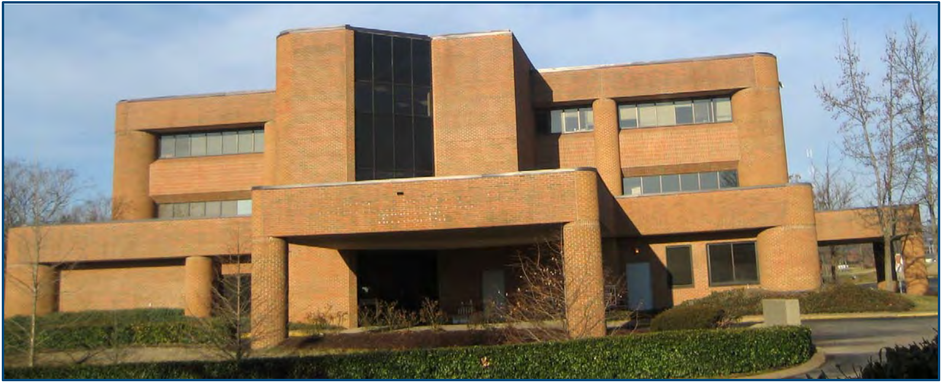

SITE & BUILDING

PICTURES
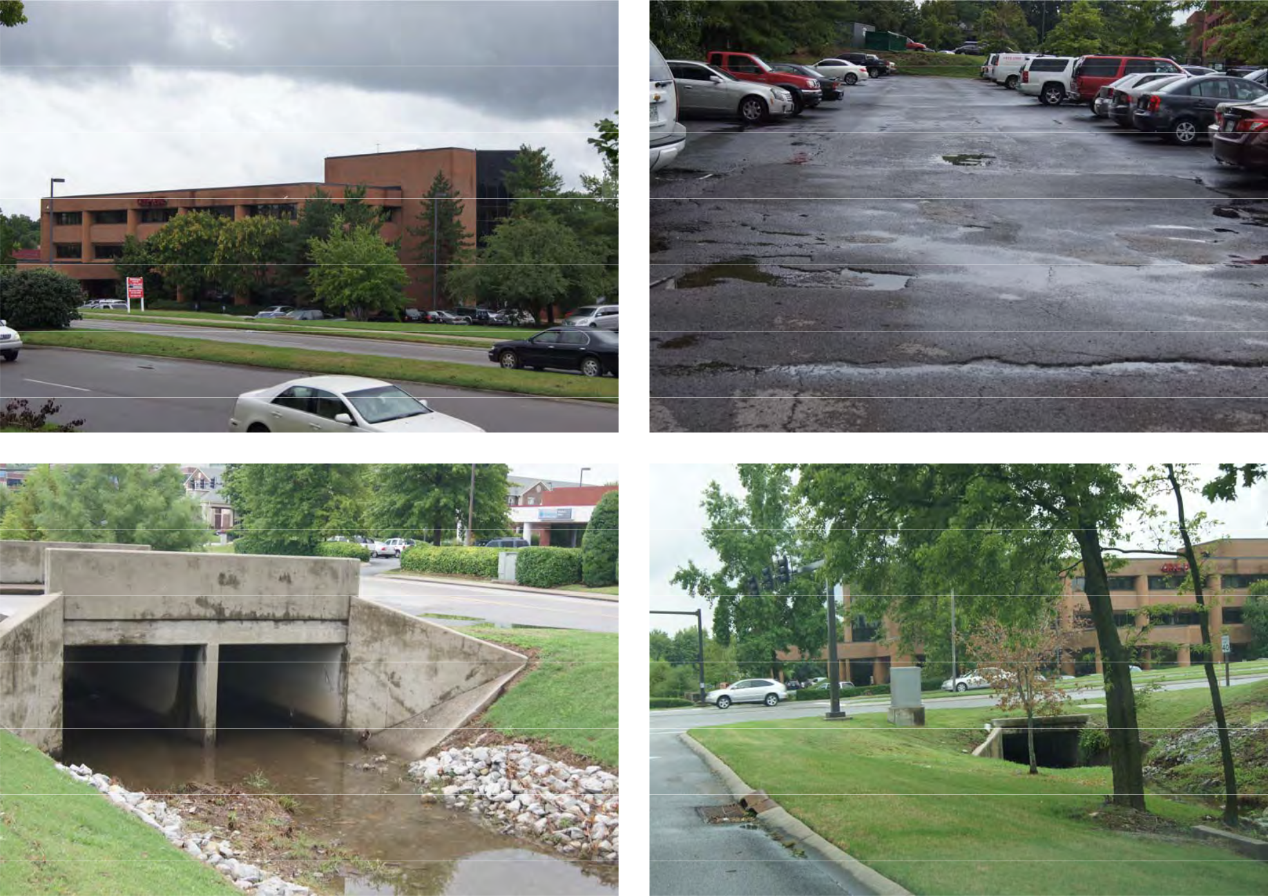
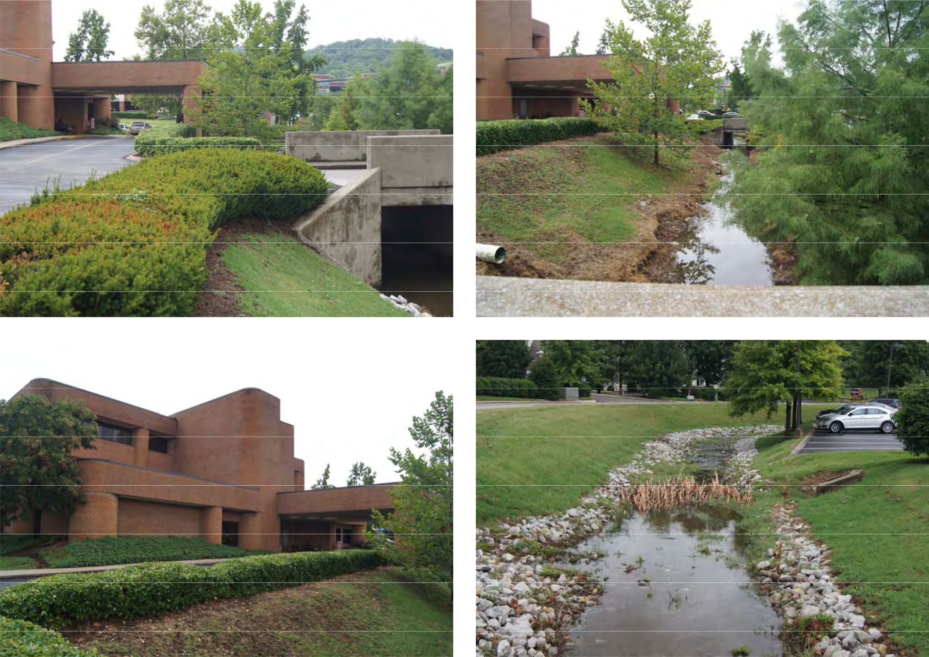
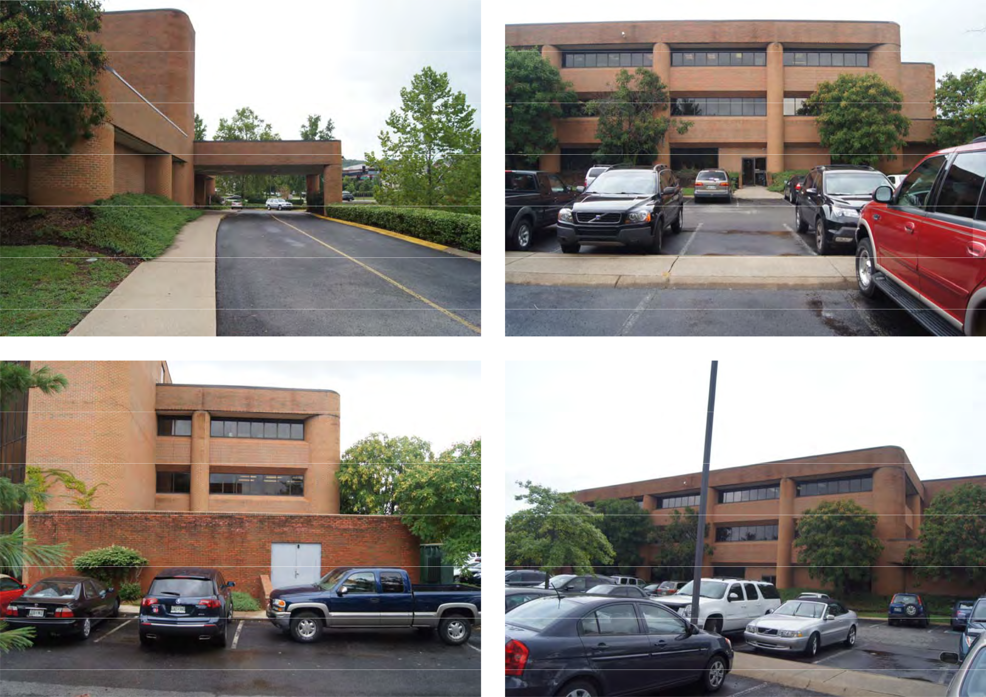
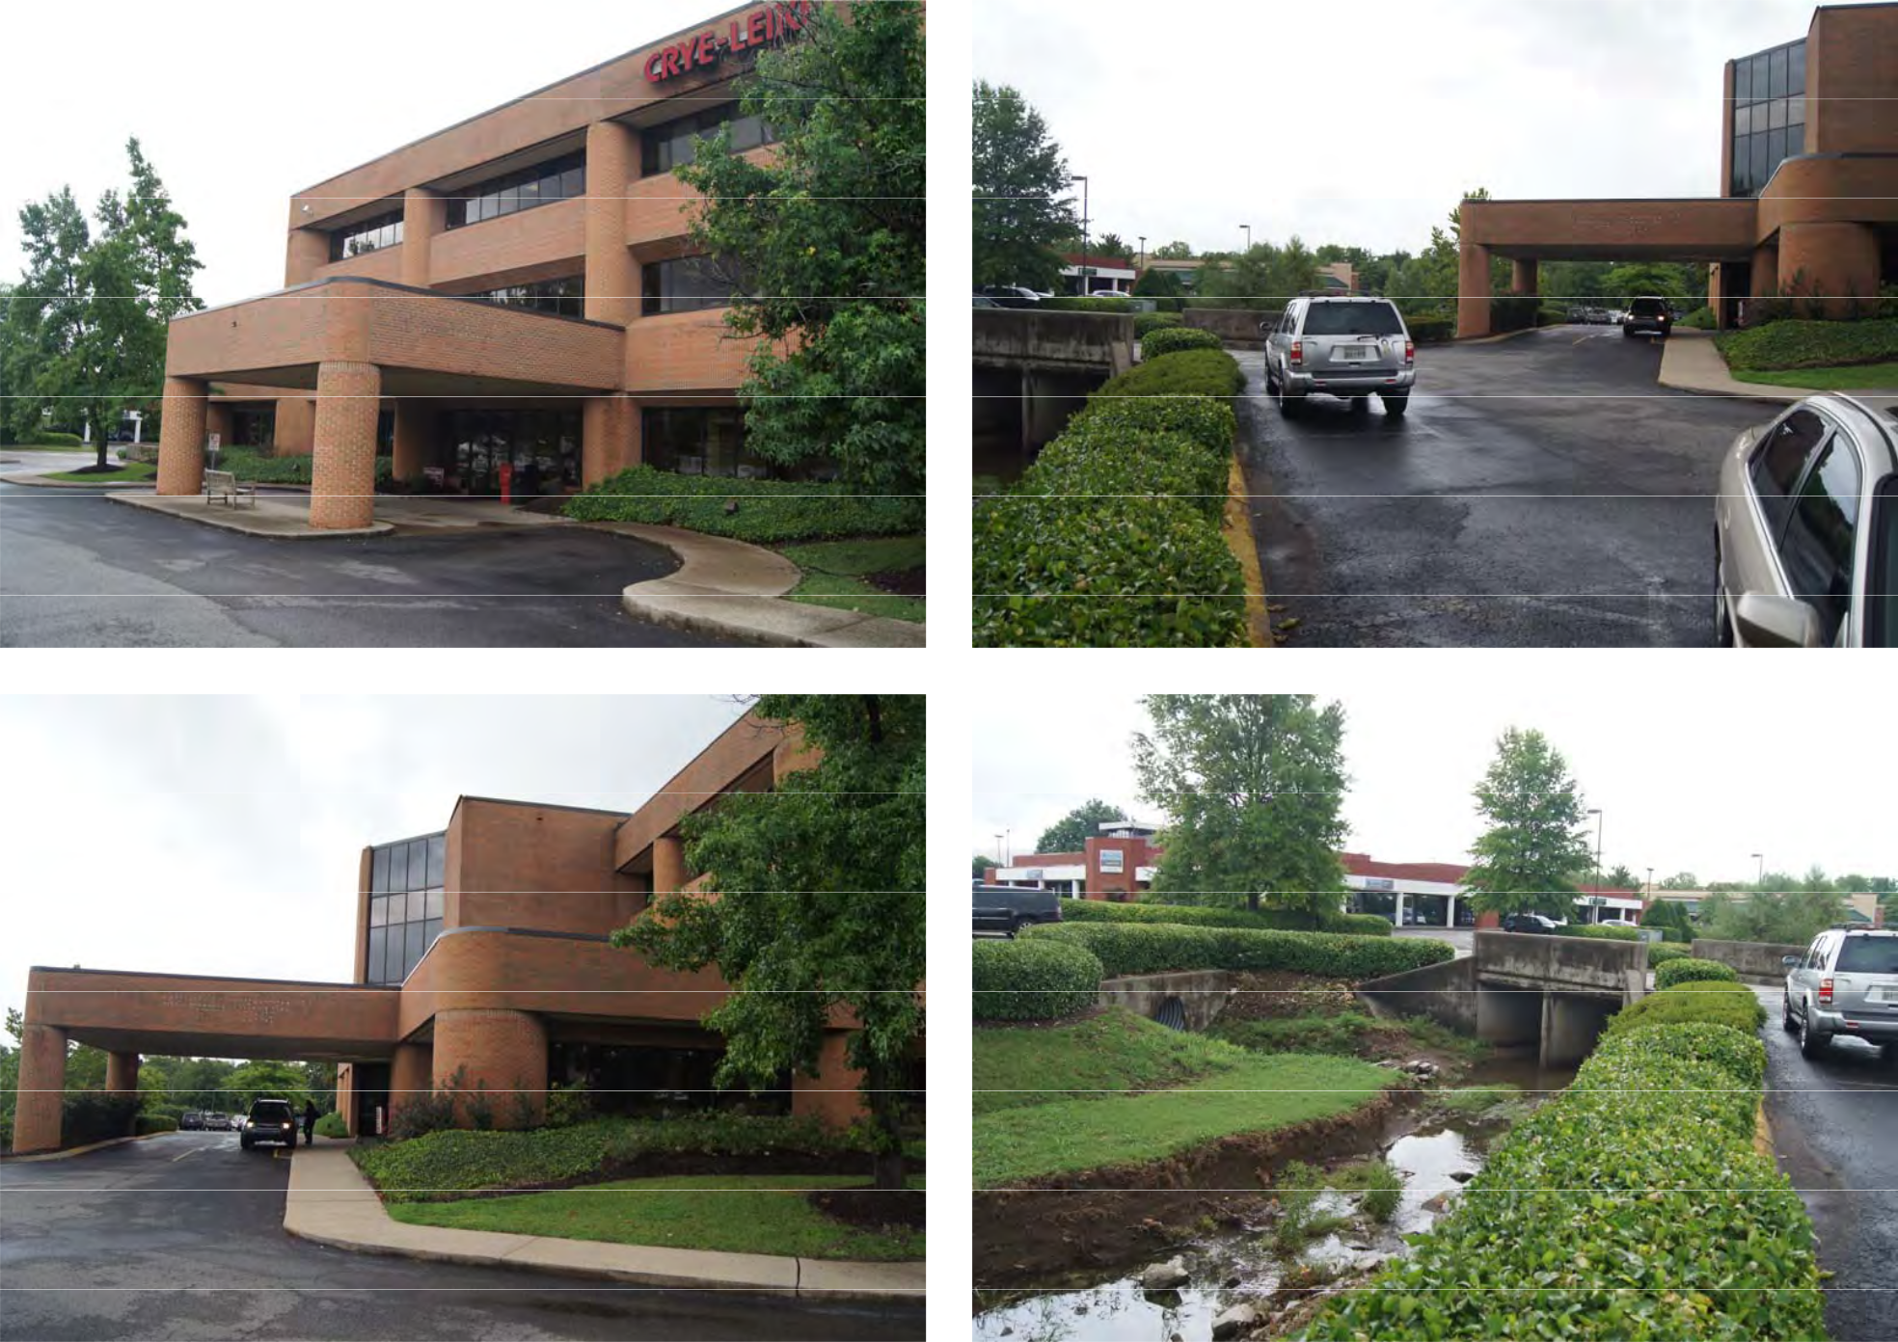
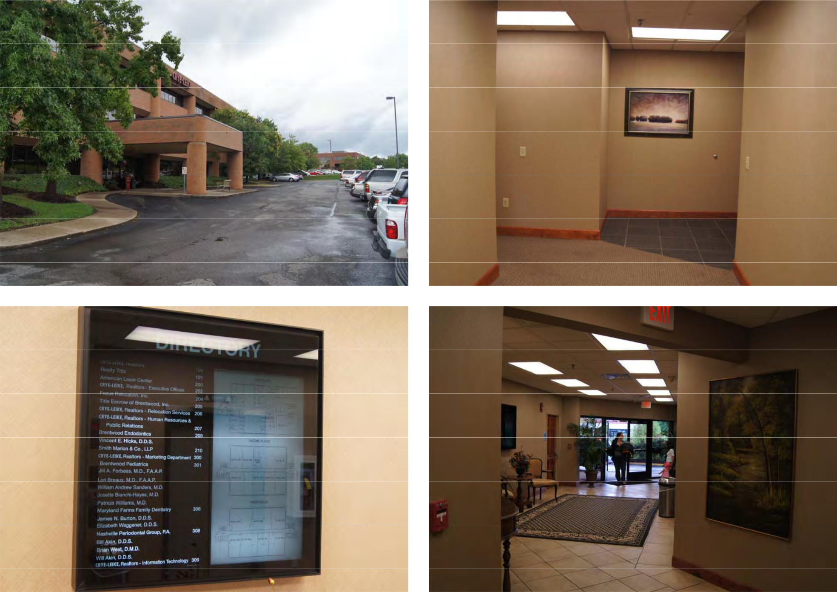
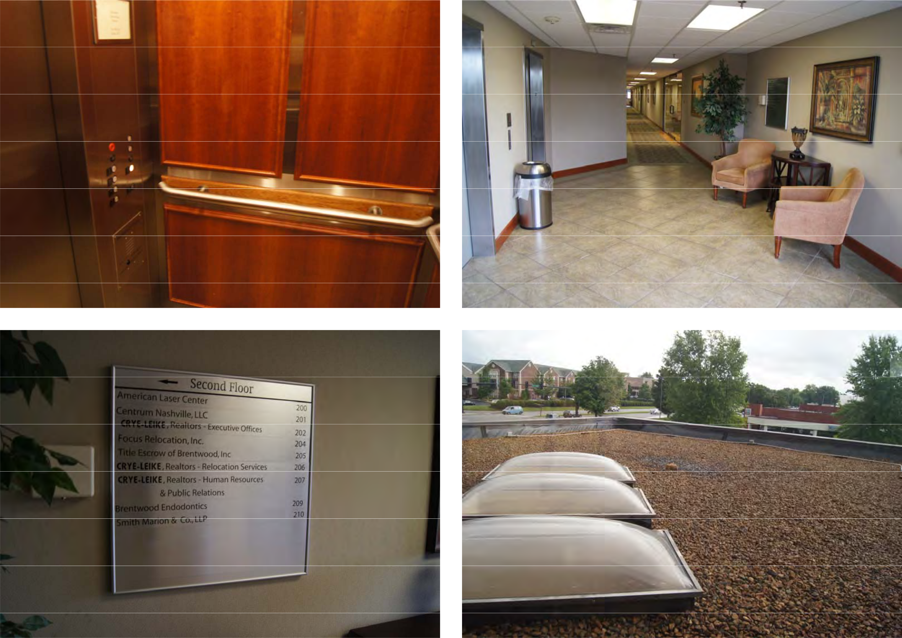
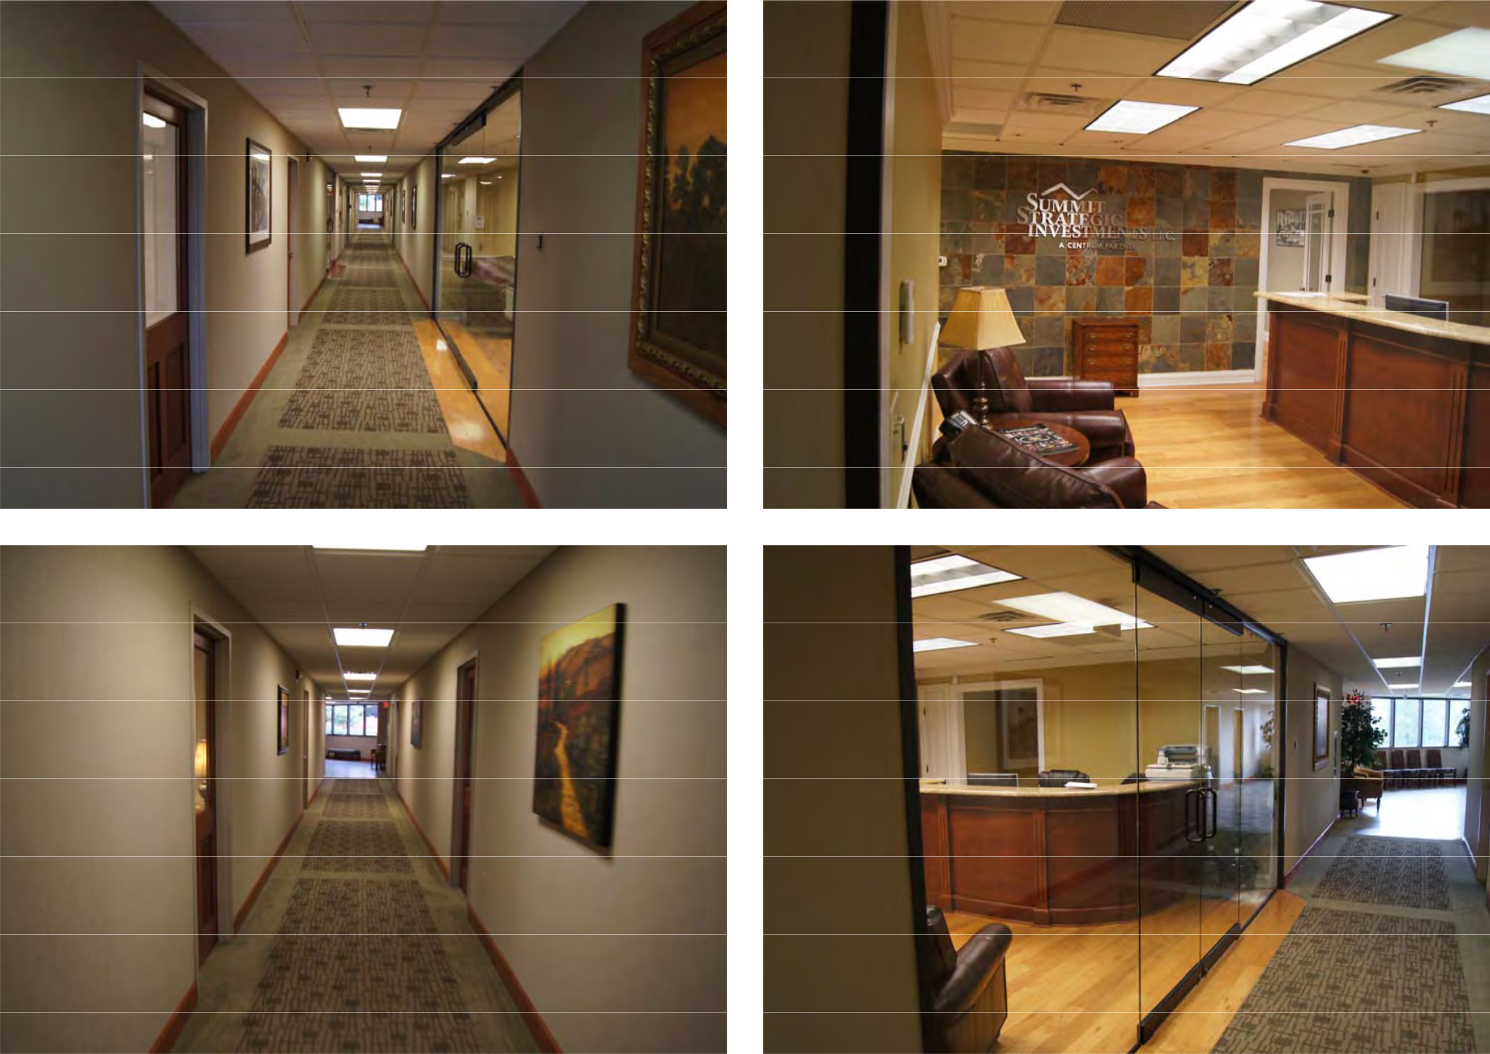
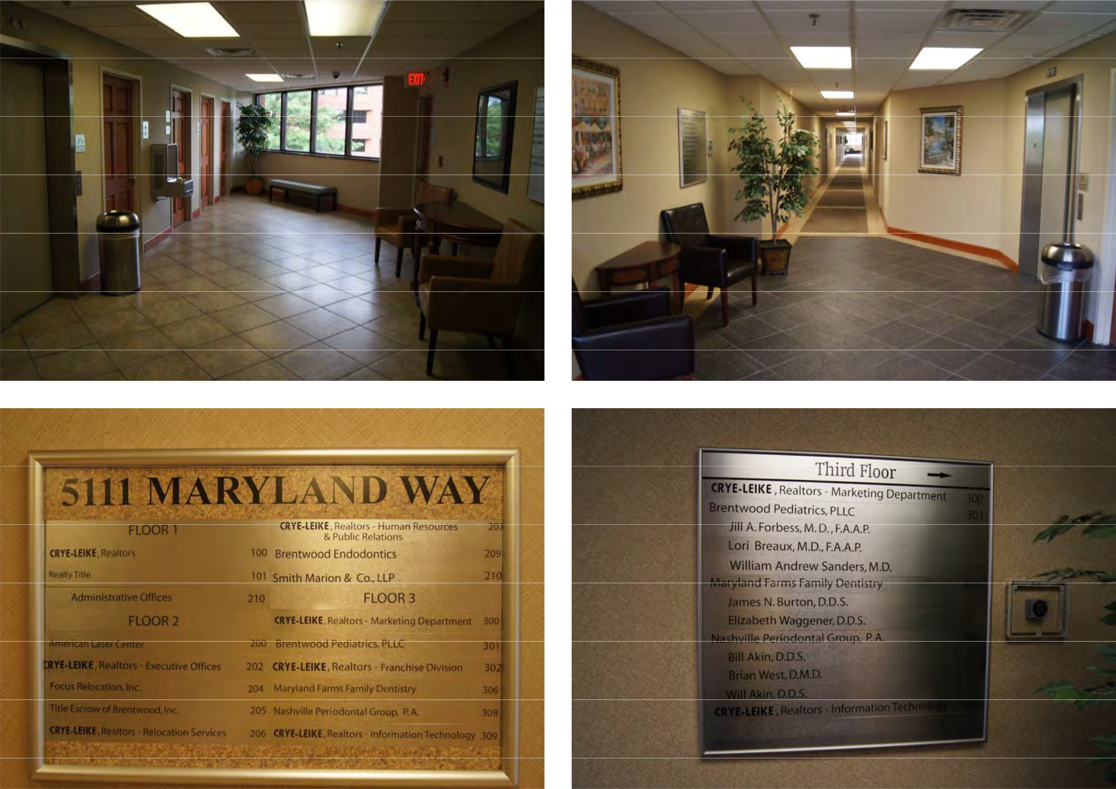
COMPARABLE

PICTURES
GATEWAY PLAZA BRENTWOOD COMMONS II
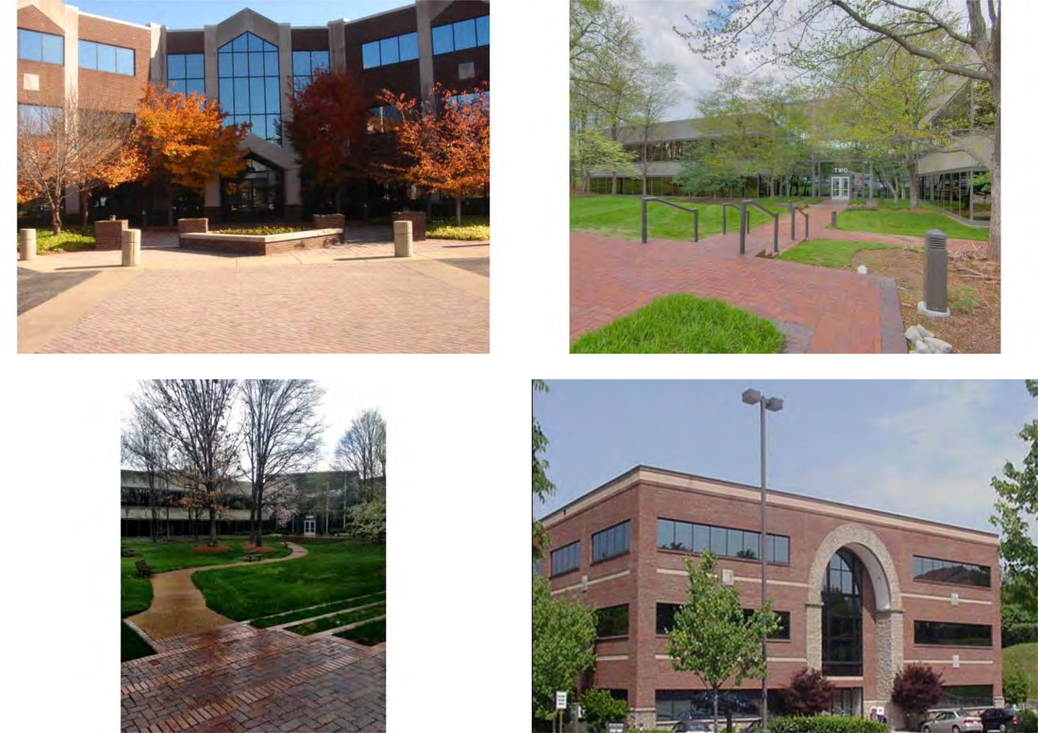

BRENTWOOD COMMONS MARYLAND PARK CENTER

SYNERGY BUSINESS PARK BRENTWOOD HIGHLANDS
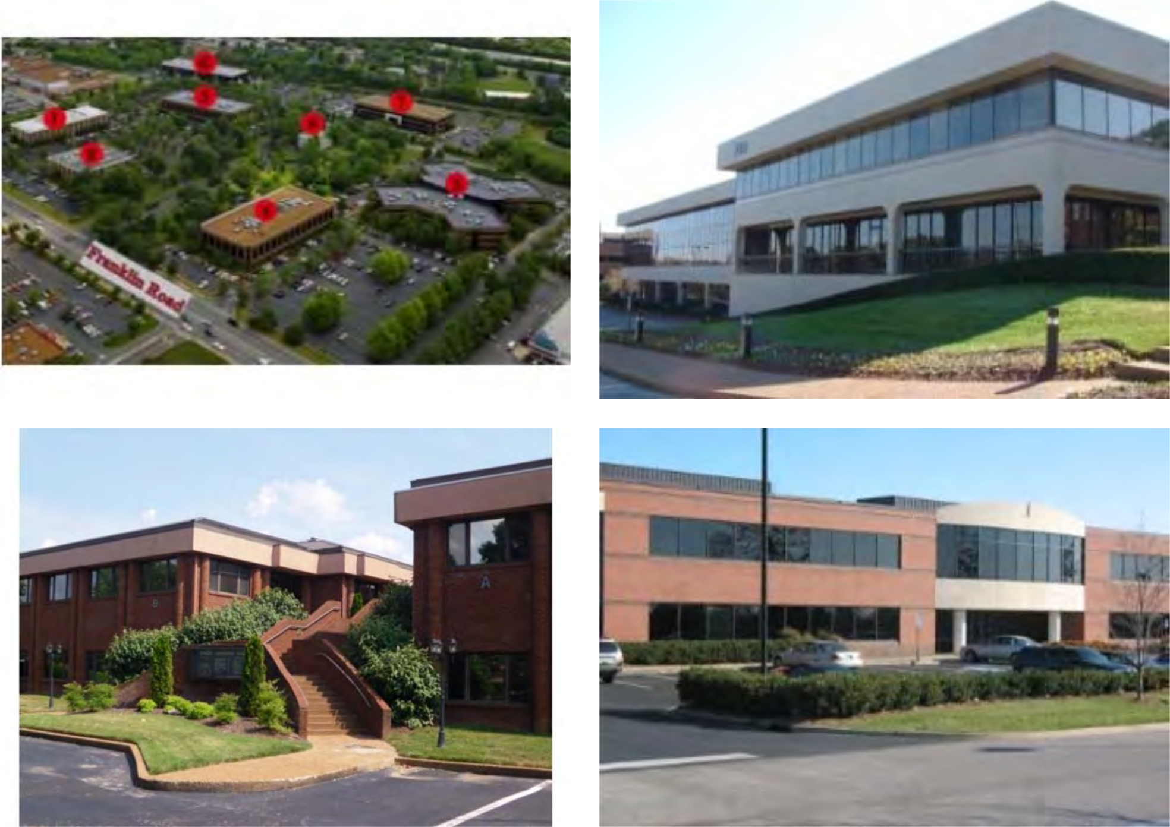

PADDOCK III WESTGATE COMMONS

FINAL PLAT & DEED


