

Housing Market A nalysis

City of La wrence

Augu st 30, 2018

Ho using Marke t Analysis

Prepared for

City of Lawrence

City Manager’s Of fice

Plan ning & Development

https ://lawrenceks.org/

Prepared by

BBC Research & C onsulting

Hous ing and Com munity Develo pment

1999 Broadway, S uite 2200

Denv er, Colorado 80202‐9750

- 321.2547 fax 303.399.0448 www .bbcresearch.com


Table of Contents

Executive Summary

Why Work to Address Housing Needs?................................................................................... | ES–1
Organization of Housing Market Analysis ............................................................................... | ES–2
Key Findings from the Housing Market Analysis ..................................................................... | ES–2
Strategic Plan for Addressing Housing Needs ......................................................................... | ES–5

- Demographic and Economic Profile

 | Lawrence Demographic Profile .................................................................................................. | I–1
 | Economic Profile......................................................................................................................... | I–7
II. | Housing Profile and Market Analysis
 | Defining and Measuring Housing Affordability ......................................................................... | II–1
 | Existing Housing Stock............................................................................................................... | II–3
 | Ownership Market Trends......................................................................................................... | II–9
 | Rental Market Trends.............................................................................................................. | II–25
 | Zoning and Land Use Analysis ................................................................................................. | II–30
III. | Community Input
 | Community Participation Opportunities .................................................................................. | III–1
 | Current Housing Choice............................................................................................................ | III–2
 | Future Housing Plans.............................................................................................................. | III–11
 | Lawrence’s Housing Spectrum ............................................................................................... | III–12
 | Stakeholder Perspectives ....................................................................................................... | III–18
 | Section Summary.................................................................................................................... | III–20
IV. Findings and Recommendations
 | Resources ................................................................................................................................ | IV–1
 | Addressing Needs.................................................................................................................... | IV–4
 | Roadmap for Addressing Needs .............................................................................................. | IV–6

Appendix A. Acronyms

BBC RESEARCH & CONSULTING i

Executive Summary

Lawrence Housing Market Analysis

EXECUTIVE SUMMARY

In late 2017, the City of Lawrence contracted with BBC Research & Consulting (BBC) to conduct a Housing Market Analysis. The primary purpose of the housing study was to conduct a Comprehensive Housing Market Study, updating and expanding the scope of the 2005 CHAT (Community Housing Assessment Team) Report to identify housing needs in the city, and to inform the allocation of the city’s new Affordable Housing Trust Fund.

This study is a critical policy document because it serves as a housing needs assessment for the City and stakeholders providing an analysis of household affordability throughout all population segments of the community. The study highlights expected demographic trends, future demands for housing, regulations, and obstacles preventing the market from effectively responding to this demand, and an inventory of the assets and programs currently available to help the community address these challenges.

This Executive Summary presents the findings from that study. It begins with a discussion about why housing needs exist—and the benefits of addressing needs.

Why Work to Address Housing Needs?

Housing markets are complex, largely because a wide variety of factors influence pricing. For example, the cost of housing is dependent upon

- Interest rates, which fluctuate with global economic conditions;

- Corporate tax rates, which incentivize investors to participate in affordable housing developments;

- The costs of labor and materials required to build housing; and

- Demographic shifts, which determine housing demand.

Unlike many goods, which can quickly adjust to changes in market demand, the physical development of housing (supply) lags behind the factors that create demand. Housing development, therefore, is slow to react to needs.

Addressing housing needs is a lot of work. Yet the return on the housing investments can be significant for the public, as well as the private, sector. Recent studies have found consistent, long‐term benefits (and lower public sector costs) for children who live in stable housing environments. Housing is also a critical element of community culture and identity, an important tool for local economic development.

Last, but not least, reducing housing costs provides households additional discretionary income to invest in local communities—saving for retirement, patronizing restaurants, providing their children with educational enrichment, and recreating. More than half of residents in Lawrence

BBC RESEARCH & CONSULTING EXECUTIVE SUMMARY, PAGE 1

said they cut back on entertainment and going out to manage housing costs. Lawrence residents with $300 more to spend per month said they would:

- Save more (46%);

- Reduce debt (18%);

- Go out more locally (15%);

- Food/improve how we eat (15%);

- Take a vacation/travel (13%);

- Make house repairs/improvements/décor (11%); and

- Buy a car (10%).

Organization of Housing Market Analysis

The Lawrence Housing Market Study is organized around the following sections:

- Section I. Demographic Profile provides a general overview of the demographic and economic environment to set the context for the housing market analysis.

- Section II. Housing Profile and Market Analysis provides an analysis of Lawrence’s housing market including a discussion of housing stock, trends in the owner and rental markets, and an analysis of affordability. The section concludes with a gaps analysis to examine mismatches in supply and demand of housing.

- Section III. Community Input describes the findings from the public participation component of the housing study, which included surveys of residents, students, employers and property owners; focus groups with community stakeholders; and presentations to the public, the Affordable Housing Advisory Board, and City Commissioners. More than 3,000 residents participated in community engagement opportunities. The public input process was designed to assess community culture and community perceptions of housing issues.

- Section IV. Findings and Recommendations summarizes housing needs and the resources available to address needs. It concludes with recommendations for allocating resources and a “dashboard” for monitoring impact.

Key Findings from the Housing Market Analysis

Demographic shifts

- Lawrence’s K‐12, college student, and 35‐44 year old cohorts have grown in the past 20 years. Shifting age cohorts suggest a pattern where students leave the city after graduation, perhaps to find employment in larger cities, resulting in an out‐migration of young adults. Consistent with national trends, the city’s Baby Boomers have aged into senior age cohorts.

- The city’s growth between 2010 and 2020 is likely to replicate 1990 to 2000 in numbers. The city will have gained 14,000 residents by 2020.

BBC RESEARCH & CONSULTING EXECUTIVE SUMMARY, PAGE 2

- The most predictable future demographic change in Lawrence is the aging of younger seniors and stability in the number of middle age families. It is difficult to tell if young adults will continue to leave the city, given the dynamics of the current economy. More young adults may find ways to remain in the city (e.g., starting businesses, pursuing work from home employment), given its high desirability.

- Lawrence’s income profile resembles that of similar cities with large universities, except for Boulder, Colorado which has shifted toward higher income residents as housing affordability has declined. Nineteen percent of Boulder’s households earn more than $150,000, compared to Lawrence’s 9 percent.

Market trends and affordability

- Rising prices have been most burdensome on renters, including low and moderate income renters who want to buy. Since 2000, the number of low income renters has declined, suggesting that renters have experienced slight income increases or left the city. Students have had a greater ability to adjust to rising rents due to family help.

- The private rental market in Lawrence largely serves renters earning between $25,000 and $50,000 per year: 65 percent of rental units are priced within that group’s affordability range, with rents between $625 and $1,250 per month. Publicly subsidized housing provides the majority of the units affordable to households earning less than $20,000/year.

- Twenty‐three percent of renters (about 4,500 households) living in Lawrence earn less than $15,000 per year. Another 1,900 renters earn between $15,000 and $20,000 per year. Of these, 5,272 cannot find rental units that are affordable (renting for less than $500 per month) and are cost burdened. 1 An estimated 2,500 of these renters are students.

- The ownership market is more strongly influenced by cash purchases today than in 2001. 2018 has lower inventory and homes spend far fewer days on the market before being sold.

- An estimated 2,300 renters would like to buy; these renters typically earn $35,000 to $75,000 per year and are employed. They have few units to choose from (fewer than 300 units), especially considering units that are bought with cash (accounting for non‐cash purchases the inventory drops to just 100 units). Most of the for sale product these households could afford to buy is older and small—but on relatively large lots. Condos and townhomes offer other affordable options, but are less likely to offer long term equity gains.

Needs expressed by residents and stakeholders

- Extremely low income residents are almost twice as likely as higher income residents to rate their housing condition as fair or poor (29% v. 16%). Nearly half receive financial support from family/friends to pay for housing costs.

- The “shortage” shown in the gaps model for high income renters (earning more than $50,000 per year) suggests those renters are spending less than 30 percent of their income on housing—perhaps in order to save for a down payment on a home purchase

BBC RESEARCH & CONSULTING EXECUTIVE SUMMARY, PAGE 3

 1 in 4 residents with disabilities live in housing that does not eet their acc essibility ne eds. 1 in 3 are extremely low income. Mo e than 1 in 10 live with family or friends due to a la ck of affordable housing to rent. Afforda ble, accessible housing is extremely difficult to find.

- Seniors who rent applied for public assistance (29 %), avoided medical treatment (29%) , cut back on medication (24%), or got food from a food bank (24%), in order to afford housing co sts. About 1 in 10 seniors overall worry they won’t be able to sta y in their home due to fina ncial issues, h ealth issues, or rent increases.

- 1 in 3 stude nts receive financial supp ort from fam ily or others to pay housing costs and 1 in 3 sought ad ditional emp loyment, 13 percent used other debt/ credit cards, 10 percent avoided me dical treatm ent.

 Families wi th children are more likely to experien ce displacem ent due to re nt/housing ost increases or high utility costs.

- Household s with any ty pe of special need have a v ery difficult time finding affordable housing. Products that are lacking in Lawrence in clude: housin g and suppo rtive services for persons with mental illn esses; affordable, accessi ble housing f or persons with disabilitie s; and transitional housing for domesti c violence su rvivors and youth aging out of foster c are.
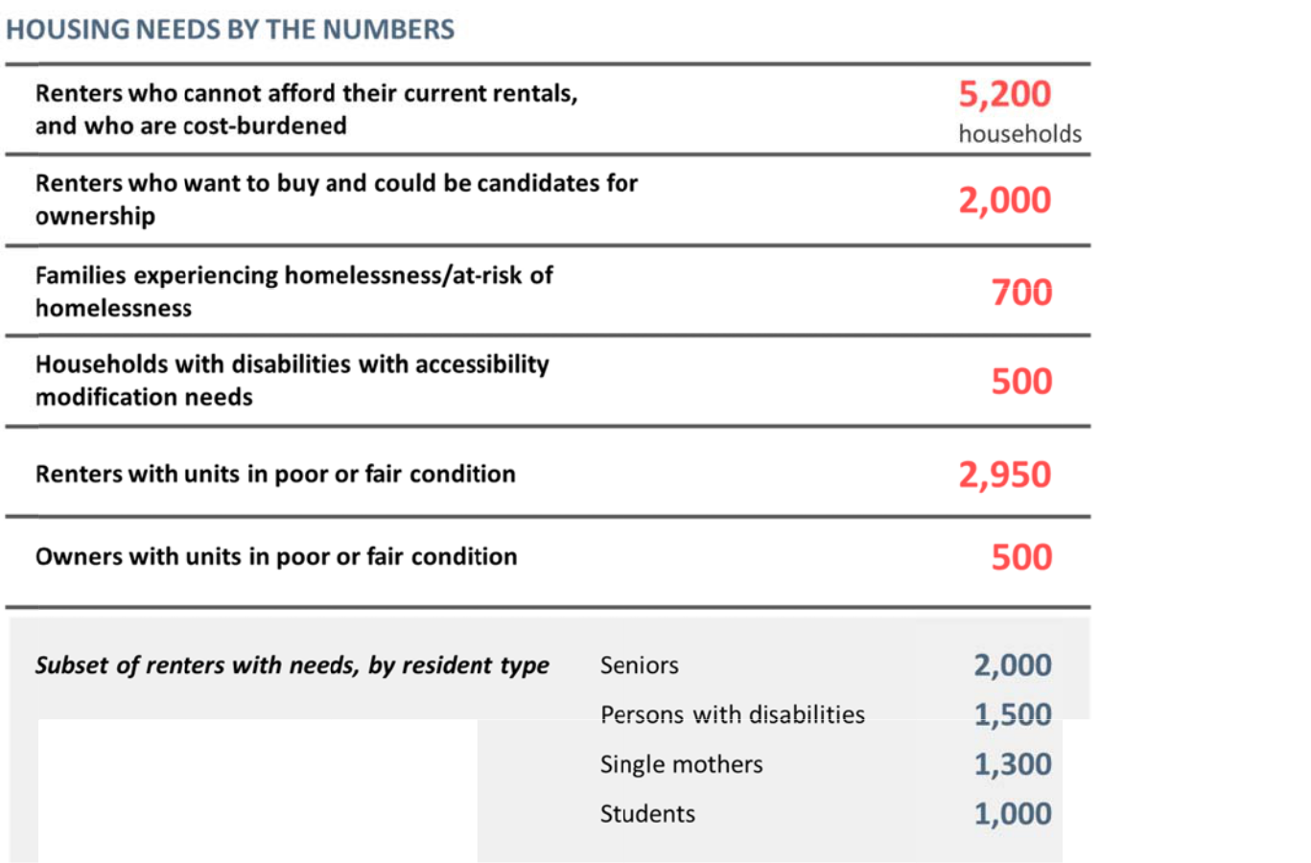

BBC RESEARCH & CONSULTING EXECUTIVE SUMMARY, PA GE 4

Strategic Plan for Addressing Housing Needs

The Dashboard. The dashboard below depicts short‐term and long‐term indicators of success, and estimated project costs, based on the outcomes developed by the AHAB and current and future housing needs.

Dashboard to Monitor and Measure Success, City of Lawrence

Short term (1‐5 years) |  | 2019‐2023
1. | Stabilize the rental gap for non‐student renters earning < $25,000/year | 100 new affordable rental units
2. Low and moderate income renters who want to become owners have more options for |  | 100 more units are affordable to low and moderate income renters who are
purchasing affordable units |  | qualified to become owners
3. | Persons with accessibility needs are able to get the improvements they need and/or find | 25 renter households that receive accessibility modifications annually
visitable and accessible housing
4. | Residents in unstable housing situations have more permanent affordable and supportive | 45 tenant based rental assistance vouchers available annually
housing options
5. | Residents living in housing in poor condition have improvements made | 70 homes and apartments brought into good condition annually
Long term (5‐10 years) |  | 2024‐2028
1. | Reduce the rental gap by 7.5% by adding new units affordable to non‐student renters earning | 500 new affordable rental units
< $25,000/year
2. Low and moderate income renters who want to become owners have more options for |  | 200 more units are affordable to low and moderate income renters who are
purchasing affordable units |  | qualified to become owners
3. | Unit accessibility for persons with disabilities is increased through rehabilitation and creation | 25 renter households that receive accessibility modifications annually
of visitable housing
4. | Residents in unstable housing situations have more permanent affordable and supportive | 70 tenant based rental assistance vouchers available annually
housing options
5. | Residents living in housing in poor condition have improvements made | 70 homes and apartments brought into good condition annually
Note: | The proposed goal numbers are based on the renter and owners gaps analysis and needs identified by residents through the survey and are rounded for simplicity.

BBC RESEARCH & CONSULTING SECTION IV, PAGE 5

Roadmap for Addressing Needs. The “roadmap” presented below details how to achieve the measures of success depicted by the dashboard. It is organized by recommended year for action.

Roadmap to Meet Dashboard Goals, City of Lawrence

Dashboard Goals
Short term (1‐5 years) | 2020‐2023 | Target Population | Roadmap
1. Stabilize the rental gap for non‐ | 100 new affordable | Persons with disabilities, | Step 1. Determine available land and property: a. Inventory city land,
student renters earning < | rental units renting | persons with mental | especially under‐utilized parcels such as parking lots, and determine
$25,000/year by creating new | for less than | illness/behavioral challenges; | appropriateness for new housing developments. b. Working with a local
deeply, permanently affordable | $500/month | seniors, single parents, victims | (preferably volunteer) commercial and residential real estate agent,
rental units, Note: Affordable rentals |  | of domestic violence, persons | inventory non‐city owned and underutilized commercial and residential
could take a variety of forms, |  | with criminal histories, | properties that could be purchased and converted to permanently
depending on the land and nature of |  | immigrants with no rental | affordable housing.
the land or property (traditional |  | history/credit
public housing, transitional housing |  |  | Step 2. Examine the sites for potential residential development.
for victims of domestic violence, |  |  | Determine redevelopment costs and potential affordability mix (both
senior housing, cooperative housing, |  |  | rental and ownership housing, a mix of MFI levels, land trust and coop
scattered site complexes). Ideally, |  |  | potential).
housing for all vulnerable resident |  |  | Step 3. Acquire land/property.
groups should have supportive |  |  | Step 4. Issue an RFP for a nonprofit or private partner to repurpose the
services and foster community
services and foster community |  |  | land or property acquired by city or owned by the partner into
support.
support. |  |  | permanent affordable housing, guided by the potential mix in Step 2.
 |  |  | Assumes partner receives additional grants to offset construction costs
 |  |  | of development.
2. Create more ownership options for | 150 more units are | Residents, workforce, small | Could be achieved through several approaches: 1) Follow Roadmap for
low and moderate income renters | affordable to low | households; 50‐100% MFI | creating affordable units (above). In that case, it is recommended that
who want to become owners | and moderate | renters who want to become | the for sale communities be a combination of land trust (deeply
 | income renters who | owners | affordable), cooperative, and modified shared equity products. 2) Use
 | are qualified to |  | density bonuses, potentially through an overlay district, to create more
 | become owners, |  | value in land for private developers. Units created through density
 | priced between |  | bonuses would likely be attached homes serving 80‐100% MFI. 3) Long
 | $100,000 and |  | term: Negotiate affordable for sale unit creation as part of annexations.
 | $260,000 |  | The proportion may vary depending on the development proposed but
 |  |  | should not be less than 10%.

Note: The proposed goal numbers are based on the renter and owners gaps analysis and needs identified by residents through the survey and are rounded for simplicity.

BBC RESEARCH & CONSULTING SECTION IV, PAGE 6

Roadmap to Meet Dashboard Goals, City of Lawrence (Continued)

Dashboard Goals
Short term (1‐5 years) | 2020‐2023 | Target Population | Roadmap
3. Persons with accessibility needs | 25 rental households | Persons with disabilities who | 1) Increase number of rental households with disabilities who receive
are able to get the improvements | assisted with | desire to live independently; | grants from the city for accessibility improvements; 2) Consider
they need and/or find visitable and | accessibility | includes many types of | enhancing this program to provide additional rehabilitation and
accessible housing | modifications | disabilities, including cognitive | weatherization to private property owners who agree to keep units
 | (benchmark is 11 | and self care | affordable for a period of time (10‐15 years, depending on amount of
 | annually) |  | grant); 3) Engage private sector developers in a discussion about
 |  |  | incentives to increase visitability in housing and consider implementing
 |  |  | solutions
4. Residents in unstable housing | 25 more vouchers | Persons with disabilities, | 1) Increase TBRA to supplement Section 8 program; buy down units in
situations have more permanent | available | persons with mental | $625‐$875 range. 2) Consider creating an incentive fund for property
affordable and supportive housing |  | illness/behavioral challenges; | owners who agree to rent to voucher holders. This fund could cover the
options |  | seniors, single parents, victims | costs of damage, wear and tear, and weatherization improvements.
 |  | of domestic violence, persons
 |  | with criminal histories,
 |  | immigrants with no rental
 |  | history/credit
5. Residents living in housing in poor | 70 number of homes | Residents living in substandard | 1) Increase funding for home modifications and weatherization. Fund
condition have improvements made | and apartments | housing; includes persons with | with housing trust funds to increase grant effectiveness and overall
 | brought into good | disabilities living in inaccessible | funding by removing regulatory inefficiencies; Supplement with
 | condition | housing | incentive programs proposed above. 2) Evaluate the CIty's current
 | (benchmark is 35 |  | rental inspection sampling program, using guidance from the survey
 | annually) |  | data in the Housing Needs Assessment, to ensure that the City's process
 |  |  | has the ability to detect condition problems reported by residents. 3)
 |  |  | Evaluate if energy codes and programs are adding unnecessary costs to
 |  |  | housing payments.

Note: The proposed goal numbers are based on the renter and owners gaps analysis and needs identified by residents through the survey and are rounded for simplicity.

BBC RESEARCH & CONSULTING SECTION IV, PAGE 7

Roadmap to Meet Dashboard Goals, City of Lawrence (Continued)

Dashboard Goals
Long term (5‐10 years) | 2024‐2028 | Target Population | Roadmap
1. Reduce the rental gap by 7.5% by | 500 new affordable rental units | Persons with disabilities, persons with mental
adding new units affordable to non‐ |  | illness/behavioral challenges; seniors, single
student renters earning less than |  | parents, victims of domestic violence, persons
$25,000/year |  | with criminal histories, immigrants with no
 |  | rental history/credit
2. Low and moderate income renters | 200 more units are affordable to | Residents, workforce, small households; 50‐
who want to become owners have | low and moderate income | 100% MFI renters who want to become owners
more options for purchasing | renters who are qualified to
affordable units | become owners
3. Unit accessibility for persons with | 25 annual rental households that | Persons with disabilities who desire to live
disabilities is increased through | receive accessibility | independently; includes many types of
rehabilitation and creation of | modifications (benchmark is 11 | disabilities, including cognitive and self care
visitable housing | annually)
4. Residents in unstable housing | 50 more vouchers available | Persons with disabilities, persons with mental
situations have more permanent |  | illness/behavioral challenges; seniors, single
affordable and supportive housing |  | parents, victims of domestic violence, persons
options |  | with criminal histories, immigrants with no
 |  | rental history/credit
5. Residents living in housing in poor | 70 number of homes and | Residents living in substandard housing;
condition have improvements made | apartments brought into good | includes persons with disabilities living in
 | condition (benchmark is 35 | inaccessible housing
 | annually)

Note: The proposed goal numbers are based on the renter and owners gaps analysis and needs identified by residents through the survey and are rounded for simplicity.

BBC RESEARCH & CONSULTING SECTION IV, PAGE 8

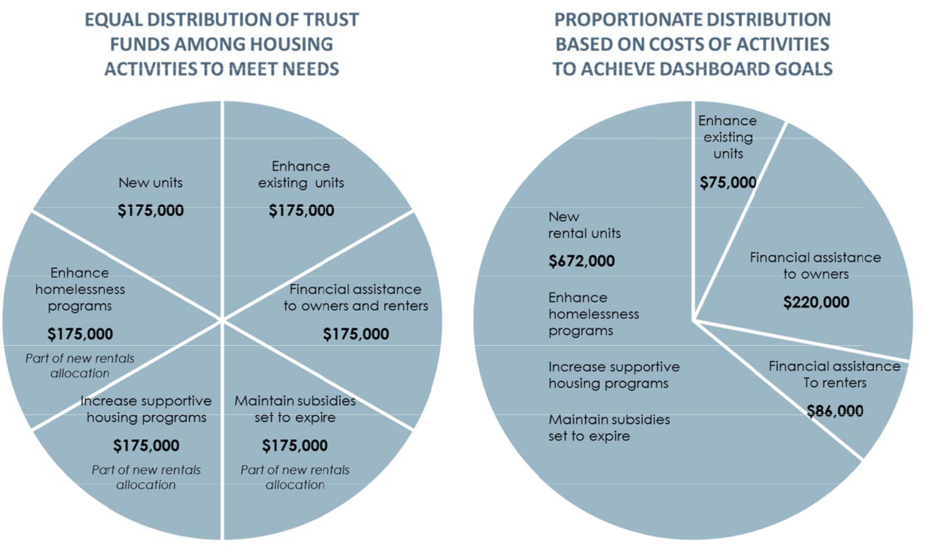

Note: Enhance existing units includes activities of accessibility improvemen ts, weatherization, and em ergency loans.

Financial assistance includes vouchers and first time homebuyer assistance.

BBC RESEARCH & CO NSULTING SEC ION IV, PAGE 9

SECTION I.

Demographic and Economic Profile

SECTION I.

Demographic and Economic Profile

This section provides an overview of Lawrence’s demographic and economic environment to set the context for the housing market analysis. The discussion is organized around population levels and trends, household diversity, and economic health.

Lawrence Demographic Profile

Similar to national trends, Kansas has experienced a population shift toward more urban areas of the state. In 2016, more people moved into Douglas County than moved away—particularly college‐aged adults. Lawrence’s diverse economy and large student population play important roles in its growth. The County is projected to grow at a steady rate over the next few decades and as people continue to seek out more affordable urban areas, Lawrence will likely grow at a similar rate, if not faster. These trends and other defining characteristics of the city are explored in this section.

Population. According to Lawrence’s Planning and Development Services Department, the city’s population increased by more than 10,000 people since 2010—the most recent population estimate was 99,496.

Figure I‐1 shows the population trends for Lawrence, Douglas County, and nearby Kansas City MSA. The city has grown modestly in the last 20 years, with an average growth rate of 1.5 percent. Lawrence experienced slightly higher growth compared to the Kansas City MSA overall.

Figure I‐1.

Population Trends, City of Lawrence, Douglas County, and Kansas City MSA, 1990, 2000, 2010, and 2017

 |  |  |  |  |  | Total Growth | Compound Annual Growth
 |  | 1990 | 2000 | 2010 | 2017 | (1990 to 2017) | Rate (1990‐2017)
Kansas City, MO |  | 435,146 | 441,545 | 459,787 | 488,943 | 53,797 | 0.4%
Lawrence, KS |  | 65,608 | 80,098 | 87,643 | 96,892 | 31,284 | 1.5%
Manhattan, KS |  | 37,712 | 44,831 | 52,281 | 54,832 | 17,120 | 1.4%
Topeka, KS |  | 119,883 | 122,377 | 127,473 | 126,587 | 6,704 | 0.2%
Wichita, KS |  | 304,011 | 344,284 | 382,368 | 390,591 | 86,580 | 0.9%
Dougle County, KS |  | 81,798 | 99,962 | 110,826 | 120,793 | 38,995 | 1.5%
Kansas City MSA |  | 1,566,280 | 1,776,062 | 2,009,342 | 2,128,912 | 562,632 | 1.1%
Source: | 1990, 2000, and 2010 U.S. Census, 2017 Population Estimates, and City of Lawrence Planning and Development Services.

Full time students. Lawrence is home to the University of Kansas (KU) and Haskell Indian Nations University (HINU)—both of which influence the city's population. Residents associated with these institutions may not be included in population totals because it is unclear how many of these students claim Lawrence residency in the Census. KU’s 2017 enrollment for fall

BBC RESEARCH & CONSULTING SECTION I, PAGE 1

semester reached 24,891 and HINU enrolls about 1,000 students per semester. Enrolled students comprise roughly one quarter of the residents in Lawrence.

More than half of the enrolled students at KU moved from within Kansas, while the remaining students moved from other states or countries (almost 10 percent of KU students are international). Twenty percent of KU students live on‐campus and the other 20,000 students live off‐campus. Students play a key role in the city’s demographic makeup, as well as the housing market. Section II will examine housing trends in more detail of students and other residents living in Lawrence.

Migration. During 2015, more people moved into Douglas County than moved out. The County gained nearly 1,500 individuals from other Kansas counties and lost almost 1,000 individuals to other states. The majority of residents moving into Douglas county came from Sedgwick County (i.e. Wichita), followed by Texas, New York, and California.

Some in‐migration is attributed to enrollment at KU and HINU. According to KU’s Office of Institutional Research & Planning, over 10,000 students moved from other states or countries.

KU is also the largest employer in Lawrence and employs over 2,800 faculty members. Combined with the city’s diverse economy, the universities attract many young adults and families.

Figure I‐2 examines annual in‐migration into Lawrence by age for 2016. As shown, much of the city's annual in‐migration is attributed to the college age and young adult populations who are likely enrolled at KU.

Figure I‐2.

Residents by Age Moving into Lawrence from Outside Douglas County, Lawrence, 2016

Note:

This includes residents that moved from outside the county, state, or the U.S.

Source:

2016 ACS 5‐year estimate.

Age Cohort | Total
Infants and toddlers (0 to 4) | 3%
School aged children (5 to 17) | 5%
College aged adults (18 to 24) | 64%
Young adults (25 to 44) | 19%
Baby boomers (45 to 64) | 6%
Seniors (65 and olders) | 3%
 | 100%

According to the 2016 United Van Lines Movers Study, the top reason people moved to and away from Kansas was for a job, followed by family. Inbound movers were most likely to make between $100,000 and $150,000 and outbound movers were most likely to make over $150,000.

Age. College students and young adults comprise the majority of residents in Lawrence, but are not the fastest growing age cohorts. Figure I‐3 compares the age distribution of Lawrence residents since 2000.

The largest growth in population occurred in school aged children and seniors.

BBC RESEARCH & CONSULTING SECTION I, PAGE 2

Fig re I‐3.
Age Trends,
Law rence, 2000,

2010, and 2016

Source:

2000 and 2010 U.S. Censu s, 2016

1‐year ACS, and BBC Research & Cons ulting.

 | 2000 | 20 | 10 | 2016 | 2010‐2016
 |  |  |  |  | Percent Change
I fants and toddle rs (0 to 4) | 4,345 | 4,827 |  | 4,863 | 1%
School aged childr en (5 to 17) | 10,526 | 10,549 |  | 12,396 | 18%
College aged adul ts (18 to 24) | 24,569 | 25,108 |  | 26,032 | 4%
Young adults (25 to 44) | 22,800 | 24,063 |  | 26,032 | 8%
Baby boomers (45 to 64) | 12,103 | 16,110 |  | 16,782 | 4%
Seniors (65 and olders) | 5,755 | 6,986 |  | 9,249 | 32%

Fig ure 1‐4 presents the chan ge in residen ts by age gro up from 2010 to 2016. As shown, the larg est change i n population occurred in residents age d 18 to 19, incoming freshman and sophomores, an d 65 to 74.

Alt hough Lawrence gained a large numbe r of 18 to 19 year olds, the city also los t residents between 20 and 24, indicating that a large share of stu dents do not stay in Lawre nce after the y graduate. It is lik ely that some Lawrence residents mo ved to the Kansas City MS A—which sa w a 5 p ercent increase in 20 to 2 4 year old residents durin g the same ti me period.

Fig re I‐4.

Change in Popul ation by Age, City of Lawrence, 2010 to 2016
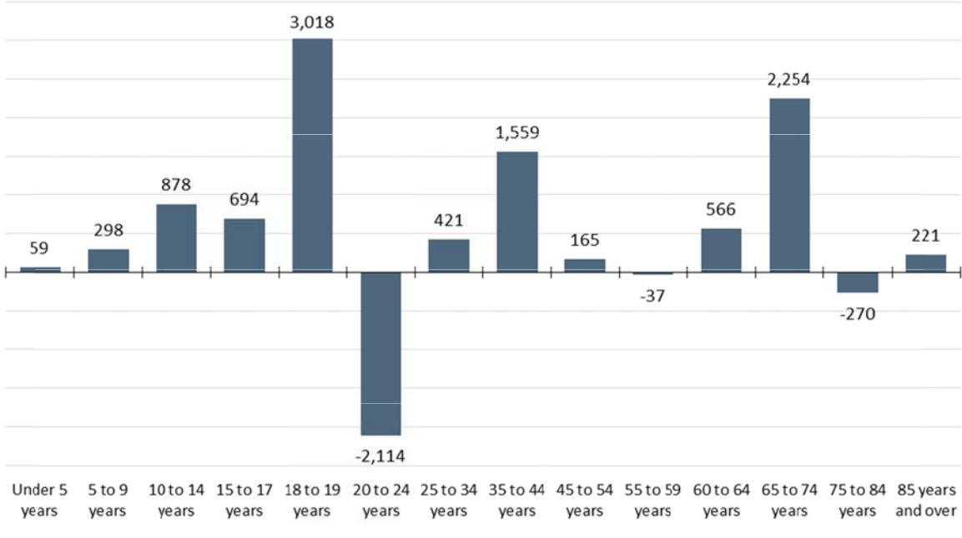

Source: 2010 U.S. Census, 2016 1‐year ACS, and BBC Research & Consulting.

Projections. The Center for Economic Development and Business R esearch (CED BR) provide s pop ulation proje ctions for Do uglas Count y through 20 64. Over the next 50 years , the County is projected to have over 200,0 00 residents —an average annual growth rate of 1.2 percent.

Fig ure I‐5 depic s population projections by age. Almo st all age coh orts are proje cted to have slo w or steady growth, except for seniors. Residents ag ed 65 and older will become the secon d larg est age cohort.

BBC RESEARCH & CONSULTING SECTION I, PAGE 3

Fig re I‐5.

Pop ulation Projection by Age, Douglas County, 2014 to 2 064
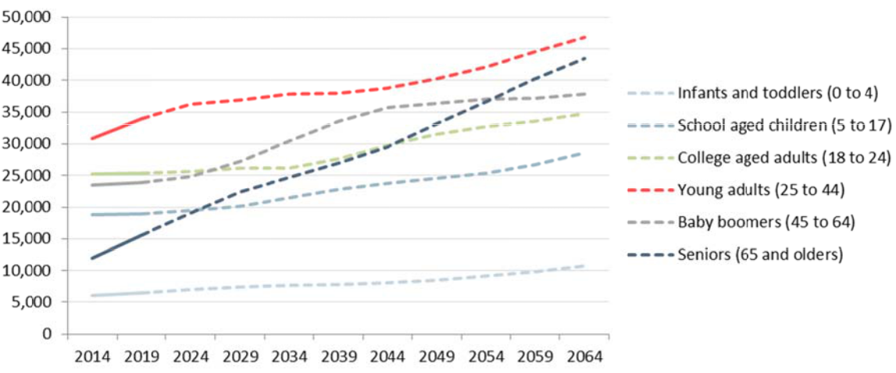

Source: The Center for E conomic Developm ent and Business Research and BBC Research & Consulting.

As he city ages, accessible ho using deman d and needs will increase as age and disability are correlated. Seni ors often req uire assistanc e with home maintenanc e and transpo rtation to ensure they maintain a high uality of life while aging in place.

Household co mposition. Lawrence’s household co mposition ha s remained r elatively

unchanged since 2000. As th population increased, each household type grew and their share of the total households changes slightly. The share of non‐family hous eholds (e.g. students) inc reased by 2 percentage points.

Fig re I‐6.
Hou sehold

Co position, City of Lawrence,
2000, 2010, and

2010

Source:

2000 and 2010 U.S. Censu s,

2016 1‐year ACS, and BBC Rese rch & Consulting.

 | 2000 |  |  | 2016
 |  | % T | otal |  | % Total
 | Number House |  | holds | Num ber | Households
Family households | 15,944 | 51 | % | 17,865 | 49%
Hu sband and wife families | 12,414 | 39 % |  | 13,218 | 36%
w ith children unde r 18 | 5,807 | 18 % |  | 6,049 | 17%
w ithout children under 18 | 6,607 | 21 % |  | 7,169 | 20%
Male householder, no wife | 964 | 3 % |  | 1,111 | 3%
w ith children unde r 18 | 476 | 2 % |  | 507 | 1%
w ithout children under 18 | 488 | 2 % |  | 604 | 2%
Fe male householder, no husband | 2,566 | 8 % |  | 3,536 | 10%
w ith children unde r 18 | 1,717 | 5 % |  | 2,039 | 6%
w ithout children under 18 | 849 | 3 % |  | 1,497 | 4%
Non‐family househol ds | 15,491 | 49 | % | 18,641 | 51%
Total households | 31,435 |  |  | 36,506
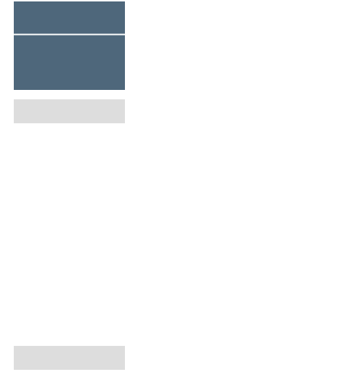

Law rence’s overall househol d compositio n is similar to other towns hosting a major universi ty. For example, 57 percent of Manhattan's ( ansas State University) households are non‐family. Other nearby communities s ch as Kansas City KS, Overland Park, and Shawnee contain a lar ger proportion of fa mily househo lds than in Lawrence.

BBC RESEARCH & CONSULTING SECTION I, PAGE 4

Fig re I‐7.

Hou sehold Comp osition by Pl ace, 2016
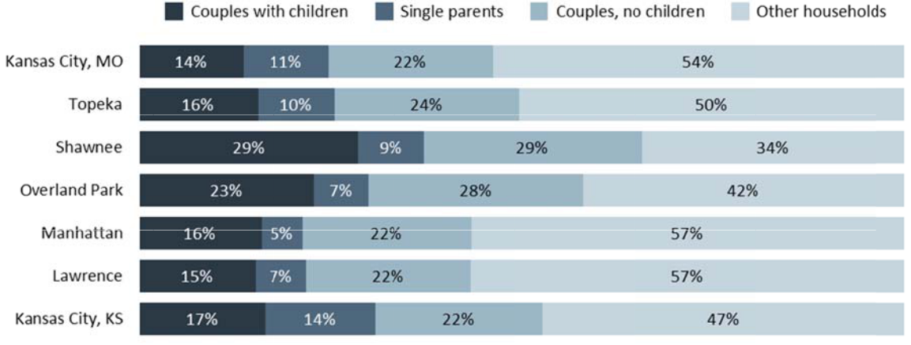

Source: 2016 5‐year ACS and BBC Research & Consulting.

Household size. The avera ge size of Law rence’s hous eholds has changed some what in the last 10 years. In 2000, the average household size was 2.28; in 2010, it was 2.41. Average family size als increased from 2.91 to 3.12 in the sa me time perio d.

Income and p overty. This section exam ines household and family income in Lawrence, as well as the prev alence of poverty among the city's resi dents.

In 2 016, the me dian household income in Lawrence w as $54,243 an d the media n income for fam ilies was $80 ,042. Married‐couple families had the highest median income (o ver $100,00 0) and college‐aged adults, singl e mothers, Asian resident s, and Native American re sidents had the low est median i ncomes, all b elow $30,000 .

Me dian househo ld income ha s steadily inc reased since 2000 (when it was $34,7 34), by an

ann ual growth rate of 2.7 percent. Figure I‐8 shows income trends s ince 2000 for both owner s and renters.

Fig re I‐8.
Inc ome Trends f or
Owners and Renters ,

Law rence, 2000 and 2016

Source:

2000 U.S. Census, 2016 1‐ year ACS, BBC Rese rch & Consulting.

 |  |  |  |  |  |  | Percent age | Numerical
 |  | 2000 |  | 20 |  | 16 | Point Ch ange |  | Change
Owners
Less than $ | 25,000 | 14% |  |  |  | 8% | ‐6% |  | ‐638
$25,000‐$50,000 |  | 28% |  | 1 |  | 0% | ‐19% |  | ‐2,506
$50,000‐$75,000 |  | 26% |  | 2 |  | 4% | ‐1% | 345
$75,000‐$100,000 |  | 15% |  | 1 |  | 3% | ‐1% | 78
$100,000+ |  |  | 17% |  | 4 | 4% | 27% |  | 4,824
Total |  | 100% |  | 10 |  | 0% |  | 2,103
Renters
Less than $ 25,000 |  | 56% |  | 3 |  | 9% | ‐17% |  | ‐1763
$25,000‐$50,000 |  | 31% |  | 3 |  | 3% | 2% | 1,363
$50,000‐$75,000 |  | 9% |  | 1 |  | 6% | 6% | 1547
$75,000‐$100,000 |  | 3% |  |  |  | 7% | 5% | 989
$100,000+ |  |  | 1% |  |  | 5% | 4% |  | 832
Total |  | 100% |  | 10 |  | 0% |  | 2,968

BBC RESEARCH & CONSULTING SECTION I, PAGE 5

Law rence experienced a loss in owners an d renters ma king under $ 25,000 over the last fiftee n years, either because those households m oved away or household i ncomes incre ased. The big gest income g ains during t his time period occurred for Lawrence households making over $10 0,000.

Fig ure 1‐9 shows the income distribution for all Lawrence resident s and compar es it to simil ar college towns.

Fig re I‐9.

Inc ome Distribution by Place, Lawrence an d Similar Com munities, 20 16
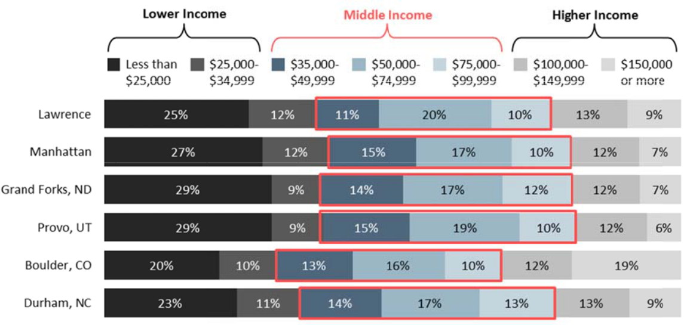

Note: 1‐year estimates were unavailable f or Grand Forks and Manhattan.

Source: 2016 1‐year ACS and 5‐year ACS and BBC Research & Consulting.

Mo re than one t hird of the cit y's households earn less t han $35,000 annually (37 %). This is not surprising, given that the figu re includes the city's stud ent populati on.

Law rence’s income distribution is similar to other coll ege towns like Manhattan and Grand Forks, North Da kota—the largest income categories are residents m aking less th an $25,000, followed by middle income r esidents (ma king between $50,000 and $75,000).

Po verty. The city's poverty rate in 2011 was 11.4 per cent, after adjusting for the student pop ulation. The overall pove rty rate including KU and HINU students is much hi gher at 23.1 more than a 10 percentage p oint differenc e. College stu dents are m ore likely to be low income com pared to oth er residents while they ar e in school. It is important to examine the poverty ate for all individual s and the no n‐student po pulation to d etermine wh ether high po verty is caused by students or s ome other reason.

As demonstrate d in Figure I‐ 10, Lawrence’s poverty rate is heavily l inked to the student pop ulation, similar to nearby college town , Manhattan.

BBC RESEARCH & CONSULTING SECTION I, PAGE 6

Fig re I‐10.

Poverty, Lawren ce, 2011

 |  | Poverty Rate | Poverty Rat | e (Excluding | Difference in
 | Total Population | (All People) | Stud | ents) | Poverty Rate
Kansas City, MO | 453,542 | 19.0 | 1 8.1 |  | ‐0.9
L awrence, KS | 79,861 | 23.1 | 1 1.4 |  | ‐11.7
M anhattan, KS | 46,151 | 27.9 | 1 1.9 |  | ‐16.0
T opeka, KS | 124,045 | 21.7 | 2 0.5 |  | ‐1.2
W ichita, KS | 377,688 | 17.0 | 1 6.3 |  | ‐0.7
Dougle County, KS | 102,397 | 19.3 | 9.9 |  | ‐9.4
Kansas | 2,770,338 | 13.6 | 1 2.4 |  | ‐1.1

Note: Students are included in the ACS po verty rates. Only data from 2011 was ava ilable for poverty rate excluding studen ts.

Source: 2009‐2011 ACS 3‐year estimates an BBC Research & Consulting.

Law rence has o e of the low st adjusted p overty rates compared to the state an d other nearb y citi es, such as To peka (20.5) and Kansas City, Missouri (18.1).

Ec onomic Profile

This section disc usses key components of the city's eco nomy, which affect the de mand for and pri e of housing.

Lab or force an d unemplo yment. Figu re I‐11 pres ents unemplo yment rates for Lawrenc e, Kan sas City MSA , the State of Kansas, and the U.S. from 2000 to the 2nd quarter of 2018.

Law rence and th e State of Kansas have consistently boasted some of the lowest unemployment rat es in the coun try for the last 10 years. While Lawren ce was not i mmune to th e economic

do nturn in 20 08 and 2009, the city and the state fair ed far better than Kansas City MSA and the U.S As of May 2 018, Lawrence’s unemplo yment rate was 2.9 percen t, compared with 3.6 per cent for Kansas City MSA and the U.S.

Fig re I‐11.

Un mployment Rates, Lawren ce, Kansas City MSA, Kansas, and United States, 2000 to June 2018
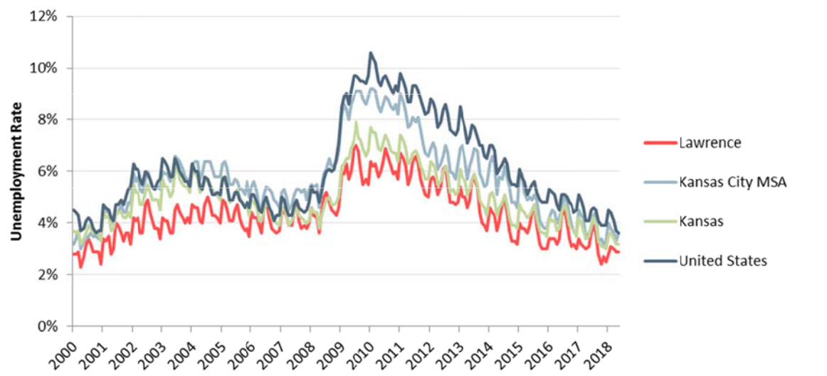

Source: Bureau of Labor Statistics.

BBC RESEARCH & CONSULTING SECTION I, PAGE 7

Job and wages by industry. Figure I‐12 compares Douglas County's job composition by industry for 2006 and 2016—the Bureau of Labor Statistics (BLS) does not provide employment data by city.

Figure I‐12.
Figure I‐12. |  | 2006 |  |  |  |  |  | 2016
Average
Average |  | Employment |  |  | % of Total |  |  | Employment |  |  | % of Total
Employment,
Douglas
Douglas | Goods Producing (Private) | 6,591 |  |  | 14% |  |  | 5,653 |  |  | 11%
County, 2006 | Goods Producing (Private)
County, 2006 | Natural Resources and Mining | 66 |  |  | 0% |  |  | 103 |  |  | 0%
and 2016 | Natural Resources and Mining
 | Construction | 2,474 |  |  | 5% |  |  | 1,681 |  |  | 3%
Note: | Manufacturing | 4,050 |  |  | 8% |  |  | 3,870 |  |  | 8%
Federal, state, and local
Federal, state, and local | Service Producing (Private) | 29,936 |  |  | 62% |  |  | 31,321 |  |  | 64%
government | Service Producing (Private)
employment data | Trade, Transportation, and Utilities | 7,924 |  |  | 16% |  |  | 8,116 |  |  | 16%
unavailable for Douglas | Information | 1,039 |  |  | 2% |  |  | 777 |  |  | 2%
County. | Information
County. | Financial Activities | 1,947 |  |  | 4% |  |  | 1,575 |  |  | 3%
Source: | Professional and Business Services | 5,382 |  |  | 11% |  |  | 5,576 |  |  | 11%
Bureau of Labor | Education and Health Services | 4,855 |  |  | 10% |  |  | 5,650 |  |  | 11%
Statistics and BBC | Leisure and Hospitality | 6,456 |  |  | 13% |  |  | 7,063 |  |  | 14%
Research & Consulting. | Other Services |  | 2,332 |  |  | 5% |  |  | 2,565 |  |  | 5%
 | Total Private Employment | 36,526 |  |  | 76% |  |  | 36,974 |  |  | 75%
 | Total Employment | 48,093 |  |  | 100% |  |  | 49,208 |  |  | 100%

Douglas County has slowly become more reliant on service producing industries and less reliant on goods producing industries. In fact, the area lost nearly 1,000 goods producing jobs in the last 10 years; most of these jobs were in construction and manufacturing. The education and health services industry gained the most jobs, followed by Leisure and Hospitality—two of the lowest paid industries.

Figure I‐13 presents wage information by industry for jobs in Douglas County in 2006 and 2016. Manufacturing jobs pay the highest annual average wages, followed by the information and financial activities industries.

BBC RESEARCH & CONSULTING SECTION I, PAGE 8

Figure I‐13.
Figure I‐13. |  | 2006 |  | 2016
Employment and |  | 2006 |  | 2016
Employment and |  | Weekly | Annual | Weekly | Annual
Average Wages,
Douglas County, |  | Employment | Total | Employment | Total
2006 and 2016
2006 and 2016 | Goods Producing (Private) | $750 | $39,024 | $934 | $48,581
Note: | Natural Resources and Mining | $433 | $22,494 | $645 | $33,528
Federal, state, and local | Construction | $684 | $35,589 | $867 | $45,060
government employment | Manufacturing | $796 | $41,393 | $971 | $50,510
data unavailable for
Douglas County.
Douglas County. | Service Producing (Private) | $459 | $23,844 | $563 | $29,300
Source: | Trade, Transportation, and Utilities | $465 | $24,165 | $558 | $29,016
Source: | Information | $634 | $32,950 | $896 | $46,611
Bureau of Labor Statistics
Bureau of Labor Statistics | Financial Activities | $710 | $36,911 | $868 | $45,144
and BBC Research &
and BBC Research & | Professional and Business Services | $571 | $29,672 | $749 | $38,944
Consulting.
 | Education and Health Services | $516 | $26,824 | $591 | $30,706
 | Leisure and Hospitality | $203 | $10,534 | $283 | $14,691
 | Other Services | $480 | $24,892 | $604 | $31,390
 | Total Private Employment | $511 | $26,584 | $620 | $32,248
 | Total Employment | $575 | $29,896 | $715 | $37,159

Occupations. According to the ACS, there are 56,601 residents 16 years and older employed in Lawrence. Most residents are employed in management, business, science, and arts occupations (44%). The other top occupations in Lawrence are sales and office occupations (22%) and service occupations (22%). The least common occupations held by Lawrence residents include production, transportation and material moving (8%), as well as natural resources, construction and maintenance (3%).

Top employers. The University of Kansas has historically provided stable employment to the Lawrence and the region. The college provides more than 9,000 jobs to the area. The second largest employer in the region is Lawrence Public Schools.

Figure I‐14 shows the top employers in Lawrence and Douglas County. Although education dominates the local economy, there is a diverse set of employers and industries that contribute to the region’s stable economic activity.

BBC RESEARCH & CONSULTING SECTION I, PAGE 9

Figure I‐14.

Top Employers, Lawrence and Douglas County

Employer | Product/Service | Number of Employees
The University of Kansas | Education | 9,881
Lawrence Public Schools | Education | 1,800
City of Lawrence | Government | 1,455
Lawrence Memorial Hospital | Medical | 1,322
Berry Plastics | Manufacturer | 739
Hallmark Cards, Inc. | Manufacturer | 525
Baker University | Education | 496
Amarr Garage Doors | Manufacturer | 461
Douglas County | Government | 435
Boston Financial Data Services | Data Services | 394
The Olivia Collection | Hospitality | 320
K‐Mart Distribution Center | Distribution Center | 320
DCCCA | Not for profit | 295
Allen Press | Printing Services | 275
Community Living Opportunities | Not for profit | 263
Haskell Indian Nations University | Education | 250
Cottonwood, Incorporated | Manufacturer | 240
Eudora School District | Education | 232
Lawrence Paper Company | Manufacturer | 209
Bert Nash Community Mental Health Center | Not for Profit | 179
Westar Energy | Utility | 170
ICL Performance Products LP | Manufacturer | 161
HP Pelzer | Manufacturer | 160
Big Heart Pet Brands | Manufacturer | 160
Schlumberger | Manufacturer | 150
PROSOCO | Manufacturer | 92
Golf Course Superintendents Association of America | Corporate Headquarters | 85

Source: EDC of Lawrence & Douglas County and BBC Research & Consulting.

The state of Kansas has low to moderate tax burden on residents and businesses, which also contributes to its stable economy. According to WalletHub’s latest Tax Burden by State study, Kansas ranks number 25 compared to all other U.S. states for tax burden. Although very low state taxes may sound appealing initially, it does not promote long‐term economic growth. On the other hand, excessively high state tax burden limits economic growth. Kansas is unique because it provides adequate revenues for schools, infrastructure, and public services, while not burdening residents or businesses with high tax rates. If the state continues to have a balanced tax structure, it will foster more economic growth.

BBC RESEARCH & CONSULTING SECTION I, PAGE 10

SECTION II.

Housing Profile and Market Analysis

SECTION II.

Housing Profile and Market Analysis

This section provides an analysis of Lawrence’s housing market. It examines housing supply and availability, development trends, affordability of rental and ownership housing, and housing demand. The analysis is tailored to Lawrence’s unique market which is affected by the city’s high desirability, two institutions of higher education and large presence of students, proximity to a major metropolitan area, and land and development constraints.

The section begins with a definition of affordability and how affordability is typically measured. This follows with a discussion of price trends and affordability in both the rental and ownership markets. The section concludes with estimated housing needs.

Defining and Measuring Housing Affordability

The most typical definition of affordability is linked to the idea that households should not be cost burdened by housing. A cost burdened household is one in which housing costs—the rent or mortgage payment, plus taxes and utilities—consumes more than 30 percent of monthly gross income.

The 30 percent proportion is derived from historically typical mortgage lending requirements. Thirty‐percent allows flexibility for households to manage other expenses (e.g., child care, health care).

Recently, the 30 percent threshold has been questioned as possibly being lower than what a household could reasonably bear. Indeed, the U.S. Department of Housing and Urban Development has considered raising the contribution expected of Housing Choice (“Section 8”) Voucher holders to 35 percent of monthly income. However, most policymakers maintain that the 30 percent threshold is appropriate, especially after taking into account increases in other household expenses such as health care.

It is generally accepted that households should not pay more than 50 percent of their incomes in housing costs. This “severe” level of cost burden puts households at high risk of homelessness— and also restricts the extent to which households can contribute to the local economy.

BBC RESEARCH & CONSULTING SECTION II, PAGE 1

Fig ure II‐1.

Aff ordability Definitions
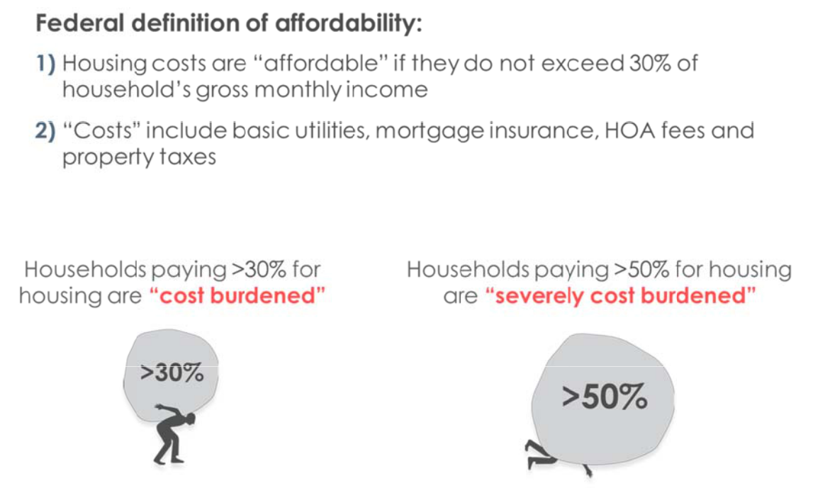

Fig ure II‐2 show s the income thresholds typically used, based on La wrence’s median income. Me dian Family Income, or M FI, is defined annually bas ed on HUD m arket studie s. The figure provides the maximum affor dability for h ouseholds at each MFI level, as well as the housing types that serve the households in the MFI range.

It is important t o note that MFI is based o n earned inco me or public assistance and does not

fact or in person al wealth and other forms of financial s upport. Students are ofte n represente d in the 0‐30 percen t MFI category yet have access to other sources of in come (e.g., parental support)

that reduce hou sing cost bur den. Similarl , seniors living on fixed in comes fall in the 0‐30 percent categor y yet have ve ry low housi g cost burden if they own their homes outright or

hav e low outsta nding mortga ge balances. (They may, h owever, struggle to affor d maintenanc e costs). For example, seniors in Lawrence r eport their average mort gage as $865 per month, com pared to $1,500 for all ho meowners.

BBC RESEARCH & CONSULTING SECTION II, PA GE 2

Fig ure II‐2.

Inc ome Thresholds and Targe t Housing
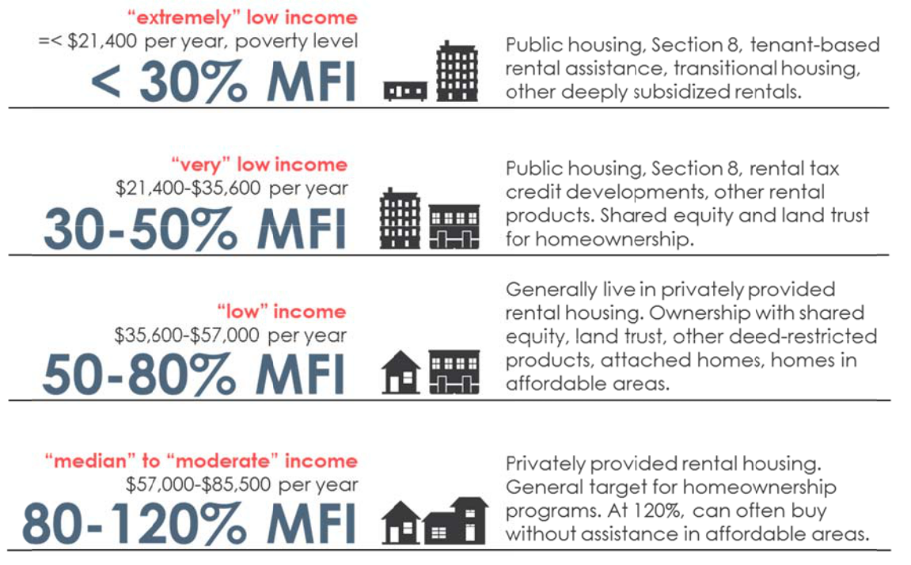

Note MFI = HUD Median Family Income, ‐person household.

Sourc e: BBC Research & Consulting and HUD 2018 income limits.

Oth er common indicators of housing affordability inclu de:

- Housing costs v. income . Many indic es used to m onitor afford ability trends compare

housing co sts to income levels. At the most simplistic level, the se compare median home prices to median incom s. Although such indices are useful in comparing m arkets, they fail to capture he uniqueness of some markets (e.g., h ow property taxes affect housing cost s).

 Housing gaps. A housin gaps model compares the supply of housing at various price points to demand, using income as a proxy. This model allows an exa mination of housing affordability challenges by income range. The gap s approach is used in this section to examine af fordability in Lawrence.

Ex sting Housing Stock

The U.S. Census counts appro ximately 40,000 housing units in Law rence, with 5 4 percent of those renter‐occ upied and the balance, 46 percent, ow ner‐occupied . This is relat ively unchanged fro m 2000, whe n 53 percent of units were renter‐occupied and 47 percent were owner‐ occupied.

As shown below, Lawrence’s homeowner ship rate of 46 percent is higher than M anhattan’s and low er than othe r Kansas com munities and the Kansas City‐Missour i (KCMO) metropolitan sta istical area (MSA).

BBC RESEARCH & CONSULTING SECTION II, PA GE 3

Fig re II‐3.
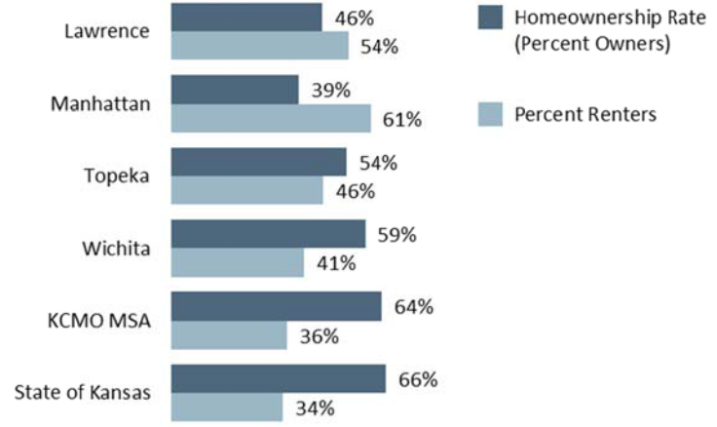
Ho meownership Rate, City
of Lawrence and

Surrounding Citi es, 2016

Sourc e:

2016 1‐year ACS.

Housing type. Just over half of Lawrenc e’s housing st ock is made up of single family detached ho mes. Another 10 percent is condominium and townh omes. Thirte en percent i s

dup lexes/triple es/fourplex es and just 2 percent mob ile homes. Th e balance, ab out 25 percent, is apartments, m ost of which are in small to medium sized apartment buildings.

The vast majority of Lawrenc e owners (8 %) live in si ngle family detached hous es and the v st majority of rent ers (80%) live in attached units. Figure II‐4 displays housing type by “tenure” for La rence. In the housing industry, tenure means the s tatus of rente r‐ or homeo wnership.

Fig ure II‐4.

Occupied Housin g by Type an d Tenure, City of Lawrence, 2016
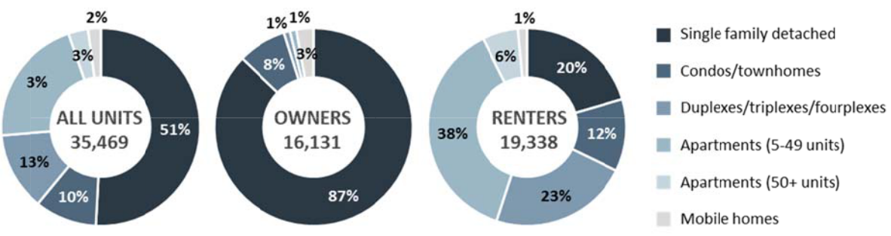

Sourc e: 2016 1‐year AC .

Co mpared to Ma nhattan, Law rence has a larger propor tion of singl e family deta ched and atta ched homes and fewer larger apartment complexe s. Manhattan has a relativ ely large

proportion of mobile homes compared to Lawrence and other com munities. As expected, both La rence and M anhattan ha ve fewer pro ortions of si ngle family detached homes and higher proportions of attached and apartment un its, driven b y student de mand for housing.

BBC RESEARCH & CONSULTING SECTION II, PA GE 4

Figure II‐5.
Figure II‐5. |  | Lawrence |  |  | Manhattan |  |  | Topeka |  |  | Wichita |  |  | KCMO
Comparative
Housing Type by | Single family detached | 51% |  |  | 44% |  |  | 68% |  |  | 71% |  |  | 71%
Tenure, City of | Single family detached |  |  |  |  |  |  |  |  |  |  |  |  | 71%
Tenure, City of | Condos/townhomes | 10% |  |  | 8% |  |  | 4% |  |  | 3% |  |  | 6%
Lawrence and | Condos/townhomes |  |  |  |  |  |  |  |  |  |  |  |  | 6%
Surrounding | Duplexes/triplexes/fourplexes | 13% |  |  | 10% |  |  | 6% |  |  | 7% |  |  | 6%
Kansas Cities, | Apartments (5‐49 units) | 21% |  |  | 30% |  |  | 14% |  |  | 13% |  |  | 11%
2016 | Apartments (50+ units) | 3% |  |  | 3% |  |  | 5% |  |  | 3% |  |  | 3%
Source: | Mobile homes |  | 2% |  |  | 4% |  |  | 2% |  |  | 3% |  | 2%
Source: | Total | 100% |  |  | 100% |  |  | 100% |  |  | 100% |  |  | 100%
2016 5‐year ACS. | Total |  |  |  |  |  |  |  |  |  |  |  |  | 100%

Figure II‐6 shows the geographic distribution of renters and owners in Lawrence. Rental units are concentrated in the central and south central part of the city. Homeownership is highest in neighborhoods on the outer ring of Lawrence, except for south Lawrence.

BBC RESEARCH & CONSULTING SECTION II, PAGE 5

Figure II‐6.

Proportion of Ho meowners and Re nters by Census Block Group, City of Lawrence, 201 6
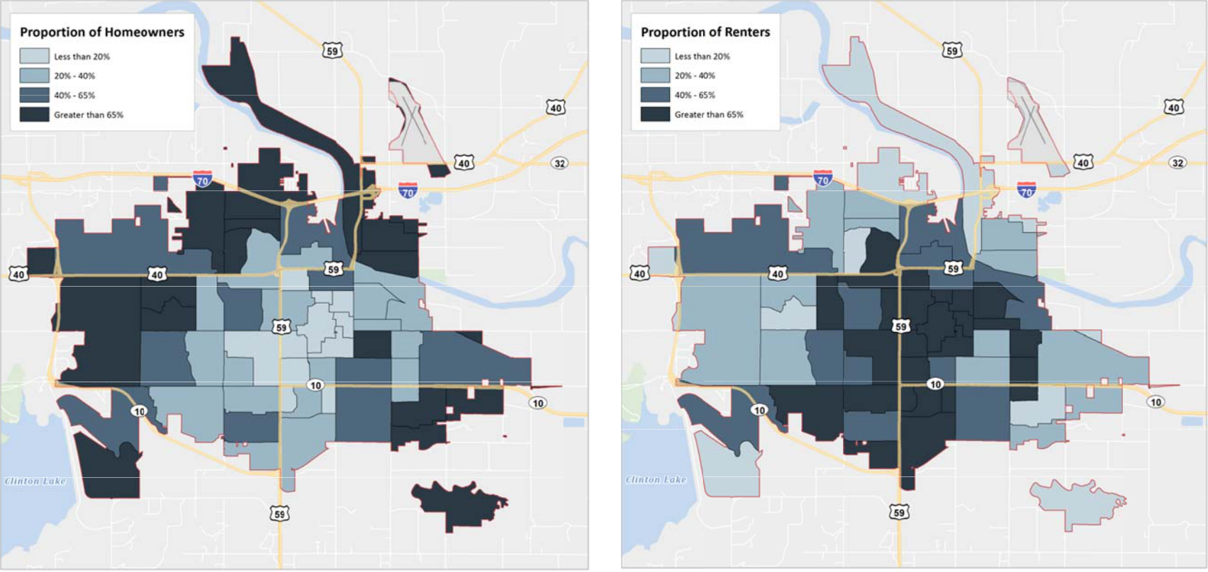

S ource: 2016 5‐year ACS.

BBC RESEARCH & CO NSULTING SEC TION II, PAGE 6

Household size and bedr ooms. The average house hold size in unit. Owner‐occupied units have an average size of 2.76; renters, a

Lawrence is 2.41 people per much lower 2 .12.

Most homes in Lawrence are good‐sized. The median n umber of ro oms per hous ing unit in

La rence is 5.2, according to the Census. Nearly 40 pe rcent of housing units have 3 bedrooms; this is the most common size of unit. Twe nty percent of units have 4 and 5 bedro oms; 14 per cent are 1 bedroom u nits; and 25 percent are 2 bedroom un its. Only 2 p ercent of units are studios.

Ag e of housing stock. Figu re II‐7 shows the distribu tion of Lawrence’s housi g stock by a ge. Alm ost half of th e city’s hous ing stock was built betwe en 1970 and 1999. This ex plains the la rger siz d units that are characteristic of the city, as homes and apartments built in t ose decades typically had mo re square fo otage than ol der units.

Fig re II‐7.
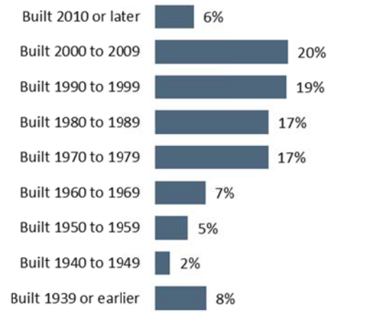
Age of Housing Stock, City of awrence, 20 16

Sourc e:

2016 1‐year ACS and BBC Research & Consult ng.

Building permits. The city’s Planning & Development Services Department pr ovides month ly

building permit reports, as well as annual analyses of p ermit activity. The figure below show

one , two, and m ultifamily per mitting activ ity from 2008 through 20 17. Until 201 7, more units in

multifamily dwe llings had been issued, with multifami ly permitting exhibiting w ider

fluc tuations. 20 5 saw a surg e in one‐ and two‐family permits; these have remained historica lly high.

According to the department’s reports, sin ce 1993, there have been 11 years in which the nu mber of multifamily units permitted exceeded one‐ and two‐fami ly dwelling u nits: first in 199 6, then not u ntil 2007, and in subsequent years unt il 2017.

BBC RESEARCH & CONSULTING SECTION II, PA GE 7

Fig ure II‐8.

Building Permit rends, One, Two, and Multifamily Resi dential Units, City of Lawre nce, 2008 – 2017
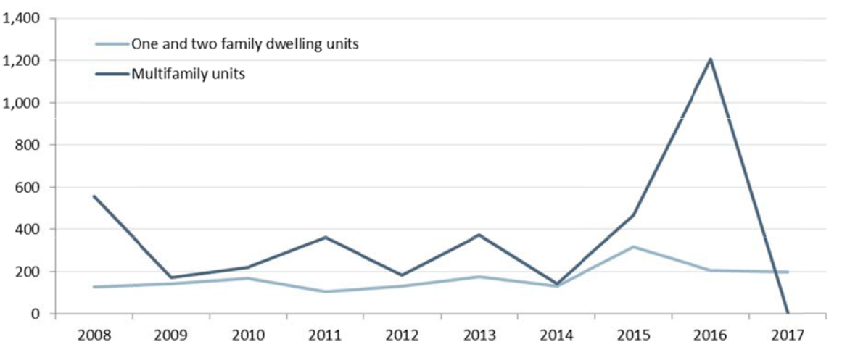

Sourc e: 2017 Building P ermit Activity and Trends Report.

Permits issued through April 2018 show a continued development preference fo r single family units: 0 multifa ily permits had been issu ed compare d to 46 single family permits and 4 duplex permits.

Alt ogether, perm its issued be tween 2013 and April 20 18 totaled 32 7 single fami ly homes an d dup lexes, compa red to 1,102 multifamily units. Until 2 018, multifa mily units ave raged 360 u nits per year.

Co st burden. ltogether, 5 percent of all Lawrence renters, more than 10,000 renter

hou seholds, are cost burdene d, spending 30 percent or more of the ir income on housing costs. Of these, most (6,0 00 household s) are severe ly cost burd ened, paying more than 5 0 percent of their inc ome on housi ng costs.

Owners face much lower rate s of cost bur den, with 15 percent of o wners with a mortgage an d 16 percent of owners without a mortgage facing cost burd en. This sug ests that maintenance of ho mes is as much of a burden on owners s is the mort gage payme nt.

Fig re II‐9.
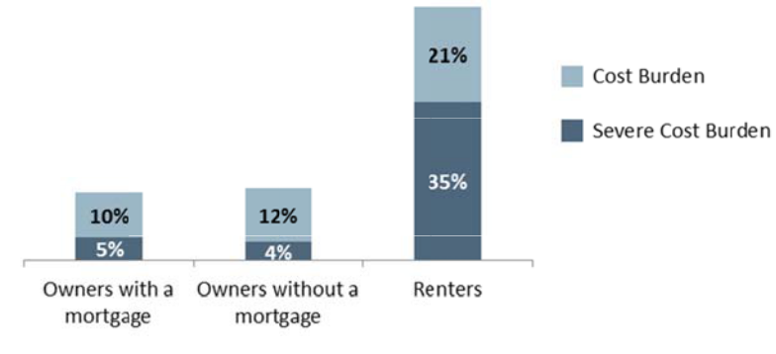
Cost Burdened O wners
and Renters, City of

Law rence, 2016

Sourc e:

2016 1‐year ACS.

BBC RESEARCH & CONSULTING SECTION II, PA GE 8

Ownership Market Trends

This section discusses ownership affordability in Lawrence, beginning with price trends, and concluding with an estimate of current and future gaps between ownership demand and supply.

Price increases. Similar to most housing markets across the country, Lawrence has experienced substantial increase in home prices since 2000. As shown in the figure below, the median price of sold and listed homes was $129,900 in 2001. By 2018, this had risen to $239,700—an increase of 85 percent.

By home type, single family homes and homes in rural subdivisions increased the most during this period, with prices doubling.

Figure II‐10.

Median Price, Sold and Listed Homes, Lawrence, 2001 to 2018

 |  |  |  |  |  |  | Change
 |  | 2001 | 2006 | 2016 | 2017 | 2018 | 2001‐2018
All |  | $129,900 | $164,950 | $186,900 | $190,204 | $239,700 | 85%
Single Family Detached |  | $134,700 | $174,900 | $199,900 | $215,000 | $259,900 | 93%
Condominium |  | $74,000 | $82,000 | $83,000 | $84,400 | $88,950 | 20%
Townhome |  | $110,000 | $138,750 | $135,000 | $141,750 | $167,000 | 52%
Rural Residential |  | $196,700 | $274,500 | $275,000 | $336,500 | $330,000 | 68%
Rural Subdivision |  | $204,900 | $305,000 | $369,000 | $279,900 | $427,250 | 109%
Note: | The Rural Subdivision category had fewer than 20 homes sold or listed each year and only 4 in 2018. Rural residential and condominium
 | categories also had few listings and sales, averaging 30‐40 annually.
Source: | Lawrence Multiple Listing Service, Lawrence Board of Realtors.

Price increases were not uniform, however. Consistent with national trends, home prices were stable (and even declined for townhomes) between 2006 and 2016, then began to rise. Price increases in the past year have been very significant for all product types except condominiums and rural residential properties.

BBC RESEARCH & CONSULTING SECTION II, PAGE 9

Fig ure II‐11.

An ual Price Incr eases by Ho me Type, 200 to 2018
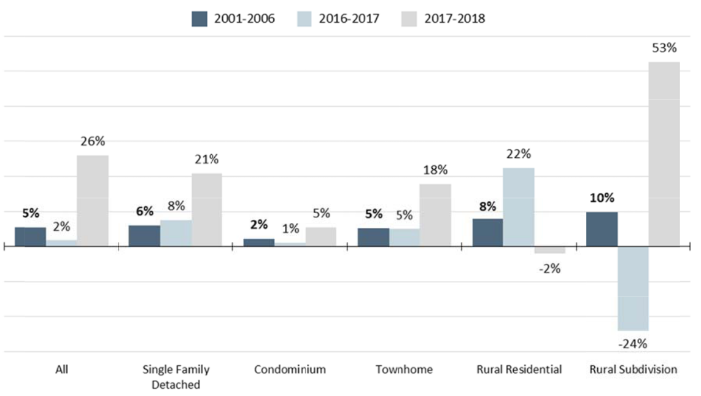

Sourc e: Lawrence Multiple Listing Service, L awrence Board of Re altors.

As shown in the price trend g raph below, Lawrence’s f or sale price trends have een most

sim ilar to the nearby communities of Baldwin City and Eudora. Law rence’s hom e prices,

alth ough lower, also track tre nds of the western Kansas City suburb s of Olathe and Shawnee.

La rence is mu ch more expensive than th e Kansas Cit y‐Missouri re gion (KCMO ) overall, and

Wi hita.

The graphic also demonstrat es how Lawr ence and sur rounding com munities avoided the price bub ble (2005‐2 008) of the U.S. overall.

BBC RESEARCH & CONSULTING SECTION II, PA GE 10

Fig ure II‐12a.

Median Sale Price of All Home s, Lawrence and Surrounding Commun ities, 1998 to 2017
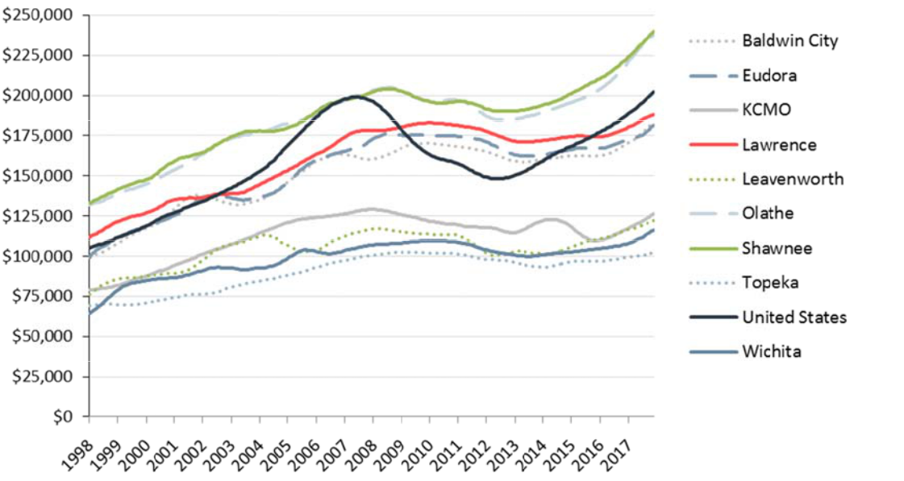

Note Includes both single family detached and condo units. Tr end data were not a vailable for Manhattan. The first quarter 2018 Zillow Media n

List Price reports Manhattan’s medi an at $215,000, compared to $260,000 f or Lawrence. This compares to $180,000 for the KCMO area overall.

Sourc e: Zillow Home Value Index and BBC R esearch & Consultin .

Fig ure II‐12b.

Median Sale Price Compared to Median Inc ome, Lawren ce and Surro unding Comm unities, 1998 to 2 017
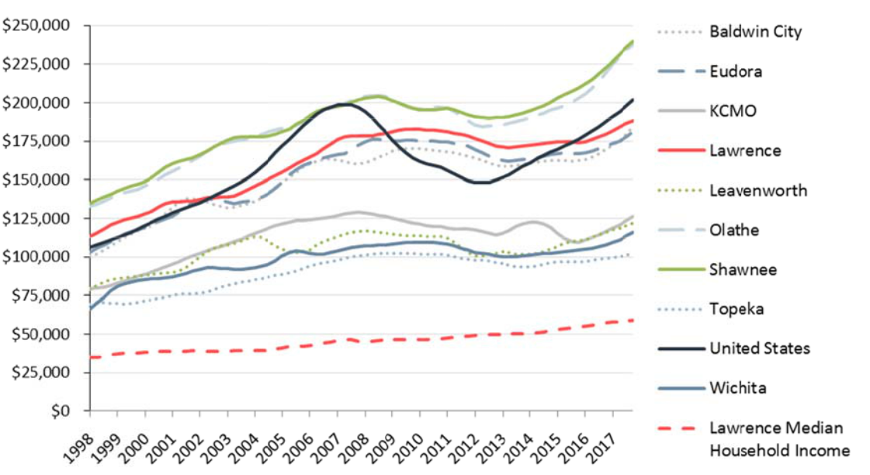

Note Includes both single family detached and condo units. Tr end data were not a vailable for Manhattan. The first quarter 2018 Zillow Media n

List Price reports Manhattan’s medi an at $215,000, compared to $260,000 f or Lawrence. This compares to $180,000 for the KCMO area overall.

Sourc e: Zillow Home Value Index and BBC R esearch & Consultin .

BBC RESEARCH & CONSULTING SECTION II, PA GE 11

Impact on affordability. Curiously, because of the drop in mortgage loan interest rates during the recession, a household can afford to buy more in 2018 than they could in 2001—thus softening the blow of price increases. Yet higher priced homes require larger downpayments, which interest rate declines do not address.

The table below shows what households at various income levels could afford in 2001 and 2018—based on average mortgage interest rates in those years—as well as 2019, based on projections for interest rate increases. Affordability will drop slightly in 2019 due to rate increases; however, households will still be able to buy more than they could in 2001.

Figure II‐13.
Homeownership Affordability, City

of Lawrence, 2001, 2018, and 2019

Note:

Interest rates assumed = 8.0% in 2001, 4.625% in 2018. 2019 assumes interest rate of 5.5%. Adjusted for changes in property taxes.

Source:

BBC Research & Consulting.

 |  | Affordably Priced Home
Household Income |  | 2001 | 2018 | 2019
$36,000 | (50% MFI) | $82,000 | $110,000 | $100,000
$57,000 | (80% MFI) | $150,000 | $201,000 | $180,000
$71,000 | (100% MFI) | $196,000 | $262,000 | $240,000
$86,000 | (120% MFI) | $240,000 | $324,000 | $290,000

Interest rates also fail to address the problem of lack of affordable housing to buy, which is discussed in the following section.

Renters who want to buy. According to the survey conducted for this study, nearly 50 percent of non‐student renters want to buy homes. This compares to just 11 percent of student renters.

Those non‐student renters who want to buy:

- Earn between $35,000 and $75,000 per year (about 50 to 100% of the HUD MFI);

- Can afford homes priced between $110,000 and $262,000;

- Are between the ages of 35 and 44, employed full time (61%) or part time (10%), do not have children, and have small household sizes (2.2 persons per household).

- These want‐to‐be owners would be well served by attached products that serve smaller families in prime working years looking for low‐maintenance living.

Other residents in the market to buy would be those who want to move. The resident survey asked about the desire to move. Those residents who want to move are young adults (18‐24), living with roommates (2.7 per household size), with earnings in the $25,000 to $35,000 range, and working full (41%) and part (30%) time. Residents who want to stay in their homes are those who would be in the market for moving up in ownership—ages 45‐54, with children, larger household sizes, employed—but are not expressing strong demand to do so.

Supply of affordable homes to buy. A household’s current choices for ownership by price and type are shown in the table below. This is based on homes that were listed or for sale between January and April 2018.

BBC RESEARCH & CONSULTING SECTION II, PAGE 12

For very low income households—new college graduates, teachers, workers in service and retail, public servants beginning their careers—34 homes were on the market that were affordable. About one‐third was single family homes; one third was condominiums; and one third was townhomes.

Households earning roughly between $35,000 and $57,000—the income range of the typical renter who wants to buy—have many more options for buying a single family home. Townhomes also serve this market segment.

Households earning $70,000 and above can afford a variety of for sale product.

Overall, Lawrence’s condo market serves the lower income households who want to become owners. Townhomes serve a broader income range with very affordable to higher end products. Single family detached homes are mostly affordable to households earning $57,000 and more.

Figure II‐14.

Current Affordability by Price Point and AMI, 2018

 |  |  | Number of homes listed/sold by price point in 2018
 |  | Less than | $110,000 ‐ | $201,000 ‐ | $262,000 ‐ | $324,000 ‐ | Over
 |  | $110,000 | $201,000 | $262,000 | $324,000 | $416,000 | $416,000
 |  | Very low | Low | Median | Moderate |  |  |  | Percent
 |  | income | income | income | income | High | Highest |  | Affordable
Affordable to… |  | (50% MFI) | (80% MFI) | (100% MFI) | (120% MFI) | income | income | Total | to 80% AMI
All Homes |  | 34 | 185 | 77 | 77 | 75 | 86 | 534 | 41%
City‐Condo |  | 14 | 0 | 1 | 0 | 2 | 3 | 20 | 70%
City‐Single Family |  | 10 | 130 | 68 | 58 | 65 | 75 | 406 | 34%
City‐Townhouse |  | 10 | 53 | 7 | 14 | 3 | 0 | 87 | 72%
Rural Residential |  | 0 | 2 | 1 | 4 | 4 | 6 | 17 | 12%
Rural Subdivision |  | 0 | 0 | 0 | 1 | 1 | 2 | 4 | 0%

Source: Lawrence Multiple Listing Service, Lawrence Board of Realtors.

Product differentiation. The type of home households can buy at various price ranges varies by size, age, and amenities, as shown in the following figures.

The data in the figures demonstrate that:

- Condo and townhome affordability are highly correlated with age. The median price of condos and townhomes built in the past 20 years is far higher than the median price of older units.

- Similarly, older single family detached homes offer more affordability. The median price of a newly built single family home in 2018 is $70,000 higher than a home just 1‐5 years old.

- The most affordable units are between 1,000 and 1,500 square feet, which is small for a family.

- Square footage has been declining for all price points.

BBC RESEARCH & CONSULTING SECTION II, PAGE 13

- All units, even the most affordable, have relatively large lots. In many markets, lot sizes of 4,000 to 5,000 square feet, designed around courtyards and/or walkable to neighborhood parks, are in highest demand. These lot sizes can offer more affordability due to overall neighborhood density.

Figure II‐15. Median Price by Year Built and Type, City of Lawrence, 2001, 2006, 2016, 2017, 2018

Note:

The number of sales for rural products is typically very low.

Source:

Lawrence Multiple Listing Service, Lawrence Board of Realtors.

 |  |  | Median Price
 | 2001 | 2006 | 2016 | 2017 | 2018
Median Price, Sold & Listed Homes
All Homes | $129,900 | $164,950 | $186,900 | $190,204 | $239,700
Condo | $74,000 | $82,000 | $83,500 | $84,400 | $88,950
Single Family | $134,700 | $174,900 | $199,900 | $215,000 | $259,900
Townhouse | $110,000 | $138,750 | $135,000 | $141,750 | $167,000
Rural Residential | $196,700 | $274,500 | $275,000 | $336,500 | $330,000
Rural Subdivision | $204,900 | $305,000 | $369,000 | $279,900 | $427,250
Median Price, new construction
All Homes | $145,900 | $251,900 | $342,650 | $339,900 | $349,500
Condo |  | $357,000 |  | $722,500
Single Family | $193,000 | $299,500 | $369,900 | $382,450 | $429,950
Townhouse | $123,900 | $182,058 | $259,900 | $169,450 | $269,900
Rural Residential | $193,500 | $349,950
Rural Subdivision | $270,000 | $297,500
Median Price, 1‐5 years old
All Homes | $138,000 | $189,900 | $340,000 | $318,556 | $358,000
Condo |  | $219,000 |  | $329,000 | $795,000
Single Family | $142,450 | $244,900 | $340,000 | $324,500 | $358,000
Townhouse | $108,500 | $152,450 |  | $259,150 | $290,950
Rural Residential | $219,900 | $215,000 |  | $406,250
Rural Subdivision | $205,950 | $399,900
Median Price, 6‐10 years old
All Homes | $136,900 | $179,900 | $276,450 | $296,000 | $299,000
Condo | $107,200 | $79,150 | $432,000 | $1,425,000
Single Family | $143,000 | $196,000 | $299,950 | $297,950 | $293,750
Townhouse | $103,000 | $136,850 | $141,950 | $145,000 | $355,000
Rural Residential | $345,000 | $265,000 | $505,000 | $450,000 | $699,950
Rural Subdivision | $169,500 | $323,950 |  | $442,500
Median Price, 11‐20 years old
All Homes | $129,950 | $159,900 | $211,750 | $226,250 | $311,000
Condo | $105,250 | $88,750 | $103,000 | $355,000 | $465,000
Single Family | $153,900 | $185,500 | $240,000 | $275,000 | $338,500
Townhouse | $93,000 | $130,000 | $145,500 | $149,900 | $158,900
Rural Residential | $162,450 | $350,000 | $415,000 | $386,500 | $425,000
Rural Subdivision | $259,000 | $303,225 | $374,900 | $479,000 | $499,000
Median Price, 21‐40 years old
All Homes | $120,500 | $158,000 | $174,950 | $177,700 | $207,500
Condo | $58,250 | $76,500 | $80,200 | $81,400 | $76,000
Single Family | $124,900 | $163,400 | $190,000 | $212,450 | $240,000
Townhouse | $68,500 | $104,900 | $123,000 | $127,000 | $149,700
Rural Residential | $215,000 | $289,500 | $275,250 | $324,900 | $300,000
Rural Subdivision | $151,450 | $257,500 | $437,000 | $275,950 | $484,500
Median Price, 40+ years old
All Homes | $104,950 | $137,000 | $155,550 | $160,000 | $174,950
Condo | $74,000 |  | $68,500 | $74,000 | $80,390
Single Family | $104,950 | $135,900 | $158,000 | $163,000 | $178,050
Townhouse |  | $127,000 | $90,500 | $104,250 | $94,250
Rural Residential | $127,000 | $174,900 | $205,000 | $180,000 | $282,250
Rural Subdivision |  | $315,000 | $229,900 | $160,000 | $324,750

BBC RESEARCH & CONSULTING SECTION II, PAGE 14

Figure II‐16.

Square Footage and Lot Size, City of Lawrence, 2001, 2006, 2016, 2017, 2018


 |  |  | Median square footage
 | Less than | $110,000 to | $201,000 to | $262,000 to | $324,000 to | Over
All Homes | $110,000 | $201,000 | $262,000 | $324,000 | $416,000 | $416,000
2001 | 1,113 | 1,670 | 2,406 | 3,017 | 3,748 | 4,154
2006 | 996 | 1,496 | 2,198 | 2,596 | 2,957 | 4,275
2016 | 1,036 | 1,483 | 2,264 | 2,661 | 3,101 | 3,788
2017 | 1,023 | 1,450 | 2,044 | 2,547 | 3,032 | 3,738
2018 | 978 | 1,443 | 1,948 | 2,374 | 2,959 | 3,703
Change 2001‐2018 | (135) | (227) | (458) | (643) | (789) | (451)

 |  |  | Median lot size (sq ft)
 | Less than | $110,000 to | $201,000 to | $262,000 to | $324,000 to
All Homes | $110,000 | $201,000 | $262,000 | $324,000 | $416,000 | Over $416,000
2001 | 6,540 | 9,125 | 11,045 | 14,392 | 13,502 | 20,440
2006 | 6,250 | 8,276 | 10,494 | 12,331 | 11,817 | 18,003
2016 | 6,288 | 8,092 | 9,600 | 10,671 | 11,446 | 15,046
2017 | 6,119 | 7,500 | 9,838 | 10,018 | 11,900 | 13,939
2018 | 6,138 | 7,850 | 9,208 | 9,920 | 10,800 | 14,487

Source: Lawrence Multiple Listing Service, Lawrence Board of Realtors.

Geographic distribution. The maps below show the distribution of homes for sale for six different income ranges, in 2001 and 2018. The maps show:

- Very few options for very low income buyers in 2001 and slightly more, but still very limited product, in 2018;

- Considerably more options once households reach the low income level (earning $57,000 and above). 2018 shows a wider geographic distribution of homes to buy.

- Units that are only affordable to the highest income households are clustered in Western Lawrence.

- The maps also demonstrate that condominiums—which are shown by red dots—remain a very affordable ownership option and can be found in Western Lawrence, which is more limited for affordable single family product.

BBC RESEARCH & CONSULTING SECTION II, PAGE 15

Figure II‐17.

Homes Affordabl e to Very Low Income Households, City of Lawrence and Surrounding Area, 2001 and 2018
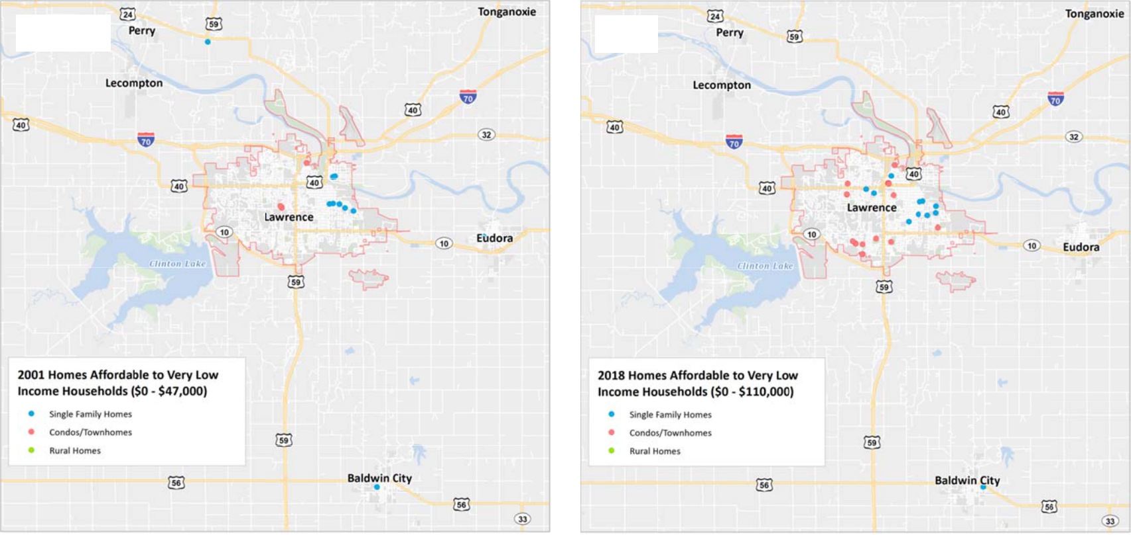

2001 201 

S ource: Lawrence Multip e Listing Service, Lawrenc e Board of Realtors.

BBC RESEARCH & CO NSULTING SECT ION II, PAGE 16

Figure II‐18.

Homes Affordabl e to Low Income Households, City of Lawrence and Surrounding Are , 2001 and 2018
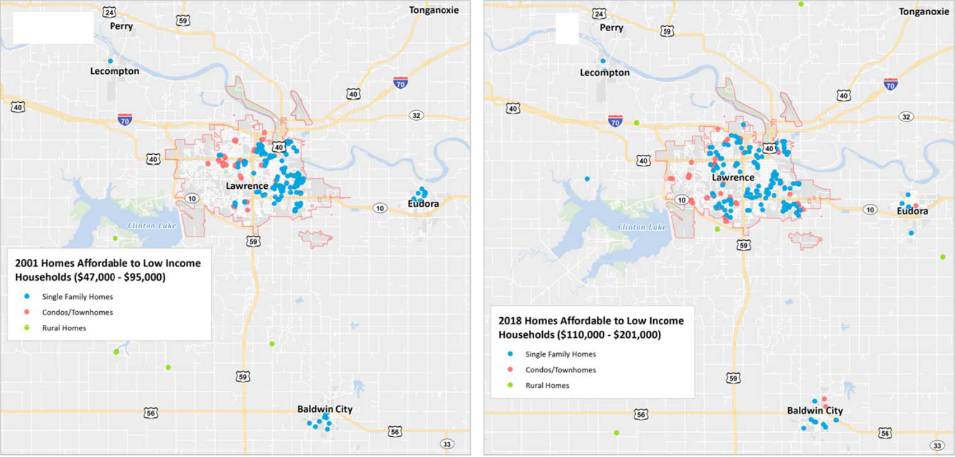

2001 2018

S ource: Lawrence Multip e Listing Service, Lawrenc e Board of Realtors.

BBC RESEARCH & CO NSULTING SECT ION II, PAGE 17

Figure II‐19.

Homes Affordabl e to Median Inco me Households, C ity of Lawrence a nd Surrounding Area, 2001 and 2018
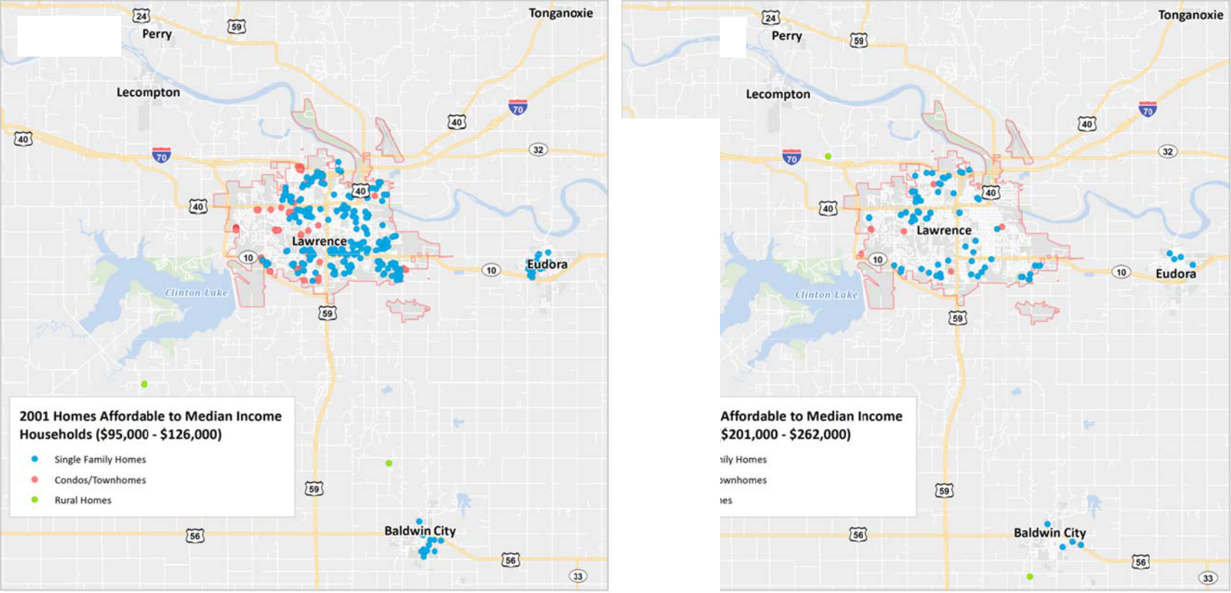

2001 2018
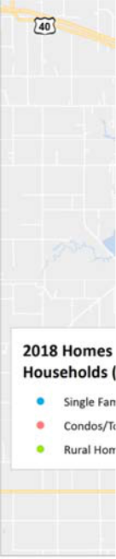

S ource: Lawrence Multip e Listing Service, Lawrenc e Board of Realtors.

BBC RESEARCH & CO NSULTING SECT ION II, PAGE 18

Figure II‐20.

Homes Affordabl e to Moderate In ome Households, City of Lawrence and Surrounding Area, 2001 and 2018
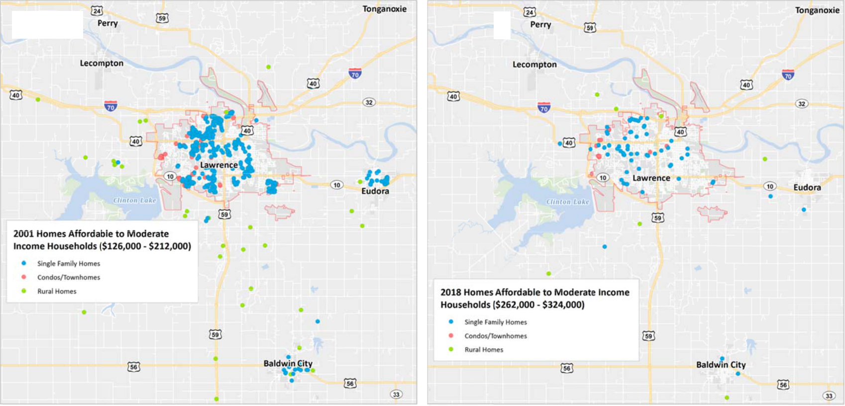

2001 2018

S ource: Lawrence Multip e Listing Service, Lawrenc e Board of Realtors.

BBC RESEARCH & CO NSULTING SECT ION II, PAGE 19

Figure II‐21.

Homes Affordabl e to High Income Households, City of Lawrence and Surrounding Area, 2001 and 2018
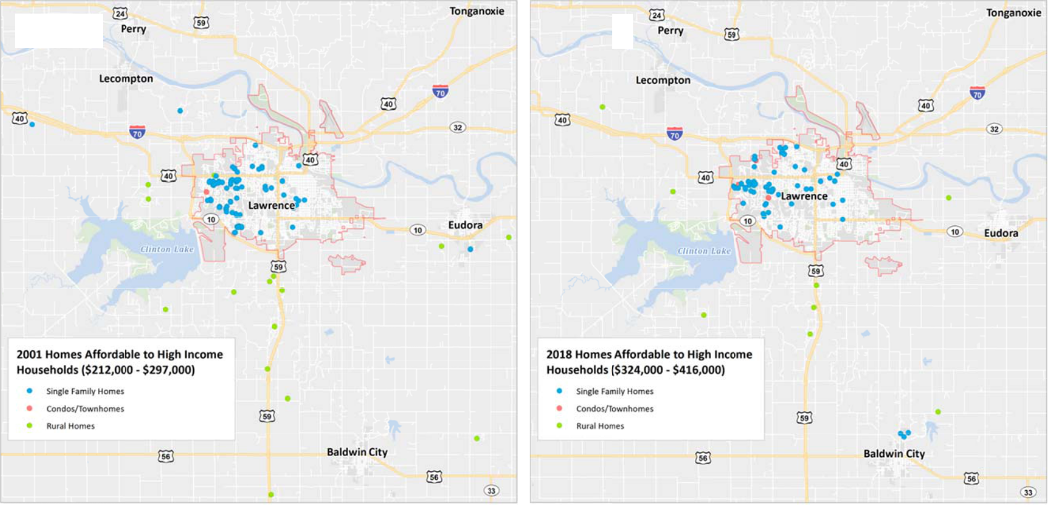

2001 2018

S ource: Lawrence Multip e Listing Service, Lawrenc e Board of Realtors.

BBC RESEARCH & CO NSULTING SECT ION II, PAGE 20

Figure II‐22.

Homes Affordabl e to Highest Inco me Households, City of Lawrence a nd Surrounding Area, 2001 and 20 18
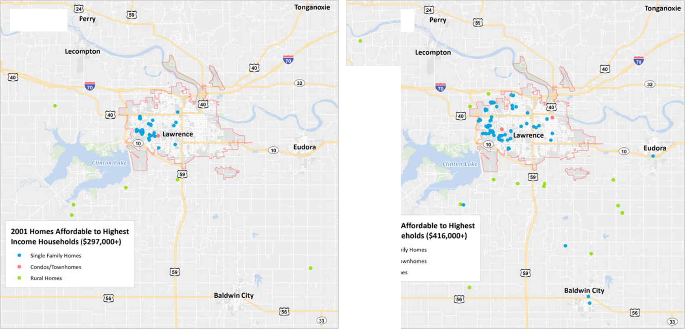

2001 2018
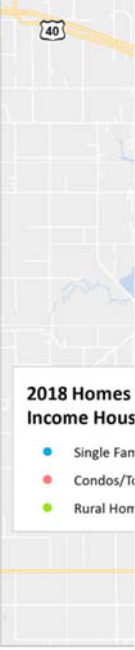

S ource: Lawrence Multip e Listing Service, Lawrenc e Board of Realtors.

BBC RESEARCH & CO NSULTING SECT ION II, PAGE 21

A changing market. A growing challenge for renters looking to buy is the presence of cash buyers and investors. Cash buyers may be households moving from higher priced markets who have equity to reinvest; investors who find Lawrence’s market to be attractive and relatively affordable; and parents who are purchasing homes for their children to rent.

Cash purchases have increased from 5 percent of all sales in the market in 2001 to 16 percent in 2018. This is much lower than the percentage of cash purchases nationally, which ranges between 20 and 30 percent.

As shown in the table below, most cash purchases were for single family homes (117 sales). And most were for very affordable homes, priced at $200,000 and less. The highest proportion of cash sales occur in the very most affordable range, homes priced less than $110,000.

A continued increase in the proportion of cash purchases is of concern, as they could lead to a reduction in supply of affordable and starter homes, assuming most cash sales will be converted to rental properties.

Figure II‐23.
Figure II‐23. | Homes for sale | Cash | Total Sold | % Sold for Cash
Cash Purchases, 2018
Source: | Price Range
Source: | Less than $110,000 | 6 | 16 | 38%
Lawrence Multiple Listing Service, Lawrence
Lawrence Multiple Listing Service, Lawrence | $110,000 ‐ $201,000 | 12 | 71 | 17%
Board of Realtors.
 | $201,000 ‐ $262,000 | 2 | 20 | 10%
 | $262,000 ‐ $324,000 | 0 | 19 | 0%
 | $324,000+ | 5 | 26 | 35%
 | Type
 | Condo | 2 | 7 | 29%
 | Single Family | 19 | 117 | 16%
 | Townhome | 4 | 24 | 17%
 | Rural | 0 | 4 | 0%
 | All Homes | 25 | 152 | 16%

The table below reports other indicators of a challenging market. Homes are staying on the market for less time, and this shift occurred very quickly, in 2017 and 2018. Homes are not yet being bid over asking price; however, that is likely to occur if price increases continue and supply diminishes.

Figure II‐24.
Figure II‐24. |  | 2001 | 2016 | 2018
Market Demand |  | 2001 | 2016 | 2018
Indicators | Sold homes, median amount over asking price | $0 | ($1,000) | $0
Source: | Sold homes, median % over asking price | 0% | ‐1% | 0%
Source: | No. sold for cash only | 56 | 181 | 25
Lawrence Multiple Listing
Service. | % sold for cash only | 5% | 17% | 16%
 | Median days on the market | 23 | 22 | 8
 | Range (low‐high) days on the market | 0‐309 | 0‐538 | 0‐110

BBC RESEARCH & CONSULTING SECTION II, PAGE 22

Ownership gaps and future needs. This gap between interest in buying and available product is demonstrated by the owners gaps analysis shown below. It is important to note that the gaps accounts only for units that fall within the affordability range of the MFI. The “cumulative gap”—which is a better measure of need—allows buyers to purchase homes that are priced at less than their affordability range.

The owners gaps models should be interpreted as:

- There are 211 extremely low income renters who would like to buy a home and have no inventory to purchase.

- Another 512 very low income renters would also like to buy. These renters have only 34 homes from which to choose. Both these and the 211 extremely low income renters are unlikely to become owners except through sweat equity or land trust programs that target very low income households.

- 890 renters earn between $35,600 and $57,000 and would also like to own homes. Another 334 earn between $57,000 and $71,250 would like to buy. Together, these approximately 1,225 renters comprise the target market for ownership that could be achievable with adequate product and some level of subsidy (downpayment assistance, interest rate subsidy, silent second mortgage. “Silent seconds” are often used to support the downpayment for low income households, are provided by housing nonprofits or agencies, and are forgiven if a household occupies the home for a certain portion of time).

- The biggest challenge in achieving ownership for this target group is lack of supply. As the cumulative gap indicates, there is a shortage of affordable homes for these renters: just 293 homes were affordable.

- In sum, if every renter who wanted to buy was qualified to buy, the Lawrence market would need to add 1,681 homes for sale to accommodate demand.

- To accommodate just 10 percent of renters who want to be owners, the market would need to add 168 homes; 20 percent of demand would require more than 300 new units. (These numbers assume that existing inventory satisfies the demand for some of the renters who want to buy). The movement from renter‐ to ownership would also benefit the rental market, which also has unmet demand, as discussed below.

- Demand for ownership products is from smaller households, who likely desire lower maintenance homes with a community aspect, and, for older adults, accessibility features (small lot, patio homes).

- Overall, there is one home for sale for every four renters who want to buy. By income range, there is:

  - One home for every 100 renters who want to buy and earn less than $35,000;

  - One home for every 8 renters who want to buy and earn less than $57,000; and

  - One home for every 6 renters who want to buy and earn less than $71,250.

.

BBC RESEARCH & CONSULTING SECTION II, PAGE 23

Figure II‐25.

Gaps in Units for Purchase, 2018

 |  |  |  |  |  |  |  |  |  |  |  | Affordable Homes on Market, 2018
 |  |  |  |  |  |  | Proportion |  |  |  | Single Family
 |  |  | Maximum |  | Renter |  | Who Want | Potential |  |  | Detached |  |  |  |  |  |  |  |  | Total |  |  | Cumulative
Renters by MFI Level |  | Income Range | Home Price | Households |  |  | to Buy* |  | Buyers |  | Homes |  |  | Condos |  |  | Townhomes |  |  | Units |  | Gap | Gap
Extremely low income |  | $0‐$21,400 | $48,752 | 6,442 |  |  | 3% | 211 |  |  | 0 |  |  | 0 |  |  | 0 |  |  | 0 |  | (211)
Very low income |  | $21,401‐$35,600 | $109,479 | 4,982 |  |  | 10% | 512 |  |  | 10 |  |  | 14 |  |  | 10 |  |  | 34 |  | (478) | (689)
Low income |  | $35,600‐$57,000 | $200,996 | 3,811 |  |  | 23% | 890 |  |  | 130 |  |  | 0 |  |  | 53 |  |  | 183 |  | (707) | (1,396)
Median income |  | $57,000‐$71,250 | $262,203 | 1789 |  |  | 19% | 334 |  |  | 68 |  |  | 1 |  |  | 7 |  |  | 76 |  | (258) | (1,654)
Moderate income |  | $71,250‐$85,500 | $323,411 | 1,077 |  |  | 13% | 141 |  |  | 58 |  |  | 0 |  |  | 14 |  |  | 72 |  | (69) | (1,723)
High income |  | $85,500+ | $415,222 |  | 1,891 |  | 6% |  | 106 |  |  | 140 |  |  | 5 |  |  | 13 |  | 148 |  | 42 | (1,681)
 |  |  |  | 19,991 |  |  |  | 2,194 |  |  | 406 |  |  | 20 |  |  | 87 |  |  | 513
Note: | *Based on survey data. The gaps model does not include rural for sale properties, as the inventory of affordable units was very small, and these properties add commute costs for low and moderate income owners.
Source: | BBC Research & Consulting.

BBC RESEARCH & CONSULTING SECTION II, PAGE 24

Ho w is the own ership market likely to shift? By 2028, if home pric es continue t o rise at the sam e rate as they did between 2001 and 2 018, median home prices will be as shown below.

Fig re II‐26.
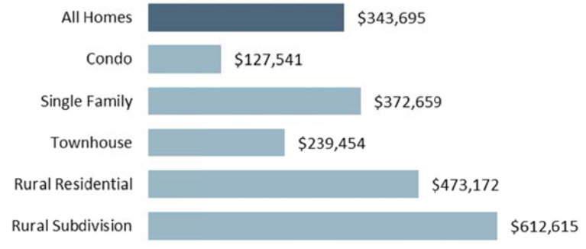
Median Home Prices, 2028

Note:

Base on price increases between 2001 and 2018.

Source:

BBC R esearch & Consultin g.

This increase will reduce the proportion of homes affo rdable to 80 percent MFI households t o 29 percent, from 41 percent now . By 2028, n early half of a ffordable units would be attached, as shown below.

Fig re II‐27.
Changes in

Aff ordability at 8 0% MF

Source:

BBC R esearch & Consultin g.

 |  | 2018 | 2028
80 % MFI Income Th reshold |  | $57,000 | $70,567
Affordable Home P ice |  | $201,000 | $249,000
Numer Homes Affordable (based on 2018 inventory) |  | 219 | 160
Pe rcent Homes Affo rdable |  | 41% | 30%
Pe rcent of Affordab le that are Attached |  | 35% | 48%


Rental Market Trends

The Census repo rted Lawrence’s median r ent at $850 per month in 2016, which is very simil ar to the median rent reported by survey respondents. Co mpared to o ther commun ities, Law rence’s median rent was relatively hig h, but lower than Manhattan’s.

Fig re II‐28.
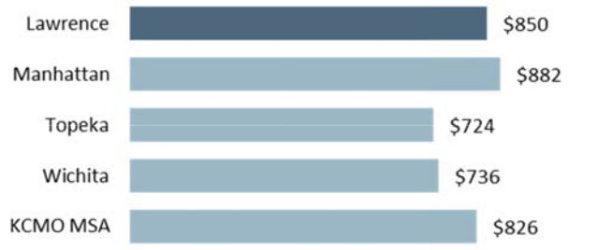
Median Rent, 2016

Source:

2016 5‐year ACS.

Sin ce 2000, rents have increa sed by $300 per month, or by $3,600 p er year. This compares with an increase in median incom e of a renter f $8,000. Ne arly half of th e increase in renter median inc ome is now going toward rent.

Residents responding to the rent. Overall, the median ren paying the least at $660 per

surveys available for this study were a sked to repor t their mont hly was $840 p er month. Re nts by sub‐group differen ce, with senio rs month. Stude nts reported paying the m ost, at $825 per month.

BBC RESEARCH & CONSULTING SECTION II, PA E 25

An analysis of re ntal units posted on Craig slist betwee n January and May 2018 f ound many fo r sin gle family roo ms for rent. The average price of a sin gle room rental was $378 per room. Th e average rent for apartments and houses w as $852, consistent with the rents reported by both survey responde nts and the ensus.

Fig re II‐29.
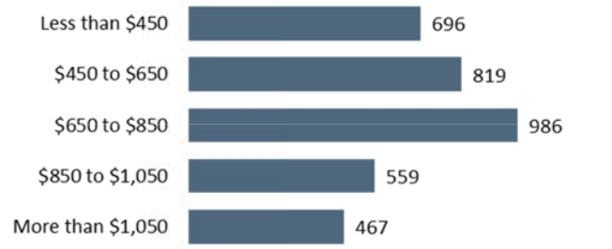
Dis ribution of Rent Prices in

Craigslist Listings Between Jan uary and May 2018

Source:

Craig slist.

Gaps in the rental marke t. Figure II‐3 0 compares the number of renter households in Law rence in 201 6, their inco me levels, the maximum m onthly rent they could afford without bei ng cost burde ned, and the number of units in the m arket that were affordable to them. Th e “Rental Gap” column shows the difference between the number of renter househ olds and the nu mber of affor dable rental u nits. Negative numbers (in parenthese s) indicate a shortage of units at the specific income le vel; positive units indicate an excess of units.

BBC RESEARCH & CONSULTING SECTION II, PA E 26

Figure II‐30.

Gaps in Rental Market, City of Lawrence, 2016

 | Maximum Rent |  |  |  |  |  |  | 2000 |  |  |  |  |  |  |  |  | 2016 |  |  |  |  | 2000‐2016 Change
 |  |  | Renter Households |  |  |  |  | Rental Units |  |  |  | Renter Households |  |  |  |  | Rental Units
 | Renter | + Utilities per |  |  |  |  |  |  |  |  |  |  |  |  |  |  |  |  |  |  |  | Renter |  | Rental
 | Incomes | Month |  | Number | Percent |  |  | Number | Percent |  | Gap |  | Number | Percent |  |  | Number | Percent |  | Gap | Households |  |  | Units |  | Gap
 | Less than $5,000 | $125 | 1,757 |  | 10% |  |  | 351 | 0% |  | (1,407) | 1,321 |  | 7% |  |  | ‐ | 0% |  | (1,321) | (436) |  |  | (351) |  | 86
 | $5,000‐$9,999 | $250 | 2,021 |  | 12% |  |  | 1,188 | 7% |  | (834) | 1,155 |  | 6% |  |  | 359 | 2% |  | (796) | (866) |  |  | (829) |  | 38
 | $10,000‐$14,999 | $375 | 2,012 |  | 12% |  |  | 3,035 | 18% |  | 1,023 | 2,022 |  | 10% |  |  | 97 | 0% |  | (1,926) | 10 |  |  | (2,938) |  | (2,948)
 | $15,000‐$19,999 | $500 | 1,869 |  | 11% |  |  | 5,122 | 31% |  | 3,253 | 1,944 |  | 10% |  |  | 715 | 4% |  | (1,230) | 75 |  |  | (4,407) |  | (4,482)
 | $20,000‐$24,999 | $625 | 1,853 |  | 11% |  |  | 3,038 | 18% |  | 1,185 | 1,307 |  | 7% |  |  | 1,995 | 10% |  | 688 | (546) |  |  | (1,044) |  | (498)
 | $25,000‐$34,999 | $875 | 2,762 |  | 16% |  |  | 2,910 | 17% |  | 148 | 3,675 |  | 18% |  |  | 6,809 | 35% |  | 3,134 | 913 |  |  | 3,900 |  | 2,987
 | $35,000‐$49,999 | $1,250 | 2,482 |  | 15% |  |  | 847 | 5% |  | (1,636) | 2,932 |  | 15% |  |  | 5,881 | 30% |  | 2,949 | 450 |  |  | 5,034 |  | 4,584
 | $50,000‐$74,999 | $1,875 | 1,591 |  | 9% |  |  | 97 | 1% |  | (1,494) | 3,138 |  | 16% |  |  | 2,552 | 13% |  | (586) | 1,547 |  |  | 2,455 |  | 908
 | $75,000‐$99,999 | $2,500 | 454 |  | 3% |  |  | 13 | 0% |  | (441) | 1,443 |  | 7% |  |  | 692 | 4% |  | (751) | 989 |  |  | 679 |  | (310)
$100,000+ |  | $2,500+ |  | 222 |  | 1% |  | 42 |  | 0% | (180) |  | 1,054 |  | 5% |  | 609 |  | 3% | (445) |  | 832 |  | 567 |  | (265)
 |  |  | 17,023 |  | 100% |  |  | 16,640 | 100% |  |  | 19,991 |  | 100% |  |  | 19,707 | 100% |  |  | 2,968 |  |  | 3,067

Source: 2015 5‐year ACS and BBC Research & Consulting.

The gaps analysis in Figure II‐30 shows that:

- Twenty‐three percent of renters (about 4,500 households) living in Lawrence earn less than $15,000 per year. These renters need units that cost less than $375 per month to avoid being cost burdened. Just 2 percent of rental units (456 units) in the city rent for less than $375/month (including subsidized rental units). This leaves a “gap,” or shortage, of 4,000 units for these extremely low income households.

- About 1,900 renters earn between $15,000 and $20,000 per year. There are 700 rental units priced at their affordability range (between $375 and $500/month), leaving a shortage of about 1,200 units.

- Altogether, the city has a shortage of 5,272 rental units priced affordably for renters earning less than $20,000 per year. 1

- The “shortage” shown in the gaps model for high income renters (earning more than $50,000 per year) suggests those renters are spending less than 30 percent of their income on housing—perhaps in order to save for a down payment on a home purchase

BBC RESEARCH & CONSULTING SECTION II, PAGE 27

The private rental market in Lawrence largely serves renters earning between $25,000 and $50,000 per year—65 percent of rental units are priced within that group’s affordability range, with rents between $625 and $1,250 per month.

Publicly subsidized housing provides the majority of the units affordable to households earning less than $20,000/year. Without subsidized housing, the rental gap would be 6,600 units (v. 5,272 currently).

Student effect. In fall 2017, the University of Kansas enrolled nearly 25,000 students at the Lawrence campus.2 Of these, the vast majority—20,000 students—live off campus—according to the university’s Housing Patterns of Students report. The number of students living off campus has consistently been in the 20,000 to 21,000 range during the past 10 years.

Students, therefore, make up a significant proportion of the renters in Lawrence. And 40 percent of the students surveyed reported incomes of less than $20,000 per year, meaning that many are represented in the rental gaps analysis.

Applying this proportion of low income students to the gaps, assuming a household size of 2.12 students per unit (based on the student survey), and removing the students who receive parental assistance for housing, an estimated 2,500 of the 5,272 renters in the gaps with needs are students. Conversely, about 2,800 of the renters with needs represented by the gaps are not students.

Students affect the rental market in many ways, other than creating demand. They also influence unit pricing in unique ways:

- Students more commonly have additional (parent or guardian) support to pay rent. Indeed, according to the survey conducted for this study, 44 percent of students receive help from their parents for rent.

- Students may be perceived as higher‐risk renters, which the private sector factors into rental pricing. Students do pay more in rent than non‐students, according to the survey.

- Students are frequent movers, which allow property owners to more frequently raise rental prices in response to the wear and tear and transactional costs of tenant moves. The survey found that 67 percent of students moved in the past year.

The 2,800 non‐student households with affordability needs that are reflected in the rental gaps are largely:

- Residents who need publicly subsidized housing and earn about $15,000/year on average. These residents can afford to pay $500 per month in rent and utilities—rents which the private sector cannot provide.

- Female heads of household (70%); seniors (38%); residents with disabilities (30%); and single mothers (25%).

- This number includes the Edwards Campus in Johnson County, which has approximately 1,800 students.

BBC RESEARCH & CONSULTING SECTION II, PAGE 28
Ch ange in the rental gaps . A comparison of the rental gaps in 2 000 shows a significant shift in the past 16 years. This shift is mostly d e to a loss of affordable rentals. In 200 0, one‐quarter of rentals were riced to acco mmodate ho useholds ear ning $15,00 0 per year. By 2016, this w as just 2 percent. The number of lower incom e renters als o declined d uring this pe riod; however, most of the incr ease in the gap is due to a decline in affordable rent als.

Fig re II‐31.

Why Did the Gap s Increase?
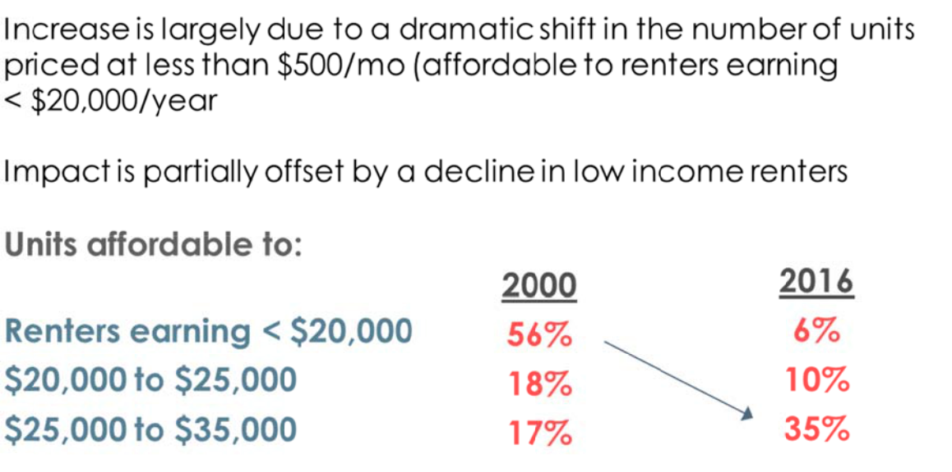

Source: BBC Researc h & Consulting.

Wa it lists. During the past s everal years, members of the Justice Matters Affordable Housing and Homelessne ss Working roup have c ollected data on househol ds on wait lists for housing fro m affordable housing prov iders.

The latest estim ate from the group is 738 unduplicated households on wait lists for affordable hou sing, includi ng Housing Choice, or Sect ion 8, Vouchers. This is a significant increase from the 624 households on wait lists in 2015. The vast majorit y of households are waitin g for affordable rentals or rental assistance ( 679 of the 738, 92%); the balance are waiting for ho meownership programs.

Ho useholds on the wait lists are a mix of l ow income fa milies, with about 100 se niors and 50 peo ple experiencing homelessness.

The se wait lists translate into :

- A two year wait list for a ffordable re tals for seni ors; and

- A 6‐8 month wait list for accessible units in public ly‐provided housing.

BBC RESEARCH & CONSULTING SECTION II, PA E 29

How is the rental market likely to shift? Based on the survey of property owners conducted for this study and expected growth in renter households we anticipate that:

- Rental increases in 2018 should average 3.5%

- The erosion of units in the $500‐$625 range—and the movement of these units in to higher priced rental categories—will continue. The 2000‐2016 “loss rate” of affordable units averaged 5 percent of units per year.

- In the next few years, new rental units are expected to be priced between $875 and $1,250.

- Given these changes, the City of Lawrence needs approximately 112 rental units priced at less than $500 per month to accommodate growth in low income renters by 2020. Assuming there is little growth in the student population, these would all be non‐students. If the city would like to reduce the rental gap by 15 percent, 1,200 affordable rentals would be needed.

Zoning and Land Use Analysis

The private sector plays a critical role in meeting housing needs. The private sector creates and maintains a significant portion of the housing stock, an estimated 90 percent of the rental units and nearly all for‐sale homes. Cities typically use land use planning, zoning and development incentives to encourage private sector development of housing that supports community needs and values.

A number of studies, including a 2006 book by Jonathan Levine (Zoned Out), have documented the impact of zoning regulations on the supply of affordable housing.3, 4 Common zoning regulations negatively impacting affordable development include:

- Minimum house size, lot size, or yard size requirements;

- Prohibitions on accessory dwelling units;

- Restrictions on land zoned and available for multifamily and manufactured housing; and

- Excessive subdivision improvement standards.

Lawrence’s development code was reviewed to determine if any of these could be creating barriers to affordable housing development.

Considerations. Based on the strengths and challenges of the housing market in Lawrence, this study recommends the following considerations for the city’s land use planning. Many of these increase the value embedded in Lawrence’s relatively large lots and address inefficient land uses. For example, larger lots can be used to increase affordability through additions, Accessory

- Levine, Jonathan, Zoned Out (RFF Press, Washington, D.C., 2006).

- Colorado Deportment of Local Affairs, Reducing Housing Costs through Regulatory Reform (Denver: Colorado Department of Local Affairs, 1998).

BBC RESEARCH & CONSULTING SECTION II, PAGE 30

Dwelling Units (ADUs) to rent and offset mortgage costs, and splits to add additional, stand‐ alone affordable homes.

- Expand where duplexes and attached dwellings (townhomes, rowhomes) are allowed by right. Duplexes and attached homes are a natural product to address the need for more affordable ownership housing, which is needed to accommodate Lawrence’s workforce. The market for these products is growing with increased preferences for low maintenance living. Duplexes and attached dwellings could be incorporated in an aesthetically pleasing manner into nearly all residential districts (the exception would be RS40 and RS20) and also placed in underutilized areas in commercial and light industrial corridors.

- Define “public benefit” in PUDs to specifically include affordable housing, defined according to the needs in this study. This would effectively create a density bonus for affordable housing.

- Consider allowing Accessory Dwelling Units (ADUs) in RS5. ADUs can be placed above garages on small lots.

- Relax the restriction that requires a single lot for every detached or attached unit. Allowing multiple homes on single lots addresses emerging trends in residential living and can facilitate certain forms of cooperative living. The city’s current restrictions on mobile home parks and placement may discourage similar, intentionally affordable, cooperative uses.

- Ensure that limits on unrelated resident occupancy do not create barriers to people living together in cooperative environments, including residents who do not gender identify. Unrelated occupant limits are quite common in university towns where overcrowded student housing can disrupt neighborhoods. Waivers could be granted for special occupancy purposes.

It should be noted that Lawrence is close to build out and does not have a great deal of vacant land for development. As such, it is important that the city add flexibility in existing land uses and unit occupancy to accommodate housing needs, as these cannot be fully addressed by adding housing supply in greenfields.

BBC RESEARCH & CONSULTING SECTION II, PAGE 31

SECTION III.

Community Input

SECTION III.

Community Input

This section describes the findings from the public participation component of the housing study. The public input process was designed to assess community culture and community perceptions of housing issues through surveys and stakeholder focus groups.

Community Participation Opportunities

The city of Lawrence housing study surveys and focus groups provided opportunities for community participation and collected data about the housing market and resident housing preferences. Surveys (n=number of participants) included:

- Resident survey (n=472 phone and n=1,978 online);

- Employer survey (n=57); and

- Rental property owner/manager survey (n=392).

In addition to the surveys, stakeholders participated in focus groups; participants included AHAB members, local housing providers, social and human service providers. Populations served by focus group participants include very low or extremely low income residents, residents with disabilities, persons experiencing homelessness, domestic violence survivors, youth aging out of foster care and other vulnerable populations. Members of the public provided comments about the study during public comment periods at AHAB and City Council meetings, and others contacted the consulting team directly by phone or email.

Resident survey. The resident survey consisted of two separate sampling methodologies and data collection methods. The intention was to field a survey that would represent the experiences and preferences of Lawrence residents (telephone survey) and to allow all interested residents to participate in the process (online survey). City of Lawrence staff and members of the AHAB reviewed the draft survey instrument. The survey gathered information about residents’ housing choices and experiences, future housing choice, opinions about Lawrence’s housing spectrum, and demographic and socioeconomic characteristics.

Sampling note. The telephone survey is a statistically valid random sample of Lawrence residents; sampling included both landline and mobile phone numbers and was available in English and Spanish. Results from the telephone survey are weighted by respondent age and housing tenure (i.e., homeowner/renter). Proportions from the resident survey are statistically valid and replicable at the 95 percent confidence level with a margin of error of +/‐ 5 percentage points. The telephone survey is representative of the experiences and preferences of Lawrence residents.

BBC RESEARCH & CONSULTING SECTION III, PAGE 1

Responses to th e online surv ey derived fr om convenie nce sampling and snowball sampling

me thods. Conve nience sampling refers to promoting th e survey to k nown indivi duals or

organizations through direct contact (e.g., email invitat ion) or public relations a nd social med ia.

Sno wball sampling is when a respondent o the survey promotes the survey to t heir peers or

social networks (e.g., sharing the survey link by email o r social media). Due to t e nature of the

sam pling methodology, the online survey responses are used to examine the preferences and

experiences of segments of th e Lawrence population r ather than th e population overall. Students

are over‐repres nted in the o nline survey and under‐r epresented i n the unweig hted telepho ne

survey. The same is true for renters. Despite difference s in samplin g methods and respondent

com position, res ponses to th e online survey are very s imilar to the weighted tel ephone surve y

res ults.

Fig ure III‐1 presents selected characteristics of the un weighted telephone and o nline survey res pondents.

Fig re III‐I.

Survey Respond nt Characteristics
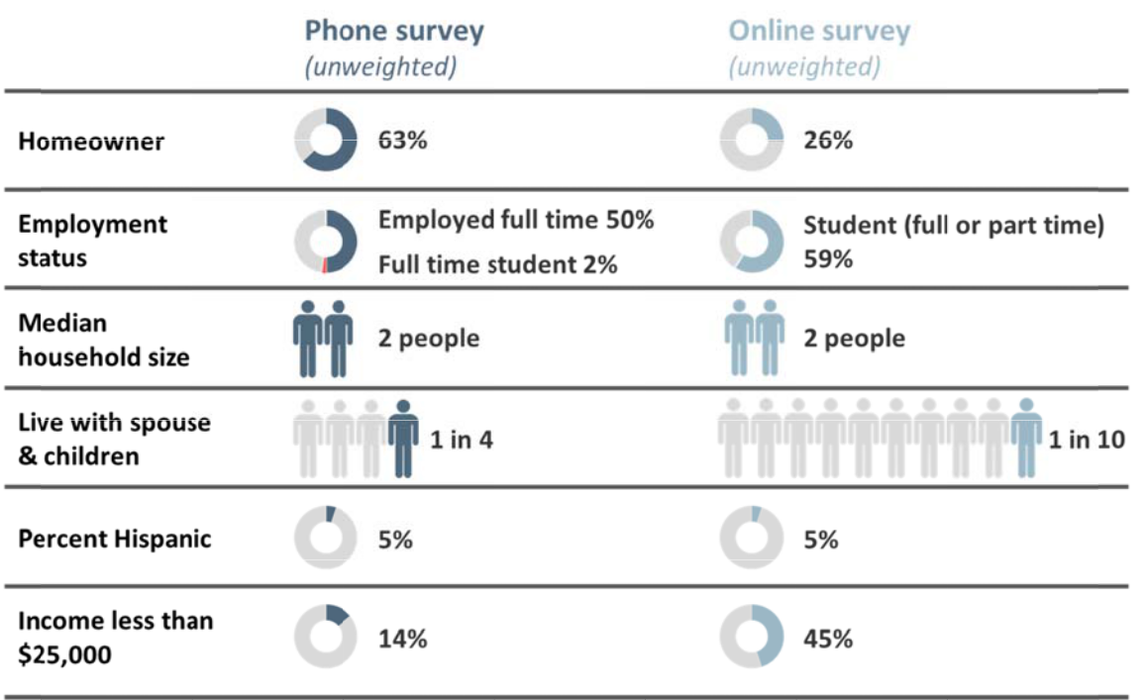

Note: For the analyses , phone survey data are weighted to adjust for city’s homeo wner/renter proport ion and by age. For the phone survey, n = n=472 and n=1, 978 for the online survey.

Source: BBC Research & Consulting from the 2018 Lawrence Market Study Resident Telephone Survey a nd Resident Online Survey.

Current Housing Choice

Determining where to live within a community is a com plex function of personal and househ old preferences, inc ome, cost of h ousing, credit history, ma rket availability of desired housing ty pes acr oss neighborhoods, and m ore.

BBC RESEARCH & CONSULTING SECTION III, PA GE 2

Mo st important factor in choosing c urrent home. When asked to identify the factors most important in choosing their current home, the ma jority of Law rence residents named “co st/I could afford it” as an important fac tor. Proximit y to college/university w as a top factor am ong many res ident groups, as was the type of neigh borhood and number of b edrooms. Figure III‐ 2 presents the most impor tant factors i n choosing t heir current home for all L awrence

res dents as well as key segm ents of the city populatio n including, h omeowners and renters, stu dents, seniors, families with children a nd others.

- Homeowners and families with children were more likely than other groups to rate “being close to qu ality public sc hools/distri ct” as one of the most important factors in their housing ch oice.

- Non‐studen t renters value pet friendly rental policies;

- Among residents with disabilities, fe w identified a home’s acce ssibility feat ures as one of their most mportant fac tors in housing choice. M ost identified cost, proxim ity to the university, and size of u nit/number o f bedrooms as their top t hree factors.

- In addition to cost and proximity to the university , African Am erican residents prioritize d housing tha t is close to work or job opportunities.

- Access to public transportation was a mong the th ree most imp ortant factors to Hispanic residents.

Fig re III‐2.

Top 3 Most Impo rtant Factors in Choosing Current Hom e
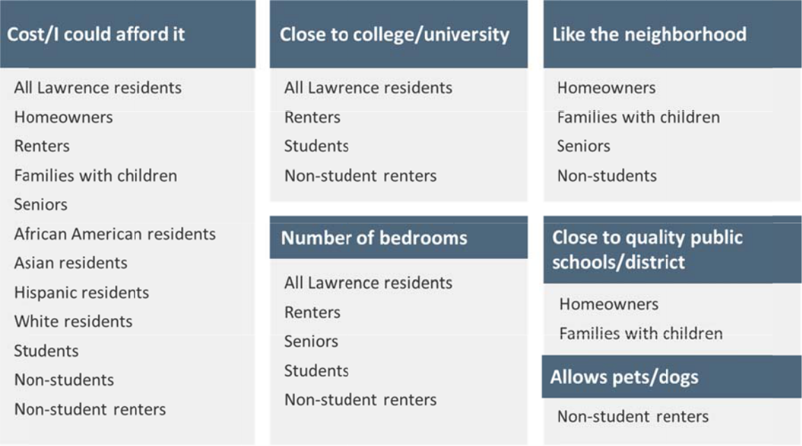

Note: “All Lawrence re sidents”, “renters” and “homeowners” r esults are derived fr om the weighted telephone survey and are representative o f the city overall; all other results are from the online survey, which yielded sufficiently large enough samples (n>40) f or crosstabulation b y demographic an d socioeconomic characteristics.

Source: BBC Research & Consulting from the 2018 Lawrence Market Study Resident Telephone Survey a nd Resident Online Survey.

BBC RESEARCH & CONSULTING SECTION III, PA GE 3

Hou sing condition. Overall, one in four Lawrence residents rate t heir housing to be in fair or poor condition. Homeowners are less likely than rente rs to think th eir housing is in fair or poor condition. As sh own in Figur e III‐3, two in five renter f amilies with five or more members (la rge fam ilies) consid er their hous ng to be in fa ir or poor condition; a sig nificantly hig her rate tha n renters overall.

Fig re III‐3.
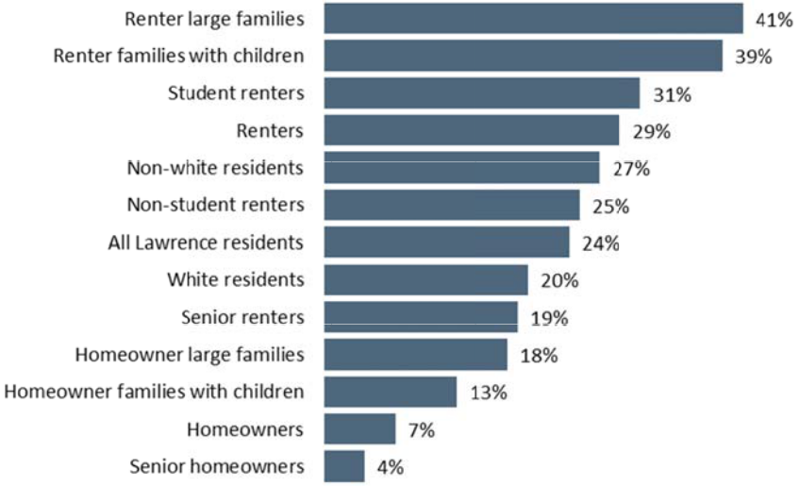
Percent Rating T heir
Ho me in Fair or oor

Con dition

Source:

BBC R esearch & Consultin g from the 2018 Lawrence Mark t Study Resident Telephone Surve y and Resident Online Survey.

Fig ure III‐4 presents respond ents’ assess ment of their home’s condition by selected househo ld characteristics. As shown, mo st of the diff erences in condition are between hom eowners and renters. Overall, the greatest proportion of homeowne rs across gro ups rate thei r home to be in good condition; only among s eniors do a majority consider their home in excellent condition. Sim ilar to home owners, the g reatest proportion of ren ters across g roups rate their homes to be in good condition.

Abo ut the same share of white residents, African American resident s, and Hispa nic residents ass ess their hom e’s condition as fair or poor; a smaller proportion than Asian re sidents. Higher inc ome households are more likely than l wer income households t o consider th eir home in excellent conditi on and are m uch less likely to rate their home’s con dition as fair .

BBC RESEARCH & CONSULTING SECTION III, PA GE 4

Figure III‐4.

Housing Condition by Selected Household Characteristics

Note:

Income refers to household income. Disability figures refer to households that include a member with a disability.

Source:

BBC Research & Consulting from the 2018 Lawrence Market Study Resident Telephone Survey and Resident Online Survey.

 |  | Housing Condition
 | Excellent | Good | Poor | Fair
All Lawrence residents | 31% | 45% | 22% | 2%
Homeowners | 44% | 50% | 6% | 1%
Renters | 20% | 51% | 24% | 5%
Senior homeowners | 51% | 45% | 4% | 0%
Senior renters | 33% | 48% | 19% | 0%
Student renters | 20% | 50% | 26% | 5%
Non‐student renters | 21% | 53% | 21% | 4%
Homeowner families with children | 34% | 53% | 11% | 2%
Renter families with children | 15% | 46% | 32% | 7%
Homeowner large family | 32% | 50% | 14% | 4%
Renter large family | 17% | 42% | 38% | 3%
Homeowners with a disability | 22% | 69% | 7% | 1%
Renters with a disability | 18% | 54% | 21% | 7%
African American residents | 20% | 60% | 18% | 3%
Asian residents | 14% | 48% | 32% | 6%
Hispanic residents | 23% | 51% | 19% | 7%
White residents | 30% | 50% | 18% | 2%
Income less than $25,000 | 21% | 51% | 23% | 5%
Income $25,000 up to $50,000 | 22% | 53% | 23% | 2%
Income $50,000 up to $75,000 | 30% | 58% | 10% | 1%
Income $75,000 up to $100,000 | 37% | 47% | 14% | 2%
Income $100,000 or more | 48% | 45% | 6% | 1%

Figure III‐5 considers housing condition by tenure and the type of housing unit. Renters living in detached single family homes are less likely than renters in other product types to rate their home in excellent condition and are more likely to assess the home’s condition as poor. Owners of attached single family homes (e.g., townhomes, duplexes) are most likely to rate their home’s condition as excellent.

Figure III‐5.

Housing Condition by Tenure and Type of Unit

Note:

*Too few owners of condo units in multifamily buildings responded to report condition data.

Source:

BBC Research & Consulting from the 2018 Lawrence Market Study Resident Telephone Survey and Resident Online Survey.

 |  | Housing Condition
 | Excellent | Good | Poor | Fair
All Lawrence residents | 31% | 45% | 22% | 2%
Homeowners | 44% | 50% | 6% | 1%
Renters | 20% | 51% | 24% | 5%
Detached single family home | 36% | 49% | 13% | 2%
Owner detached single family home | 43% | 51% | 5% | 1%
Renter detached single family home | 15% | 49% | 31% | 5%
Attached single family home | 29% | 48% | 20% | 3%
Owner attached single family home | 47% | 45% | 9% | 0%
Renter attached single family home | 24% | 48% | 23% | 5%
Renter in multifamily building* | 21% | 54% | 21% | 4%
On‐campus dorms/student housing | 23% | 50% | 23% | 4%

BBC RESEARCH & CONSULTING SECTION III, PAGE 5

Repair needs. Overall, 41 percent of Lawrence residents with homes in fair or poor condition need repairs to improve their home’s condition. When asked to identify the most important repair needed for their home, the greatest proportion of respondents identified:

- Weatherization (26%);

- Roof (8%);

- Heating/cooling (8%); and

- Bathroom plumbing (8%).

None of the respondents with repair needs explicitly shared concerns about indoor air quality or health impacts they may experience due to fair/poor housing conditions; however, the significant need for weatherization, roofing, and HVAC repairs may indicate some households experience health impacts due to housing conditions.

When asked why these important repairs have not yet been made:

- Three in four homeowners (75%) haven’t made needed repairs because they cannot afford them; and

- Nearly three in five renters (57%) have landlords who refuse or have yet to make needed repairs despite requests.

Overall, 16 percent of renters who participated in the survey live in single family homes. Nearly three in 10 renters (28%) who said their landlord refused or had yet to make needed repairs despite requests live in single family homes, almost twice the expected proportion. Similarly, renters living in multifamily buildings comprise 54 percent of all renters participating in the survey but only 41 percent of those who have a landlord that needs to make a repair. Renters who have unmet repair needs are also more likely to have household incomes of $35,000 to $50,000 compared to other renters (17% v. 11%), to have children under 18 in the home (15% v. 8%), and to have five or more members in the household (18% v. 7%).

Accessible housing. One in four Lawrence residents with disabilities (24%) live in housing that does not meet their accessibility needs. Among the residents whose homes need accessibility modifications, two in three need a ramp, half need grab bars in bathrooms, and half need wider doorways.

In focus groups, stakeholders serving residents with disabilities described shared that finding a home that is affordable and that meets the resident’s accessibility needs is nearly impossible in Lawrence. Few market rate rentals have accessible units due to when the buildings were constructed (pre‐ADA). Overall, units that are affordable to residents relying on disability income are extremely rare. This results in residents with disabilities resorting to securing housing that does not meet their accessibility needs but is housing they can afford.

Housing costs. Figure III‐6 presents median monthly housing costs for Lawrence renters and homeowners overall and for selected household types. Overall, the median rent paid by all Lawrence renters participating in the resident survey is $840 per month plus $200 in utilities.

BBC RESEARCH & CONSULTING SECTION III, PAGE 6

Homeowners spend $1,500 on their mortgages, including insurance and taxes, plus $300 per month in utilities.

Figure III‐6.

Median Monthly Rent, Mortgage and Utility Costs, All Residents and Selected Household Types

 | Renter Households |  | Homeowners
Household Type | Median Rent | Median Utilities | Median Mortgage | Median Utilities
Large families | $1,150 | $200 | $1,300 | $350
All Lawrence residents | $840 | $200 | $1,500 | $300
Students | $825 | $150 | $1,000 | $280
Families with children under 18 | $775 | $230 | $1,173 | $300
Disability | $710 | $200 | $1,000 | $350
Seniors | $660 | $160 | $865 | $265

Source: BBC Research & Consulting from the 2018 Lawrence Market Study Resident Telephone Survey and Resident Online Survey.

Figure III‐7 examines monthly housing cost data based on the number of years that a resident has lived in their current home. Renters who have lived in their unit for less than one year have the highest monthly rent, and those who have lived in their unit for 10 or more years pay the lowest monthly rent. This is not surprising, as long‐term tenants often benefit from no to small monthly rent increases compared to rates charged to new tenants, especially in markets with stable vacancy rates. Unit turnover provides property owners frequent opportunities to increase rents if demand for rentals is strong.

Figure III‐7.

Median Monthly Rent, Mortgage and Utility Costs by Tenure and Number of Years in the Home


Number of Years | Renter Households |  | Homeowners
in Current Home | Median Rent | Median Utilities | Median Mortgage | Median Utilities
Less than 1 year (2017‐present) | $870 | $150 | $1,053 | $250
1 year up to 5 years (2012‐2017) | $771 | $190 | $1,070 | $280
5 years up to 10 years (2007‐2012) | $750 | $250 | $664 | $275
10 years or more (Prior to 2007) | $590 | $180 | $1,095 | $300

Source: BBC Research & Consulting from the 2018 Lawrence Market Study Resident Telephone Survey and Resident Online Survey.

Rental property owners and managers who participated in the rental survey report that vacant units fill quickly. One in three rental owners/managers increased rents in 2017 and 36 percent plan 2018 increases. The median increase in 2018 is expected to be 1 to 5 percent. Despite the low vacancy rate and short amount of time units are available, some believe that amenity‐rich large developments targeting student renters is being overbuilt.

Strategies to afford housing costs. When housing costs rise or incomes fall, residents respond by cutting costs or seeking additional income. Lawrence residents most vulnerable to housing insecurity employed a number of strategies to be able to afford housing costs.

- Households with incomes less than $20,000 received financial support from family or friends (46%), had to find additional employment (28%), used credit card or other debt to

BBC RESEARCH & CONSULTING SECTION III, PAGE 7

pay for housing costs (17%), and avoided needed medical treatment (16%) in order to afford housing. Less than 16 percent of extremely low income households reported that their income was sufficient to afford housing costs.

- Seniors who rent applied for public assistance (29%), avoided medical treatment (29%), cut back on medication (24%), or got food from a food bank (24%), in order to afford housing costs. About 1 in 10 seniors overall worry they won’t be able to stay in their home due to financial issues, health issues, or rent increases.

- Nearly three in 10 residents with disabilities receive financial support from family or friends (27%), sought additional employment (25%), avoided needed medical treatment (23%), cut back on or stopped taking prescriptions or medicine (16%), used credit card or other debt to pay for housing (16%) in order to afford housing costs. More than 1 in 10 live with family or friends due to a lack of affordable housing to rent.

- One in three students receive financial support from family or others to pay housing costs and the same proportion—33 percent—sought additional employment, 13 percent used other debt/credit cards, and 10 percent avoided medical treatment in order to pay housing costs.

Displacement vulnerabilities. In the past three years, one in 10 Lawrence renters experienced displacement—having to move from a home when they did not want to move. Figure III‐8 presents the proportion of Lawrence renters who experienced displacement in the past three years by selected household characteristics. As shown, renters with children and non‐ student renters were most likely to have experienced displacement in the past three years. Students and higher income households were less likely to experience displacement.

Figure III‐8.
Households Experiencing
Displacement in the Past

Three Years

Source:

BBC Research & Consulting from the 2018 Lawrence Market Study Resident Telephone Survey and Resident Online Survey.

Renter Household Type | Percent
Renter Household Type | Displacement
All Lawrence renters | 10%
Renters with children | 17%
Non‐student renters | 16%
Senior renters | 14%
Renters with a disability | 14%
African American renters | 14%
Asian renters | 12%
Renters with household income $25,000 up to $50,000 | 12%
Renters with large families | 11%
Hispanic renters | 10%
Renters with household income less than $25,000 | 8%
White renters | 6%
Student renters | 6%
Renters with household income $75,000 up to $100,000 | 6%
Renters with household income $100,000 or more | 6%
Renters with household income $50,000 up to $75,000 | 3%

BBC RESEARCH & CONSULTING SECTION III, PAGE 8

The most common reasons for why displaced renters had to move include:

- Rent increased; couldn’t afford to stay (23%);

- Cost of utilities; couldn’t afford to pay utilities (16%);

- Personal reasons (16%);

- Change in household size (11%);

- Owner sold rental unit (10%); and

- Condition issues such as mold, pests or rodents (8%).

A review of electricity costs compiled by the U.S. Energy Information Administration shows that, since 2008, residential use costs for electricity have increased by 14 percent (as measured by cents per kilowatt hour) compared to just 4 percent for commercial use and a decline for industrial use.1 Trends are not readily available at small geographic levels; however, if Lawrence costs are similar to those in the U.S., rising utilities costs have been a factor in higher housing costs.

Disproportionate housing needs of Non‐White residents. In many communities across the country, Non‐White residents often experience disproportionate housing needs—higher proportion of cost‐burdened households, higher rates of poor housing conditions, higher rates of overcrowding. Often these disproportionate housing needs reflect a lack of access to economic opportunity and other impediments to fair housing choice.2 The resident survey presents an opportunity to explore the extent to which the housing experience of Non‐White Lawrence residents is different from White residents.

Housing condition. Among students, there are no meaningful differences in how Non‐White and White residents assess their housing condition. For example, Non‐White student renters are as likely as White student renters to rate their housing condition as fair/poor (29% v. 30%). For those student renters living in units that need some type of repair, weatherization is the most typical need. When asked why repairs had not yet been made, the same proportion of Non‐White and White student renters (57%) said their landlord refuses to make repairs.

Among non‐students, there are differences in housing condition ratings between Non‐White and White residents, both overall and by tenure. Overall, 28 percent of Non‐White non‐student residents consider their housing condition to be fair/poor compared to 11 percent of White non‐ student residents. Although sample sizes by tenure are small, the data suggest that both Non‐ White non‐student homeowners and renters are more likely to rate their housing condition fair/poor than White residents.

- https://www.eia.gov/electricity/monthly/epm_table_grapher.php?t=epmt_5_3#menu

- In 2017, with Douglas County and the Housing Authority, the City of Lawrence prepared an Assessment of Fair Housing which considered fair housing issues in depth. https://assets.lawrenceks.org/assets/agendas/cc/2017/10‐17‐17/Lawrence‐ Assessment‐of‐Fair‐Housing‐final‐v2.pdf

BBC RESEARCH & CONSULTING SECTION III, PAGE 9

Strategies to afford housing costs. Overall, 80 percent of students used one or more strategies to afford housing cost. Parents of two in five White students pay all or a portion of the rent; Non‐ White students are somewhat less likely to receive this specific type of parental financial support (33%). There are no other meaningful differences between White and Non‐White students in the strategies used to afford housing costs.

Among non‐students, 59 percent of White residents and 77 percent of Non‐White residents used one or more strategies to afford housing costs. For both groups, cutting back on entertainment and going out was the most common strategy. Compared to White non‐student residents, Non‐ White non‐student residents are more likely to have:

- Received financial support from friends/family (30% of Non‐White non‐students v. 16% of White non‐students);

- Had to find additional employment (27% v. 14%);

- Had to get food from a food bank (23% v. 5%);

- Cut back on classes/job training (14% v. 7%);

- Applied for public assistance (13% v. 5%);

- Cut back on or stopped taking needed medications (13% v. 6%); and

- Been at risk of eviction (11% v. 1%).

These findings suggest that non‐student Non‐White residents, who are also more likely than White residents to be renters, experience disproportionate housing needs associated with housing costs, and may also experience disparities in access to economic opportunity.

Homeownership. Among non‐students, Non‐White Lawrence residents who responded to the survey are less likely to be homeowners (44% compared to 68% of White respondents). When asked for the top two reasons they have not yet bought a home, there were no meaningful differences in the responses between White and Non‐White non‐student renters who want to buy. For both groups, a lack of affordable housing to buy was the primary factor. Among students, there are no meaningful differences in homeownership rates (4% of Non‐White students compared to 5% of White students).

Students. Students play a large role in Lawrence’s rental market. Among the students participating in the resident survey:

- Most (75%) are renters; 4 percent are homeowners, and the remainder live in student housing, including fraternities and sororities;

- Nearly half (47%) have help from parents or guardians to pay for housing;

- Half live with roommates and 21 percent live alone;

- Slightly fewer than one in 10 have children under the age of 18 living in their home (8%);

- The majority (62%) have lived in their current home for less than one year, and 32 percent have been in their home from one year up to five years;

BBC RESEARCH & CONSULTING SECTION III, PAGE 10

- More than wo in five (45%) live in m ultifamily b uildings, 18 percent in on‐campus student housing, 17 percent in detached single family hom es and 11 pe rcent live in attached sin le family homes;

- Nearly three in 10 students (28%) liv e in housing they conside r to be fair o r poor;

- One in 10 live with fami ly or friends due to a lack of housing; and

- Three in fo ur plans to move in the next five years.

Future Hous ng Plans

The resident survey included a section as ing respond ents about th eir future housing plans.

Wa nt to move . Overall, six in 10 Lawre nce residents plan to move at some poi nt in the next five years, and 36 percent pla n to stay in their current home for as long as possib le. One in 20 wa nt to stay in their current home but worry they won’t be able to.

 Renter households are ost likely to plan to mov e in the next f ive years—75 percent of renters com pared to 28 percent of ho meowners. A slightly hig her proportio n of non‐ student ren ters (79%) p lan to move.

- Younger respondents are much more likely than o lder respond ents to plan to move in th e next five years. For exam ple, 65 perc ent of 25 to 34 year olds p lan to move, compared to 18 percent of 65 to 74 year olds.

- Household s with childre n under 18 are less likely to want to m ove than other household s (38% comp ared to 60%).

Fig ure III‐9 presents the top reasons why residents pla n to move in the next five years. About one in 10 want to move into a larger hom and the sam e proportion want to mo ve out of Law rence. Seven percent of t hose planning to move re nt and want to buy. Most p rospective movers think th at Lawrence offers the type of housing they would l ike to move to (79%).

Fig re III‐9.
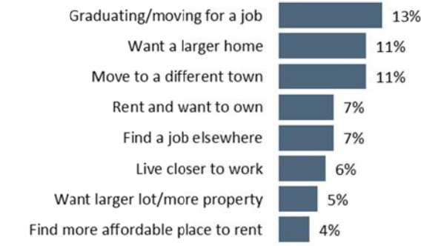
What is the primary reason yo u plan to mo ve in the future?

Note:

n=25 8 residents planning to move in the next five years.

Source:

BBC R esearch & Consultin g from the 2018 Law rence Market Study Resident Telephone Surve y.

Mo st prospective movers thi nk that Lawr ence offers th e type of hou sing they wo uld like to move to (79%).

BBC RESEARCH & CONSULTING SECTION III, PA E 11

Want to buy. About 29 percent of non‐student renters plan to move because they want to buy a home. The non‐student renters who want to become homeowners:

- Are primarily between the ages of 25 and 34 (44%) or 35 to 44 (24%);

- Have household incomes of $25,000 up to $50,000 (41%), $50,000 up to $75,000 (24%), or $75,000 or more (28%); and

- One in five have children under age 18 in the household (22%).

Non‐student renters who want to buy but haven’t offered a number of reasons why they have not yet bought. Reasons identified by at least 10 percent of non‐student renters who want to buy are:

- Housing is not affordable to buy where I want to live (25%);

- Can’t come up with a down payment (24%);

- Income too low to qualify for a mortgage (16%);

- I don’t want to buy/live in Lawrence (15%);

- There is no affordable housing I want to buy (13%);

- Bad credit/low credit score (10%); and

- Affordable housing isn’t available at all—I would live anywhere in the city (10%).

Lawrence’s Housing Spectrum

To understand residents’ preferences for the composition of Lawrence’s housing supply across housing types as well as housing products and affordability for different types of households, the survey posed two key questions. The first asked residents to rate the importance to them personally that the housing supply included housing for different types of residents. The second asked where different types of housing products would be appropriate in Lawrence (if at all).

Composition of Lawrence’s housing supply. Residents rated the importance to them that Lawrence’s housing supply included housing that would appeal to or be suitable for a number of different types of households. Figure III‐10 presents those ratings; higher values indicate higher average importance. On the whole, residents’ ratings suggest that they prefer Lawrence’s housing supply to offer suitable and affordable housing for a diversity of resident life stages and incomes. It is most important to Lawrence residents that the city’s housing supply includes housing that is affordable to residents on a fixed income, low and modest income families, first time homebuyers, workers employed in public service and retail/services, middle class families, and young adults or families.

BBC RESEARCH & CONSULTING SECTION III, PAGE 12

Fig re III‐10. On a scale of 1 to imp ortant to you

10, where 1 0 means extr emely important and 1 is not at all impo rtant, how is it that Law rence’s housing supply in cludes the following types of homes?
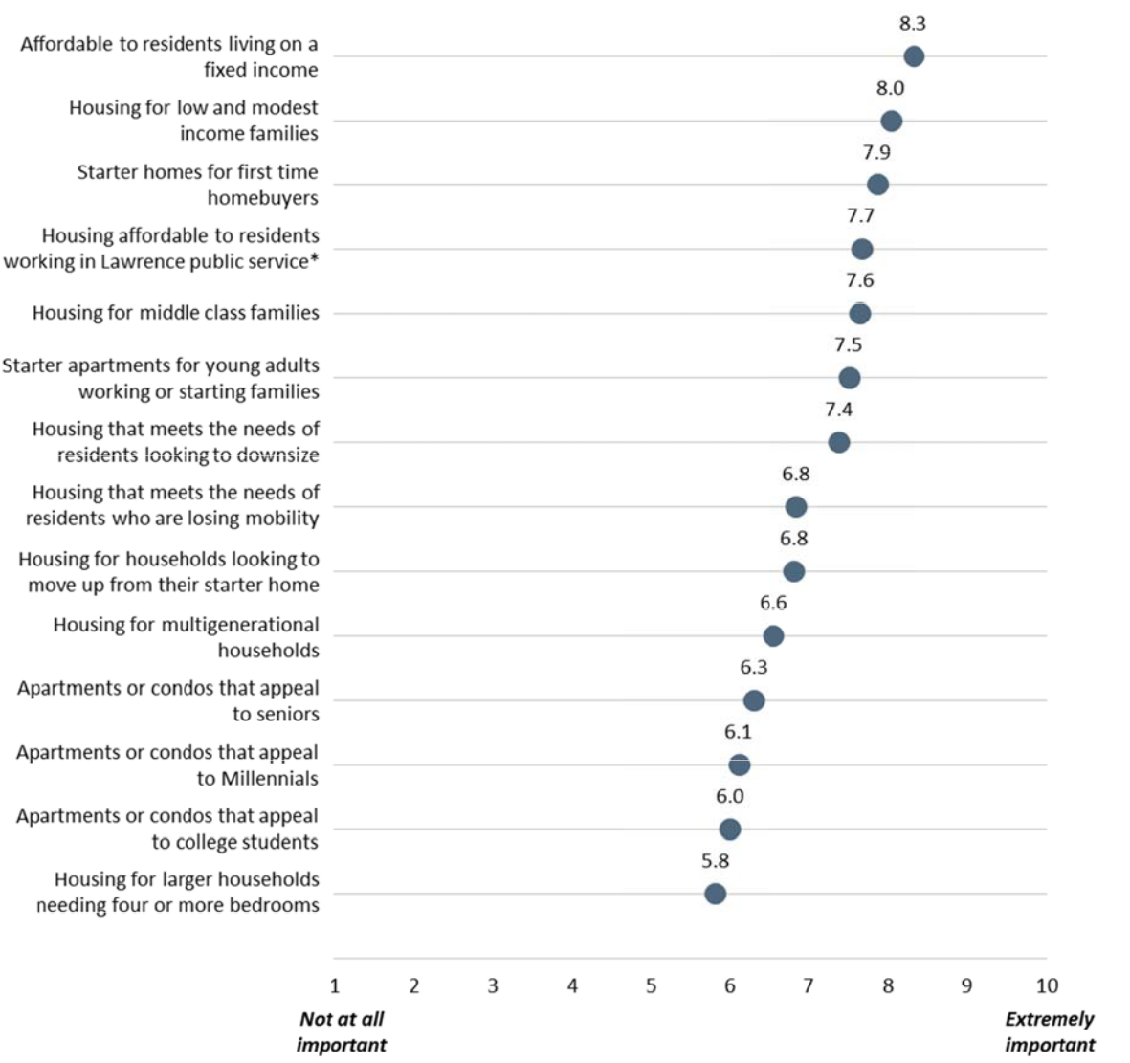

Note: *E.g., grocery stores, librarians, teachers.

Source: BBC Research & Consulting from the 2018 Lawrence Market Study Resident Telephone Survey.

BBC RESEARCH & CONSULTING SECTION III, PA E 13

Fig ure III‐11 pre sents the three most imp ortant housin g types that should be pr esent in

Law rence based on the respondent’s ZIP c ode of reside nce. Across ZIP codes, res idents value hou sing for a mix of household incomes, seniors, and first‐time hom ebuyers.

Fig re III‐11.

Top 3 Most Impo rtant Housin g Types that S hould be Present in Lawre nce, by Respondent’s ZIP Cod e
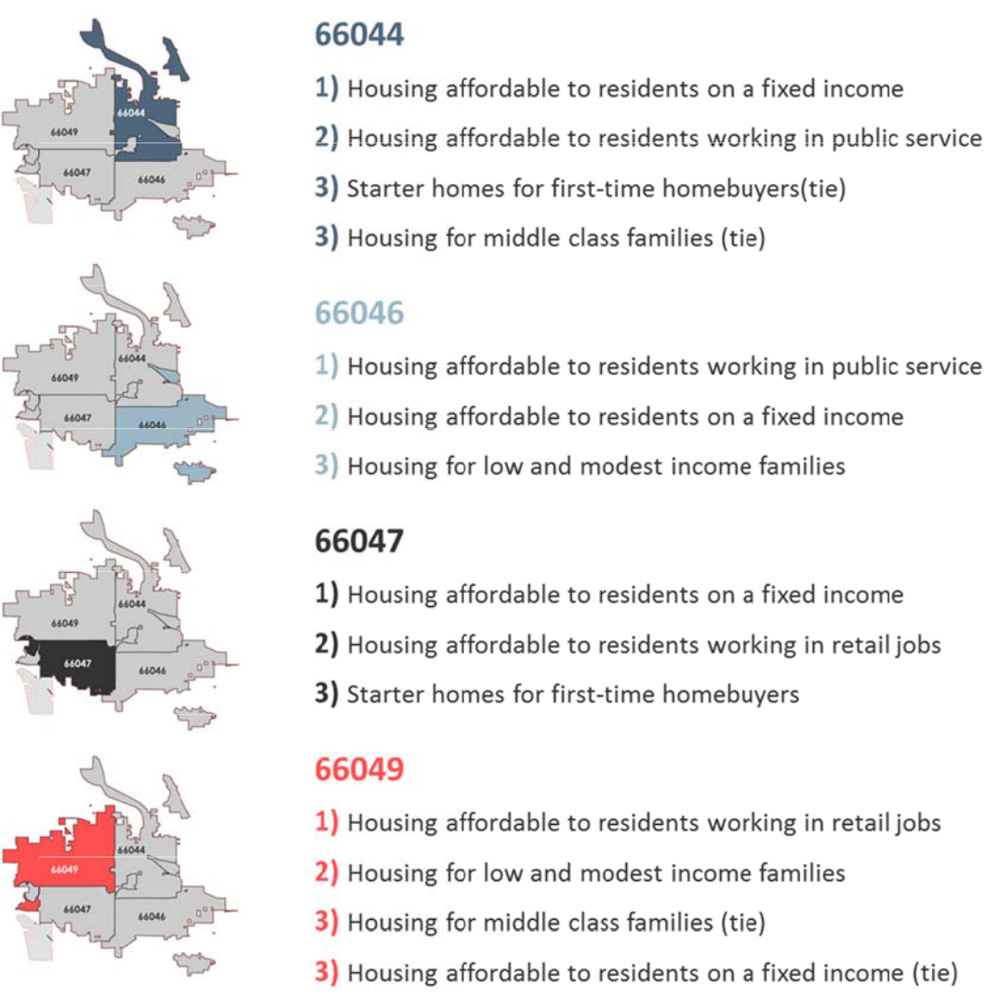

Source: BBC Research & Consulting from the 2018 Lawrence Market Study Resident Telephone Survey.

Appropriate l cations for different h ousing product types. Residents were asked to consider whethe r or not diffe rent housing types were appropriate in their neighborhood, other Law rence neigh borhoods, or not appropriate in Lawrence. Figure III‐12 present s these result s; the shaded housing types are the top five rate by the gr eatest propo rtion of resid ents as bein g app ropriate “in my neighbor hood”. These housing type s—medium single family homes,

tow nhomes wit the same setback, height as neighbori ng homes, d uplex homes on the same lot size as single fa mily homes, small single fa mily homes, and medium lots—are si milar to most of the city’s single amily and lowest density neighborhoo ds, and suggest an appetite for allowin g

BBC RESEARCH & CONSULTING SECTION III, PA E 14

some increased density through attached products that fit with the scale and setbacks of existing single family homes.

Figure III‐12.

Appropriate Locations for Housing Types

 |  | Appropriate
 | Appropriate in | in other | Not
 | my | Lawrence | appropriate | Don’t
Housing Type | neighborhood | neighborhoods | in Lawrence | know
Medium single family homes (1,500‐3,000 sq ft) | 63% | 34% | 1% | 2%
Townhomes with same setback, height as neighboring homes | 53% | 33% | 11% | 3%
Duplex homes on same lot size as single family homes | 51% | 39% | 9% | 2%
Small single family homes (<1,500 sq ft) | 51% | 40% | 5% | 4%
Medium lots (6,000‐10,000 sqft) | 43% | 29% | 24% | 4%
ADU/granny flat | 42% | 39% | 13% | 6%
Small lots (<5,000 sqft) | 41% | 40% | 7% | 12%
Tiny homes (<500 sqft) | 35% | 44% | 17% | 5%
Apartment buildings with 5+ stories by bus/major roads | 32% | 52% | 15% | 2%
Small apartment building with <10 units | 31% | 49% | 15% | 5%
Large single family homes (5,000 sqft+) | 26% | 55% | 17% | 3%
Apartment buildings up to 5 stories by bus/major roads | 23% | 63% | 11% | 3%
Large lots (10,000+ sq ft) | 12% | 41% | 44% | 4%

Source: BBC Research & Consulting from the 2018 Lawrence Market Study Resident Telephone Survey.

Figure III‐13 presents the top five housing types residents identified as “appropriate in my neighborhood” by the respondent’s ZIP code. The composition of the top five housing types varies somewhat by ZIP code, reflecting the character of those neighborhoods and resident preferences.

BBC RESEARCH & CONSULTING SECTION III, PAGE 15

Fig re III‐13.

App ropriate Housing in My N ighborhood, by Respondent’s ZIP Code
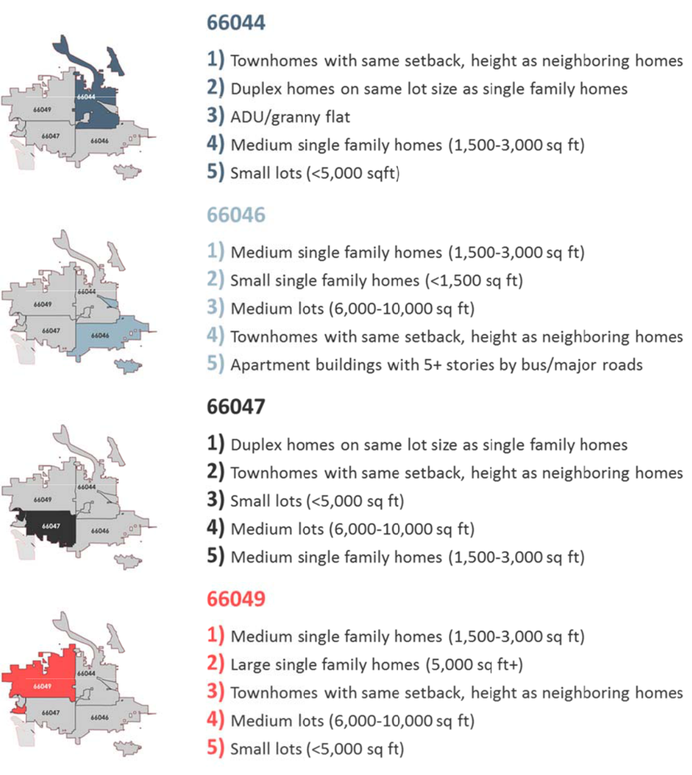

Source: BBC Research & Consulting from the 2018 Lawrence Market Study Resident Telephone Survey.

Appetite for density. Figure III‐14 looks at housing types reside nts considered appropriate in their neighborh ood by the respondent’s ZIP code and in categories of housing types—single fam ily home siz , lot flexibilit y, apartment buildings, a nd emerging products. Th e types of hou sing deemed appropriate in a given ZIP code (“my neighborhoo d”) vary.

- With respe ct to single family homes, nearly four i n five 66046 residents con sider small single fami y homes appropriate in t eir neighbor hood, nearly twice that of residents in

BBC RESEARCH & CONSULTING SECTION III, PA E 16

66047 and 66049. Fewer than one in five resident s of 66044 and 66046 think that large single fami y homes are appropriate, compared to half of residents living in the 66049 a rea.

 With respe ct to lot flexi ility, residen ts are least likely to think large lots ar e appropriate in their neigh borhood acro ss all ZIP cod es. Townho me and duplex products a re considered appropriat e by at least h alf of reside ts in most ar eas.

- With respe ct to apartme nt buildings, residents of 66046 were the most likely to say that apartment buildings with five or mor e stories wer e appropriat e in their neighborhood by bus routes or on major r oads.

- Residents o f 66044 wer e most likely to think ADU s are appropriate in their neighborhoo d.

Fig re III‐14.

App etite for Density, by ZIP C ode
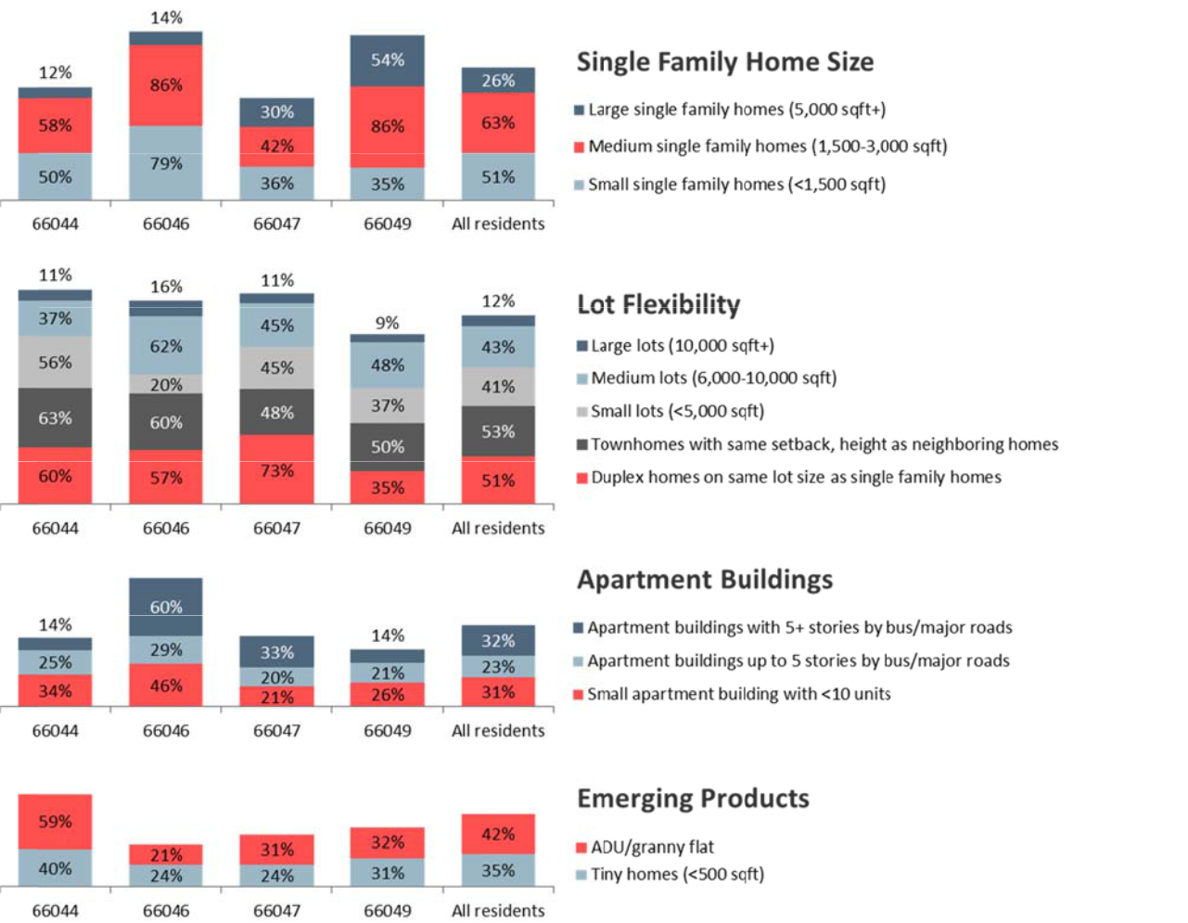

Note: Percent respon ing yes, the housing type is appropriate in their neighborho od.

Source: BBC Research & Consulting from the 2018 Lawrence Market Study Resident Telephone Survey.

BBC RESEARCH & CONSULTING SECTION III, PA E 17

Stakeholder Perspectives

In addition to the stakeholder feedback incorporated above, focus group participants offered additional insight into the housing needs and challenges of hard‐to‐house and vulnerable populations in Lawrence.

Residents who have felony drug charges and persons in recovery are particularly vulnerable in tight rental markets. Families with parents in recovery need stable, affordable housing to support their recovery—which is very difficult to find. The city’s new housing fund would be ideal for addressing this gap in need and funding (federally funded properties have very strict requirements for criminal history).

People with criminal histories find housing through informal networks. Lawrence has many good‐hearted property owners providing this housing, but there is no guarantee they will continue this service to the community.

From the perspective of stakeholders, the incentives for rental property owners to accept Housing Choice Vouchers (HCV) and house lower income tenants have diminished significantly, due to several factors:

- Property taxes have increased, yet low income persons cannot pay additional rents to cover those increases; and

- Funding for HCVs has declined.

Property owners would benefit from an insurance fund that compensates them for damage caused by tenants perceived as “risky” (a fund akin to private mortgage insurance, or PMI, which lenders require of higher risk homebuyers).

Stakeholders who assist victims of domestic violence and who were interviewed for the study agreed that the most significant need for their clients is transitional housing and support to move from the emergency shelter into stable independent living Lawrence has sufficient emergency assistance/shelter beds for domestic violence to meet demand; the gap exists for transitional housing. These households are often 0‐30% income; finding an adequate, affordable place to rent is very difficult. The city’s PHA has 10 24‐month transitional vouchers for domestic violence and would benefit from additional vouchers.

Persons with disabilities face multiple barriers to finding the housing they need, some of which are related to federal fair housing accessibility requirements:

- Renters with disabilities do not have the resources to pay for needed accessibility modifications unless they receive grant assistance; as such, they usually go without modifications.

- Federal requirements do not require that units be affordable. Because many people with disabilities live on fixed incomes, they cannot afford to pay market rents, especially newly constructed buildings.

BBC RESEARCH & CONSULTING SECTION III, PAGE 18

- Federal requirements state that accessibility modifications must be removed when the tenant with a disability leaves the property and cannot interfere with the marketability of the property. Property owners who perceive modifications as affecting the marketability of their properties may refuse rents to people with disabilities; require that leases contain a provision that the modification be removed; and/or remove interior and exterior modifications before they try to rent to another tenant with a disability.

- Housing with supportive services is needed for persons with mental illnesses. Property owners have no incentive to rent to populations perceived as “hard to house.”

- Affordable, accessible housing is extremely difficult to find. Many seniors are “over” housed in less than ideal homes. Accessibility requirements in the Fair Housing Act are inadequate to meet needs of persons with disabilities.

- Rental property owner/manager requirements that tenants demonstrate earning three times the rent (3X the rent) is all but impossible for residents living on disability or social security income to obtain private rental market housing. Even residents with assets, such as a senior with proceeds from a home sale, are unable to meet the 3X income requirement. The 3X rent income rules disproportionately impact seniors and residents with disabilities on disability income, and may be a disparate impact on the basis of disability under the Fair Housing Act.

Stakeholders identified the greatest housing needs in the city as:

- Transitional housing/support to transition from the emergency shelter into a program or stable independent living;

- Rental housing for larger families;

- Housing with supportive services for residents with mental health and cognitive disabilities;

- Lack of housing accessible to persons with disabilities; and

- Affordable low/no maintenance homes for seniors who are currently “over” housed.

Employer perspectives. Most employers who participated in the employer survey think it is fairly easy for employees to find housing to rent in Lawrence (10% very easy, 52% easy). The remainder (38%), think it is difficult for employees to find housing to rent. Conversely, nearly three in four employers think it is difficult or very difficult for their employees to find housing to buy in Lawrence (43% difficult, 29% very difficult). One in five employers report having difficulty recruiting employees due to housing conditions in Lawrence.

Employers reported that the most common ways their employees adjust when they cannot find housing to meet their affordability needs and/or preferences include:

- Live in another part of the county and drive (19% of employers);

- Live with family (18%);

- Get more roommates (11%); and

- Live in housing in poor condition (11%).

BBC RESEARCH & CONSULTING SECTION III, PAGE 19
Rental property owner/manager perspectives. Property owners and managers who participated in the rental property survey provided information about the rental market, anticipated rent increases and perspectives on issues related to occupancy and the rental registration system.

- Half (52%) of landlords rent available units in less than 1 week;

- The median number of rental applications received for each available rental unit is three applications;

- One‐third increased rents in 2017, and 36 percent plan 2018 increases;

- The median 2018 increase expected to be one to five percent;

- Many would like to see 3‐unrelated rule increased to 4‐unrelated;

- Many are concerned rental market is being overbuilt, particularly amenity‐rich larger developments targeting student renters; and

- Several local rental property owners participated in focus groups and spoke at the City Council meeting where preliminary study results were presented. Their primary concern was the treatment of properties that had been split into multiple units in the past and, as a result of licensing renewals and/or financing, are required to conform with current zoning. These property owners view these actions as reducing the stock of much needed rentals.

Section Summary

- Affordability is one of the top factors for choosing a home for all residents and across resident demographic groups.

- Most residents consider their home to be in excellent/good condition. Renters are more likely than homeowners to live in housing they consider to be in fair/poor condition, especially renters of detached single family homes. Renters with children and renters with large families are more likely than other renter households to live in fair/poor condition homes.

- Weatherization is the repair need identified by the greatest proportion of respondents. Most homeowners who need repairs have not made them because they cannot afford to make repairs.

- Affordable and accessible housing is extremely difficult for residents with disabilities to find.

- Renters with children, non‐student renters, and senior renters are most vulnerable to displacement, compared to other renters.

- For non‐student renters who want to own, a lack of affordable housing in the areas they want to live and/or a lack of a downpayment are the most common barriers to owning.

- Lawrence residents value a housing supply that serves residents of all incomes and life stages. Based on their survey responses, a majority or plurality of residents in most areas believe that products that may increase affordability—low density attached housing, small and medium lots and home sizes—are appropriate in their neighborhoods.

BBC RESEARCH & CONSULTING SECTION III, PAGE 20

SECTION IV.

Findings and Recommendations

SECTION IV.

Findings and Recommendations

This section evaluates the resources and options available to Lawrence to address the housing challenges identified in prior sections of this report. These resources include direct allocations of funding for housing, as well as other effective contributions (e.g., zoning and land use modifications to incentivize development).

The primary focus of this section is recommendations for strategies to address needs. This is presented in the form of a “dashboard” for measuring progress and a “road map” to get there.

These recommendations were informed by best practices in similar communities—yet are unique to Lawrence. They focus on how to retain what makes Lawrence a special place for a variety of residents to call home.

Resources

The City of Lawrence is fortunate to have a number of direct financial resources that support housing investments. Most impressive is the new dedicated housing fund, which was approved by voters in late 2017. Housing trust funds not only provide additional resources to communities with fewer requirements than federal or state sources, they can be used to leverage other resources, bringing more private and public investment into a community. This is important because many foundations and businesses base investment decisions on the demonstrated commitment, which includes contribution of local resources.

According to the Center for Community Change, there are nearly 800 housing trust funds in the United States—yet these are not distributed according to needs. Most housing trust funds exist on the East Coast, followed by California. Areas with some of the greatest needs—e.g., rural America with little economic development and aging populations—lack housing trust funds.1 Lawrence’s housing fund is a strong testament to the unique and committed community culture the city has fostered and supported.

Lawrence’s current resources available to address housing needs include:

- In January 2017, the City incorporated affordable housing requirements into the City’s economic development policy regarding any mixed‐use project which creates four or more housing units.

- New dedicated housing fund. In November 2017, Lawrence residents voted in favor of a proposed retailers’ sales tax for “the purposes of providing and improving the quality, availability, and affordability of housing in Lawrence; acquiring land for future affordable

- http://housingtrustfundproject.org/housing‐trust‐funds/

BBC RESEARCH & CONSULTING SECTION IV, PAGE 1

housing units; investing in private/public partnerships for the provision of affordable housing; and such other related affordable housing purposes as may be in the best interest of the City..”2. The tax is the five one‐hundredths of 1 percent (0.05%), equivalent to one cent on a $20 purchase. Collection begins on April 1, 2019 and will sunset in 10 years. The City estimates that the tax will generate $10.5 million over the 10 year period.

- Direct allocations of the Community Development Block Grant (CDBG) and HOME Investment Partnerships Fund (HOME) from the U.S. Department of Housing and Urban Development (HUD)—approximately $900,000 annually. These funds are currently used for home rehabilitation for low income homeowners ($200,000 in 2018 program year to assist two households); first time homebuyer assistance ($90,000 for three households); weatherization and emergency repairs for homeowners ($115,000 for 35 households); accessibility improvements to rental housing ($33,000 for 11 households); tenant based rental assistance ($171,000 for 20 households); and subsidies for affordable housing construction ($50,000 for two households); as well as public infrastructure improvements that support neighborhood revitalization (sidewalk repairs, public facility projects), and funds to support the operations of nonprofit service providers.

- The federal Emergency Shelter Grant (ESG)—received through the State Kansas Housing Resources Corporation. ESG dollars are available to help families at‐risk of or experiencing homelessness find temporary and permanent housing.

- The City of Lawrence received a total of $1,312,384 from the State of Kansas for the Neighborhood Stabilization Program (NSP1). This grant began with an original formula allocation to the City in 2009, and later included several subsequent applications to access Program Income from the State within the NSP1 program. The program was closed in late 2017 and ultimately provided 12 new units of affordable rental housing to the community. The households that reside in these units fall between 50% AMI and 80% AMI. The units were constructed by and are managed by the Lawrence Community Housing Trust.

- Rental licensing program—The goal of the city’s rental licensing program is to ensure that renters live in safe and habitable housing. Effective January 1, 2015, all rental properties in Lawrence must maintain a valid rental license and undergo periodic inspections in compliance with City Ordinance 8840.

Past housing investments. Lawrence has invested in affordable housing through general fund allocations and leveraging partnerships:

- 2005 Housing Trust Fund Projects. In 2005, the City allocated $570,000 to emergency rental assistance, a homeless management information system, construction of nine affordable elderly housing units, acquisition/ development of property for Habitat for Humanity, the Homeless to Housed program, and to land acquisition for the Community Housing Trust.

- Text in quotation is directly from the ballot question.

BBC RESEARCH & CONSULTING SECTION IV, PAGE 2

- Housing Demonstration Project. Through this partnership between the City of Lawrence, Tenants to Homeowners, Habitat for Humanity, Family Promise, Lawrence Douglas County Housing Authority, and Willow Domestic Violence Center, $100,000 of city funds were leveraged to construct three permanently affordable homes in 2017.

- Transitional Housing Voucher Program. Through this program, the Lawrence Douglas County Housing Authority received $100,000 from the City to provide housing vouchers to help families move from the Lawrence Community Shelter into transitional housing in 2017.

The City is also fortunate to have an Affordable Housing Advisory Board (AHAB) that was established in mid‐2015. The role of the AHAB is to:

- Advise the Governing Body regarding issues affecting affordable housing and supportive services in the community;

- Oversee and facilitate the purpose of the Affordable Housing Trust Fund, which is to support the acquisition, rehabilitation, and development of affordable housing and supportive services so that all persons in the community have access to independent living with dignity;

- Make recommendations to the Governing Body regarding the expenditure of money from the Affordable Housing Trust Fund in order to fund projects, as reviewed and approved by the Board, that are consistent with the purpose of the Affordable Housing Trust Fund; and

- Make recommendations to the Governing Body regarding the cultivation and maintenance of steady and various streams of income to fund the Affordable Housing Trust Fund. However, the Board shall not apply for any grant without prior approval of the Governing Body; nor shall it accept any gift or donation without prior approval of the Governing Body.

The Board represents a variety of interests and includes:

- Two representatives of the City of Lawrence, appointed by the Governing Board;

- One representative of Douglas County, appointed by the Board of County Commissioners;

- One representative of the Lawrence‐Douglas County Housing Authority, or any successor in interest, appointed by the Governing Body;

- One representative of Family Promise of Lawrence, appointed by the Governing Body;

- One representative of Lawrence Habitat for Humanity, appointed by the Governing Body;

- One representative of Tenants to Homeowners, Inc., appointed by the Governing Body;

- One representative who is a current or former resident of subsidized housing, appointed by the Governing Body;

BBC RESEARCH & CONSULTING SECTION IV, PAGE 3

- One representative of Justice Matters of Lawrence , appointed by the Gover ing Body;

- One representative of th e Lawrence Home Builde rs Associatio n, appointed by the Governing Body;

- One representative of th e University of Kansas, ap pointed by t he Governing Body;

- One representative of th e Lawrence Chamber of Commerce, ap pointed by t he Governing Body; and

- One representative of th e Lawrence Board of Real tors, appoint ed by the Governing Body .

Addressing N eeds

Sections II and I II of this repo rt the data a nd informati on analyzed for this study. This

info rmation was provided to the AHAB, La wrence citizens, and the City Commis ion as it was developed, thro ugh consulta nt presentati ons in April, May, and Jun e 2018.

The city’s housi g needs, by type and pop ulation most affected, include:
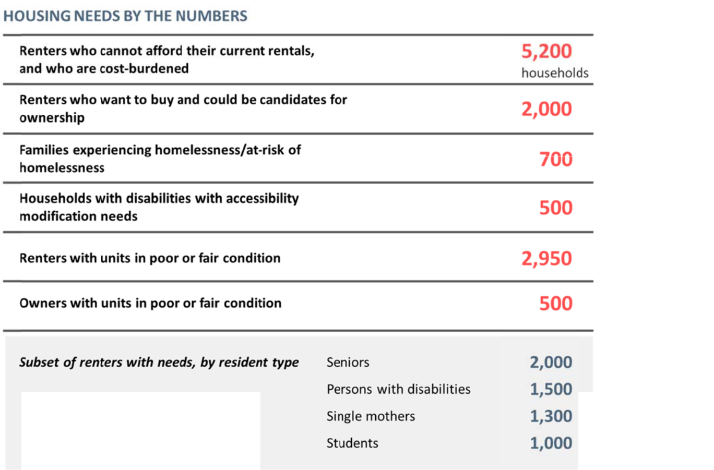

BBC RESEARCH & CONSULTING SECTION IV, PA GE 4

On June 4, 2018, a workshop was held with the AHAB to prioritize the city’s hou sing needs; th e me eting was op en to and atte nded by man y members of the public. The worksh p began wit h a rec ap of the findings from th analysis an community engagement.

Dur ing the workshop, the AHAB developed a set of gui ding principl es for determ ining the pri oritization of needs and allocating the ousing trust fund:

Guiding principles.

- The City of Lawrence’s role in addressing housing needs sh ould be “reasonable and broad.” The city’s role should focus on facilitati ng new affordable development, incentivizing and partnering with the private sector, enacti ng reasonabl e regulations, and evaluating progress.

- “There is no silver bu llet.” The ho using market is dynamic and ever‐chan ging. Housing

needs will always exist in some form. Housing programs and policies sh ould allow flexibility adjust to u nmet deman as the city changes.

- “We can ask the priv ate sector to help in this e ndeavor.” Pu blic sector investments an d entitlem ents provide value to the private sector. It is appro priate to ask for affordabl e housing contributions in return.

- Housing investments should be focused on the areas where the market is unable to m eet the hous ing needs that exist.

Su cessful outcomes. The AHAB also considered a r ange of outc omes for the Affordable

Ho using Trust Fund. These o utcomes would help Lawrence retain w hat is specia l about the c ity, add ress the most severe hou sing needs, a nd ensure tha t all types of residents ca n continue to call the city home.
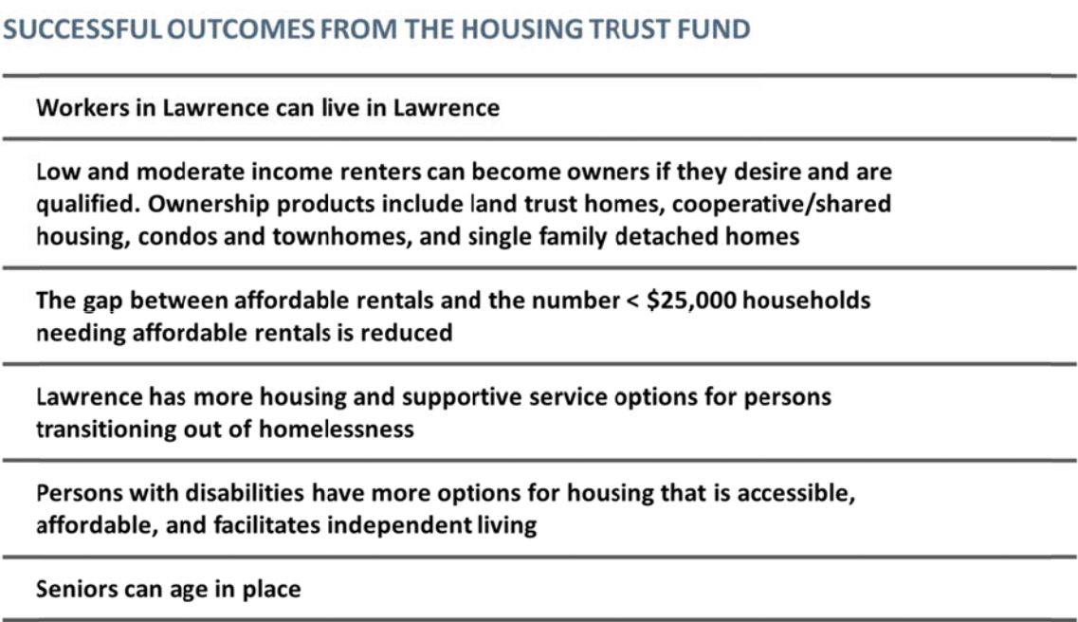

BBC RESEARCH & CONSULTING SECTION IV, PA GE 5

The Dashboard. The dashboard below depicts short‐term and long‐term indicators of success, and estimated project costs, based on the outcomes developed by the AHAB and current and future housing needs.

Dashboard to Monitor and Measure Success, City of Lawrence

Short term (1‐5 years) |  | 2019‐2023
1. | Stabilize the rental gap for non‐student renters earning < $25,000/year | 100 new affordable rental units
2. Low and moderate income renters who want to become owners have more options for |  | 100 more units are affordable to low and moderate income renters who are
purchasing affordable units |  | qualified to become owners
3. | Persons with accessibility needs are able to get the improvements they need and/or find | 25 renter households that receive accessibility modifications annually
visitable and accessible housing
4. | Residents in unstable housing situations have more permanent affordable and supportive | 45 tenant based rental assistance vouchers available annually
housing options
5. | Residents living in housing in poor condition have improvements made | 70 homes and apartments brought into good condition annually
Long term (5‐10 years) |  | 2024‐2028
1. | Reduce the rental gap by 7.5% by adding new units affordable to non‐student renters earning | 500 new affordable rental units
< $25,000/year
2. Low and moderate income renters who want to become owners have more options for |  | 200 more units are affordable to low and moderate income renters who are
purchasing affordable units |  | qualified to become owners
3. | Unit accessibility for persons with disabilities is increased through rehabilitation and creation | 25 renter households that receive accessibility modifications annually
of visitable housing
4. | Residents in unstable housing situations have more permanent affordable and supportive | 70 tenant based rental assistance vouchers available annually
housing options
5. | Residents living in housing in poor condition have improvements made | 70 homes and apartments brought into good condition annually
Note: | The proposed goal numbers are based on the renter and owners gaps analysis and needs identified by residents through the survey and are rounded for simplicity.

BBC RESEARCH & CONSULTING SECTION IV, PAGE 6

Roadmap for Addressing Needs. The “roadmap” presented below details how to achieve the measures of success depicted by the dashboard. It is organized by recommended year for action.

Roadmap to Meet Dashboard Goals, City of Lawrence

Dashboard Goals
Short term (1‐5 years) | 2020‐2023 | Target Population | Roadmap
1. Stabilize the rental gap for non‐ | 100 new affordable | Persons with disabilities, | Step 1. Determine available land and property: a. Inventory city land,
student renters earning < | rental units renting | persons with mental | especially under‐utilized parcels such as parking lots, and determine
$25,000/year by creating new | for less than | illness/behavioral challenges; | appropriateness for new housing developments. b. Working with a local
deeply, permanently affordable | $500/month | seniors, single parents, victims | (preferably volunteer) commercial and residential real estate agent,
rental units, Note: Affordable rentals |  | of domestic violence, persons | inventory non‐city owned and underutilized commercial and residential
could take a variety of forms, |  | with criminal histories, | properties that could be purchased and converted to permanently
depending on the land and nature of |  | immigrants with no rental | affordable housing.
the land or property (traditional |  | history/credit
public housing, transitional housing |  |  | Step 2. Examine the sites for potential residential development.
for victims of domestic violence, |  |  | Determine redevelopment costs and potential affordability mix (both
senior housing, cooperative housing, |  |  | rental and ownership housing, a mix of MFI levels, land trust and coop
scattered site complexes). Ideally, |  |  | potential).
housing for all vulnerable resident |  |  | Step 3. Acquire land/property.
groups should have supportive |  |  | Step 4. Issue an RFP for a nonprofit or private partner to repurpose the
services and foster community
services and foster community |  |  | land or property acquired by city or owned by the partner into
support.
support. |  |  | permanent affordable housing, guided by the potential mix in Step 2.
 |  |  | Assumes partner receives additional grants to offset construction costs
 |  |  | of development.
2. Create more ownership options for | 150 more units are | Residents, workforce, small | Could be achieved through several approaches: 1) Follow Roadmap for
low and moderate income renters | affordable to low | households; 50‐100% MFI | creating affordable units (above). In that case, it is recommended that
who want to become owners | and moderate | renters who want to become | the for sale communities be a combination of land trust (deeply
 | income renters who | owners | affordable), cooperative, and modified shared equity products. 2) Use
 | are qualified to |  | density bonuses, potentially through an overlay district, to create more
 | become owners, |  | value in land for private developers. Units created through density
 | priced between |  | bonuses would likely be attached homes serving 80‐100% MFI. 3) Long
 | $100,000 and |  | term: Negotiate affordable for sale unit creation as part of annexations.
 | $260,000 |  | The proportion may vary depending on the development proposed but
 |  |  | should not be less than 10%.
Note: The proposed goal numbers are based on the renter and owners gaps analysis and needs identified by residents through the survey and are rounded for simplicity.

BBC RESEARCH & CONSULTING SECTION IV, PAGE 7

Roadmap to Meet Dashboard Goals, City of Lawrence (Continued)

Dashboard Goals
Short term (1‐5 years) | 2020‐2023 | Target Population | Roadmap
3. Persons with accessibility needs | 25 rental households | Persons with disabilities who | 1) Increase number of rental households with disabilities who receive
are able to get the improvements | assisted with | desire to live independently; | grants from the city for accessibility improvements; 2) Consider
they need and/or find visitable and | accessibility | includes many types of | enhancing this program to provide additional rehabilitation and
accessible housing | modifications | disabilities, including cognitive | weatherization to private property owners who agree to keep units
 | (benchmark is 11 | and self care | affordable for a period of time (10‐15 years, depending on amount of
 | annually) |  | grant); 3) Engage private sector developers in a discussion about
 |  |  | incentives to increase visitability in housing and consider implementing
 |  |  | solutions
4. Residents in unstable housing | 25 more vouchers | Persons with disabilities, | 1) Increase TBRA to supplement Section 8 program; buy down units in
situations have more permanent | available | persons with mental | $625‐$875 range. 2) Consider creating an incentive fund for property
affordable and supportive housing |  | illness/behavioral challenges; | owners who agree to rent to voucher holders. This fund could cover the
options |  | seniors, single parents, victims | costs of damage, wear and tear, and weatherization improvements.
 |  | of domestic violence, persons
 |  | with criminal histories,
 |  | immigrants with no rental
 |  | history/credit
5. Residents living in housing in poor | 70 number of homes | Residents living in substandard | 1) Increase funding for home modifications and weatherization. Fund
condition have improvements made | and apartments | housing; includes persons with | with housing trust funds to increase grant effectiveness and overall
 | brought into good | disabilities living in inaccessible | funding by removing regulatory inefficiencies; Supplement with
 | condition | housing | incentive programs proposed above. 2) Evaluate the CIty's current
 | (benchmark is 35 |  | rental inspection sampling program, using guidance from the survey
 | annually) |  | data in the Housing Needs Assessment, to ensure that the City's process
 |  |  | has the ability to detect condition problems reported by residents. 3)
 |  |  | Evaluate if energy codes and programs are adding unnecessary costs to
 |  |  | housing payments.

Note: The proposed goal numbers are based on the renter and owners gaps analysis and needs identified by residents through the survey and are rounded for simplicity.

BBC RESEARCH & CONSULTING SECTION IV, PAGE 8

Roadmap to Meet Dashboard Goals, City of Lawrence (Continued)

Dashboard Goals
Long term (5‐10 years) | 2024‐2028 | Target Population | Roadmap
1. Reduce the rental gap by 7.5% by | 500 new affordable rental units | Persons with disabilities, persons with mental
adding new units affordable to non‐ |  | illness/behavioral challenges; seniors, single
student renters earning less than |  | parents, victims of domestic violence, persons
$25,000/year |  | with criminal histories, immigrants with no
 |  | rental history/credit
2. Low and moderate income renters | 200 more units are affordable to | Residents, workforce, small households; 50‐
who want to become owners have | low and moderate income | 100% MFI renters who want to become owners
more options for purchasing | renters who are qualified to
affordable units | become owners
3. Unit accessibility for persons with | 25 annual rental households that | Persons with disabilities who desire to live
disabilities is increased through | receive accessibility | independently; includes many types of
rehabilitation and creation of | modifications (benchmark is 11 | disabilities, including cognitive and self care
visitable housing | annually)
4. Residents in unstable housing | 50 more vouchers available | Persons with disabilities, persons with mental
situations have more permanent |  | illness/behavioral challenges; seniors, single
affordable and supportive housing |  | parents, victims of domestic violence, persons
options |  | with criminal histories, immigrants with no
 |  | rental history/credit
5. Residents living in housing in poor | 70 number of homes and | Residents living in substandard housing;
condition have improvements made | apartments brought into good | includes persons with disabilities living in
 | condition (benchmark is 35 | inaccessible housing
 | annually)

Note: The proposed goal numbers are based on the renter and owners gaps analysis and needs identified by residents through the survey and are rounded for simplicity.

BBC RESEARCH & CONSULTING SECTION IV, PAGE 9

Note: Enhance existing units includes activities of accessibility improvemen ts, weatherization, and em ergency loans.

Financial assistance includes vouchers and first time homebuyer assistance.

BBC RESEARCH & CO NSULTING SECTION IV, PAGE 10

APPENDIX A.

Acronyms

Acronyms used in Housing Studies

Commonly used acronyms in housing market analyses and referred to in this report include:

ACS – American Community Survey

ADA – Americans With Disabilities Act

AFFH – Affirmatively Further Fair Housing

AFH – Assessment of Fair Housing

AI – Analysis of Impediments to Fair Housing

AMI/MFI – Area Median Income / Median Family Income CDBG – Community Development Block Grant CIL – Center for Independent Living

ESG – Emergency Solutions Grant

FHA – Fair Housing Act (sometimes referred to as the Federal Fair Housing Act, or FFHA, to distinguish from the Federal Housing Administration)

HMA – Housing Market Analysis

HOME – HOME Investment Partnership Program HUD – U.S. Dept. of Housing and Urban Development LIHTC – Low Income Housing Tax Credit MLS – Multiple Listing Service

MSA – Metropolitan Statistical Area

NIMBY – “Not In My Back Yard”

NOAH – Naturally Occurring Affordable Housing

PHA – Public Housing Agency

BBC RESEARCH & CONSULTING APPENDIX A, PAGE 1

