

DRAFT - Real Estate Market Analysis: State of New Hampshire Lakes Region Facility

May 18, 2018

Prepared for:

State of New Hampshire

Lakeshore Redevelopment Planning Commission


120 West Avenue, Suite 303

Saratoga Springs, NY 12866

518.899.2608

www.camoinassociates.com

About Camoin Associates

Camoin Associates has provided economic development consulting services to municipalities, economic development agencies, and private enterprises since 1999. Through the services offered, Camoin Associates has had the opportunity to serve EDOs and local and state governments from Maine to California; corporations and organizations that include Lowes Home Improvement, FedEx, Volvo (Nova Bus) and the New York Islanders; as well as private developers proposing projects in excess of $600 million. Our reputation for detailed, place-specific, and accurate analysis has led to projects in 30 states and garnered attention from national media outlets including Marketplace (NPR), Forbes magazine, and The Wall Street Journal. Additionally, our marketing strategies have helped our clients gain both national and local media coverage for their projects in order to build public support and leverage additional funding. We are based in Saratoga Springs, NY, with regional offices in Portland, ME; Boston, MA; Brattleboro, VT; and Richmond, VA. To learn more about our experience and projects in all of our service lines, please visit our website at www.camoinassociates.com. You can also find us on Twitter @camoinassociate and on Facebook.

The Project Team

Michael N’dolo

Vice President, Project Principal

Rachel Selsky

Senior Project Manager, Project Manager

Anna Winslow

Analyst, Project Staff
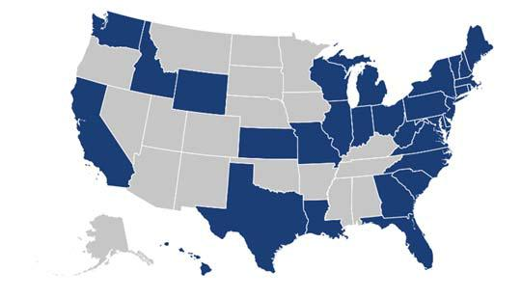
Table of Contents

Executive Summary 1

Site Location and Previous Work 7

Demographic and Socioeconomic Profile 8

Industrial and Flex Space 13

Office Space 16

Residential 21

Retail 31

Tourism and Recreation 41

Attachment A: Data Sources 50

Table of Tables

Table 1: Basic Demographic Comparison 9

Table 2: Residents by Place of Work, Economic Region 11
Table 3: Workers by Place of Residence, Economic Region 11
Table 4: Industrial Job Growth, Lakes Region 14
Table 5: Industrial Job Growth, Economic Region 15
Table 6: Growth in Office Utilizing Occupations, Lakes Region 17
Table 7: Growth in Office Utilizing Occupations, Economic Region 18
Table 8: Office Space Demand 19
Table 9: Health Industry Growth, Lakes Region 19
Table 10: Health Industry Growth, Economic Region 20
Table 11: Housing Units by Units in Structure 21
Table 12: Housing Units by Year Structure Built, 2015 22
Table 13: Residential Building Permits Issued, Economic Region, 2013-2017 22
Table 14: Housing Values (Owner Occupied Housing), Lakes Region 24
Table 15: Housing Values (Owner Occupied Housing), Economic Region 24
Table 16: Renter-Occupied Housing Units by Monthly Rent, 2015 25
Table 17: Change in Number of Households, 2000-2022 26
Table 18: Household Trends by Tenure, Lakes Region 26
Table 19: Household Trends by Tenure, Economic Region 27
Table 20: Households by Size, 2010 27
Table 21: Household Income Trends, Lakes Region 28
Table 22: Household Income Trends, Economic Region 29
Table 23: Age 50+ Population Growth, Lakes Region 30
Table 24: Age 50+ Population Growth, Economic Region 30
Table 25: Households by Income and Age of Householder (2017), 15 Minute Drive Time 32
Table 26: Households by Income and Age of Householder (2017), 45 Minute Drive Time 32
Table 27: Top Tapestry Segments of the Economic Region, 2017 33
Table 28: Consumer Spending Index, 45 Minute Drive Time 36
Table 29: Supportable Retail - 15-Minute Drive Time from Lakes Region Facility 40
Table 30: Supportable Retail - 45-Minute Drive Time from Lakes Region Facility 40


Camoin Associates | DRAFT - Real Estate Market Analysis: State of New Hampshire Lakes Region Facility
Table 31: Accommodation Inventory, Lakes Region, 2018 43

Table 32: Arts, Entertainment, and Recreation Businesses 45
Table 33: Arts, Entertainment, and Recreation Industry Groups, Economic Region 45
Table 34: Top Arts, Entertainment, and Recreation Industry Sub-Sectors, Economic Region 46
Table 35: Leisure and Sports Market Potential, Economic Region 47
Table 36: General Sports Market Potential, Economic Region 47
Table 37: Fitness Market Potential, Economic Region 48
Table 38: Outdoor Activity Market Potential, Economic Region 48
Table 39: Entertainment Industry Market Potential, Economic Region 49

Table of Figures

Figure 1: Study Areas 1

Figure 2: Study Areas 2
Figure 3: Site Location 7
Figure 4: Commuting Patterns, Economic Region 10
Figure 5: Map - Workers by Place of Residence, Economic Region 11
Figure 6: Map - Residents by Place of Work, Economic Region 11
Figure 7: Owner Occupied Housing Values, 2017 23
Figure 8: Percent Change in Households by Income Range, 2017-2022 28
Figure 12: Map - Accessibility to the Lakes Region 42

Camoin Associates | DRAFT - Real Estate Market Analysis: State of New Hampshire Lakes Region Facility
Executive Summary

Camoin Associates was commissioned to complete a market analysis report for the state-owned Lakes Region Facility Site (the “Site”) and the surrounding region to identify potential redevelopment opportunities for the Site. The following market data analysis consists of:

- Demographic and Socioeconomic Profile

- Industrial and Flex Market Analysis

- Office Space Market Analysis

- Hospitality Market Analysis

- Residential Market Analysis

- Retail Market Analysis

- Tourism and Recreation Market Analysis

The purpose of this report is to describe current market conditions and identify local and regional trends that may affect the redevelopment of the Lakes Region Facility. The key findings of the market analysis are summarized in the executive summary with more information included in the full report.

Geographies Studied

This market analysis considers several different geographical areas to compare local and regional trends, as well as to align with the available data sources. See Figure 1: Study Areasand Figure 2: Study Areas for more detail on the

study areas. The following geographies were considered:
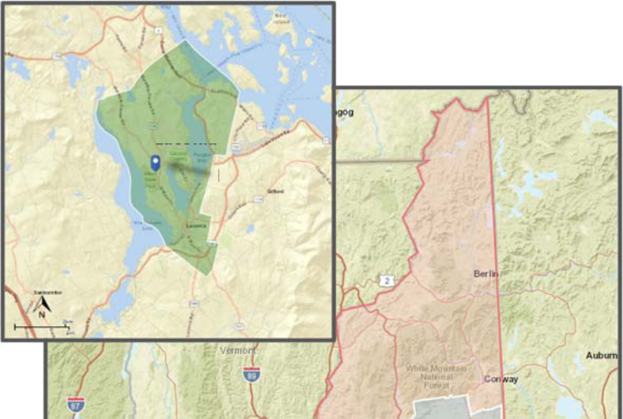

- City of Laconia: The city was examined for demographic and socioeconomic comparison.
- County of Belknap: The county was examined for demographic and socioeconomic comparison.

- Lakes Region: The Lakes Region is defined by the Lakes Region Planning Commission as the towns of Alexandria, Alton, Andover, Ashland, Barnstead, Belmont, Bridgewater, Bristol, Center Harbor, Danbury, Effingham, Franklin, Freedom, Gilford, Gilmanton, Hebron, Hill, Holderness, Laconia, Meredith, Moultonborough, New Hampton, Northfield, Ossipee, Sanbornton, Sandwich, Tamworth, Tilton, Tuftonboro, and Wolfeboro. The Lakes Region was used throughout this report to examine demographic, socioeconomic, office, residential, industrial, and tourism data.

- Economic Region: The Economic Region is defined by the counties of Belknap, Strafford, Hillsborough, and Merrimack. The Economic Region was also used throughout the report.

Figure 1: Study Areas

City of

Laconia

Lakes Region

Facility

State of New

Hampshire

Lakes
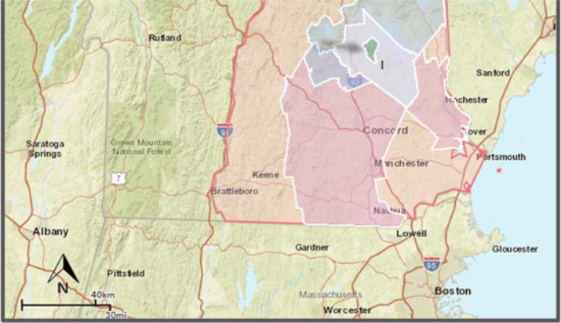
City of ^{Region}
Laconia
Belknap
County

Economic

Region


Camoin Associates | DRAFT - Real Estate Market Analysis: State of New Hampshire Lakes Region Facility | 1


- State of New Hampshire: Data for the state was used to provide context for smaller geographies throughout the analysis.

- 15 Minute Drive-time from Lakes Region Facility Site (Local Trade Area): This drive-time radius was utilized to study the local retail trade area.

- 45 Minute Drive-time from Lakes Region Facility Site (Regional Trade Area): This drive-time radius was utilized to study the regional retail trade area.

- Interstate 93/Route 3 Corridor: The 93/3 Corridor was used to provide context for the office and industrial space markets, using the CBRE New England Market Outlook report.

Figure 2: Study Areas

Local

Trade Area

Regional
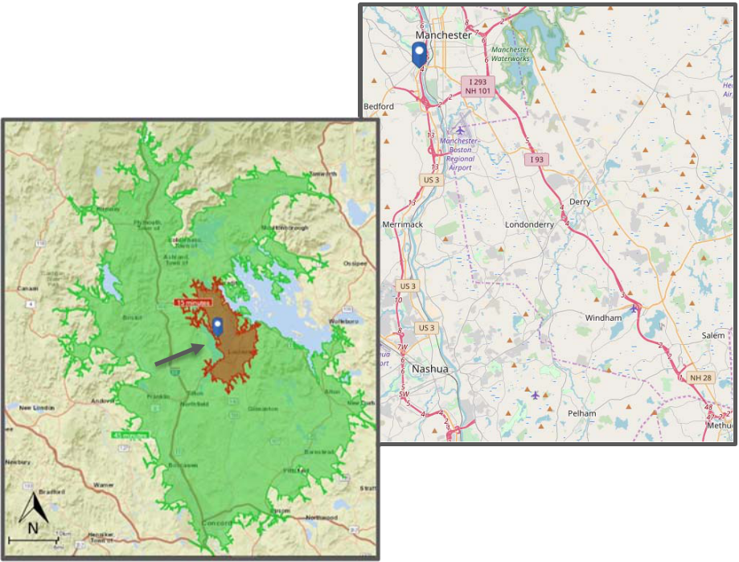

Trade Area

Interstate

93/Route 3

Corridor

Key Findings: Demographic & Socioeconomic

- The Economic Region is projected to grow at the fastest rate compared to other geographies in terms of population and households, adding 23,460 people and 9,376 households, an increase of 3.1% and 3.2% from 2017 through 2022.

- The population of the Economic Region is significantly younger than the population of the Lakes Region and the county, with a median age of 41.1. The Lakes Region demonstrates the oldest population, with a median age of 47.5, which is projected to increase to nearly 49 by 2022. The immediate vicinity of the Lakes Region Facility has an older median age, with the City of Laconia having a median age of 44.5 and Belknap County having median age of 46.6. As the age of residents increases, there will be more need for units that allow aging in place, transitional housing options, and potential to downsize.

- Economic Region households are wealthier than residents of comparison geographies overall, with a median household income of nearly $71,000.

- Approximately 234,400 people both live and work within the Economic Region. Approximately 113,500 live within the region and are employed outside, while 94,400 are employed within the region and live outside. Finding employment opportunities for those residents who are traveling out of the Economic Region will decrease their commute time and improve their quality of life.

Key Findings: Industrial and Flex

- The Lakes Region has excess industrial and flex space available, including at nearby O’Shea Industrial Park and the Lakes Region Industrial park. Laconia, and the Site specifically, have limited access to the highway and ease of transportation would be a constraint for production-related industries. Projected growth in industrial utilizing industries can be accommodated within the existing business parks in Laconia and/or the parks in Franklin and Tilton.

Camoin Associates | DRAFT - Real Estate Market Analysis: State of New Hampshire Lakes Region Facility | 2

- When considering the larger Economic Region, CBRE reports an existing inventory of 44.2 million square feet within the 93/3 Corridor in southern New Hampshire. Absorption rates rested at 6.6% in 2017. Low vacancy and increasing demand have allowed for less flexible terms and more expensive new leases. NNN rates rose to $6.16 in 2017.¹ Southern New Hampshire has more attractive market conditions for industrial development than the area surrounding the Site. Therefore, industrial companies would look to southern New Hampshire before considering locating in Laconia.

- The Manufacturing and Transportation and Warehousing industries show the some demand in the Lakes Region in terms of industrial space. The Manufacturing industry is expected to see a net gain 127 jobs over the next 10 years, while Transportation and Warehousing is projected to gain 37 jobs over the same period. Within the greater Economic Region, Transportation and Warehousing is projected to gain 212 jobs through 2027. However, the Manufacturing industry shows a projected net loss of over 1,300 jobs. Overall, the local region around the Site is not seeing any substantial job growth that would warrant additional industrial space.

Key Findings: Office

- Nationally, preferences are evolving in the office market, causing much of existing space to be considered outdated. While there are still some office users who are looking for a more traditional office park style development, more and more tenants are seeking spaces that are attractive to their workforce with high levels of amenities, walkability to a wide variety of services, flexible layout, and more urban connectivity. The location and connectivity of the Lakes Region Facility as it currently exists would not be ideal for an office park development; however, with some additional amenities, use-types, and increased connectivity, it could become an attractive location for office users.

- According to CBRE, the Interstate 93/Route 3 Corridor office vacancy rates were healthy in 2016 and 2017, remaining constant at 10.4%. Both rents and vacancies are lower within the Southern New Hampshire subregions compared to the rest of New England. NNN rates in the Corridor stayed stagnant at $11.31 in 2016 and 2017. Currently, the 93/3 Corridor has approximately 22.3 million square feet of office space.

- Based on growth in office-utilizing occupations, the office space outlook in the Economic Region shows demand for an annual estimated 212,160 square feet of new office space. Over 5 years, this demand equals 1.06 million square feet of space. Some of this could be captured on the Site; however, changing preferences for office space users would require development of nearby amenities and increased connectivity with goods and services. Furthermore, looking at the more local region around the Site the overall economic activity is very low and suggests a weak office market.

- The demand for medical office is expected to be strong over the next five years with growth expected in office-utilizing industries, such as Offices of Physicians (1,500 new jobs in Economic Region); Offices of Dentists (208 new jobs in Economic Region); and Offices of Other Health Practitioners (387 new jobs in Economic Region).

Key Findings: Residential

- Home-buying practices are drastically evolving as millennials and baby boomers dominate the housing market. Both young and old are looking for homes that are connected to amenities such as restaurants, shopping, entertainment, and work space. The combined trend of having children later in life and empty-nesters looking to downsize has put increased pressure on multifamily housing development projects.

- CoStar defines triple net (NNN) rents as, “A lease in which a tenant is responsible for all expenses associated with their proportional share of occupancy of the building.”

Camoin Associates | DRAFT - Real Estate Market Analysis: State of New Hampshire Lakes Region Facility | 3
- The Economic Region population is projected to increase at the fastest rate compared to the other geographies, increasing by 3.1% over the coming five years. The Economic Region is projected to experience an increase of nearly 9,400 households through 2022. Within the Economic Region there are a number of unique small cities that offer walkability, night life, and attractive housing options; however, with the right development project, Laconia could be able to capture that growth.

- It is reported that the available inventory for purchasing residential units is extremely limited, making it difficult for people who desire to live in the area to find houses. The homes in the $200,000 to $300,000 range sell extremely quickly.

■

■

■

■

■

Single-family housing is the dominant type of residential development in both the Lakes Region and Economic Region, at 78% and over 65%, respectively.

The Lakes Region housing stock is younger than that of the Economic Region, with a median year built of 1978 compared to 1975 in the Economic Region.

Housing values are relatively lower in the Lakes Region with median home value of owner-occupied housing at $231,400 compared to $255,400 in the Economic Region.

Household incomes are projected to rise, specifically within the greater Economic Region, indicating there may be potential for higher-end housing.

About 37% of housing units in the Lakes Region are vacant compared to 11% in the overall Economic Region; however, the vast majority of vacancy within the Lakes Region is due to seasonal vacancy and does not indicate a surplus of housing inventory. About 85% of Belknap County vacant homes are seasonally vacant. Approximately 26% of occupied housing units within the Lakes Region are renter-occupied, while 33% within the Economic region are renter-occupied. The mix between owners and renters is not projected to change.

■

■

Lakes Region median rental rate is about $100 lower than that of the greater Economic Region. This is a result of the Economic Region having a greater proportion of high-end rental units (over $1,250 per month).

The population over the age of 55 is projected to grow significantly in both regions, meaning there will be demand for age-appropriate housing. The most immediate demand will be for independent living facilities, as well as market-rate condos and apartments in the core of the community. This is because empty-nesters will begin to shift their housing preferences from the single-family home to smaller units with less upkeep in areas that are walkable to local shops and amenities. Many people have strong connections to the Lakes Region after years of summer vacations and visiting with family and therefore, may look to retire or downsize in the area. There has been high demand for smaller units by older individuals looking to buy housing in the area, both single family and multifamily.

Key Findings: Retail

- The retail market is rapidly changing as consumers continue to incorporate online shopping into their everyday lives. Brick and mortar stores are finding ways to adapt and thrive in this market by incorporating more experiences, online/offline coordination, focusing on customer service, and being a destination for repeat visitation. Creating a retail destination within the Lakes Region Facility would require a variety of retailers, incorporating the tourism sector, and offering an experience that is appealing to a wide range of family members and demographics.

- A retail gap analysis found that in the Local Trade Area (15-minute drive time from the Lakes Region Facility), eight industries have sales leakage, meaning that local businesses are not meeting all of the needs of local customers. These industries are:

Camoin Associates | DRAFT - Real Estate Market Analysis: State of New Hampshire Lakes Region Facility | 4

- Electronics & Appliance Stores (Note that electronics are increasingly purchased online, and thus a physical electronics store would likely not be the best fit for a new business.)

  - Grocery Stores, o Clothing Stores,

o Sporting Goods & Hobby Stores, o Book, Periodical & Music Stores, o Department Stores,

o Other General Merchandise Stores, and o Office Supplies, Stationery & Gift Stores.

- A retail gap analysis for the Regional Trade Area (45-minute drive time from Site) demonstrated four areas with leakage: Grocery Stores; Clothing Stores; Book, Periodical & Music Stores; and Office Supplies, Stationery & Gift Stores.

- Presence of sales leakage does not necessarily indicate that there is business potential. In order to determine business potential, the analysis considers the amount of spending that could be “captured” locally by new businesses to see if there is enough potential to actually support new businesses. The results showed that there is enough leakage within the Grocery Stores and Clothing Stores areas to support a new business opening. This analysis is based on existing economic activity and does not account for potential increase in residents due to new housing and/or commercial activity.

- Retail development should consider the work being done to revitalize downtown Laconia to avoid creating a competing retail destination, but rather link the two areas and support the development of the larger area.

Key Findings: Tourism and Recreation

- The Site offers access to Ahearn State Park, proximity to Lake Winnisquam beachfront, and many acres of what could be open space for trails or other recreational uses. The Site is also home to the Robbie Mills sports complex that is owned by the City of Laconia and used as sports fields.

- Based on interviews with local stakeholders, there is a demand for event, conference, and wedding space that can accommodate larger events. Currently. the area lacks space that can accommodate large parties of over 300.

- Market trends indicate that people are looking for authentic experiences when they are traveling and will look to spend time where they can do multiple things on their trip.

- In 2016, there were 2.42 million visits to the Lakes Region, much of which was concentrated in the summer season. However, there are regional ski resorts and winter destinations as well. Visits to the Lakes Region in 2016 made up approximately 22.8% of State of New Hampshire visits as a whole, despite the Lakes Region accounting for only 8.5% of the state’s population.

- Travelers to the Lakes Region spent approximately $564.3 million in the region, comprising 11.1% of total spending by travelers in New Hampshire.

- The Lakes Region is easily accessible by major highways and state routes; however, the region is a significant distance from any major airport, aside from a smaller airport that is used by private planes.

- The Lakes Region has a diverse inventory in terms of hotel accommodations and recreational assets, particularly for family activities during summer months.

Camoin Associates | DRAFT - Real Estate Market Analysis: State of New Hampshire Lakes Region Facility | 5
- The Arts, Entertainment, and Recreation industry in the Economic Region is expected to grow by 11% over the next 10 years as measured by employment. Most growth will be in Gambling Industries at 52% projected growth. Note that growth in gambling industries may be a “statistical anomaly” and warrants additional qualitative research.

- Of 367 Arts, Entertainment, and Recreation businesses in the Economic Region, 119 are operating within the Fitness and Recreational Sports Centers industry. Golf Courses and Country Clubs employ 1,050 people. All Other Amusement and Recreation Industries is projected to see significant job growth over the coming 10-year period.

- Residents of the Economic Region participate in outdoor recreation activities substantially more than the national average in terms of canoeing/kayaking, mounting biking, bird watching, backpacking, camping, hiking, and skiing.

- General sports participation is average, with the exception of golf and baseball, which are especially popular in the Economic Region compared to the US overall. The fitness market, specifically related to jogging/running, weight lifting, yoga, walking, aerobics, Pilates, and swimming is also relatively strong in the Economic Region.

■

■

■

Attendance at non-sports-related venues is also strong with rock and country concerts among the most popular followed by art galleries and bars/night clubs.

The Colonial Theater in downtown Laconia is undergoing major renovations that will attract performances to serve residents and visitors.

Overall, the results indicate that new entertainment and recreation businesses and/or facilities such as sports fields may be feasible given strong participation rates. Further investigation will be needed to determine if existing businesses and facilities are meeting current demand.

Camoin Associates | DRAFT - Real Estate Market Analysis: State of New Hampshire Lakes Region Facility | 6

Site Location and Previous Work
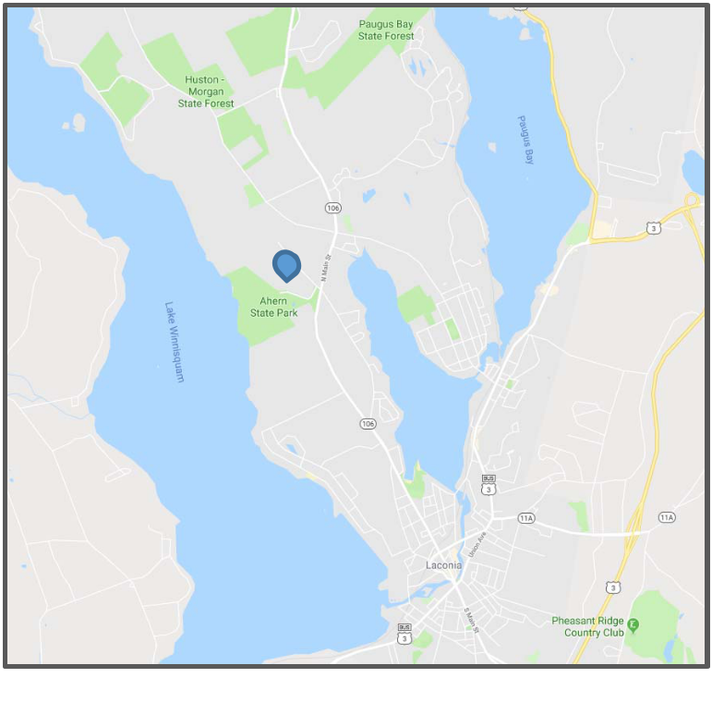

The Lakes Region Facility Site (“Site”), located along State Route 106 in the City of Laconia is currently owned by the State of New Hampshire and is approximately 250 acres. It is surrounded by large areas of open space and passive recreation land, including the immediately adjacent Ahearn State Park with 3,500 linear feet of waterfront access to Lake Winnisquam and is used for swimming, biking, fishing, and hiking. The Site is within three miles of downtown Laconia along Route 3.

Currently the property is primarily unused, with some remaining users such as the Lakes Region Mutual Fire Aid station on the southern portion of the property, a sports complex owned by the City in the northern part of the property, and some remaining state intuitional users. Structures do remain onsite, but most of them have significant environmental and structural issues.

Lakes Region

Facility

Figure 3: Site Location

The Site was appraised in 2011 at $2,160,000. The

appraisal included assumptions regarding the zoning associated with the parcel of Rural Residential 1, which required a lot area of two acres and any cluster developments requiring a Conditional Use Permit from the City. This zoning allowed for approximately 75 building lots when accounting for infrastructure, roads, and some common area. Since that time, there has been discussion regarding adjusting the zoning and the City is undergoing a Master Planning process where zoning of the Site for mixed-use is being considered.

Significant planning and visioning work has been done related to the Site to help identify potential redevelopment opportunities. Some of the work includes a report by
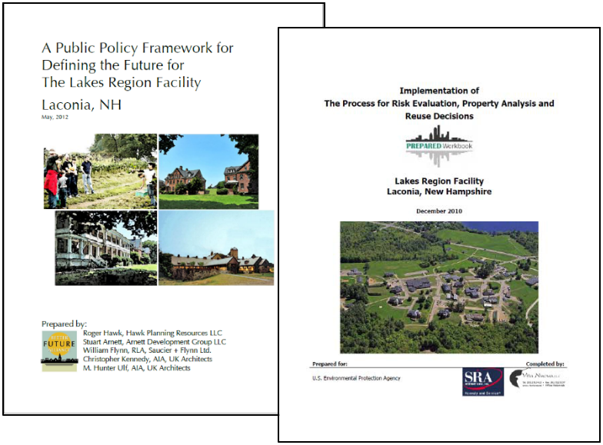
Vita Nuova that was prepared for the United States Environmental Protection Agency, a community visioning process around reuse of the Site, an appraisal of the property, a Public Policy Framework for Defining the Future of the Lakes Region Facility prepared by Better Future Alliance, and many other community conversations and engagement sessions. All of this work was reviewed as part of this market analysis and supplemented with additional information gathered from data collection and analysis as well as interviews.

Camoin Associates | DRAFT - Real Estate Market Analysis: State of New Hampshire Lakes Region Facility | 7

Demographic and Socioeconomic Profile

Overview:

Table 1, below, compares basic demographic indicators for the City of Laconia, Belknap County, Lakes Region, Economic Region, and State of New Hampshire. The key comparisons include the following:

■

■

The Economic Region is projected to grow at the fastest rate compared to comparison geographies in terms of population and households, adding 23,460 people, an increase of 3.1% through 2022.

The average household size is largest in the Economic Region, followed by the state with 2.49 and 2.45, respectively. Average household size is projected to stay stagnant across all geographies, except for the City of Laconia, where average household size is projected to increase by 0.01 to 2.28, a 0.4% increase.

- The population of the Economic Region is significantly younger than the populations of the other study areas, with a median age of 41.1. The Lakes Region has the oldest population, with median age of 47.5, and is also projected to age faster than comparison geographies over the coming five years.

- Economic Region households are wealthier than residents of comparison geographies overall, with a median household income of nearly $71,000. The City of Laconia demonstrates the lowest median household income, at $51,963.

- Despite the City of Laconia showing the lowest median income in 2017 with $51,963, income is projected to grow rapidly through 2022, with a growth rate of 18.8% to $61,736. The Economic Region shows the slowest projected growth, at 9.7%.

Camoin Associates | DRAFT - Real Estate Market Analysis: State of New Hampshire Lakes Region Facility | 8

Table 1: Basic Demographic Comparison

Basic Demographics

 |  |  |  | Population
 |  | 2017 |  | 2022 | Change 2017-2022 |  | % Change 2017-2022
City of Laconia |  | 16,393 |  | 16,696 |  | 303 | 1.8%
Belknap County |  | 62,479 |  | 64,033 |  | 1,554 | 2.5%
Lakes Region |  | 116,558 |  | 118,628 |  | 2,070 | 1.8%
Economic Region |  | 761,455 |  | 784,915 |  | 23,460 | 3.1%
New Hampshire |  | 1,364,251 |  | 1,397,066 |  | 32,815 | 2.4%
 |  |  |  | Households
 |  | 2017 |  | 2022 | Change 2017-2022 |  | % Change 2017-2022
City of Laconia |  | 6,999 |  | 7,125 |  | 126 | 1.8%
Belknap County |  | 25,687 |  | 26,313 |  | 626 | 2.4%
Lakes Region |  | 48,543 |  | 49,412 |  | 869 | 1.8%
Economic Region |  | 296,072 |  | 305,448 |  | 9,376 | 3.2%
New Hampshire |  | 538,434 |  | 552,164 |  | 13,730 | 2.5%
 |  | Average Household Size
 |  | 2017 |  | 2022 | Change 2017-2022 |  | % Change 2017-2022
City of Laconia |  | 2.27 |  | 2.28 |  | 0.01 | 0.4%
Belknap County |  | 2.40 |  | 2.40 |  | 0.00 | 0.0%
Lakes Region |  | 2.36 |  | 2.36 |  | 0.00 | 0.0%
Economic Region |  | 2.49 |  | 2.49 |  | 0.00 | 0.0%
New Hampshire |  | 2.45 |  | 2.45 |  | 0.00 | 0.0%
 |  |  |  | Median Age
 |  | 2017 |  | 2022 | Change 2017-2022 |  | % Change 2017-2022
City of Laconia |  | 44.5 |  | 45.2 |  | 0.7 | 1.6%
Belknap County |  | 46.6 |  | 47.9 |  | 1.3 | 2.8%
Lakes Region |  | 47.5 |  | 48.9 |  | 1.4 | 2.9%
Economic Region |  | 41.1 |  | 42.0 |  | 0.9 | 2.2%
New Hampshire |  | 42.7 |  | 43.6 |  | 0.9 | 2.1%
 |  | Median Household Income
 |  | 2017 |  | 2022 | Change 2017-2022 |  | % Change 2017-2022
City of Laconia | $ | 51,963 | $ | 61,736 | $ | 9,773 | 18.8%
Belknap County | $ | 59,621 | $ | 68,503 | $ | 8,882 | 14.9%
Lakes Region | $ | 58,010 | $ | 66,361 | $ | 8,351 | 14.4%
Economic Region | $ | 70,931 | $ | 77,829 | $ | 6,898 | 9.7%
New Hampshire | $ | 69,725 | $ | 77,446 | $ | 7,721 | 11.1%
Source: Esri


Camoin Associates | DRAFT - Real Estate Market Analysis: State of New Hampshire Lakes Region Facility | 9
Commuting Patterns

The following images and tables present information on where Economic Region residents work and where Economic Region workers live. Jobs are concentrated primarily in Manchester, where nearly 13% of residents work. Manchester also houses the highest concentration of regional workers, at 11.4%. Approximately 234,400 people both live and work within the Economic Region. Approximately 113,500 live within the Economic Region and are employed outside, while 94,400 are employed within the region and live outside.

Figure 4: Commuting Patterns, Economic Region

Source: OntheMap

Camoin Associates | DRAFT - Real Estate Market Analysis: State of New Hampshire Lakes Region Facility | 10

Table 2 and Figure 6 show the concentrations of where residents of the Economic Region work. The City of Manchester holds the most workers by far, at 12.9% of the regional population. However, the City of Nashua and City of Concord also hold high concentrations of workers, at 9.7% and 8.6%, respectively. This data indicates that work places are fairly spread out across the Economic Region, as 50% of the regional population falls under the “All Other Municipalities” category.

Table 2: Residents by Place of Work, Economic Region

Economic Region Residents by Place of Work, 2015
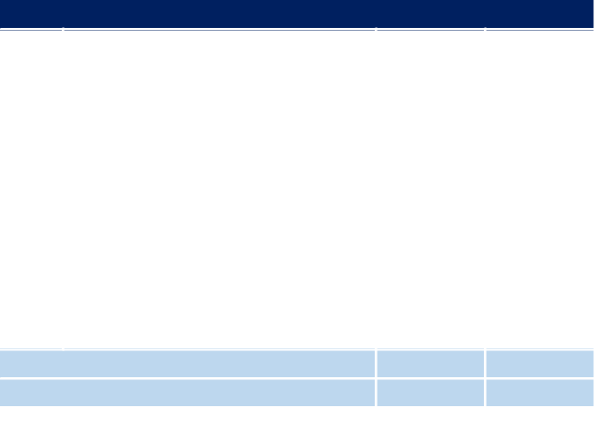

Rank | Municipality | Count | Share
1 | Manchester city, NH | 44,752 | 12.9%
2 | Nashua city, NH | 33,710 | 9.7%
3 | Concord city, NH | 29,852 | 8.6%
4 | Merrimack town, NH | 11,020 | 3.2%
5 | Bedford town, NH | 10,702 | 3.1%
6 | Portsmouth city, NH | 10,351 | 3.0%
7 | Dover city, NH | 9,973 | 2.9%
8 | Hooksett town, NH | 8,608 | 2.5%
9 | Londonderry town, NH | 7,767 | 2.2%
10 | Rochester city, NH | 7,538 | 2.2%
 | All Other Municipalities | 173,620 | 49.9%
 | Total | 347,893 | 100%

Sourc: Census OnTheMap

Figure 6: Map - Residents by Place of Work, Economic Region

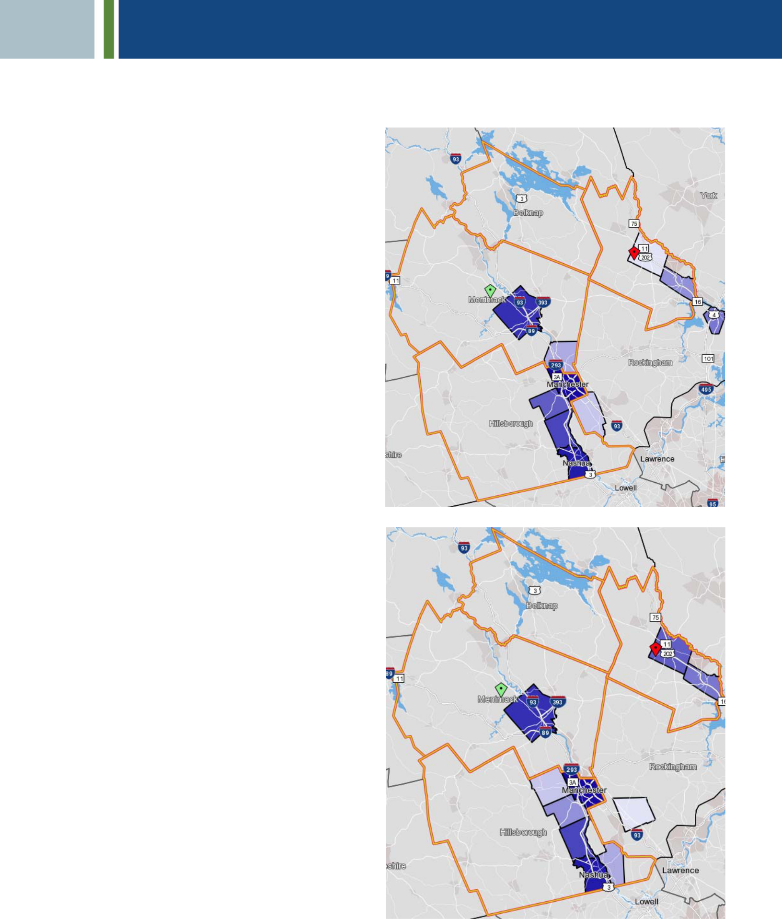

Source: OntheMap

Figure 5: Map - Workers by Place of Residence, Economic Region

Table 3 and Figure 5 show the concentrations of where Economic Region workers live. Few people who work within the region live outside of it. Workers primarily live within Manchester, followed by Nashua and Concord cities, at 11.4%, 7.6%, and 5.1%, respectively. Again, workers’ places of residence are vastly spread out across the region, as over 60% fall within the “All Other Municipalities” category.

Table 3: Workers by Place of Residence, Economic Region

Economic Region Workers by Place of Residence, 2015
Rank | Municipality | Count | Share
1 | Manchester city, NH | 37,463 | 11.4%
2 | Nashua city, NH | 25,125 | 7.6%
3 | Concord city, NH | 16,771 | 5.1%
4 | Merrimack town, NH | 7,493 | 2.9%
5 | Rochester city, NH | 8,597 | 2.6%
6 | Dover city, NH | 7,553 | 2.3%
7 | Bedford town, NH | 7,280 | 2.2%
8 | Hudson town, NH | 6,597 | 2.0%
9 | Goffstown town, NH | 6,297 | 1.9%
10 | Derry town, NH | 6,070 | 1.8%
 | All Other Municipalities | 197,537 | 60.1% | Source: OntheMap
 | Total | 328,893 | 100% | Source: OntheMap
Sourc: Census OnTheMap
 | Camoin Associates | | DRAFT - Real Estate Market Analysis: State of New Hampshire Lakes Region Facility |  |  | 11

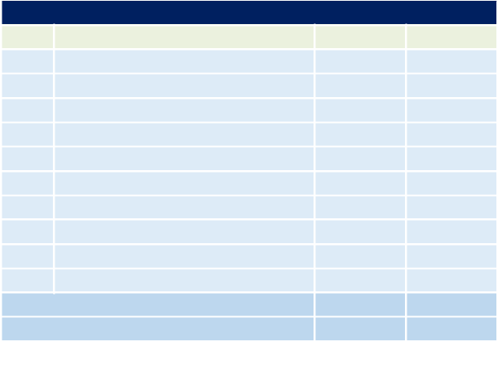

Conclusion

Through the interviews and analysis of demographic data, it is evident that the Lakes Region is facing a large challenge related to the older age of residents. This challenge is similar to many other communities in New England, and is a result of limited housing options, limited job options, and limited entertainment and social opportunities. As young people move out of the area, the businesses have a greater difficulty finding a quality workforce and they are forced to look to locate elsewhere.

Camoin Associates | DRAFT - Real Estate Market Analysis: State of New Hampshire Lakes Region Facility | 12
Industrial and Flex Space

Industrial space is commercial space that is utilized for purposes such as light manufacturing, warehousing and distribution, research and development, transportation, etc. Similar to industrial space, flex space is defined as:

“A type of building(s) designed to be versatile, which may be used in combination with office (corporate headquarters), research and development, quasi- retail sales, and including but not limited to industrial, warehouse, and distribution uses. At least half of the rentable area of the building must be used as office space. Flex buildings typically have ceiling heights under 18', with light industrial zoning. Flex buildings have also been called Incubator, Tech and Showroom buildings in markets throughout the country.”²

Flex space buildings can be used for office, medical, industrial, warehouse, distribution, quasi-retail, or research and development space.

Market Conditions

The national market for industrial space continues to tighten as consumer spending steadily rises and e-commerce becomes a staple in everyday life, causing increased need for warehousing and distribution space across the country. Industrial demand has not wavered, despite rising rents. Average NNN rents in the US in Q1 of 2017 reached $ 5.25 for industrial space, while vacancy fell to 5.3% in the same period.³ The Jones Lang LaSalle (JLL) Industrial Outlook for 2017 reported that 206.7 million square feet of industrial space was under construction in Q1 of 2017. However, absorption continues to outpace new deliveries nationally. Most regional markets are projected to continue to favor landlords as demand remains steady.⁴

According to CBRE’s most recent 2018 New England Market Outlook report, the New Hampshire industrial and flex space market is extremely tight, with a steady increase in demand coupled with stagnant supply. This combination has led to an increase in off-market transactions as motivated buyers look to get creative to acquire desired space. Digging deeper into the market in the 93/3 Corridor (which contains the Economic Region but is more focused on Southern New Hampshire) more specifically, CBRE reports that developers are quickly moving to identify sites for new industrial space. Currently, there is 44.2 million square feet of industrial space within this submarket; however, absorption rates are high, at 6.6% in 2017. The low vacancy rates and high demand have given landlords the power to capture longer and more expensive lease agreements. Looking at Manchester as an example, NNN rates rose from $6.09 in 2016 to $6.16 in 2017.

CBRE states, “…existing inventory will continue to have strong absorption unless a property’s obsolescence prevents this, in which case repurposing and redevelopment remain viable options.” The report also projects that rental rates may continue to rise throughout the southern part of New Hampshire. The scarcity of high quality industrial and flex space leaves room for new development within the region.⁵

Looking more specifically in the Laconia area, existing industrial parks such as the Lakes Region Industrial Park and O’Shea Industrial park have excess supply and have been unable to lease up or sell the space. The transportation access to the Site is a constraint for manufactures who are looking to locate in close proximity to major highways and close to major markets.

- CoStar.
- CoStar defines triple net (NNN) rents as, “A lease in which a tenant is responsible for all expenses associated with their proportional share of occupancy of the building.”

⁴ JLL US Industrial Outlook 2017.
⁵ CBRE 2018 New England Market Outlook.

Camoin Associates | DRAFT - Real Estate Market Analysis: State of New Hampshire Lakes Region Facility | 13
Demand

Future demand for industrial and flex space can be better understood by looking at employment projections within the industry sectors likely to utilize this space. Specifically, the following two-digit NAICS industries were examined: Mining, Quarrying, and Oil and Gas Extraction; Utilities; Manufacturing; and Transportation and Warehousing.

Table 4 shows employment growth in the four industries broken down into the more detailed 3-digit NAICS level for the Lakes Region. Most growth is expected in Manufacturing, which will expand by 127 jobs on net over the next 10 years. This growth is most concentrated in the Fabricated Metal Product Manufacturing, which is projected to grow by 127 jobs, as well as Transportation Equipment Manufacturing, which is predicted to grow by 37 jobs. Assuming that manufacturing related jobs require approximately 500 square feet per job, that would mean that the market could support approximately 63,500 square feet of industrial space, which could be accommodated within the existing parks or at other business parks in the Lakes Region.

Table 4: Industrial Job Growth, Lakes Region

Industrial Growth, Lakes Region


NAICS | Description | 2017 Jobs | 2027 Jobs | 2017 - 2027 2017 - 2027
 |  |  |  | # Change | % Change
211 | Oil and Gas Extraction | 0 | 0 | 0 | 0%
212 | Mining (except Oil and Gas) | 63 | 67 | 4 | 6%
213 | Support Activities for Mining | 12 | 25 | 13 | 108%
221 | Utilities | 237 | 241 | 4 | 2%
311 | Food Manufacturing | 63 | 95 | 32 | 51%
312 | Beverage and Tobacco Product Manufacturing | 50 | 65 | 15 | 30%
313 | Textile Mills | <10 | <10 | Insf. Data | Insf. Data
314 | Textile Product Mills | 17 | 20 | 3 | 18%
315 | Apparel Manufacturing | <10 | <10 | Insf. Data | Insf. Data
316 | Leather and Allied Product Manufacturing | 0 | 0 | 0 | 0%
321 | Wood Product Manufacturing | 202 | 216 | 14 | 7%
322 | Paper Manufacturing | 28 | 17 | (11) | -39%
323 | Printing and Related Support Activities | 62 | 53 | (9) | -15%
324 | Petroleum and Coal Products Manufacturing | <10 | <10 | Insf. Data | Insf. Data
325 | Chemical Manufacturing | 13 | 17 | 4 | 31%
326 | Plastics and Rubber Products Manufacturing | 318 | 350 | 32 | 10%
327 | Nonmetallic Mineral Product Manufacturing | 48 | 47 | (1) | -2%
331 | Primary Metal Manufacturing | 278 | 294 | 16 | 6%
332 | Fabricated Metal Product Manufacturing | 1,726 | 1,853 | 127 | 7%
333 | Machinery Manufacturing | 884 | 812 | (72) | -8%
334 | Computer and Electronic Product Manufacturing | 606 | 582 | (24) | -4%
335 | Electrical Equipment, Appliance, and Component | 70 | 96 | 26 | 37%
335 | Manufacturing
336 | Transportation Equipment Manufacturing | 286 | 323 | 37 | 13%
337 | Furniture and Related Product Manufacturing | 20 | 28 | 8 | 40%
339 | Miscellaneous Manufacturing | 372 | 302 | (70) | -19%
481 | Air Transportation | 0 | 0 | 0 | 0%
482 | Rail Transportation | <10 | <10 | Insf. Data | Insf. Data
483 | Water Transportation | 0 | 0 | 0 | 0%
484 | Truck Transportation | 187 | 217 | 30 | 16%
485 | Transit and Ground Passenger Transportation | 240 | 239 | (1) | 0%
486 | Pipeline Transportation | 0 | 0 | 0 | 0%
487 | Scenic and Sightseeing Transportation | <10 | <10 | Insf. Data | Insf. Data
488 | Support Activities for Transportation | 37 | 36 | (1) | -3%
491 | Postal Service | <10 | <10 | Insf. Data | Insf. Data
492 | Couriers and Messengers | 155 | 138 | (17) | -11%
493 | Warehousing and Storage | 22 | 31 | 9 | 41%
Total |  | 6,017 | 6,180 | 163 | 0
Source: EMSI

Camoin Associates | DRAFT - Real Estate Market Analysis: State of New Hampshire Lakes Region Facility | 14
Table 5 examines the same industrial growth data for the Economic Region. On net, Transportation and Warehousing industries are projected to see the most growth over the coming 10-year period, adding 212 jobs. Transit and Ground Passenger Transportation and Couriers and Messengers are projected to see the most growth of these subsectors, adding 145 jobs and 126 jobs, respectively. Though the 2 -digit Manufacturing industry shows net job loss of 1,323 jobs, three Manufacturing subsectors are projected to see significant growth: Fabricated Metal Product Manufacturing (+375 jobs); Transportation Equipment Manufacturing (+314 jobs); and Food Manufacturing (+149 jobs).

Table 5: Industrial Job Growth, Economic Region

Industrial Growth, Economic Region


NAICS | Description | 2017 Jobs | 2027 Jobs | 2017 - 2027 2017 - 2027
 |  |  |  | # Change | % Change
211 | Oil and Gas Extraction | 0 | 0 | 0 | 0%
212 | Mining (except Oil and Gas) | 306 | 315 | 9 | 3%
213 | Support Activities for Mining | 30 | 57 | 27 | 90%
221 | Utilities | 798 | 678 | (120) | -15%
311 | Food Manufacturing | 1,007 | 1,156 | 149 | 15%
312 | Beverage and Tobacco Product Manufacturing | 508 | 506 | (2) | 0%
313 | Textile Mills | 1,303 | 1,388 | 85 | 7%
314 | Textile Product Mills | 299 | 366 | 67 | 22%
315 | Apparel Manufacturing | 325 | 361 | 36 | 11%
316 | Leather and Allied Product Manufacturing | 43 | 38 | (5) | -12%
321 | Wood Product Manufacturing | 649 | 702 | 53 | 8%
322 | Paper Manufacturing | 501 | 210 | (291) | -58%
323 | Printing and Related Support Activities | 1,410 | 1,165 | (245) | -17%
324 | Petroleum and Coal Products Manufacturing | 30 | 26 | (4) | -13%
325 | Chemical Manufacturing | 439 | 476 | 37 | 8%
326 | Plastics and Rubber Products Manufacturing | 3,342 | 3,249 | (93) | -3%
327 | Nonmetallic Mineral Product Manufacturing | 844 | 783 | (61) | -7%
331 | Primary Metal Manufacturing | 1,881 | 1,951 | 70 | 4%
332 | Fabricated Metal Product Manufacturing | 5,765 | 6,140 | 375 | 7%
333 | Machinery Manufacturing | 2,333 | 1,949 | (384) | -16%
334 | Computer and Electronic Product Manufacturing | 12,327 | 11,490 | (837) | -7%
335 | Electrical Equipment, Appliance, and Component | 1,585 | 1,020 | (565) | -36%
335 | Manufacturing
336 | Transportation Equipment Manufacturing | 1,757 | 2,071 | 314 | 18%
337 | Furniture and Related Product Manufacturing | 406 | 488 | 82 | 20%
339 | Miscellaneous Manufacturing | 2,945 | 2,841 | (104) | -4%
481 | Air Transportation | 270 | 302 | 32 | 12%
482 | Rail Transportation | 163 | 165 | 2 | 1%
483 | Water Transportation | 0 | 0 | 0 | 0%
484 | Truck Transportation | 1,786 | 1,777 | (9) | -1%
485 | Transit and Ground Passenger Transportation | 1,789 | 1,934 | 145 | 8%
486 | Pipeline Transportation | 0 | 0 | 0 | 0%
487 | Scenic and Sightseeing Transportation | 62 | 80 | 18 | 29%
488 | Support Activities for Transportation | 546 | 522 | (24) | -4%
491 | Postal Service | <10 | <10 | Insf. Data | Insf. Data
492 | Couriers and Messengers | 1,697 | 1,823 | 126 | 7%
493 | Warehousing and Storage | 1,115 | 1,037 | (78) | -7%
Total |  | 48,265 | 47,074 | (1,191) | (0)
Source: EMSI

Conclusion

The Lakes Region and City of Laconia do not have strong demands for industrial space. While there is some growth in industrial utilizing industries, a traditional industrial park would not be appropriate for the Site as the demand is not strong enough. Niche industrial users could be a good fit if they are aligned with the increased interest for people to know where they are getting their goods and products from.

Camoin Associates | DRAFT - Real Estate Market Analysis: State of New Hampshire Lakes Region Facility | 15
Office Space

Market Conditions

The rise of the tech industry nationally is driving most demand for office space. The tech industry’s leasing volume has vastly outpaced that of any other industry. This trend has been particularly driven by increasing business and consumer confidence. JLL’s 2017 US Office Outlook report concludes that, “rents surge as business confidence jumps and economic forecasts remain optimistic.” National data shows that Class A rents have outpaced Class B rents more than two -fold, bringing the average rent in the US office market to $32.78 per square foot in Q1 of 2017. Vacancy during that same period was 14.7% and is projected to rise nationally through 2018 due to additional completions resulting in tenants shifting to newer space, leaving outdated space vacant.⁶

Office culture in the United States is drastically evolving due to changing preferences and priorities of employees. CBRE posits,

“Driven by the purported preferences of millennial employees, who make up an ever-increasing share of the workforce, ‘traditional’ office configurations have become a borderline liability in many places. Instead of long hallways with closed-door private offices and low-ceilinged, fluorescent-lit cube farms, open bench seating and exposed HVAC systems are becoming de rigueur for most remodeling efforts.”

This cultural shift is in turn affecting the types of office space demanded by local businesses. Employees expect to see open space with lounge areas, cafés, and glass walls and doors dispersed throughout their work environment.

Examining office market trends in the Interstate 93/Route 3 Corridor shows that vacancies are lower in southern New Hampshire as compared to other New England regions; however, rents are also lower. CBRE reported a vacancy rate of 10.4% in both 2016 and 2017 in the corridor, while NNN rents also remained flat at $11.31. In total, the corridor currently houses about 22.3 million square feet of office space. CBRE’s projections through 2018 show that vacancy and rental rates will remain flat, but will also stay above those of the adjacent Seacoast submarket. ⁷

- JLL US Office Outlook 2017.
- CBRE 2018 New England Market Outlook.

Camoin Associates | DRAFT - Real Estate Market Analysis: State of New Hampshire Lakes Region Facility | 16
Demand

The demand outlook for office space in the Lakes Region and Economic Region markets is dependent on growth in office-utilizing occupations. Table 6 shows the categories of office utilizing occupations and the expected 10-year growth in those occupations through 2027. The total number of new office-utilizing occupations is then used to estimate future office space demand. There is projected to be a total of 730 new office-utilizing occupations in the Lakes Region and 10,608 new office-utilizing jobs throughout the Economic Region by 2027.

Table 6: Growth in Office Utilizing Occupations, Lakes Region

 | Growth in Office Utilizing Occupations, Lakes Region
SOC Code | Title | 2017 Jobs 2027 Jobs # Change % Change |  |  |  | Avg. Hourly
 |  |  |  |  |  | Earnings
11-1000 | Top Executives | 795 | 842 | 47 | 6% | $ | 55.35
11-2000 | Advertising, Marketing, Promotions, Public | 179 | 193 | 14 | 8% | $ | 56.42
 | Relations, and Sales Managers
11-3000 | Operations Specialties Managers | 497 | 537 | 40 | 8% | $ | 51.42
11-9000 | Other Management Occupations | 1,308 | 1,322 | 14 | 1% | $ | 32.84
13-1000 | Business Operations Specialists | 1,094 | 1,184 | 90 | 8% | $ | 31.55
13-2000 | Financial Specialists | 590 | 616 | 26 | 4% | $ | 32.70
15-1100 | Computer Occupations | 683 | 766 | 83 | 12% | $ | 36.64
15-2000 | Mathematical Science Occupations | 41 | 49 | 8 | 20% | $ | 35.28
17-1000 | Architects, Surveyors, and Cartographers | 57 | 53 | (4) | -7% | $ | 29.75
17-2000 | Engineers | 471 | 491 | 20 | 4% | $ | 40.12
17-3000 | Drafters, Engineering Technicians, and Mapping | 243 | 242 | (1) | 0% | $ | 24.98
 | Technicians
19-3000 | Social Scientists and Related Workers | 88 | 92 | 4 | 5% | $ | 34.42
21-1000 | Counselors, Social Workers, and Other | 577 | 614 | 37 | 6% | $ | 21.69
 | Community and Social Service Specialists
23-1000 | Lawyers, Judges, and Related Workers | 170 | 157 | (13) | -8% | $ | 47.67
23-2000 | Legal Support Workers | 98 | 87 | (11) | -11% | $ | 24.09
27-1000 | Art and Design Workers | 279 | 321 | 42 | 15% | $ | 17.26
27-2000 | Entertainers and Performers, Sports and Related | 227 | 259 | 32 | 14% | $ | 21.11
 | Workers
27-3000 | Media and Communication Workers | 200 | 212 | 12 | 6% | $ | 22.38
27-4000 | Media and Communication Equipment Workers | 70 | 78 | 8 | 11% | $ | 19.03
29-1000 | Health Diagnosing and Treating Practitioners | 1,677 | 1,747 | 70 | 4% | $ | 48.01
29-2000 | Health Technologists and Technicians | 803 | 868 | 65 | 8% | $ | 22.81
29-9000 | Other Healthcare Practitioners and Technical | 63 | 66 | 3 | 5% | $ | 31.72
 | Occupations
31-2000 | Occupational Therapy and Physical Therapist | 90 | 112 | 22 | 24% | $ | 24.68
 | Assistants and Aides
31-9000 | Other Healthcare Support Occupations | 351 | 388 | 37 | 11% | $ | 17.14
33-1000 | Supervisors of Protective Service Workers | 118 | 126 | 8 | 7% | $ | 32.23
33-9000 | Other Protective Service Workers | 231 | 228 | (3) | -1% | $ | 14.43
37-1000 | Supervisors of Building and Grounds Cleaning and | 167 | 175 | 8 | 5% | $ | 19.47
 | Maintenance Workers
43-1000 | Supervisors of Office and Administrative Support | 413 | 440 | 27 | 7% | $ | 24.99
 | Workers
43-2000 | Communications Equipment Operators | 33 | 24 | (9) | -27% | $ | 14.51
43-3000 | Financial Clerks | 870 | 825 | (45) | -5% | $ | 17.20
43-4000 | Information and Record Clerks | 1,443 | 1,515 | 72 | 5% | $ | 15.10
43-5000 | Material Recording, Scheduling, Dispatching, and | 1,358 | 1,352 | (6) | 0% | $ | 15.61
 | Distributing Workers
43-6000 | Secretaries and Administrative Assistants | 1,039 | 1,047 | 8 | 1% | $ | 17.31
43-9000 | Other Office and Administrative Support Workers | 1,189 | 1,212 | 23 | 2% | $ | 16.51
Total |  | 17,510 | 18,240 | 730 | 4% | $ | 28.38
Source: EMSI


Camoin Associates | DRAFT - Real Estate Market Analysis: State of New Hampshire Lakes Region Facility | 17
Table 7: Growth in Office Utilizing Occupations, Economic Region

 | Growth in Office Utilizing Occupations, Economic Region
SOC Code | Title | 2017 Jobs 2027 Jobs # Change % Change |  |  |  | Avg. Hourly
 |  |  |  |  |  | Earnings
11-1000 | Top Executives | 6,808 | 7,131 | 323 | 5% | $ | 60.91
11-2000 | Advertising, Marketing, Promotions, Public | 2,080 | 2,205 | 125 | 6% | $ | 61.06
 | Relations, and Sales Managers
11-3000 | Operations Specialties Managers | 5,527 | 5,866 | 339 | 6% | $ | 55.70
11-9000 | Other Management Occupations | 9,163 | 9,369 | 206 | 2% | $ | 38.81
13-1000 | Business Operations Specialists | 11,929 | 12,819 | 890 | 7% | $ | 32.91
13-2000 | Financial Specialists | 6,849 | 7,425 | 576 | 8% | $ | 36.76
15-1100 | Computer Occupations | 11,051 | 12,181 | 1,130 | 10% | $ | 40.93
15-2000 | Mathematical Science Occupations | 610 | 734 | 124 | 20% | $ | 38.51
17-1000 | Architects, Surveyors, and Cartographers | 386 | 364 | (22) | -6% | $ | 29.76
17-2000 | Engineers | 5,071 | 5,052 | (19) | 0% | $ | 44.43
17-3000 | Drafters, Engineering Technicians, and Mapping | 2,595 | 2,462 | (133) | -5% | $ | 27.12
 | Technicians
19-3000 | Social Scientists and Related Workers | 646 | 678 | 32 | 5% | $ | 36.58
21-1000 | Counselors, Social Workers, and Other | 4,964 | 5,401 | 437 | 9% | $ | 22.35
 | Community and Social Service Specialists
23-1000 | Lawyers, Judges, and Related Workers | 1,535 | 1,507 | (28) | -2% | $ | 54.04
23-2000 | Legal Support Workers | 1,068 | 1,057 | (11) | -1% | $ | 26.29
27-1000 | Art and Design Workers | 2,366 | 2,588 | 222 | 9% | $ | 19.11
27-2000 | Entertainers and Performers, Sports and Related | 1,803 | 2,080 | 277 | 15% | $ | 19.75
 | Workers
27-3000 | Media and Communication Workers | 2,134 | 2,209 | 75 | 4% | $ | 24.60
27-4000 | Media and Communication Equipment Workers | 744 | 809 | 65 | 9% | $ | 19.38
29-1000 | Health Diagnosing and Treating Practitioners | 15,175 | 17,068 | 1,893 | 12% | $ | 51.02
29-2000 | Health Technologists and Technicians | 7,108 | 8,042 | 934 | 13% | $ | 23.51
29-9000 | Other Healthcare Practitioners and Technical | 596 | 647 | 51 | 9% | $ | 31.46
 | Occupations
31-2000 | Occupational Therapy and Physical Therapist | 568 | 686 | 118 | 21% | $ | 23.41
 | Assistants and Aides
31-9000 | Other Healthcare Support Occupations | 3,931 | 4,536 | 605 | 15% | $ | 17.74
33-1000 | Supervisors of Protective Service Workers | 686 | 719 | 33 | 5% | $ | 35.40
33-9000 | Other Protective Service Workers | 2,263 | 2,430 | 167 | 7% | $ | 15.43
37-1000 | Supervisors of Building and Grounds Cleaning and | 922 | 989 | 67 | 7% | $ | 20.37
 | Maintenance Workers
43-1000 | Supervisors of Office and Administrative Support | 3,946 | 4,221 | 275 | 7% | $ | 26.73
 | Workers | 299 | 226 | (73) | -24% | $ | 15.77
43-2000 | Communications Equipment Operators
43-3000 | Financial Clerks | 8,285 | 8,141 | (144) | -2% | $ | 18.56
43-4000 | Information and Record Clerks | 13,816 | 14,799 | 983 | 7% | $ | 16.55
43-5000 | Material Recording, Scheduling, Dispatching, and | 12,191 | 12,098 | (93) | -1% | $ | 16.66
 | Distributing Workers
43-6000 | Secretaries and Administrative Assistants | 10,528 | 11,096 | 568 | 5% | $ | 18.42
43-9000 | Other Office and Administrative Support Workers | 13,171 | 13,787 | 616 | 5% | $ | 17.65
Total |  | 170,812 | 181,420 | 10,608 | 6% | $ | 30.82
Source: EMSI


Camoin Associates | DRAFT - Real Estate Market Analysis: State of New Hampshire Lakes Region Facility | 18
Based on the above analysis, it is estimated that the Lakes Region will add 73 office-utilizing occupations per year, while the Economic Region is projected to add approximately 1,061 office occupations per year. Using an industry standard of 200 square feet per employee, we estimated an annual demand of 14,600 square feet of office space per year in the Lakes Region and 212,160 square feet of space in the Economic Region. Over five years to 2022, the total office demand in the Lakes Region is estimated to be 73,000 square feet and 1.06 million square feet in the Economic Region. It is important to point out that there is some overlap between the regions geographically and therefore, job figures and square foot estimates in the two regions will also contain some overlap.

Table 8: Office Space Demand

Office Space Demand
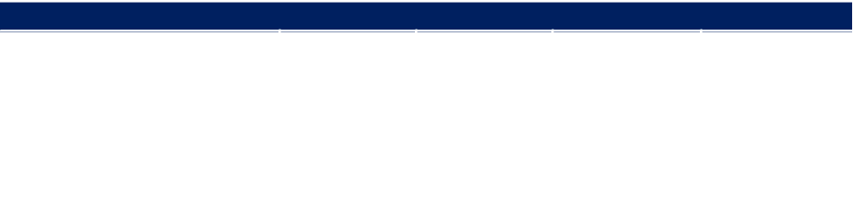

Geography | Annual New | SF per | Annual | 5-Year
Geography | Annual New | SF per | Demand for | Demand for
Geography | Employees | Employee | Demand for | Demand for
 | Employees | Employee | Office Space | Office Space
Lakes Region | 73 | 200 | 14,600 | 73,000
Economic Region | 1,061 | 200 | 212,160 | 1,060,800
Source: EMSI; Camoin Associates

Medical Office Demand

The level of future demand for medical office space can be determined by looking at industry job projections for the various health -related industry sub-sectors. Table 9 and Table 10 show a breakdown of job growth in the health industry from 2017 to 2027 for the Lakes Region and Economic Region. Over the next ten years, there will be an estimated 204 new health industry jobs in the Lakes Region and 5,562 new health industry jobs in the Economic Region. Not all of the sub-sectors require office space; however, some that do are expected to see large gains, including Offices of Physicians (1,500 new jobs in Economic Region); Offices of Dentists (208 new jobs in the Economic Region); and Offices of Other Health Practitioners (387 new jobs in the Economic Region).

Table 9: Health Industry Growth, Lakes Region

 | Health Industry Growth, Lakes Region |  |  | 2017 - 2027 | 2017 - 2027
NAICS | Description | 2017 Jobs | 2027 Jobs | 2017 - 2027 | 2017 - 2027
 |  |  |  | # Change | % Change
6211 | Offices of Physicians | 593 | 658 | 65 | 11%
6212 | Offices of Dentists | 253 | 279 | 26 | 10%
6213 | Offices of Other Health Practitioners | 336 | 458 | 122 | 36%
6214 | Outpatient Care Centers | 248 | 327 | 79 | 32%
6215 | Medical and Diagnostic Laboratories | <10 | <10 | Insf. Data | Insf. Data
6216 | Home Health Care Services | 344 | 400 | 56 | 16%
6219 | Other Ambulatory Health Care Services | 98 | 128 | 30 | 31%
6221 | General Medical and Surgical Hospitals | 1,821 | 1,707 | (114) | -6%
6222 | Psychiatric and Substance Abuse Hospitals | 0 | 0 | 0 | 0%
6223 | Specialty (except Psychiatric and Substance Abuse) Hospitals | 0 | 0 | 0 | 0%
6231 | Nursing Care Facilities (Skilled Nursing Facilities) | 793 | 706 | (87) | -11%
6232 | Residential Intellectual and Developmental Disability, Mental | 106 | 134 | 28 | 26%
Total | Health, and Substance Abuse Facilities | 4,593 | 4,797 | 204 | 4%
Source: EMSI
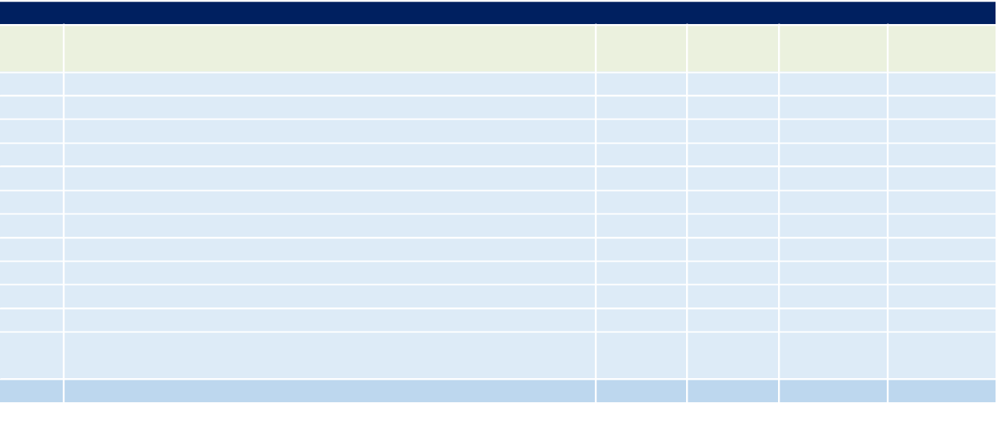

Camoin Associates | DRAFT - Real Estate Market Analysis: State of New Hampshire Lakes Region Facility | 19
Table 10: Health Industry Growth, Economic Region

Health Industry Growth, Economic Region


NAICS | Description | 2017 Jobs | 2027 Jobs | 2017 - 2027 | 2017 - 2027
 |  |  |  | # Change | % Change
6211 | Offices of Physicians | 7,935 | 9,435 | 1,500 | 19%
6212 | Offices of Dentists | 2,701 | 2,909 | 208 | 8%
6213 | Offices of Other Health Practitioners | 2,269 | 2,656 | 387 | 17%
6214 | Outpatient Care Centers | 2,589 | 3,196 | 607 | 23%
6215 | Medical and Diagnostic Laboratories | 250 | 346 | 96 | 38%
6216 | Home Health Care Services | 2,599 | 3,294 | 695 | 27%
6219 | Other Ambulatory Health Care Services | 712 | 915 | 203 | 29%
6221 | General Medical and Surgical Hospitals | 14,875 | 16,109 | 1,234 | 8%
6222 | Psychiatric and Substance Abuse Hospitals | 0 | 0 | 0 | 0%
6223 | Specialty (except Psychiatric and Substance Abuse) Hospitals | 940 | 1,254 | 314 | 33%
6231 | Nursing Care Facilities (Skilled Nursing Facilities) | 4,633 | 4,701 | 68 | 1%
6232 | Residential Intellectual and Developmental Disability, Mental | 1,460 | 1,710 | 250 | 17%
 | Health, and Substance Abuse Facilities
Total |  | 40,964 | 46,526 | 5,562 | 14%
Source: EMSI

Conclusion

A traditional office park is not be a feasible use for the Site due to limited demand and changing preferences of office users. Office space that is incorporated into a larger mixed-use project would be feasible as long as consideration is given to the end office user and their interest in having walkability, connectivity, and amenities.

Camoin Associates | DRAFT - Real Estate Market Analysis: State of New Hampshire Lakes Region Facility | 20
Residential

Market Conditions

As baby boomers age into retirement and millennials continue to make up more of the workforce and inch towards starting families of their own, the housing market will have to shift offerings towards preferences of these two generations. Baby boomers seek independence as they age, but still demonstrate the need and desire to downsize. Millennials continue to pursue housing options that offer amenities and “walkability”. Crippling student loan debt continues to postpone homeownership for millennials. This, in conjunction with millennial preference towards residing in urban centers as opposed to suburban homes, creates a need for a strong rental market across the nation.

Despite this apparent demand, JLL notes that there has been a decline in multifamily construction starts, while single-family homes continue to be built. However, the nation faces a shortage of developable land for single-family offerings, as well as tight municipal regulations in many submarkets. In their Housing Insights cut sheet from October 2017, JLL states, “many markets across the country are struggling to build new housing and keep pace with demand.” The housing market on the whole seems undersupplied; sales are lagging prerecession levels, and much of this is rooted in an overarching affordability issue. Prices of single-family homes have surged in recent history and a labor shortage has simultaneously stunted construction.⁸

Supply

Table 11 shows the Lakes Region and Economic Region housing stocks by structure type. The vast majority of homes within both regions are single-family detached homes, at 75.3% in the Lakes Region and 60.3% in the Economic Region. The Lakes Region has very few structures containing more than 9 units, at about 3.1%, while the Economic Region has 11.1% of its housing structures with more than 9 units. Overall, the Economic Region has a higher composition of multifamily housing options.

Table 11: Housing Units by Units in Structure

 | Housing Units by Units in Structure
Units in Structure | Lakes Region |  | Economic Region
Units in Structure | Number | Percent | Number | Percent
1, detached | 56,303 | 75.3% | 193,348 | 60.3%
1, attached | 1,987 | 2.7% | 16,490 | 5.1%
2 | 2,774 | 3.7% | 21,942 | 6.8%
3 or 4 | 3,167 | 4.2% | 21,199 | 6.6%
5 to 9 | 2,497 | 3.3% | 16,861 | 5.3%
10 to 19 | 979 | 1.3% | 11,063 | 3.5%
20 to 49 | 871 | 1.2% | 17,146 | 5.4%
50 or more | 450 | 0.6% | 7,468 | 2.3%
Mobile home | 5,689 | 7.6% | 15,168 | 4.7%
Boat, RV, van, etc. | 21 | 0.0% | 23 | 0.0%
Total | 74,738 | 100% | 320,708 | 100%

Source: 2011-2015 American Community Survey

With a median year built of 1978, the Lakes Region housing stock is younger than that of the larger Economic Region, which shows a median year built of 1975. About 56.9% of the Lakes Region housing stock was built between 1970 and 2010; however, approximately 19.7% was built prior to 1940. The Economic Region shows a higher

- JLL US Housing Insights, October 2017.

Camoin Associates | DRAFT - Real Estate Market Analysis: State of New Hampshire Lakes Region Facility | 21
concentration of homes built before 1940, at 22%. A relatively older housing stock in the Economic Region demonstrates there may be demand for replacement housing as buildings become obsolete or less desirable.

Table 12: Housing Units by Year Structure Built, 2015

Housing Units by Year Structure Built, 2015
Year | Lakes Region |  | Economic Region
Year | Number | Percent | Number | Percent
Built 2014 or later | 9 | 0.0% | 272 | 0.1%
Built 2010 to 2013 | 487 | 0.7% | 2,996 | 0.9%
Built 2000 to 2009 | 11,289 | 15.1% | 38,335 | 12.0%
Built 1990 to 1999 | 8,445 | 11.3% | 33,123 | 10.3%
Built 1980 to 1989 | 14,637 | 19.6% | 64,776 | 20.2%
Built 1970 to 1979 | 10,008 | 13.4% | 46,277 | 14.4%
Built 1960 to 1969 | 6,205 | 8.3% | 28,384 | 8.9%
Built 1950 to 1959 | 5,882 | 7.9% | 23,272 | 7.3%
Built 1940 to 1949 | 3,041 | 4.1% | 12,607 | 3.9%
Built 1939 or earlier | 14,735 | 19.7% | 70,666 | 22.0%
Median Year Built | 1978 |  | 1975
Total | 74,738 | 100% | 320,708 | 100%

Source: 2011-2015 American Community Survey

Table 13 shows new housing development activity in the Economic Region from 2013 to 2017 as measured by residential building permits. An average of 1,662 housing permits were acquired annually during this timeframe. Nearly 66% of these were single-family homes. An average of 561 housing permits were obtained for multifamily structures each year. The data indicate that demand for single-family housing product has been the driving force in recent housing development.

Table 13: Residential Building Permits Issued, Economic Region, 2013-2017

 | Residential Building Permits Issued, Economic Region, 2013-2017
 |  | 2013 | 2014 | 2015 | 2016 | 2017 | Total | Pct. of | Annual
 |  |  |  |  |  |  |  | Total | Average
Total Units |  | 1,366 | 1,894 | 1,974 | 1,883 | 1,191 | 8,308 | 100% | 1,662
Units in Single-Family Structures |  | 1,034 | 1,011 | 1,188 | 1,396 | 858 | 5,487 | 66% | 1,097
Units in All Multi-Family Structures |  | 332 | 883 | 768 | 487 | 333 | 2,803 | 34% | 561
Units in | 2-unit Multi-Family Structures | 44 | 60 | 34 | 52 | 60 | 250 | 9% | 50
Units in | 3- and 4-unit Multi-Family Structures | 22 | 47 | 17 | 7 | 11 | 104 | 4% | 21
Units in | 5+ Unit Multi-Family Structures | 266 | 776 | 717 | 428 | 262 | 2,449 | 87% | 490

Source: US Department of Housing and Urban Development

Camoin Associates | DRAFT - Real Estate Market Analysis: State of New Hampshire Lakes Region Facility | 22
Owner-occupied housing values in the Lakes Region skew towards the lower end compared to the Economic Region. The Lakes Region median home value is about $231,400 compared to $ 255,400 in the Economic Region. The graph below shows that the Lakes Region has a greater percentage of units in the housing value ranges below $200,000 compared to the Economic Region. Additionally, the Lakes Region shows slightly larger concentrations in the $500,000 to $1,000,000 + categories when compared to the Economic Region.

Figure 7: Owner Occupied Housing Values, 2017
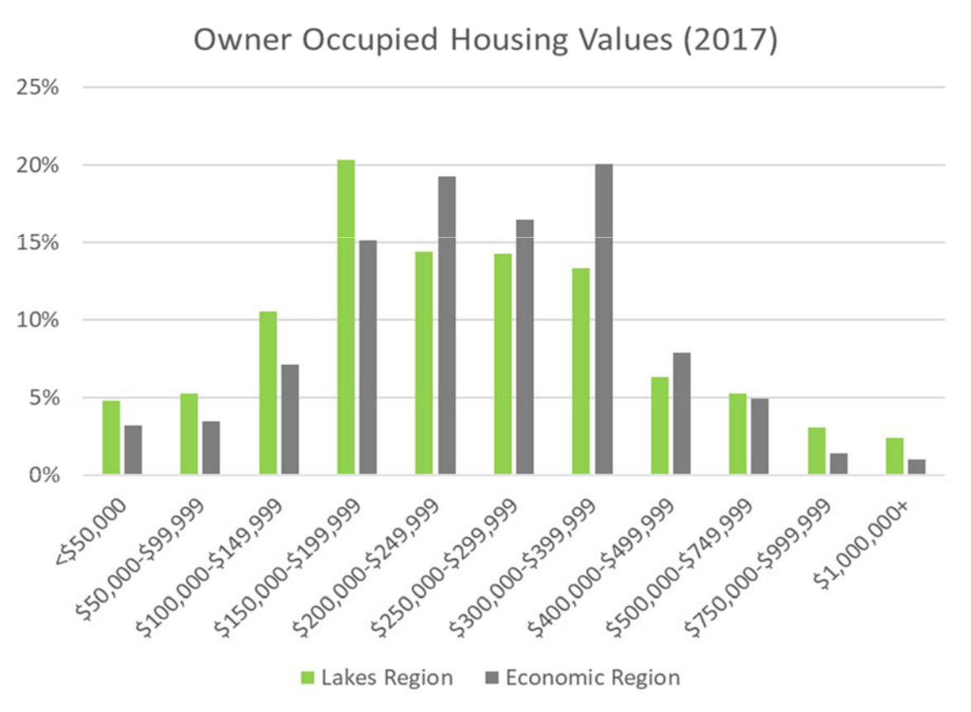

Source: Esri

Housing values are projected to increase in the Lakes Region over the next five years. Most of the growth will be in homes with values between $300,000 and $750,000. There will be substantially fewer housing units in the sub-$200,000 range in 2022. The median housing value in the Lakes Region is expected to jump nearly 13% ($29,900) over the next 5 years. The number of housing units will remain relatively flat, increasing by less than 2% over the next five years.

Through the interviews it was discovered that homes that are in the $200,000 to $300,000 range are in very high demand and sell as soon as they go on the market. There is very limited inventory in the Laconia area, which is resulting in rising prices and making it difficult for young professionals, couples, and families to stay in the area or move up out of an apartment. Exacerbating the limited stock of homes is the fact that young families are often competing with older couples from out of the area looking for a second home or to downsize. Additionally, quality single family homes that are in the $150,000 - $175,000 price range and affordable for first time home buyers are nonexistent.

Camoin Associates | DRAFT - Real Estate Market Analysis: State of New Hampshire Lakes Region Facility | 23
Table 14: Housing Values (Owner Occupied Housing), Lakes Region
Housing Values (Owner Occupied Housing), Lakes Region
Housing Value | 2017 |  | 2022 |  | Change
Housing Value | Number | Percent | Number | Percent | Number | Percent
<$50,000 | 1,731 | 4.8% | 1,257 | 3.4% | (474) | -27.4%
$50,000-$99,999 | 1,883 | 5.3% | 1,388 | 3.8% | (495) | -26.3%
$100,000-$149,999 | 3,782 | 10.6% | 2,732 | 7.5% | (1,050) | -27.8%
$150,000-$199,999 | 7,287 | 20.3% | 5,427 | 14.9% | (1,860) | -25.5%
$200,000-$249,999 | 5,164 | 14.4% | 6,025 | 16.5% | 861 | 16.7%
$250,000-$299,999 | 5,120 | 14.3% | 6,286 | 17.2% | 1,166 | 22.8%
$300,000-$399,999 | 4,771 | 13.3% | 5,895 | 16.2% | 1,124 | 23.6%
$400,000-$499,999 | 2,282 | 6.4% | 2,822 | 7.7% | 540 | 23.7%
$500,000-$749,999 | 1,883 | 5.3% | 2,319 | 6.4% | 436 | 23.2%
$750,000-$999,999 | 1,093 | 3.1% | 1,322 | 3.6% | 229 | 21.0%
$1,000,000+ | 858 | 2.4% | 1,026 | 2.8% | 168 | 19.6%
Total | 35,854 | 100% | 36,499 | 100% | 645 | 1.8%
Median Value | $ | 231,410 | $ | 261,299 | 29,889 | 12.9%
Average Value | $ | 290,201 | $ | 321,455 | 31,254 | 10.8%
Source: Esri


The Economic Region is projected to grow 3.2% from 2017 to 2022, this is a faster rate than the Lakes Region during that same timeframe. The increase in housing values is projected to remain consistent throughout the Economic Region. The median value is expected to increase by 8%, growing from $255,400 to $276,300 over 5 years. The most significant change in values will occur in the $400,000 to $500,000 and $500,000 to $750,000 ranges, where there are projected increases of 33.0% and 39.8%, respectively. From 2017 to 2022, concentration of households below the value of $250,000 will decline in all value cohorts.

Table 15: Housing Values (Owner Occupied Housing), Economic Region

Housing Values (Owner Occupied Housing), Economic Region
Housing Value | 2017 |  | 2022 |  | Change
Housing Value | Number | Percent | Number | Percent | Number | Percent
<$50,000 | 6,342 | 3.2% | 4,304 | 2.1% | (2,038) | -32.1%
$50,000-$99,999 | 6,879 | 3.5% | 5,279 | 2.6% | (1,600) | -23.3%
$100,000-$149,999 | 14,109 | 7.2% | 11,923 | 5.9% | (2,186) | -15.5%
$150,000-$199,999 | 29,798 | 15.1% | 24,819 | 12.2% | (4,979) | -16.7%
$200,000-$249,999 | 37,997 | 19.3% | 37,522 | 18.4% | (475) | -1.3%
$250,000-$299,999 | 32,465 | 16.5% | 33,993 | 16.7% | 1,528 | 4.7%
$300,000-$399,999 | 39,601 | 20.1% | 45,897 | 22.6% | 6,296 | 15.9%
$400,000-$499,999 | 15,483 | 7.9% | 20,585 | 10.1% | 5,102 | 33.0%
$500,000-$749,999 | 9,786 | 5.0% | 13,678 | 6.7% | 3,892 | 39.8%
$750,000-$999,999 | 2,764 | 1.4% | 3,395 | 1.7% | 631 | 22.8%
$1,000,000+ | 2,002 | 1.0% | 2,122 | 1.0% | 120 | 6.0%
Total | 197,226 | 100% | 203,517 | 100% | 6,291 | 3.2%
Median Value | $ | 255,372 | $ | 276,346 | 20,974 | 8.2%
Average Value | $ | 288,983 | $ | 312,636 | 23,653 | 8.2%
Source: Esri

Multifamily & Rental Market

Rents in the Lakes Region are generally lower than those of the greater Economic Region, with the Lakes Region median rent at $796 and the Economic Region median rent at $894. The Economic Region has a comparatively greater proportion of high end rental units (units over $1,250) with about 15.0% of rental units falling into this

Camoin Associates | DRAFT - Real Estate Market Analysis: State of New Hampshire Lakes Region Facility | 24
category compared to about 6.6% in the Lakes Region. Based on stakeholder input, Laconia has a very limited amount of middle to high end rental units that would be attractive to a young professional or young couple.

Table 16: Renter-Occupied Housing Units by Monthly Rent, 2015

Renter-Occupied Housing Units by Monthly Rent
Rent | Lakes Region |  |  | Economic Region
Rent | Number | Percent |  | Number | Percent
Less than $100 | 18 | 0.2% |  | 302 | 0.3%
$100 to $149 | 74 | 0.7% |  | 409 | 0.5%
$150 to $199 | 75 | 0.7% |  | 1,036 | 1.1%
$200 to $249 | 269 | 2.4% |  | 1,666 | 1.8%
$250 to $299 | 272 | 2.4% |  | 1,525 | 1.7%
$300 to $349 | 234 | 2.1% |  | 1,302 | 1.4%
$350 to $399 | 221 | 1.9% |  | 1,349 | 1.5%
$400 to $449 | 246 | 2.2% |  | 1,407 | 1.6%
$450 to $499 | 196 | 1.7% |  | 1,025 | 1.1%
$500 to $549 | 353 | 3.1% |  | 1,585 | 1.8%
$550 to $599 | 298 | 2.6% |  | 1,658 | 1.8%
$600 to $649 | 753 | 6.6% |  | 3,333 | 3.7%
$650 to $699 | 701 | 6.2% |  | 3,769 | 4.2%
$700 to $749 | 739 | 6.5% |  | 4,576 | 5.1%
$750 to $799 | 791 | 7.0% |  | 5,545 | 6.1%
$800 to $899 | 1,499 | 13.2% |  | 13,879 | 15.4%
$900 to $999 | 1,082 | 9.5% |  | 11,827 | 13.1%
$1,000 to $1,249 | 1,768 | 15.6% |  | 17,443 | 19.3%
$1,250 to $1,499 | 441 | 3.9% |  | 8,262 | 9.2%
$1,500 to $1,999 | 261 | 2.3% |  | 4,310 | 4.8%
$2,000 to $2,499 | 41 | 0.4% |  | 808 | 0.9%
$2,500 to $2,999 | - | 0.0% |  | 64 | 0.1%
$3,000 to $3,499 | 7 | 0.1% |  | 44 | 0.0%
$3,500 or more | - | 0.0% |  | 61 | 0.1%
Median Contract Rent | $ | 796 | $ |  | 894
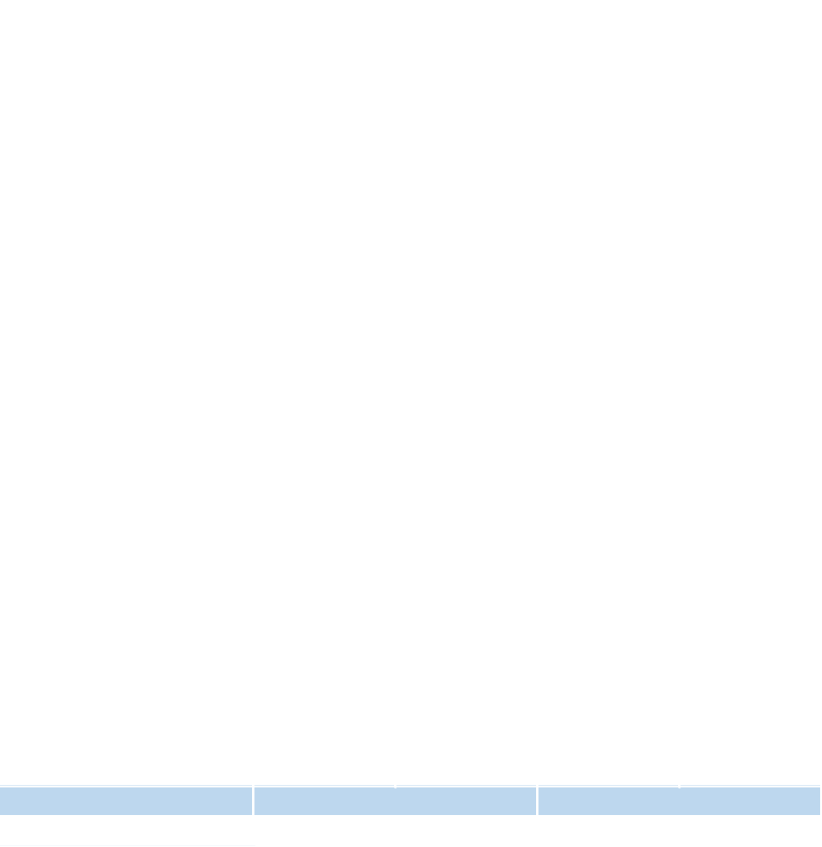
Source: 2011-2015 American Community Survey

Camoin Associates | DRAFT - Real Estate Market Analysis: State of New Hampshire Lakes Region Facility | 25
Demand

Over the 2010 to 2017 period, the Economic Region experienced larger growth in number of households compared to the Lakes Region, with the Economic Region increasing 4.1% (11,671 households) and the Lake Region growing by 3.4% (1,574 households). This trend is projected to continue through 2022; with the Economic Region projected to grow by 3.2% and the Lakes Region projected to see 1.8% growth in households.

Table 17: Change in Number of Households, 2000-2022

 | Change in Number of Households (2000 to 2022)
 |  | Lakes Region | Economic Region
2000 | Households | 42,874 | 261,338
2010 | Households | 46,969 | 284,401
2017 | Households | 48,543 | 296,072
2022 | Households | 49,412 | 305,448
# Change 2010 to 2017 |  | 1,574 | 11,671
% Change 2010 to 2017 |  | 3.4% | 4.1%
# Change 2017 to 2022 |  | 869 | 9,376
% Change 2017 to 2022 |  | 1.8% | 3.2%
Source: Esri

Occupancy Trends

Approximately 16.5% of housing units are occupied by renters in the Lakes Region, while about 46.7% are owner-occupied and the remaining 36.8% are vacant (note: A housing unit is vacant if no one is living in it at the time of the interview and likely captures a lot of second homes). These trends are expected to continue into the future as current occupancy patterns are expected to remain constant. From 2017 to 2022, the Lakes Region is projected to see an increase of 227 renter-occupied units, while there is anticipated to be 641 new owner-occupied units.

Table 18: Household Trends by Tenure, Lakes Region

 | Household Trends by Tenure - Lakes Region
 | 2010 |  | 2017 |  | 2022
 | # | % | # | % | # | %
Owner-occupied | 35,430 | 47.9% | 35,855 | 46.7% | 36,496 | 45.8%
Renter-occupied | 11,539 | 15.6% | 12,689 | 16.5% | 12,916 | 16.2%
Vacant | 27,000 | 36.5% | 28,313 | 36.8% | 30,316 | 38.0%
Total | 73,969 | 100% | 76,856 | 100% | 79,728 | 100%
Source: Esri
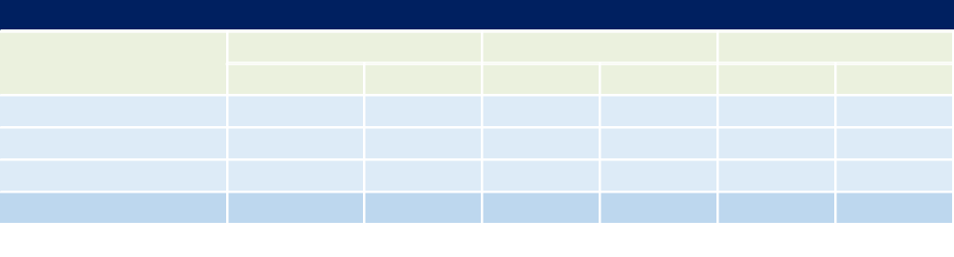

The greater Economic Region shows lower vacancy rates and a higher concentration of owner-occupied units. Only 29.7% of housing units are renter-occupied in 2017 and this percentage is projected to remain constant. Over the next five years, the Economic Region is projected to add nearly 6,300 owner-occupied households and over 3,000 renter-occupied housing units.

Camoin Associates | DRAFT - Real Estate Market Analysis: State of New Hampshire Lakes Region Facility | 26
Table 19: Household Trends by Tenure, Economic Region

Household Trends by Tenure - Economic Region


 | 2010 |  | 2017 |  | 2022
 | # | % | # | % | # | %
Owner-occupied | 194,402 | 61.0% | 197,226 | 59.3% | 203,517 | 59.3%
Renter-occupied | 89,999 | 28.2% | 98,846 | 29.7% | 101,931 | 29.7%
Vacant | 34,276 | 10.8% | 36,483 | 11.0% | 37,555 | 11.0%
Total | 318,677 | 100% | 332,555 | 100% | 343,003 | 100%
Source: Esri

Examining the two region’s household size indicates that households of 2 people are the most common type, followed by 1-person and then 3-person households in both the Lakes Region and Economic Region.

Table 20: Households by Size, 2010

Households by Size (2010)
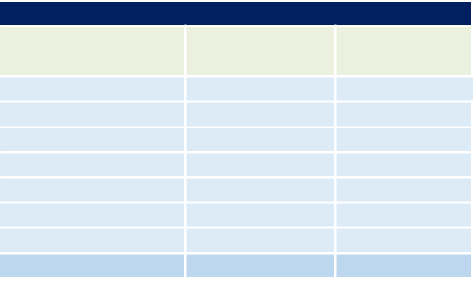

Household Size | Lakes Region | Economic
Household Size | Lakes Region | Region
1-Person | 12,279 | 72,603
2-Person | 18,891 | 100,696
3-Person | 7,101 | 47,688
4-Person | 5,489 | 39,765
5-Person | 2,097 | 15,572
6-Person | 760 | 5,436
7+ Person | 352 | 2,641
Total | 46,969 | 284,401
Source: Esri

Trends in household income can help identify the type of housing product that will be in demand in the future. Household incomes are projected to rise in both the Lakes Region and Economic Region. The Lakes Region will see greater increases in the number of households within the income ranges from $50,000 - $75,000 to $100,000 - $149,999. Conversely, the Economic Region is projected to see the biggest increases in income ranges above $150,000, indicating there may be potential demand for higher end housing products. Furthermore, both regions are projected to see negative growth in households falling within the income cohorts below $49,999.

Camoin Associates | DRAFT - Real Estate Market Analysis: State of New Hampshire Lakes Region Facility | 27
Figure 8: Percent Change in Households by Income Range, 2017-2022
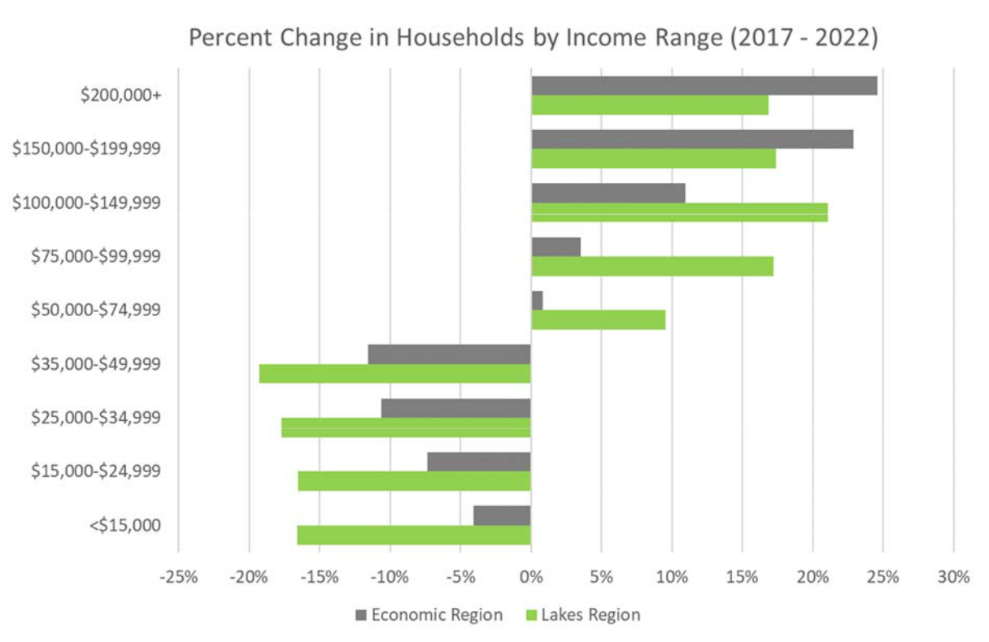

Source: Esri

Table 21 outlines projected household income trends in the Lakes Region by income cohort. The largest concentration of households falls within the income cohort between $ 50,000 and $74,999 at 20.8% of households. Median income in the Lakes Region is projected to grow by $8,351 by 2022.

Table 21: Household Income Trends, Lakes Region

 | Household Income Trends (Lakes Region)
Household Income | 2017 |  |  | 2022 |  |  | Change
Household Income | # | % |  | # | % |  | # | %
<$15,000 | 4,501 | 9.3% |  | 3,754 | 7.6% |  | (747) | -16.6%
$15,000-$24,999 | 4,800 | 9.9% |  | 4,007 | 8.1% |  | (793) | -16.5%
$25,000-$34,999 | 4,719 | 9.7% |  | 3,884 | 7.9% |  | (835) | -17.7%
$35,000-$49,999 | 6,028 | 12.4% |  | 4,866 | 9.9% |  | (1,162) | -19.3%
$50,000-$74,999 | 10,106 | 20.8% |  | 11,072 | 22.4% |  | 966 | 9.6%
$75,000-$99,999 | 6,888 | 14.2% |  | 8,072 | 16.3% |  | 1,184 | 17.2%
$100,000-$149,999 | 7,090 | 14.6% |  | 8,584 | 17.4% |  | 1,494 | 21.1%
$150,000-$199,999 | 2,375 | 4.9% |  | 2,788 | 5.6% |  | 413 | 17.4%
$200,000+ | 2,040 | 4.2% |  | 2,384 | 4.8% |  | 344 | 16.9%
Total | 48,547 | 100% |  | 49,411 | 100% |  | 864 | 12.0%
Median Income | $ | 58,010 | $ |  | 66,361 | $ |  | 8,351
Source: Esri


Table 22 shows a similar breakdown for changes in household incomes in the Economic Region. As of 2017, median household income is higher in the Economic Region compared to the Lakes Region, at $70,931 and $58,010, respectively. The median income for the Economic Region is projected to increase $6,898 to $77,829 by 2022.

Camoin Associates | DRAFT - Real Estate Market Analysis: State of New Hampshire Lakes Region Facility | 28
Table 22: Household Income Trends, Economic Region

Household Income Trends (Economic Region)


Household Income | 2017 |  | 2022 |  |  | Change
Household Income | # | % | # | % |  | # | %
<$15,000 | 21,847 | 7.4% | 20,951 | 6.9% |  | (896) | -4.1%
$15,000-$24,999 | 23,594 | 8.0% | 21,857 | 7.2% |  | (1,737) | -7.4%
$25,000-$34,999 | 22,489 | 7.6% | 20,101 | 6.6% |  | (2,388) | -10.6%
$35,000-$49,999 | 33,813 | 11.4% | 29,901 | 9.8% |  | (3,912) | -11.6%
$50,000-$74,999 | 52,581 | 17.8% | 53,031 | 17.4% |  | 450 | 0.9%
$75,000-$99,999 | 44,705 | 15.1% | 46,286 | 15.2% |  | 1,581 | 3.5%
$100,000-$149,999 | 52,748 | 17.8% | 58,533 | 19.2% |  | 5,785 | 11.0%
$150,000-$199,999 | 23,303 | 7.9% | 28,631 | 9.4% |  | 5,328 | 22.9%
$200,000+ | 20,992 | 7.1% | 26,157 | 8.6% |  | 5,165 | 24.6%
Total | 296,072 | 100% | 305,448 | 100% |  | 9,376 | 29.2%
Median Income | $ | 70,931 | $ | 77,829 | $ |  | 6,898
Source: Esri

Age-Restricted Housing Market

Age-restricted housing can take different forms including independent living facilities, assisted living, and nursing homes. These are described in more detail below:

- Independent Living: Independent Living facilities and communities are for seniors that are very independent with few medical problems. Residents typically live in fully equipped private apartments. Facilities typically have on-site dining and meal plans available. Independent living facilities include retirement communities, congregate care, 55+ communities, and senior apartments.⁹
- Assisted Living: Assisted living communities are for seniors that cannot live on their own safely, but do not yet need the intense care provided by a nursing home. Typically, the assistance is needed for medications, activities of daily living, meals, and housekeeping. There is a 24-hour staff and residents live in private apartments. Some facilities provide skilled nursing care. These facilities are also known as assisted care communities.

- Nursing Homes: These provide the greatest amount of care with nursing care for elderly that have a high level of need for medical care and assistance. Residents either share a room or have their own room and partake in common activities in common spaces, such as dining in a central dining area. Many nursing homes provide separate units for Alzheimer’s residents to specialize care. Nursing homes are also known as long term care facilities.

Nationally, there has been increased emphasis on the “aging in place” trend. Aging in place is a process that helps residents stay in their homes and communities as they grow old rather than moving to a new place to live in a specialized facility. As a result of this shift and the general aging of the population, there has been an increase in demand for age-restricted housing in local communities.

The Continuing Care Retirement Communities and Assisted Living Facilities for the Elderly industry has seen significant growth over the past five years in the Economic Region, growing by 12.9% (as measured by employment). As of 2017, there were 66 establishments in the industry. This industry is projected to continue its upward trajectory with 23.4% job growth over the next five years. The aging population has been the driving force for this trend.

- A Place for Mom, Senior Housing 101.

Camoin Associates | DRAFT - Real Estate Market Analysis: State of New Hampshire Lakes Region Facility | 29
The local Lakes Region population is aging significantly. The population age 65 and older grew by 26.4% between 2010 and 2017 and is expected to grow by another 17.7% over the next five years. That means over 4,400 more residents of the Lakes Region will be 65 or older. The greatest increase will be in the 75-79 age range.

Table 23: Age 50+ Population Growth, Lakes Region

 |  | Age 50+ Population Growth: Lakes Region
 | 2010 | 2017 | 2022 | Change | % Change | Change | % Change
 | 2010 | 2017 | 2022 | 2010 - 2017 2010 - 2017 |  | 2017-2022 2017-2022
Total (50+) | 47,760 | 54,349 | 57,699 | 6,589 | 13.8% | 3,350 | 6.2%
50-54 | 9,915 | 9,118 | 8,285 | (797) | -8.0% | (833) | -9.1%
55-59 | 9,476 | 10,210 | 9,429 | 734 | 7.7% | (781) | -7.6%
60-64 | 8,641 | 10,078 | 10,632 | 1,437 | 16.6% | 554 | 5.5%
65-69 | 6,365 | 8,798 | 9,782 | 2,433 | 38.2% | 984 | 11.2%
70-74 | 4,464 | 6,304 | 7,877 | 1,840 | 41.2% | 1,573 | 25.0%
75-79 | 3,525 | 4,067 | 5,417 | 542 | 15.4% | 1,350 | 33.2%
80-84 | 2,736 | 2,711 | 3,148 | (25) | -0.9% | 437 | 16.1%
85+ | 2,638 | 3,063 | 3,129 | 425 | 16.1% | 66 | 2.2%
65+ | 19,728 | 24,943 | 29,353 | 5,215 | 26.4% | 4,410 | 17.7%
Source: Esri
 |  | Table 24: Age 50+ Population Growth, Economic Region
 |  | Age 50+ Population Growth: Economic Region
 | 2010 | 2017 | 2022 | Change | % Change | Change | % Change
 | 2010 | 2017 | 2022 | 2010 - 2017 2010 - 2017 |  | 2017-2022 2017-2022
Total (50+) | 246,466 | 290,924 | 314,589 | 44,458 | 18.0% | 23,665 | 8.1%
50-54 | 60,812 | 58,962 | 53,864 | (1,850) | -3.0% | (5,098) | -8.6%
55-59 | 50,902 | 59,795 | 57,491 | 8,893 | 17.5% | (2,304) | -3.9%
60-64 | 42,515 | 51,762 | 57,675 | 9,247 | 21.7% | 5,913 | 11.4%
65-69 | 29,099 | 42,748 | 49,164 | 13,649 | 46.9% | 6,416 | 15.0%
70-74 | 20,171 | 29,567 | 38,596 | 9,396 | 46.6% | 9,029 | 30.5%
75-79 | 16,376 | 19,091 | 26,103 | 2,715 | 16.6% | 7,012 | 36.7%
80-84 | 13,140 | 13,197 | 15,390 | 57 | 0.4% | 2,193 | 16.6%
85+ | 13,451 | 15,802 | 16,306 | 2,351 | 17.5% | 504 | 3.2%
65+ | 92,237 | 120,405 | 145,559 | 28,168 | 30.5% | 25,154 | 20.9%
Source: Esri
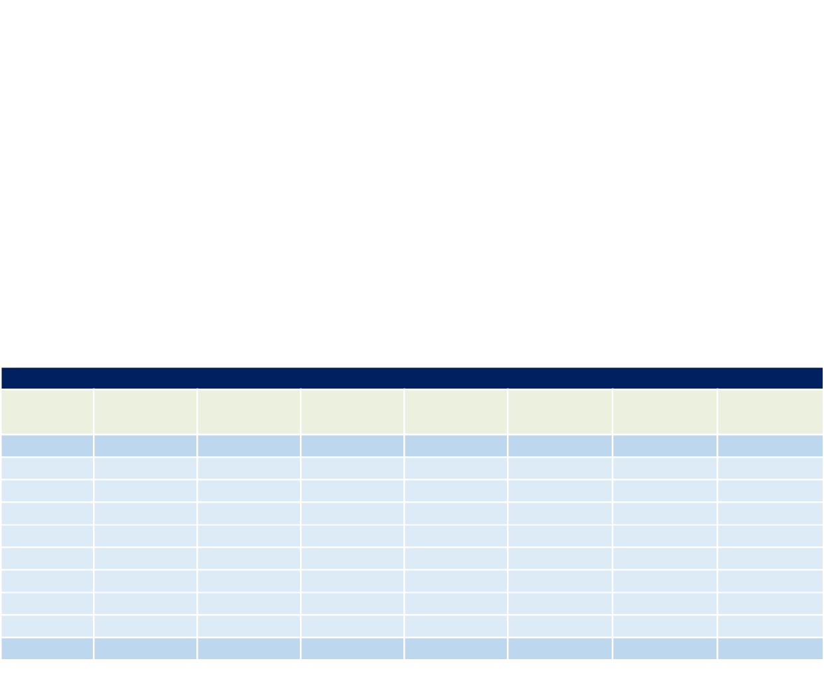

Overall, the population over age 65 is expected to increase significantly. This suggests that independent living facilities would likely be in the greatest demand with some potential need for assisted living (especially as the population continues to age). There may also be an opportunity to provide traditional market -rate condos and apartment units that target this age demographic. A major trend among “empty-nesters” has been to leave their single-family home (and its maintenance requirements) in favor of smaller units in community centers where they can walk to shops and other amenities.

Conclusion

Residential development is the strongest market in the area, with limited existing inventory and high demand for both workforce housing and second homes. The Site could accommodate a diversity of housing types and prices and would have a positive impact on economic development opportunities as it would build up the workforce and create opportunities for businesses to locate in the area.

Camoin Associates | DRAFT - Real Estate Market Analysis: State of New Hampshire Lakes Region Facility | 30
Retail

Market Conditions

In the same way that technology is transforming the trajectory of the office and industrial markets, tech advances and preferences surrounding convenience have caused a shift in the retail market from shopping malls to e-commerce, leaving downtowns with empty storefronts. Our prior research into national retail trends has shown that shopping malls dominated the retail real estate market throughout most of recent history, but changing consumer preferences, technological advances and e-commerce are currently having significant implications on real estate markets and economic development efforts in communities across the country. Despite this, retail remains a major component of our local, regional, and national economies for many reasons, including providing valuable workforce training opportunities for local labor pools.

Shifting trends should not deter the integration of new retail into economic development plans entirely; but rather, retailers need to adjust to new preferences by offering unique shopping experiences and products. As said in the white paper, The Case of the Disappearing Main Street Retail,¹⁰

“Today we have seen that retail stores can no longer be standalone entities. Successful retailers have positioned themselves in strategic real estate locations where they will benefit from their surrounding tenants, events, transportation and a variety of other factors.”

As of Q1 of 2017, the national vacancy rate for retail space, which includes general retail, malls, power centers, shopping centers, and specialty centers, was 4.9%. Average rent rested at $16.70 per square foot. Big box stores continue to shut their doors. JLL states that, “While the upcoming vacancies will pose opportunities for strong malls to upgrade to a more productive tenant or refresh the space with an entertainment destination, weaker malls could experience a ripple effect to their inline occupancy.”¹¹

JLL describes the retail market in one strong statement: “The bottom line is retail isn’t dead. But the old way of selling and operating stores is dying.”

- Written by Hrishue Mahalaha of Innovation Economy Partners and Jim Damicis and Alex Tranmer of Camoin Associates.
- JLL US Retail Outlook 2017

Camoin Associates | DRAFT - Real Estate Market Analysis: State of New Hampshire Lakes Region Facility | 31
Demand

Trade Area Demographics

This section outlines the key demographic trends within the trade areas studied for the retail market analysis, which include the 15-minute and 45-minute drive times from the Lakes Region Facility Site. Table 25 and Table 26, below, show the number of households by age and income for the local and regional trade areas, which are helpful in concluding the mix of retail offerings best suited for the Site. Income and age categories with the greatest number of households are represented in green, while categories with the fewest households are represented in red. The age range with the greatest number of households in the Lakes Region is 55-64. Within this age range, households are most concentrated in the $50,000 to $74,999 income cohort.

Table 25: Households by Income and Age of Householder (2017), 15 Minute Drive Time

Households by Income and Age of Housheholder (2017) - Local Trade Area
 | <25 |  | 25-34 | 35-44 | 45-54 | 55-64 | 65-74 | 75+ | Total
<$15,000 | 68 |  | 122 | 125 | 167 | 257 | 225 | 230 | 1,194
$15,000-$24,999 | 50 |  | 117 | 112 | 118 | 194 | 182 | 272 | 1,045
$25,000-$34,999 | 40 |  | 147 | 124 | 141 | 199 | 204 | 236 | 1,091
$35,000-$49,999 | 41 |  | 184 | 183 | 213 | 246 | 221 | 217 | 1,305
$50,000-$74,999 | 51 |  | 274 | 301 | 362 | 409 | 380 | 219 | 1,996
$75,000-$99,999 | 32 |  | 212 | 218 | 288 | 316 | 232 | 101 | 1,399
$100,000-$149,999 | 26 |  | 167 | 253 | 324 | 370 | 211 | 55 | 1,406
$150,000-$199,999 | 3 |  | 38 | 85 | 172 | 173 | 72 | 11 | 554
$200,000+ | 0 |  | 36 | 82 | 138 | 128 | 80 | 18 | 482
Total | 311 |  | 1,297 | 1,483 | 1,923 | 2,292 | 1,807 | 1,359 | 10,472
Median HH Income | $ 34,188 |  | $ 55,145 | $ 64,056 | $ 71,245 | $ 62,979 | $ 53,226 | $ 31,859
Source: Esri
Red= least number of households
Green = greatest number of households

Regional trade area demographics are similar to those of the local trade area. The greatest number of households again falls in the 55-64 age group, with 14,650 households. Median household incomes are measurably greater in the regional trade area in age categories below 64 years old. However, the local trade area median household incomes surpass the regional trade area in age categories 65 and older.

Table 26: Households by Income and Age of Householder (2017), 45 Minute Drive Time

Households by Income and Age of Housheholder (2017) - Regional Trade Area
 | <25 | 25-34 | 35-44 | 45-54 | 55-64 | 65-74 | 75+ | Total
<$15,000 | 460 | 669 | 628 | 843 | 1,390 | 1,264 | 1,290 | 6,544
$15,000-$24,999 | 309 | 680 | 642 | 712 | 1,132 | 1,237 | 1,619 | 6,331
$25,000-$34,999 | 288 | 872 | 771 | 895 | 1,248 | 1,199 | 1,212 | 6,485
$35,000-$49,999 | 299 | 1,109 | 1,069 | 1,342 | 1,583 | 1,286 | 1,159 | 7,847
$50,000-$74,999 | 428 | 1,743 | 1,912 | 2,418 | 2,723 | 2,127 | 1,032 | 12,383
$75,000-$99,999 | 237 | 1,450 | 1,707 | 2,217 | 2,394 | 1,472 | 564 | 10,041
$100,000-$149,999 | 120 | 1,074 | 1,776 | 2,147 | 2,337 | 1,328 | 332 | 9,114
$150,000-$199,999 | 30 | 316 | 571 | 1,075 | 1,033 | 398 | 83 | 3,506
$200,000+ | 12 | 232 | 543 | 810 | 809 | 418 | 96 | 2,920
Total | 2,183 | 8,145 | 9,619 | 12,459 | 14,649 | 10,729 | 7,387 | 65,171
Median HH Income | $ 36,282 | $ 58,156 | $ 71,151 | $ 75,154 | $ 66,079 | $ 53,079 | $ 30,698
Source: Esri
Red = least number of households
Green = greatest number of households
Camoin Associates | | DRAFT - Real Estate Market Analysis: State of New Hampshire Lakes Region Facility |  |  |  |  |  |  | 32
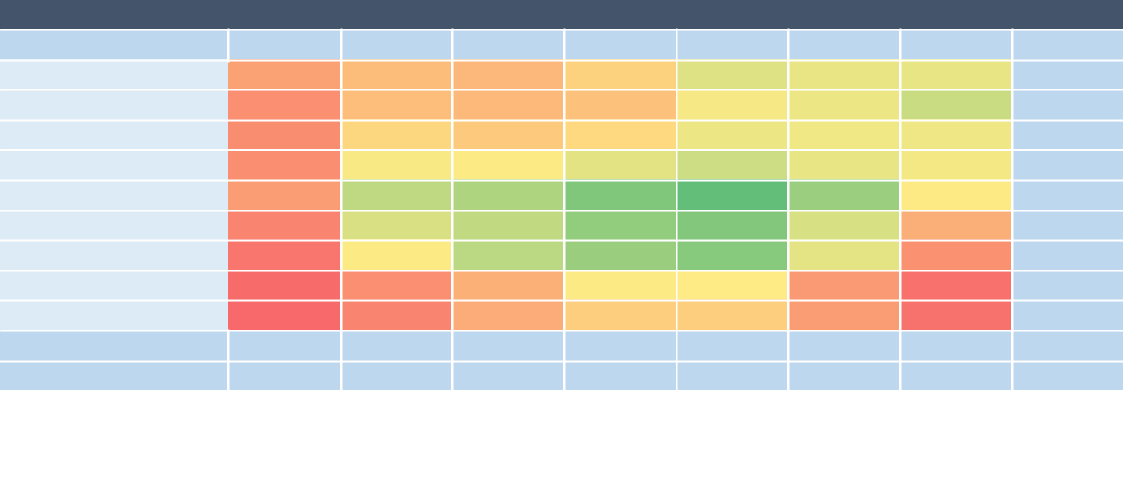
Tapestry Segmentation

A tool used by retail site selectors in determining the characteristics of a particular trade area is market segmentation, which is the classification of consumers according to demographic, socioeconomic, housing, and lifestyle characteristics. It is how retailers and site selectors compare consumer trends across trade areas when considering many site locations.

Market segmentation is based on the concept that people with similar demographic characteristics, purchasing habits, and media preferences naturally gravitate toward each other and into the same communities. Businesses utilize segmentation to understand their customers’ lifestyle choices, purchasing preferences, and how they spend their free time.

Market segmentation data for the regional trade area were obtained from ESRI’s Tapestry segmentation model. Additional information about ESRI’s model can be found here: http://www.esri.com/landing-pages/tapestry. For tapestry segmentation surrounding the Lakes Region Facility Site, we focus on the characteristics of consumers living in the broader regional trade area since the retail categories with the best potential for success in the area tend to have a regional reach.

It is important to recognize that the classifications and labels that ESRI uses for defining market segments are generalizations. The descriptions of each segment are based on comparisons with the U.S. as a whole and reflect the propensity of households within that segment to exhibit certain demographic, lifestyle, and consumer characteristics relative to the overall population. The purpose of this exercise is to compare local consumer trends to those of consumers across the U.S. so businesses and developers not familiar with the Region understand consumer demand in this area.

The top Esri Tapestry segments are listed in the table below, with profiles of each segment, including household composition, housing type, income, age, education, and consumer habits following.

Table 27: Top Tapestry Segments of the Economic Region, 2017

Top Tapestry Segments of the Economic Region, 2017
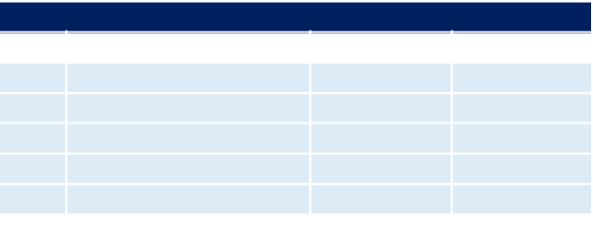

Rank | Tapestry Segment | Households | Percent
1 | Green Acres | 34,990 | 11.8%
2 | Parks and Rec | 33,240 | 11.2%
3 | Savvy Suburbanites | 24,454 | 8.3%
4 | The Great Outdoors | 21,628 | 7.3%
5 | Soccer Moms | 21,104 | 7.1%

Source: Esri

Green Acres (11.8%)

- Average Household Size: 2.69

- Median Age: 43.0

- Median Household Income: $72,000

The Green Acres lifestyle features country living and self-reliance. They are avid do- it-yourselfers, maintaining and remodeling their homes, with all the necessary power tools to accomplish the jobs. Gardening, especially growing vegetables, is also a priority, again with the right tools, tillers, tractors, and riding mowers. Outdoor living also features a variety of sports: hunting and fishing, motorcycling, hiking and camping, and even golf. Self-described conservatives, residents of Green Acres remain pessimistic about the near future yet are heavily invested in it.

Parks and Rec (11.2%)

- Average Household Size: 2.49

Camoin Associates | DRAFT - Real Estate Market Analysis: State of New Hampshire Lakes Region Facility | 33
- Median Age: 40.3

- Median Household Income: $55,000

These practical suburbanites have achieved the dream of home ownership. They have purchased homes that are within their means. Their homes are older, and town homes and duplexes are not uncommon. Many of these families are two-income married couples approaching retirement age; they are comfortable in their jobs and their homes, budget wisely, but do not plan on retiring anytime soon or moving. Neighborhoods are well established, as are the amenities and programs that supported their now independent children through school and college. The appeal of these kid-friendly neighborhoods is now attracting a new generation of young couples.

Savvy Suburbanites (8.3%)

- Average Household Size: 2.83

- Median Age: 44.1

- Median Household Income: $104,000

Savvy Suburbanites residents are well educated, well read, and well capitalized. Families include empty nesters and empty nester wannabes, who still have adult children at home. Located in older neighborhoods outside the urban core, their suburban lifestyle includes home remodeling and gardening plus the active pursuit of sports and exercise. They enjoy good food and wine, plus the amenities of the city’s cultural events.

The Great Outdoors (7.3%)

- Average Household Size: 2.43

- Median Age: 46.3

- Median Household Income: $53,000

Not surprisingly, residents of the Great Outdoors enjoy outdoor activities, such as hiking, hunting, fishing, and boating. They reside in small, rural towns, often own multiple vehicles, and have pets in the home. Being cost-conscious empty nesters nearing retirement, Great Outdoors families appreciate home-cooked meals and do it yourself home improvement projects. Families in this segment live modest, but active lifestyles, using technology sparingly for entertainment.

Soccer Moms (7.1%)

- Average Household Size: 2.96

- Median Age: 36.6

- Median Household Income: $84,000

Soccer Moms is an affluent, family-oriented market with a country flavor. Residents are partial to new housing away from the bustle of the city, but close enough to commute to professional job centers. Life in this suburban wilderness offsets the hectic pace of two working parents with growing children. They favor time-saving devices, like banking online or housekeeping services, and family-oriented pursuits.

Consumer Spending Patterns

Expenditures on goods and services are used to evaluate the spending patterns and purchasing power of residents in the regional trade area. This section of the report looks at spending by local residents but does not show where these expenditures were made.

Table 28 shows spending by regional trade area residents on select retail goods and services. Variables shown include the average annual spending per household on a particular good or service, the regional trade area total

Camoin Associates | DRAFT - Real Estate Market Analysis: State of New Hampshire Lakes Region Facility | 34
spending on that good, and the spending potential index (SPI) for both the regional trade area and the local trade area. The SPI represents household expenditures on a product or service relative to a national average of 100. An SPI greater than 100 indicates that, on average, households within the local trade area spend more on that particular good than the average U.S. household. The difference between the regional trade area and local trade area SPI (the last column) gives a snapshot of how the spending power of local residents compares with those in the greater region. A very high SPI can mean a number of things:

- Costs of goods and services within that particular spending category are much higher within a trade area than they are elsewhere throughout the nation.

- Residents within a trade area may be wealthier than the national average.

- Population characteristics can drive up SPI in certain categories. For example, a trade area with a large retired population will likely spend more on healthcare and Medicare.

The SPI is a good preliminary measure used to identify market characteristics that may necessitate additional attention within an analysis. The average SPI in the Regional Trade Area is 105, indicating that households spend only slightly more than the national average. No category has a SPI above 104, which indicates there are no individual categories that specifically stand out as strong market opportunities.

Camoin Associates | DRAFT - Real Estate Market Analysis: State of New Hampshire Lakes Region Facility | 35
Table 28: Consumer Spending Index, 45 Minute Drive Time

Consumer Spending Index: Regional Trade Area


Category | SPI | Avg. Amount
Category | SPI |  | Spent
Apparel and Services | 93 | $ | 2,012.67
Men's | 94 | $ | 396.64
Women's | 95 | $ | 700.96
Children's | 90 | $ | 300.85
Footwear | 93 | $ | 428.86
Watches & Jewelry | 95 | $ | 112.22
Apparel Products and Services (1) | 90 | $ | 73.14
Computer
Computers and Hardware for Home Use | 95 | $ | 163.74
Portable Memory | 94 | $ | 4.99
Computer Software | 94 | $ | 10.86
Computer Accessories | 97 | $ | 17.48
Entertainment & Recreation | 97 | $ | 3,038.51
Fees and Admissions | 93 | $ | 591.59
Membership Fees for Clubs (2) | 93 | $ | 196.52
Fees for Participant Sports, excl. Trips | 95 | $ | 93.89
Tickets to Theatre/Operas/Concerts | 95 | $ | 56.65
Tickets to Movies/Museums/Parks | 93 | $ | 71.31
Admission to Sporting Events, excl. Trips | 93 | $ | 51.83
Fees for Recreational Lessons | 91 | $ | 120.66
Dating Services | 91 | $ | 0.74
TV/Video/Audio | 97 | $ | 1,247.03
Cable and Satellite Television Services | 98 | $ | 932.53
Televisions | 94 | $ | 112.59
Satellite Dishes | 91 | $ | 1.32
VCRs, Video Cameras, and DVD Players | 96 | $ | 6.27
Miscellaneous Video Equipment | 94 | $ | 9.05
Video Cassettes and DVDs | 99 | $ | 15.06
Video Game Hardware/Accessories | 93 | $ | 27.27
Video Game Software | 92 | $ | 14.29
Streaming/Downloaded Video | 95 | $ | 24.32
Rental of Video Cassettes and DVDs | 94 | $ | 14.34
Installation of Televisions | 96 | $ | 0.85
Audio (3) | 96 | $ | 85.41
Rental and Repair of TV/Radio/Sound Equipment | 92 | $ | 3.70
Pets | 102 | $ | 607.59
Toys/Games/Crafts/Hobbies (4) | 97 | $ | 117.24
Recreational Vehicles and Fees (5) | 102 | $ | 103.82
Sports/Recreation/Exercise Equipment (6) | 97 | $ | 165.82
Photo Equipment and Supplies (7) | 94 | $ | 52.36
Reading (8) | 100 | $ | 125.56
Catered Affairs (9) | 90 | $ | 27.49
Food | 96 | $ | 8,012.36
Food at Home | 97 | $ | 4,862.79
Bakery and Cereal Products | 97 | $ | 641.87
Meats, Poultry, Fish, and Eggs | 96 | $ | 1,099.27
Dairy Products | 98 | $ | 521.35
Fruits and Vegetables | 96 | $ | 937.52

Camoin Associates | DRAFT - Real Estate Market Analysis: State of New Hampshire Lakes Region Facility | 36
 | Consumer Spending Index: Regional Trade Area
 | Category | SPI | Avg. Amount
 | Category | SPI |  | Spent
 | Snacks and Other Food at Home (10) | 97 | $ | 1,662.77
 | Food Away from Home | 95 | $ | 3,149.57
 | Alcoholic Beverages | 95 | $ | 528.83
 | Financial
 | Value of Stocks/Bonds/Mutual Funds | 98 | $ | 6,088.08
 | Value of Retirement Plans | 99 | $24,204.19
 | Value of Other Financial Assets | 104 | $ | 1,348.32
 | Vehicle Loan Amount excluding Interest | 98 | $ | 2,666.98
 | Value of Credit Card Debt | 97 | $ | 566.42
 | Health
 | Nonprescription Drugs | 101 | $ | 128.47
 | Prescription Drugs | 102 | $ | 396.98
 | Eyeglasses and Contact Lenses | 100 | $ | 94.18
 | Home
 | Mortgage Payment and Basics (11) | 97 | $ | 8,333.23
 | Maintenance and Remodeling Services | 99 | $ | 1,918.92
 | Maintenance and Remodeling Materials (12) | 101 | $ | 409.40
 | Utilities, Fuel, and Public Services | 98 | $ | 4,928.69
 | Household Furnishings and Equipment
 | Household Textiles (13) | 96 | $ | 91.55
 | Furniture | 94 | $ | 539.62
 | Rugs | 96 | $ | 22.40
 | Major Appliances (14) | 100 | $ | 319.68
 | Housewares (15) | 97 | $ | 92.26
 | Small Appliances | 98 | $ | 47.27
 | Luggage | 92 | $ | 10.92
 | Telephones and Accessories | 93 | $ | 64.70
 | Household Operations
 | Child Care | 87 | $ | 418.62
 | Lawn and Garden (16) | 103 | $ | 430.09
 | Moving/Storage/Freight Express | 94 | $ | 60.33
 | Housekeeping Supplies (17) | 97 | $ | 692.80
 | Insurance
 | Owners and Renters Insurance | 101 | $ | 521.29
 | Vehicle Insurance | 97 | $ | 1,145.32
 | Life/Other Insurance | 99 | $ | 422.37
 | Health Insurance | 99 | $ | 3,630.05
 | Personal Care Products (18) | 96 | $ | 449.66
 | School Books and Supplies (19) | 93 | $ | 144.08
 | Smoking Products | 102 | $ | 425.73
 | Transportation
 | Payments on Vehicles excluding Leases | 97 | $ | 2,185.06
 | Gasoline and Motor Oil | 98 | $ | 2,704.28
 | Vehicle Maintenance and Repairs | 98 | $ | 1,053.17
 | Travel
 | Airline Fares | 95 | $ | 482.00
 | Lodging on Trips | 97 | $ | 507.13
 | Auto/Truck Rental on Trips | 95 | $ | 25.14
 | Food and Drink on Trips | 97 | $ | 478.90
 | Source: ESRI
 |  |  |  |  |  | 37
Camoin Associates | DRAFT - Real Estate Market Analysis: State of New Hampshire Lakes Region Facility |  |  |  |  |  | 37

- Apparel Products and Services includes material for making clothes, sewing patterns and notions, shoe repair and other shoe services, apparel laundry and dry cleaning, alteration, repair and tailoring of apparel, clothing rental and storage, and watch and jewelry repair.
- Membership Fees for Clubs includes membership fees for social, recreational, and civic clubs.

- Audio includes satellite radio service, sound components and systems, digital audio players, records, CDs, audio tapes, streaming/downloaded audio, tape recorders, radios, musical instruments and accessories, and rental and repair of musical instruments.

- Toys and Games includes toys, games, arts and crafts, tricycles, playground equipment, arcade games, and online entertainment and games.

- Recreational Vehicles & Fees includes docking and landing fees for boats and planes, purchase and rental of RVs or boats, and camp fees.

- Sports/Recreation/Exercise Equipment includes exercise equipment and gear, game tables, bicycles, camping equipment, hunting and fishing equipment, winter sports equipment, water sports equipment, other sports equipment, and rental/repair of sports/recreation/exercise equipment.

- Photo Equipment and Supplies includes film, film processing, photographic equipment, rental and repair of photo equipment, and photographer fees.

- Reading includes magazine and newspaper subscriptions, single copies of magazines and newspapers, and books.

- Catered Affairs includes expenses associated with live entertainment and rental of party supplies.

- Snacks and Other Food at Home includes candy, chewing gum, sugar, artificial sweeteners, jam, jelly, preserves, margarine, fat, oil, salad dressing, nondairy cream and milk, peanut butter, frozen prepared food, potato chips, nuts, salt, spices, seasonings, olives, pickles, relishes, sauces, gravy, other condiments, soup, prepared salad, prepared dessert, baby food, miscellaneous prepared food, and nonalcoholic beverages.

- Mortgage Payment and Basics includes mortgage interest, mortgage principal, property taxes, homeowner’s insurance, and ground rent.

- Maintenance and Remodeling Materials includes supplies/tools/equipment for painting and wallpapering, plumbing supplies and equipment, electrical/heating/AC supplies, materials for hard surface flooring, materials for roofing/gutters, materials for plaster/panel/siding, materials for patio/fence/brick work, landscaping materials, and insulation materials for owned homes.

- Household Textiles includes bathroom linens, bedroom linens, kitchen linens, dining room linens, other linens, curtains, draperies, slipcovers, decorative pillows, and materials for slipcovers and curtains.

- Major Appliances includes dishwashers, disposals, refrigerators, freezers, washers, dryers, stoves, ovens, microwaves, window air conditioners, electric floor cleaning equipment, sewing machines, and miscellaneous appliances.

- Housewares include plastic dinnerware, china, flatware, glassware, serving pieces, nonelectric cookware, and tableware.

- Lawn and Garden includes lawn and garden supplies, equipment and care service, indoor plants, fresh flowers, and repair/rental of lawn and garden equipment.

- Housekeeping Supplies includes soaps and laundry detergents, cleaning products, toilet tissue, paper towels, napkins, paper/plastic/foil products, stationery, giftwrap supplies, postage, and delivery services.

- Personal Care Products includes hair care products, nonelectric articles for hair, wigs, hairpieces, oral hygiene products, shaving needs, perfume, cosmetics, skincare, bath products, nail products, deodorant, feminine hygiene products, and personal care appliances.

- School Books and Supplies include school books and supplies for college, elementary school, high school, and preschool.

- Vehicle Purchases (Net Outlay) includes net outlay for new and used cars, trucks, vans, motorcycles, and motor scooters.

Camoin Associates | DRAFT - Real Estate Market Analysis: State of New Hampshire Lakes Region Facility | 38
Retail Leakage Analysis

In a retail leakage analysis, the existing retail sales (“supply”) of trade area businesses are compared to the estimated retail spending of trade area residents (“demand”). The difference between demand and supply is referred to as the “retail gap.”¹² The retail gap can be positive or negative.

When the demand (spending by trade area residents) for goods and services is greater than sales at trade area businesses, sales are said to “leak out” of the trade area, creating a positive retail gap (i.e. sales leakage).

Conversely, if the supply of goods sold (local trade area sales) exceeds trade area demand (spending by trade area residents), it is assumed that non-residents are coming into the trade area and spending money, creating a negative retail gap (i.e. sales surplus).

Sales leakage and sales surplus carry different implications. In many cases, sales leakage presents an opportunity to capture unmet demand in a trade area since a percentage of residential spending occurs outside the trade area. This demand can be met within the trade area by opening new businesses or expanding existing businesses within retail sectors that show sales leakage. However, not all retail categories that exhibit sales leakage within a particular trade area are a good fit for the region.

A sales surplus might exist for several reasons. For example, the region might be a popular shopping destination for tourists and other out-of-towners, or a cluster of competing businesses offering a similar product or service may be located within the trade area, creating a specialty cluster that draws in spending by households from outside the trade area. Alternatively, a sales surplus could be an indicator of market saturation.

The following Retail Leakage Analysis tables contain a list of industry groups sorted by 4-digit NAICS codes and include figures for sales demand (estimated spending by local trade area residents), sales supply (existing retail sales within the trade area), and retail gap (demand minus supply). Table 29 and Table 30 show only retail categories with sales leakage.

We compare the retail gaps within the retail categories that have sales leakage to the average sales of similar businesses in the State of New Hampshire. This allows us to identify which of the industries with sales leakage may have enough unmet demand to warrant opening a new store or expanding existing stores.

The tables below identify the number of new businesses that, theoretically, could be supported in the 15-minute drive time, followed by the 45-minute drive time, assuming:

- 25% of the sales leakage is recaptured within the local trade area and 10% is recaptured in the regional trade area, and

- New businesses have sales comparable to the average sales of all state businesses in the same retail category.

Based on the recapture rates discussed above, the results of the analysis show that the greatest potential within both trade areas is for Grocery Stores and Clothing Stores. Clothing Stores could support one new business within the local trade area and two new businesses within the regional trade area. Grocery Stores could support one new business within the local trade area. Table 29 and Table 30 below outline the square footage of retail space that could be supported by these new businesses within their respective trade areas.

- Note that existing retail sales are specific to the defined trade area whereas retail spending is an estimate of gross spending by residents living in the trade area regardless of where the retail spending occurs.

Camoin Associates | DRAFT - Real Estate Market Analysis: State of New Hampshire Lakes Region Facility | 39
Table 29: Supportable Retail - 15-Minute Drive Time from Lakes Region Facility

Supportable Retail - 15-Minute Drive Time from Lakes Region Facility


A | B |  | C |  | D |  | E | F |  | G | H
NAICS | Retail Category |  | Retail Gap | 25% Leakage |  | Average Sales |  | Supportable | Average |  | Supportable
NAICS | Retail Category |  | Retail Gap | Recapture |  | per Business |  | Businesses | Sales per |  | SF
 |  |  |  |  |  |  |  | (D/E) |  | SF | (D/G)
4431 | Electronics & Appliance Stores | $ | 203,083 | $ | 50,771 | $ | 1,786,282 | 0 | $ | 500 | 102
4451 | Grocery Stores | $ | 28,354,715 | $ | 7,088,679 | $ | 5,956,151 | 1 | $ | 500 | 14,177
4481 | Clothing Stores | $ | 5,435,193 | $ | 1,358,798 | $ | 1,322,130 | 1 | $ | 300 | 4,529
4511 | Sporting Goods & Hobby Stores | $ | 2,269,985 | $ | 567,496 | $ | 1,401,176 | 0 | $ | 250 | 2,270
4512 | Book, Periodical & Music Stores | $ | 295,021 | $ | 73,755 | $ | 1,752,030 | 0 | $ | 250 | 295
4521 | Department Stores | $ | 8,828,126 | $ | 2,207,032 | $ | 20,462,568 | 0 | $ | 250 | 8,828
4529 | Other General Merchandise Stores | $ | 401,255 | $ | 100,314 | $ | 3,239,779 | 0 | $ | 500 | 201
4532 | Office Supplies, Stationery & Gift Stores | $ | 551,661 | $ | 137,915 | $ | 573,316 | 0 | $ | 300 | 460
Source: Esri, Camoin Associates
 | Table 30: Supportable Retail - 45-Minute Drive Time from Lakes Region Facility
A | B |  | Supportable Retail |  |  |  | E | F |  | G | H
A | B |  | C |  | D |  | E | F |  | G | H
NAICS | Retail Category |  | Retail Gap | 10% Leakage |  | Average Sales |  | Supportable | Average |  | Supportable
NAICS | Retail Category |  | Retail Gap | Recapture |  | per Business |  | Businesses | Sales per |  | SF
 |  |  |  |  |  |  |  | (D/E) |  | SF | (D/G)
4451 | Grocery Stores | $10,900,746 |  | $ | 1,090,075 | $ | 5,956,151 | (D/E) | $ | SF | (D/G)
 |  |  |  |  |  |  |  | 0 | $ | 500 | 2,180
4481 Clothing Stores |  | $20,178,714 |  | $ | 2,017,871 | $ | 1,322,130 | 2 | $ | 300 | 6,726
4512 | Book, Periodical & Music Stores | $ | 1,457,684 | $ | 145,768 | $ | 1,752,030 | 0 | $ | 250 | 583
4532 Office Supplies, Stationery & Gift Stores |  | $ | 2,117,726 | $ | 211,773 | $ | 573,316 | 0 | $ | 300 | 706
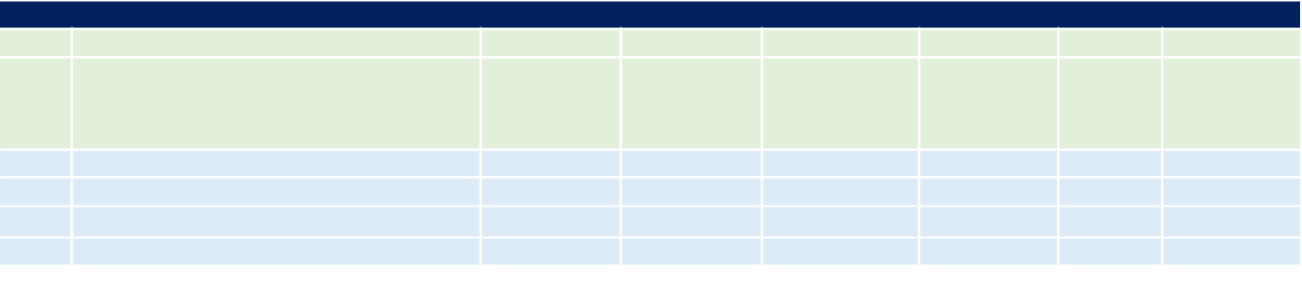
Source: Esri, Camoin Associates

Conclusion

Retail demand exists for a number of types of uses and could be successfully integrated into a larger mixed -use project to support other use types. Attention should be paid to the work being done in Downtown Laconia to revitalize the Main Street area, including significant investment in the Colonial Theatre, and anything done at the Site should be careful not to compete with, but to complement, the downtown offerings.

Camoin Associates | DRAFT - Real Estate Market Analysis: State of New Hampshire Lakes Region Facility | 40
Tourism and Recreation

Market Conditions - Tourism

National Tourism Trends

Tourism encompasses all visitor spending during travel for business or leisure. The tourism industry in the United States currently produces upward of $932.6 billion in revenue and supports over $188.0 billion in wages annually. Furthermore, tourism in the United States is anticipated to grow at an annualized rate of 1.8% from 2017 to 2022.F6P¹³P The majority of tourism demand is derived from leisure travel, including travel for purposes such as vacations, visiting friends or family, and attending events. Domestic travel is projected to increase an annualized 1.9% over five years to 2022.

Travelers are embracing experiences engrossed in local features and culture, and the tourism market is evolving to incorporate experiences into aspects of traditional traveling. Some of this change is accredited to the coming of age of millennials who travel more and are more passionate about travel in comparison to previous generations, such as Baby Boomers or Gen X. Destinations and businesses that can promise travelers quality experiences will prosper in this new age of tourism.

The hotel industry has responded to the demand for experiences by expanding from traditional hotels that serve as a place to rest your head at night to establishments that aid travelers in developing experiences. Hotels are adapting communal spaces, and local design touches in addition to providing digital connectivity throughout. Hotel businesses are shifting towards smaller buildings in more hospitable locations that prioritize convenience to events and attractions. Additionally, the industry is being affected by the sharing economy through house sharing companies such as AirBnB. These accommodations allow visitors to attain a single room, entire home, loft, or boat that offers a local experience unparalleled to a traditional hotel, often for a reduced cost.

Activities are the third largest segment of travel revenue, accounting for 10% of global travel revenue and projected to reach $183 billion by 2020.F7P¹⁴P Activities that make up this segment include tours, activities, attractions, and events at travel destinations. Further capitalizing on traveler experience, travel companies and hotels have begun integrating tours and activities into their online platforms. This allows for an additional revenue stream, while providing fast and simple options for customers to add when customizing their travel plans.

Another trend impacting the national tourism industry is the presence of technology. Various technological advancements across the industry have reduced labor costs and enhanced customer service. Online booking services and kiosk/online check-in services have reduced the number of hotel concierges needed to fulfill accommodation services. Additionally, consumers can be greatly impacted by online reviews when choosing a tourist location, hotel, activity, etc. and therefore, maintaining a positive online presence is crucial in generating future demand.

Regional Trends

The Lakes Region is home to 273 lakes and ponds and offers endless outdoor recreation assets, such as beaches, breweries and wineries, fishing, boating, canoeing and kayaking, hiking, biking, sailing, and more. The six major lakes in the region are: Lake Winnipesaukee, Newfound Lake, Squam Lake, Lake Winnisquam, Ossipee Lake, and Lake Sunapee. The majority of the attractions located within the Lakes Region are outdoor-oriented, save for a couple of museums sprinkled throughout the region. The Lakes Region offers a plethora of family-driven activities and attractions. The Lakes Region is home to multiple biking and hiking trail circuits such as the Northern Rail Trail and the Highland Mountain Bike Park. While the majority of tourism activity occurs during the summer season, the

- IBIS, Tourism in the US.
- Preservation Virginia, The Economic Impact of Heritage Tourism in Virginia.

Camoin Associates | DRAFT - Real Estate Market Analysis: State of New Hampshire Lakes Region Facility | 41
region and the state offers winter sport attractions as well, such as multiple ski resorts, snowmobiling, and snow tubing.

The combination of these assets drew in approximately 2.42 million visitors to the Lakes Region of New Hampshire in 2016, making up 6.81 million total visitor nights. In 2015, the Lakes Region Planning Commission estimated that the population of the 30 communities comprising the region tripled during the summer months due to the drastic increase in tourist activity. Traveler spending during the summer of 2016 reached $220.9 million within the Lakes Region, compared to $97.5 million during the winter season. In total, traveler spending within the Lakes Region totaled $564.34 million and made up just over 11% of total spending in the state. In terms of total visits, the Lakes Region captures about 23% of the state’s visits, according to 2016 data.

Accessibility

Ease of traveling to and within a region is important when considering its tourism potential. The Lakes Region is accessible by major highway I-93 to the west and New Hampshire Route 16 to the east, as well as New Hampshire Routes 3A, 106, 107, and 109, which cross the region from north to south. Other significant roads that run through the region include U.S. Route 3 and New Hampshire Routes 301, 11, 25, 28, 104, and 140. Figure 9 shows the Lakes Region in relation to major roadways.

Manchester-Boston Regional Airport is approximately 50 miles away from Laconia, the approximate center of the region. Portsmouth International Airport is also nearby, a 55-mile drive from Laconia. Boston Logan International Airport is also less than 100 miles away. There are other small, local airports within the region as well.

Figure 9: Map - Accessibility to the Lakes Region
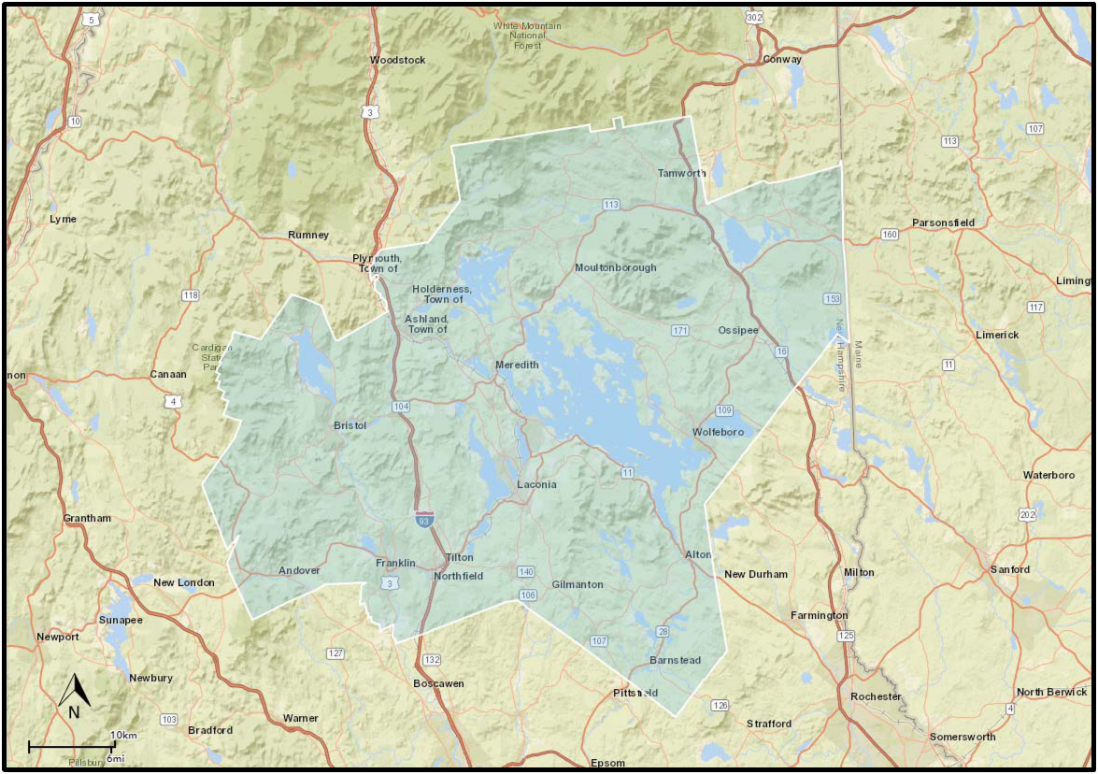

Source: Esri

Camoin Associates | DRAFT - Real Estate Market Analysis: State of New Hampshire Lakes Region Facility | 42

Accommodations

Table 31 outlines accommodations by type and price in the Lakes Region. Currently, there are diverse accommodations options within the Lakes Region, including numerous 2-and 3- star hotels, motels, resorts, and bed & breakfasts. Prices range from $60 to over $300 per night and vary vastly depending on the season. In addition to traditional accommodations, house sharing options such as AirBnB allow customers to gain access to a room or entire unit at a fraction of the cost. AirBnB prices for the Lakes Region ranged from $60 a night for a private room to over $500 a night for a private five-bedroom house. There are also multiple campsites in addition to the accommodations listed below.

Event Space

The area is limited in terms of access to a space that is large enough for an event such as a wedding, corporate meeting, or conference. Church’s Landing in Meredith came up many times as a potential location for an event up to 300 people; however, there doesn’t seem to be anything else regionally to accommodate something larger than that. The Lakes Region has a strong connection for many people throughout New England and through the interviews it was identified as an attractive wedding destination with the wedding industry growing year after year.

Table 31: Accommodation Inventory, Lakes Region, 2018
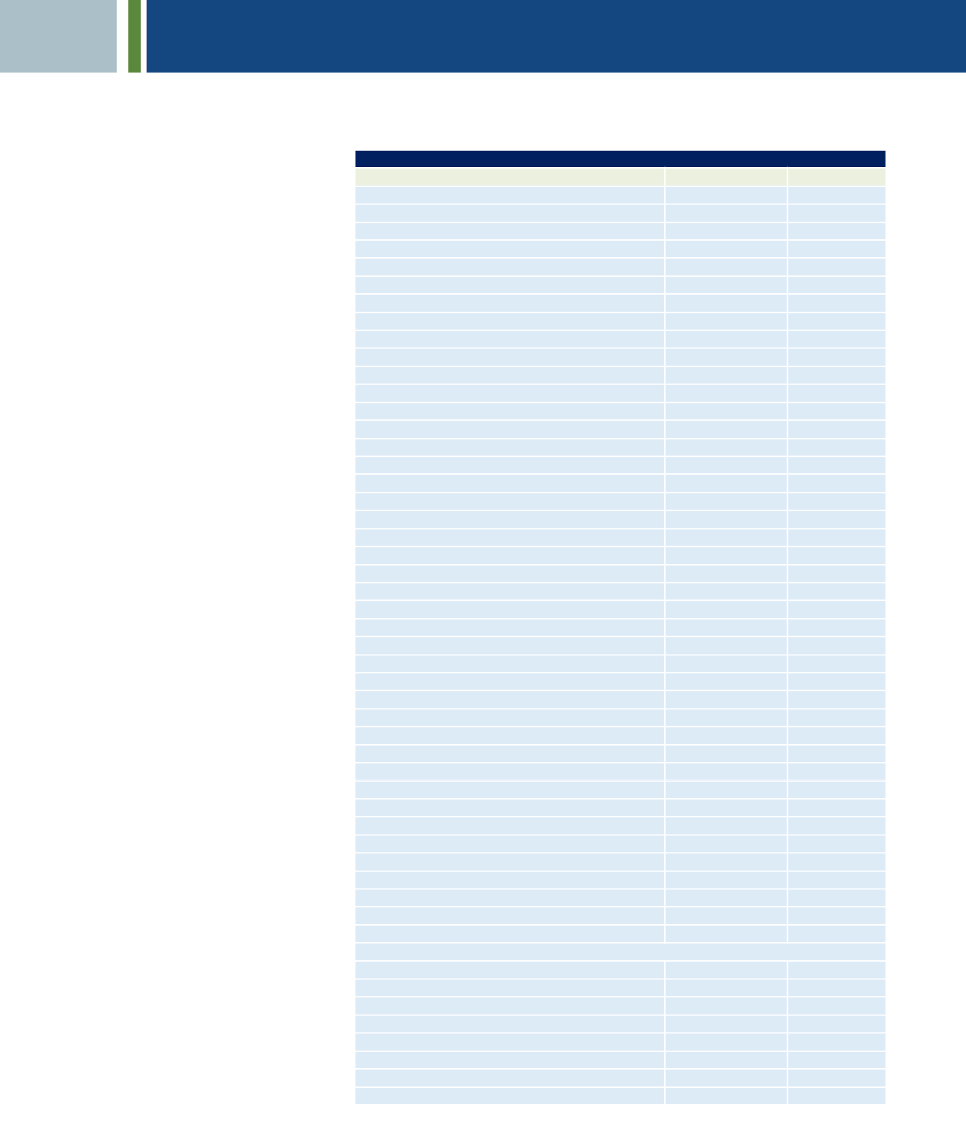

Accommodations in Lakes Region, 2018
Hotel | Type | Price Estimate
TownePlace Suites by Marriott Laconia Gilford | 2-Star Hotel | $ | 189
The Landmark Inn | 2-Star Hotel | $ | 85
Hampton Inn & Suites Tilton | 3-Star Hotel | $ | 134
The Margate Resort | 3-Star Hotel | $ | 119
Econo Lodge Lakes Region | 2-Star Hotel | $ | 89
Holiday Inn Express & Suites Tilton-Lakes Region | 2-Star Hotel | $ | 126
Lake Opechee Inn and Spa | 2-Star Hotel
Anchorage at the Lake | 2-Star Hotel | $ | 90
Bay Top Motel | 3-Star Hotel | $ | 89
Summit Resort | 3-Star Hotel | $ | 189
Lake Winnipesaukee Motel | 2-Star Hotel | $ | 99
Half Moon Motel & Cottages | 2-Star Hotel | $ | 105
Weirs Beach Motel and Cottages | 2-Star Hotel | $ | 95
The Naswa Resort | 3-Star Hotel | $ | 149
Barton's Motel | Motel
Lakeside Get-A-Way | 3-Star Hotel | $ | 101
Econo Lodge Inn & Suites | 3-Star Hotel | $ | 80
Super 8 Tilton/Lake Winnipesaukee | 2-Star Hotel | $ | 89
Fireside Inn & Suites at Lake Winnipesaukee | 3-Star Hotel | $ | 110
Grand View Resort | Motel | $ | 159
Birch Knoll Motel | 2-Star Hotel | $ | 119
Mill Falls at the Lake | Spa Resort | $ | 169
The Inn on Newfound Lake | Bed & Breakfast | $ | 145
The Lake House at Ferry Point Inn | 4-Star Hotel | $ | 230
Misty Harbor Barefoot Beach Resort | 3-Star Hotel | $ | 120
Cottage Place on Squam Lake | Motel
Center Harbor Inn | 2-Star Hotel | $ | 139
Squam Lake Inn | 3-Star Hotel | $ | 179
Gunstock Inn & Resort | 3-Star Hotel | $ | 71
Sun Valley Cottages | 3-Star Hotel | $ | 80
Rockywold-Deephaven Camps | Camp/Resort
Inn at Smith Cove | Hotel | $ | 150
The Inn at Mill Falls | 3-Star Hotel | $ | 169
Wolfeboro Inn | 3-Star Hotel | $ | 143
The Oliver Lodge | 3-Star Hotel | $ | 285
Bay Side Inn | Hotel | $ | 175
Church Landing at Mill Falls | 3-Star Hotel | $ | 300
Crescent Lake Inn & Suites | Hotel | $ | 180
Silver Sands Motel | Motel | $ | 100
Highland Lake Inn | Bed & Breakfast | $ | 220
Lakeview House & Cottages | 3-Star Hotel
Lantern Inn B&B | Bed & Breakfast | $ | 150
A Newfound Bed & Breakfast | 3-Star Hotel | $ | 175
Travelodge Tilton/Lake Winnisquam | Motel | $ | 62
Lake View Inn Bed & Breakfast | Bed & Breakfast
The Manor on Golden Pond | 4-Star Hotel | $ | 275
Black Swan Inn | Bed & Breakfast | $ | 125
Ames Farms Inn | Inn | $ | 145
Belknap Point Inn | 2-Star Hotel | $ | 100
The Inn on Golden Pond | 3-Star Hotel | $ | 210
Boulders Motel & Cottages | 4-Star Hotel
Source: Camoin Associates

Camoin Associates | DRAFT - Real Estate Market Analysis: State of New Hampshire Lakes Region Facility | 43

Market Conditions – Recreation

Recreation and entertainment in the United States continues to evolve based on a range of external factors, such as the decreasing unemployment rate, an overall rise in disposable income, the decline in leisure time, consumer adoption of healthy lifestyles, and constant shifts in consumer preferences. These threats and opportunities have affected different sectors of the industry in different ways. Some industries have evolved to meet the changing economic landscape while others will need to innovate in order to remain competitive.

A key market within recreation and entertainment includes gym, health, and fitness clubs. This industry specifically includes fitness and recreational sports facilities, including centers that support exercise equipment, fitness classes, indoor sports and other recreational activities, such as swimming, skating, and racquet sports. Demand for these services has been increasing due in part to both increasing disposable income and a trend toward healthy living.

As with gyms and fitness centers, a rise in new and unique offerings, coupled with increased disposable incomes have driven demand for various active recreational attractions that promote physical activity and healthy lifestyle choices. These attractions include golf driving ranges, miniature golf centers, go-kart racetracks, batting cages, family fun centers, recreational sports leagues and a wide assortment of outdoor recreational activities.

Another traditional entertainment industry is movie theatres, which include cinemas, drive-in theatres, and other outdoor movie venues and film festivals exhibitors. As with other entertainment industries, increased competition has both decreased demand for this industry and shaped how firms operate.

Gyms, fitness clubs, bowling centers, arcades, movie theatres, and the like, are all traditional venues for entertainment and recreation within the United States. All of these industries are being shaped by the increasing amount of competition; some competition is stemming from technological advancements making it easier for consumers to participate in activities in the comforts of their own home, while other competition is coming from new and innovative recreation options.

Growing in popularity are nontraditional entertainment options including high-adrenaline options like indoor trampoline parks, indoor rock climbing, and axe throwing, as well as less physically demanding options like paint-and-sip studios. Individually, these industries are smaller and less encompassing, however, consumers are taking interest in availability of new and unique options. Since consumers have less time to spend on leisure activities, they are looking for new and worthwhile experiences. However, these experiences must be convenient for the consumer, both in location and price. Additionally, consumers demand experiences that are tailored to them, providing them with high-quality customer service and supportive amenities.

With the strong tourist economy in the Lakes Region there is potential to create a destination that would be attractive to the families visiting the area for something to do in the shoulder seasons and to spruce up the variety of options surrounding the lakes.

Camoin Associates | DRAFT - Real Estate Market Analysis: State of New Hampshire Lakes Region Facility | 44
Market Potential

Table 32: Arts, Entertainment, and Recreation Businesses

Arts, Entertainment, and Recreation Businesses


 | No. of Businesses | No. of
 | No. of Businesses | Employees
15 Min Drive Time | 48 | 624
45 Min Drive Time | 175 | 2,988
Lakes Region | 159 | 1,498
Economic Region | 367 | 7,737
Source: Esri

Looking at the broader Economic Region, there are 367 Arts, Entertainment, and Recreation businesses with over 7,700 employees. Over the next ten years, the industry is expected to grow by 11.0%, or nearly 800 jobs.

At the 4-digit NAICS industry level, most of the employment is classified in the Other Amusement and Recreation Industries, which accounts for 62% of jobs and 252 businesses. Independent Artists, Writers, and Performers ranks second with 828 jobs and 13 businesses, while Spectator Sports follows with 509 jobs and 9 businesses. The greatest growth by percentage is expected in Gambling Industries with an anticipated growth of 52% over the next 10 years. Jobs are projected to decline in Spectator Sports and Museums, Historical Sites, and Similar Institutions, indicating weakness in these categories.

The table below provides additional detail on the industry groups within the Arts, Entertainment, and Recreation industry. The Location Quotient (LQ) column represents the relative concentration of each industry compared to the rest of the nation. A LQ of more than 1.0 means that an industry is more concentrated than the rest of the country, while a LQ of less than 1.0 means the industry is less concentrated. With an LQ of 1.31, Other Amusement and Recreation Industries is the only industry considered significantly concentrated in the region (a LQ at or above 1.2).

Table 33: Arts, Entertainment, and Recreation Industry Groups, Economic Region

Arts, Entertainment, and Recreation Industry Groups (4-Digit NAICS) - Economic Region
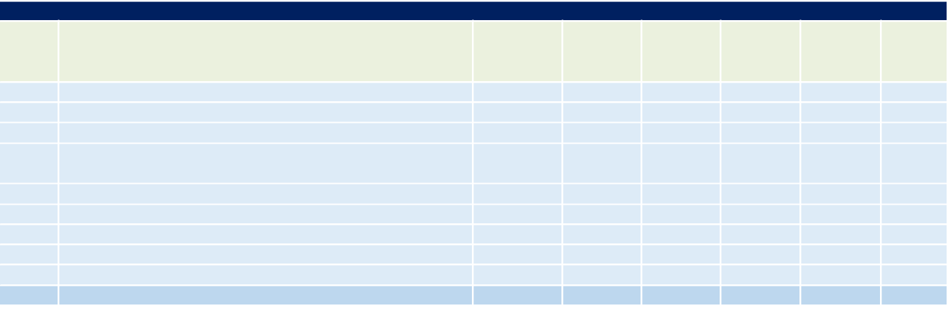

 |  | No. of |  |  | 2017-2027 | 2017-2027 | 2017
NAICS | Description | No. of | 2017 Jobs | 2027 Jobs | 2017-2027 | 2017-2027 | Location
NAICS | Description | Businesses | 2017 Jobs | 2027 Jobs | Change | % Change | Location
 |  |  |  |  |  |  | Quotient
7111 | Performing Arts Companies | 21 | 294 | 323 | 29 | 10% | 0.79
7112 | Spectator Sports | 9 | 509 | 494 | (15) | -3% | 1.09
7113 | Promoters of Performing Arts, Sports, and Similar Events | 17 | 380 | 546 | 166 | 44% | 1.01
7114 | Agents and Managers for Artists, Athletes, Entertainers, | 4 | 31 | 36 | 5 | 16% | 0.32
 | and Other Public Figures
7115 | Independent Artists, Writers, and Performers | 13 | 828 | 1,002 | 174 | 21% | 1.13
7121 | Museums, Historical Sites, and Similar Institutions | 26 | 263 | 242 | (21) | -8% | 0.64
7131 | Amusement Parks and Arcades | 15 | 273 | 339 | 66 | 24% | 0.53
7132 | Gambling Industries | 9 | 149 | 227 | 78 | 52% | 0.46
7139 | Other Amusement and Recreation Industries | 252 | 4,474 | 4,784 | 310 | 7% | 1.31
Total |  | 367 | 7,201 | 7,994 | 793 | 11%

Source: EMSI

The following table provides a similar breakdown for the Economic Region, providing a more detailed insight into the strengths of the market. Of the 367 businesses in the region falling into this category, 119 are within the Fitness and Recreational Sports Centers industry, employing 1,747 individuals in the Economic Region. Golf Courses and Country Clubs also contributes a significant number of jobs, at 1,050. The greatest job growth is projected to be in All Other Amusement and Recreation Industries, followed by Promoters of Performing Arts, Sports, and Similar Events without Facilities. The LQ analysis indicates a significant concentration of multiple industries, the highest of which being in Skiing Facilities; Racetracks; and Amusement Arcades, all having LQs above 2.00. All Other

Camoin Associates | DRAFT - Real Estate Market Analysis: State of New Hampshire Lakes Region Facility | 45
Amusement and Recreation Industries; Theatre Companies and Dinner Theatres; Marinas; and Promoters of Performing Arts, Sports, and Similar Events with Facilities also show LQs above 1.2.

Table 34: Top Arts, Entertainment, and Recreation Industry Sub-Sectors, Economic Region

Top Arts, Entertainment, and Recreation Industry Sub-Sectors (6-Digit NAICS) - Economic Region
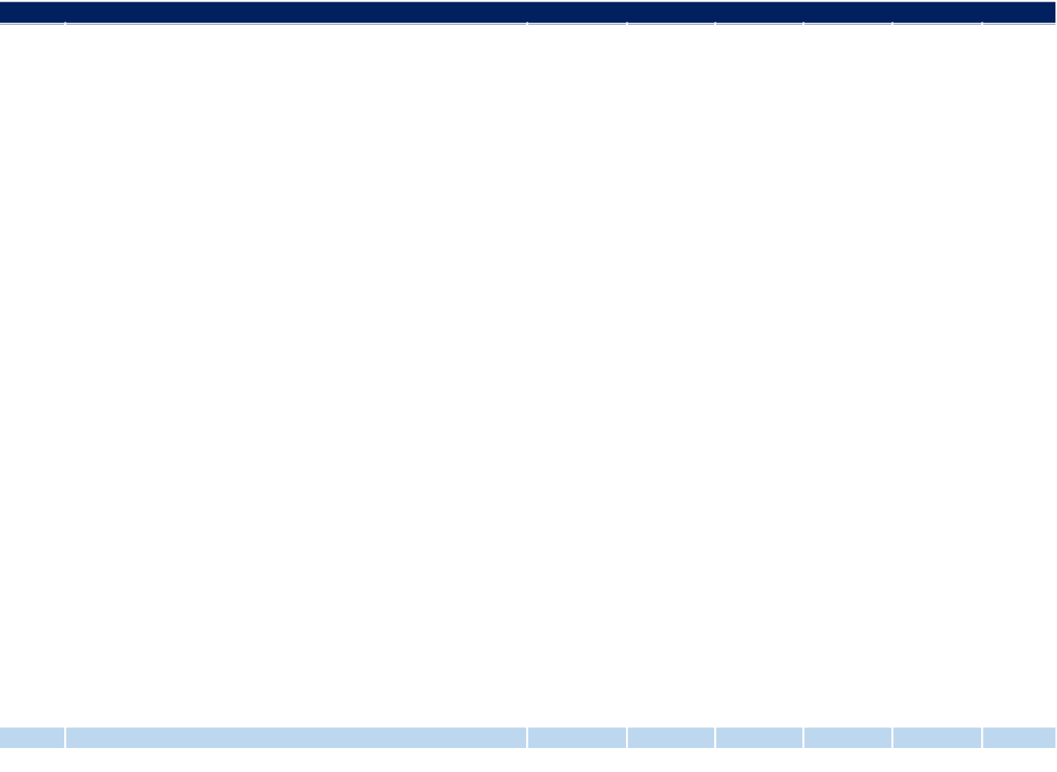

 |  | No. of |  |  | 2017-2027 | 2017-2027 | 2017
NAICS | Description | No. of | 2017 Jobs | 2027 Jobs | 2017-2027 | 2017-2027 | Location
NAICS | Description | Businesses | 2017 Jobs | 2027 Jobs | Change | % Change | Location
 |  |  |  |  |  |  | Quotient
713940 | Fitness and Recreational Sports Centers | 119 | 1,747 | 1,839 | 92 | 5% | 1.09
713990 | All Other Amusement and Recreation Industries | 65 | 746 | 993 | 247 | 33% | 1.40
713910 | Golf Courses and Country Clubs | 40 | 1,050 | 1,039 | (11) | -1% | 1.14
712110 | Museums | 20 | 223 | 219 | (4) | -2% | 0.92
711110 | Theater Companies and Dinner Theaters | 14 | 224 | 236 | 12 | 5% | 1.20
711510 | Independent Artists, Writers, and Performers | 13 | 828 | 1,002 | 174 | 21% | 1.13
713930 | Marinas | 13 | 149 | 163 | 14 | 9% | 1.44
713120 | Amusement Arcades | 12 | 183 | 232 | 49 | 27% | 2.78
711310 | Promoters of Performing Arts, Sports, and Similar Events | 9 | 333 | 483 | 150 | 45% | 1.26
 | with Facilities
713950 | Bowling Centers | 9 | 109 | 114 | 5 | 5% | 0.64
713290 | Other Gambling Industries | 8 | 105 | 142 | 37 | 35% | 0.86
711320 | Promoters of Performing Arts, Sports, and Similar Events | 8 | 47 | 63 | 16 | 34% | 0.42
 | without Facilities
711130 | Musical Groups and Artists | 8 | 61 | 73 | 12 | 20% | 0.48
713920 | Skiing Facilities | 7 | 673 | 635 | (38) | -6% | 6.81
711211 | Sports Teams and Clubs | 5 | 163 | 150 | (13) | -8% | 0.68
712120 | Historical Sites | 4 | 36 | 20 | (16) | -44% | 0.97
711410 | Agents and Managers for Artists, Athletes, Entertainers, | 4 | 31 | 36 | 5 | 16% | 0.32
 | and Other Public Figures
711212 | Racetracks | 3 | 286 | 272 | (14) | -5% | 3.07
713110 | Amusement and Theme Parks | 3 | 89 | 107 | 18 | 20% | 0.20
711219 | Other Spectator Sports | 1 | 61 | 72 | 11 | 18% | 0.45
713210 | Casinos (except Casino Hotels) | 1 | 44 | 85 | 41 | 93% | 0.22
712190 | Nature Parks and Other Similar Institutions | 1 | <10 | <10 | Insf. Data | Insf. Data | 0.03
712130 | Zoos and Botanical Gardens | 1 | <10 | <10 | Insf. Data | Insf. Data | 0.02
711120 | Dance Companies | 0 | 0 | 0 | 0 | 0% | 0.00
711190 | Other Performing Arts Companies | 0 | <10 | 14 | Insf. Data | Insf. Data | 0.41
Total |  | 367 | 7,201 | 7,994 | 793 | 11%
Source: EMSI

Table 35 and Table 36 below analyze the demand for entertainment activities and leisure products and services in the Economic Region. This information helps show what types of entertainment, recreation, and leisure businesses are likely to be the most successful in Laconia based on consumer demand. Market potential is measured by the Market Potential Index (MPI), which is an indication of the probability of residents to engage in certain activities as compared to the U.S. overall. A MPI of 100 means that residents of the region have the same participation rate for that activity as the rest of the U.S. while a MPI greater than 100 means that residents have a greater participation rate in that activity.

Table 35 shows the recreation and leisure activities with the greatest MP in the region. Backpacking is the top ranked activity, followed by downhill skiing, power boating, birdwatching, and canoeing/kayaking. The analysis indicates a propensity of regional residents to engage in outdoor activities. Aside from sports and outdoor activities, attending a rock music performance, participating in photography, and baking ranked among the highest leisure activities.

Camoin Associates | DRAFT - Real Estate Market Analysis: State of New Hampshire Lakes Region Facility | 46
Table 35: Leisure and Sports Market Potential, Economic Region

Leisure and Sports Market Potential: Top 25, Economic Region


 | Expected |  | Market
Product/Consumer Behavior | Number of |  | Market
Product/Consumer Behavior | Number of | Percent | Potential
Product/Consumer Behavior | Resident | Percent | Potential
 | Resident |  | Index
 | Participants |  | Index
Participated in canoeing/kayaking in last 12 months | 44,090 | 7.3% | 126
Watch on TV: ice hockey (NHL playoffs/Stanley Cup) | 69,702 | 11.5% | 122
Watch on TV: ice hockey (NHL regular season) | 69,021 | 11.4% | 121
Participated in bicycling (mountain) in last 12 months | 29,861 | 4.9% | 120
Did birdwatching in last 12 months | 32,575 | 5.4% | 119
Participated in backpacking in last 12 months | 22,819 | 3.8% | 117
Attended rock music performance in last 12 months | 66,281 | 10.9% | 117
Participated in motorcycling in last 12 months | 21,337 | 3.5% | 116
Member of veterans club | 16,569 | 2.7% | 116
Participated in golf in last 12 months | 60,911 | 10.0% | 115
Attend sports events: football game (college) | 31,144 | 5.1% | 115
Attend sports events: football game - NFL weekend | 24,088 | 4.0% | 115
Member of union | 25,007 | 4.1% | 115
Went on overnight camping trip in last 12 months | 84,967 | 14.0% | 115
Participated in hiking in last 12 months | 71,588 | 11.8% | 114
Watch on TV: golf (LPGA) | 29,090 | 4.8% | 114
Did woodworking in last 12 months | 30,884 | 5.1% | 114
Participated in skiing (downhill) in last 12 months | 18,505 | 3.1% | 113
Spent on sports/rec equip in last 12 months: $250+ | 53,269 | 8.8% | 113
Attend sports events: baseball game - MLB reg seas | 50,771 | 8.4% | 113
Watch on TV: baseball (MLB regular season) | 146,852 | 24.2% | 113
Watch on TV: golf (PGA) | 90,508 | 14.9% | 113
Watch on TV: Olympics (winter) | 147,533 | 24.3% | 113
Played board game in last 12 months | 92,586 | 15.3% | 113
Attended country music performance in last 12 months | 40,124 | 6.6% | 113
Source: Esri

Table 35 looks at market potential by general sports activity. Within the Economic Region, the General Sports market participation is similar to the national average in all activities except for Golf and Baseball, for which the MPI is moderately greater at 115 and 112, respectively.

Table 36: General Sports Market Potential, Economic Region

General Sports Market Potential, Economic Region
Activity | MPI
Participated in Baseball | 112
Participated in Basketball | 98
Participated in Football | 99
Participated in Golf | 115
Participated in Soccer | 100
Participated in Softball | 103
Participated in Tennis | 102
Participated in Volleyball | 105
Source: Esri
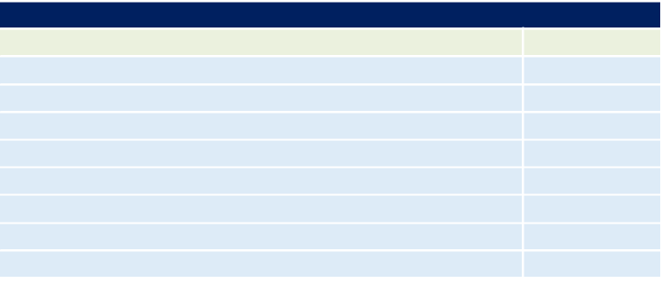

Table 37 displays the market potential for fitness activities within the Economic Region. All of the fitness categories have MPI figures above the rest of the country, suggesting there may be market potential for businesses offering

Camoin Associates | DRAFT - Real Estate Market Analysis: State of New Hampshire Lakes Region Facility | 47
relevant services. Within the Economic Region, Swimming, and Jogging/Running rank especially high with MPIs of 111 and 112.

Table 37: Fitness Market Potential, Economic Region

Fitness Market Potential, Economic Region
Activity | MPI
Aerobics | 106
Jogging/Running | 112
Pilates | 107
Swimming | 111
Walking for Exercise | 108
Weight Lifting | 107
Yoga | 108
Zumba | 101
Source: Esri


As previously discussed, outdoor activities are a strong market, and while most of these activities are not provided by the private market, outdoor recreation participants are the target market for certain types of retailers such as clothing and equipment providers. Table 38 shows the outdoor activity market potential within the Economic Region. Activities such as Canoeing/Kayaking, Bicycling (mountain) and Backpacking rank high with MPIs of 126, 120 and 117.

Table 38: Outdoor Activity Market Potential, Economic Region

Outdoor Activity Market Potential, Economic Region
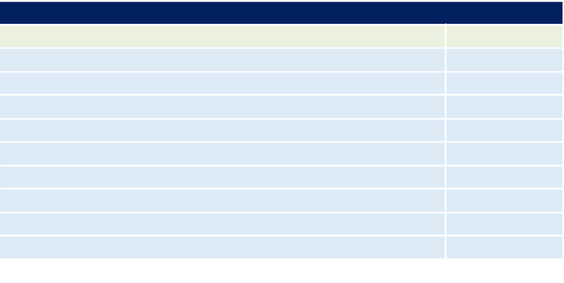

Activity | MPI
Backpacking | 117
Hiking | 114
Bicycling (mountain) | 120
Bicycling (road) | 111
Boating (power) | 110
Canoeing/Kayaking | 126
Fishing (fresh water) | 105
Fishing (salt water) | 107
Horseback Riding | 110
Source: Esri

Table 39 looks at attendance at non-sports related venues for entertainment. Attending a rock music performance ranks first followed by attending a country music performance. In general, residents of the region and more likely to go out to entertainment venues than their national counterparts.

Camoin Associates | DRAFT - Real Estate Market Analysis: State of New Hampshire Lakes Region Facility | 48
Table 39: Entertainment Industry Market Potential, Economic Region

Entertainment Industry Market Potential, Economic Region


Activity | MPI
Went to art gallery | 107
Went to bar/night club | 109
Played billiards/pool | 105
Dined out | 108
Attended a movie | 104
Went to a museum | 109
Attended classical music/opera performance | 102
Attended country music performance | 113
Attended rock music performance | 117
Went to live theater | 107
Source: Esri

Conclusion

Participation in leisure and recreational activities is generally strong in the Economic Region, which suggests there may be market potential for new recreational or entertainment-oriented businesses. Outdoor recreation, fitness activities, and team sports participation all ranked higher than national averages. This may indicate a need for new recreational facilities such as sports fields or indoor sports facilities if there is existing demand that is not being met by the current local and regional offerings.

Camoin Associates | DRAFT - Real Estate Market Analysis: State of New Hampshire Lakes Region Facility | 49
Attachment A: Data Sources

Proprietary Data Sources

Economic Modeling Specialists International (EMSI)

To analyze the industrial makeup of a study area, industry data organized by the North American Industrial Classification System (NAICS) is assessed. Camoin Associates subscribes to Economic Modeling Specialists Intl. (EMSI), a proprietary data provider that aggregates economic data from approximately 90 sources. EMSI industry data, in our experience, is more complete than most or perhaps all local data sources (for more information on EMSI, please see www.economicmodeling.com). This is because local data sources typically miss significant employment counts by industry because data on sole proprietorships and contractual employment (i.e. 1099 contractor positions) is not included and because certain employment counts are suppressed from BLS/BEA figures for confidentiality reasons when too few establishments exist within a single NAICS code.

Esri Business Analyst Online (BAO)

ESRI is the leading provider of location-driven market insights. It combines demographic, lifestyle, and spending data with map-based analytics to provide market intelligence for strategic decision-making. ESRI uses proprietary statistical models and data from the U.S. Census Bureau, the U.S. Postal Service, and various other sources to present current conditions and project future trends. Esri data are used by developers to maximize their portfolio, retailers to understand growth opportunities, and by economic developers to attract business that fit their community. For more information, visit www.esri.com.

IBISWorld

IBISWorld is one of the world's leading publishers of business intelligence, specializing in industry and procurement research. Through its detailed industry reports available at 5-digit NAICS level, IBISWorld provides insight into market conditions for targeted industries, helps to identify major suppliers or supply chain, and provides an understanding of competitor activity. More at www.ibisworld.com

Public Data Sources

American Community Survey (ACS), U.S. Census

The American Community Survey (ACS) is an ongoing statistical survey by the U.S. Census Bureau that gathers demographic and socioeconomic information on age, sex, race, family and relationships, income and benefits, health insurance, education, veteran status, disabilities, commute patterns, and other topics. The survey is mandatory to fill out, but the survey is only sent to a small sample of the population on a rotating basis. The survey is crucial to major planning decisions, like vital services and infrastructure investments, made by municipalities and cities. The questions on the ACS are different than those asked on the decennial census and provide ongoing demographic updates of the nation down to the block group level. For more information on the ACS, visit http://www.census.gov/programs-surveys/acs/

OnTheMap, U.S. Census

OnTheMap is a tool developed through the U.S. Census Longitudinal Employer-Household Dynamics (LEHD) program that helps to visualize Local Employment Dynamics (LED) data about where workers are employed and where they live. There are also visual mapping capabilities for data on age, earnings, industry distributions, race, ethnicity, educational attainment, and sex. The OnTheMap tool can be found here, along with links to documentation: http://onthemap.ces.census.gov/.

Camoin Associates | DRAFT - Real Estate Market Analysis: State of New Hampshire Lakes Region Facility | 50

Camoin Associates | DRAFT - Real Estate Market Analysis: State of New Hampshire Lakes Region Facility | 51
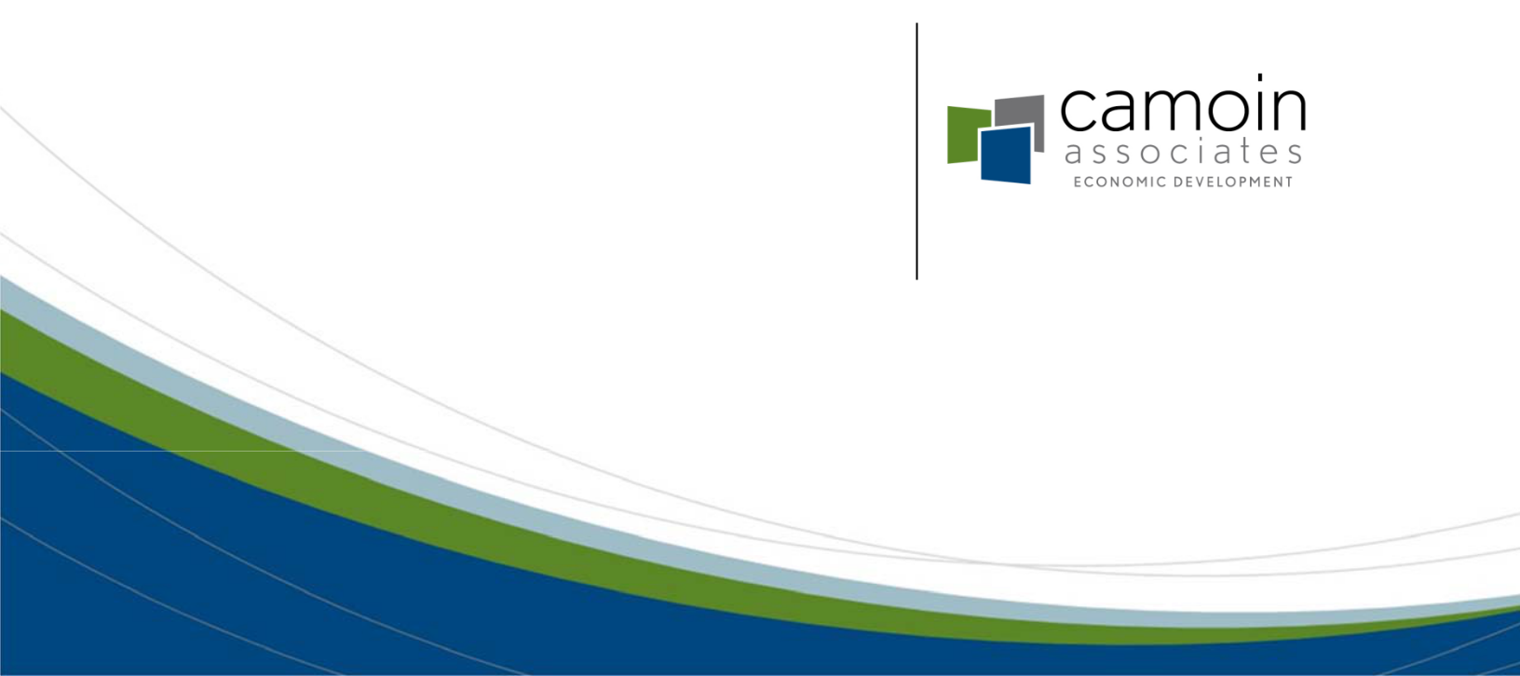

Camoin Associates, Inc.

120 West Avenue, Suite 303
Saratoga Springs, NY 12866

518.899.2608

www.camoinassociates.com
@camoinassociate

Camoin Associates | DRAFT - Real Estate Market Analysis: State of New Hampshire Lakes Region Facility | 52

