 |  |  |  |  |  |  |  |  |  | Project Charter
 |  |  |  |  |  |  |  |  |  | Address Verification
 |  |  |  |  |  |  |  |  |  | Rev. 1.1.0 – 03/03/2009
 | PROJECT CHARTER
 | 1. General Project Information
 | * Project Name: |  |  |  | Address Verification (Batch Processing)
 | * Project Sponsor(s):
 | • What department is the primary proponent of this project? |  |  |  |  |  |  |  | Academic Support Resources (ASR)
 | • Who is the primary Project Sponsor? |  |  |  |  |  |  |  | Sue Van Voorhis, Academic Support Resources
 | • | Additional Project Co-Sponsors: |  |  |  |  |  |  | Miriam Ward, Office of Human Resources (OHR)
 |  |  |  |  |  |  |  |  | Lincoln Kallsen, University Budget and Finance
 |  |  |  |  |  |  |  |  | Doug O’Sullivan, Office of Information Technology
 | • Is this an Enterprise Project with significant impact on |  |  |  |  |  |  |  | Yes | No
 |  | 3 or more departments?
 |  |  |  |  |  | Document History
 | Version |  | Date |  |  | Author |  | Reason for Change
 | 1.0 |  | 01/28/2009 |  |  | Barbara Mueller |  | Re-initiating this project effort, with information gathered
 |  |  |  |  |  |  |  | from previous project documentation
 | 1.0.1 |  | 01/29/2009 |  |  | Barbara Mueller |  | Minor updates per Sponsor Review (01/29/2009)
 | 1.1.0 |  | 03/03/2009 |  |  | Barbara Mueller |  | Added Project Sponsor (Lincoln Kallsen), representing
 |  |  |  |  |  |  |  | Enterprise Ticketing interests.

H:\PMO Templates\Documentation Examples\Address Verification Charter.docx Page 1

Project Charter
Address Verification
Rev. 1.1.0 – 03/03/2009

2. Project / Service Description
* Project Purpose / Business Justification

Address data integrity and synchronization has been an ongoing issue for the University of Minnesota. With the implementation of shared address data in the PeopleSoft Campus Solutions systems for Student Administration and Human Resources in 1998, and the more recent implementation of the PeopleSoft Financial Systems in 2008, it has become even more important to maintain the accuracy of address data in these enterprise-wide resources. While there are approved standards for address entry, there are no batch or online edits to enforce these standards. As a result, addresses may be entered incorrectly via many sources including:

- Batch loads from interfaces that contain inaccurate addresses or addresses that fail to meet USPS standards.

- Inaccurate address entry by U of M staff, as a result of not knowing or not following the USPS standards for address entry, inability to decipher hand-written documents, or as a result of simple keying errors.

- Inaccurate address entry via Web self-service, as a result of not knowing or not following the USPS standards for address entry, or as a result of simple keying errors.

A large percentage of addresses in these enterprise-wide resources are inaccurate and/or fail to meet United States Postal Service (USPS) standards, resulting in a large volume of return mail received by staff in University Addressing and Mailing, the University Foundation, the Office of Student Finance, Intercollegiate Athletics, Accounts Receivable Services, and Sponsored Projects Administration, among many other departments.

To date, departments have tended to isolate and correct problems using a variety of software products run against data fed from PeopleSoft to help them conform data to USPS standards. Each area is either using departmentally purchased software and/or contracting individually with outside vendors to verify the integrity of their data. This results in a huge duplication of effort on campus to clean data that could be done at the source rather than piece-meal on a departmental basis.
* Business Objectives

The overall objective of this and subsequent project phases is to implement Clean_Address for all of the following: batch processing of flat files, batch processing of standard database address formats, point-of-entry address cleansing in the PeopleSoft environments, and point-of-entry address cleansing in additional applications via web services.

This first phase of the project is intended to implement the batch processing of flat files and standard database address formats, to achieve the following outcomes:

- Reduce the cost of bad addresses by identifying addresses for correction at the source.
- Enhance revenues by improving marketing and fund-raising initiatives.

- Improve the University’s ability to recruit and retain exceptional students, faculty, and staff.

- Increase customer satisfaction and enhance the public perception of the University.

This first phase of the project is intended to implement only the Clean_Address batch processing of flat files and Oracle address table data that can be provided in a standard format. This phase of the overall project effort is intended to implement a service which will take as input a flat file or data base table of address data, process the data for address corrections, and provide as output a flat file or data base table of the corrected data.

See Appendix D – Estimated Cost of Bad Addresses for Selected Departments.

H:\PMO Templates\Documentation Examples\Address Verification Charter.docx Page 2

Project Charter
Address Verification
Rev. 1.1.0 – 03/03/2009

2. Project / Service Description
* Project Deliverables:
Project Initiation and Planning
DLVRBL: Business Case
DLVRBL: Updated Portfolio Summary
DLVRBL: Kick Off Agenda
DLVRBL: Project Scope & Related Deliverables
DLVRBL: Project Work Plan & Schedule
DLVRBL: Issues Log
Analyze
DLVRBL: To-Be Process Flow: Batch Address Verification / Generic
DLVRBL: To-Be Process Flow: Batch Address Verification / PeopleSoft Campus Solutions
DLVRBL: To-Be Process Flow: Batch Address Verification / Audience View
DLVRBL: Documentation of Analysis for Operations, Infrastructure, and Architecture
DLVRBL: Requirements & Fit/Gap Report(s)
DLVRBL: Testing Strategy / Test Plans
Design
DLVRBL: Documentation of Design for Operations, Infrastructure, and Architecture
DLVRBL: Functional Design
DLVRBL: Technical Design
Build
DLVRBL: Build Summary
Test
DLVRBL: Testing Strategy & Approach
DLVRBL: Detailed Test Cases
DLVRBL: Bug/Fix Log
MILESTONE: Unit Test Results
MILESTONE: System Test Results
MILESTONE: Acceptance Test Results
MILESTONE: Performance Test Results
Deploy
DLVRBL: Rollout Planning deliverables
DLVRBL: Deployment deliverables

DLVRBL: Post-Implementation Review Report

H:\PMO Templates\Documentation Examples\Address Verification Charter.docx Page 3

Project Charter
Address Verification
Rev. 1.1.0 – 03/03/2009
2. Project / Service Description

Clear Statement of What This Project Will Include

The batch processing included in this phase of the project is specifically limited to the following:

- Standard batch processing of flat file or Oracle table address data that has been exported for processing, utilizing the standard Clean_Address schema on a separate datastore.

- Standard batch processing of AudienceView address data, accessed via a database link, and utilizing the generic Clean_Address schema on a separate datastore.

  - Standard batch processing utilizing the delivered Clean_Address schema for PeopleSoft Campus Solutions, on the PeopleSoft Campus Solutions datastore.

- Clear Statement of What This Project Will Not Include

This first phase of the project will not include point-of-entry address correction (i.e. real-time address correction for PeopleSoft Campus Solutions, PeopleSoft Financials, and other real-time address correction via web services).

The batch process services to be implemented as part of this project are limited to receipt of the input address data, the batch processing to cleanse the address data, and the return of an output file of cleansed address data along with the unresolved address data. The scope of this project does not include application development for the correction of address data in the source applications.

Additional notes on what this project will not include:

  - The implementation of Clean_Address is limited to U.S. Postal Addresses. It does not include the verification and correction of University campus addresses, except to the extent that any or all of these would be considered valid U.S. Postal Addresses.

- Project Success Define what must be done in order for this project to be considered a success by its stakeholders.

*****TBD*****

- Project Milestones

  - Proposed project start date: January 30 (Initial Kick-Off Meeting).

  - Proposed project end date: TBD

- Major Known Risks (including significant Assumptions)

    - Multiple project sponsors and business process owners

    - Resource constraints (staff, hardware, competing work requests, funding)
    - Lag time from initial RFP and software purchase

    - Software Vendor’s PS interface has changed from initial software purchase

    - Additional PS system has been added since initial software purchase

    - PS implementation may require or warrant PS mods?

    - Potential differences in business need / configuration compared to the U Foundation implementation
    - New area of enterprise software for OIT

    - Wide variance between average and peak transaction volumes

See Appendix B – Risk Ratings

* Constraints

Resource constraints (staff, competing work requests), especially as pertains to resource allocations for
FY2009 Quarter 3 work requests
H:\PMO Templates\Documentation Examples\Address Verification Charter.docx Page 4

 |  |  |  |  |  |  | Project Charter
 |  |  |  |  |  |  | Address Verification
 |  |  |  |  |  |  | Rev. 1.1.0 – 03/03/2009
 |  | 2. Project / Service Description
 |  | External Dependencies
 |  | No External Dependencies have been identified.
 |  | 3. Financial / Resources Information
 |  | Funding Source
 |  | Initial OSF Funding: | $ |  | 128,360
 |  | Software Subscription: | $ |  | 45,390
 |  | Balance remaining: | $ |  | 82,970
 |  | Estimate of time required of IT Department Staff:
 |  | See Appendix E – Preliminary Estimate of Work
 |  | 4. Sign-off
 |  |  |  | Name |  | Signature |  | Date (MM/DD/YYYY)
 |  | Business Sponsor |  | Sue Van Voorhis
 |  | Business Sponsor |  | Miriam Ward
 |  | Business Sponsor |  | Lincoln Kallsen
 |  | Technical Sponsor |  | Doug O’Sullivan
 |  | Business Process Owner |  | Carolee Cohen
 |  | Business Process Owner |  | Kelly Krattiger
 |  | Technical Manager |  | Andrew Hill
 |  | EPMO Director |  | Garfield Bowen
 |  | Project Manager |  | Barbara Mueller
5. List of Addenda
List all files supplemental to this Charter here. Optional: Use filename to create hyperlink to document.
 | Document Name | Filename
 | Appendix A– Stakeholders & Other Interested Parties
 | Appendix B – Risk Ratings
 | Appendix C – Impact / Benefit (Value) Ratings
 | Appendix D – Estimated Cost of Bad Addresses for Selected Departments
 | Appendix E – Preliminary Estimate of Work

H:\PMO Templates\Documentation Examples\Address Verification Charter.docx Page 5

Project Charter
Address Verification
Rev. 1.1.0 – 03/03/2009

6. Notes

H:\PMO Templates\Documentation Examples\Address Verification Charter.docx Page 6

 |  |  |  | Project Charter
 |  |  |  | Address Verification
 |  |  |  | Rev. 1.1.0 – 03/03/2009
 | Appendix A– Stakeholders & Other Interested Parties
 | Key Stakeholders
 |  | Name | Department | Telephone | E-mail
 | * Project Sponsor | Sue Van Voorhis | ASR
 | * Project Sponsor | Miriam Ward | OHR
 | * Project Sponsor | Lincoln Kallsen | Budget & Finance
 | * Technical Sponsor | Doug O’Sullivan | OIT
 | * Business Process Owner | Carolee Cohen | ASR
 | * Business Process Owner | Kelly Krattiger | OHR
 | * EPMO Director | Garfield Bown | OIT EPMO
 | * Project Manager | Barbara Mueller | OIT EPMO | 612-624-8838 | b-muel@umn.edu
 | * Technical Manager | Andrew Hill | OIT AAS
Other Interested Parties

Neil Grass | Addressing and Mailing | Sherise Morgan | Duluth School of Fine Arts
George Hudacheck | Admissions | Bryan Herrman | Morris Admissions
Lauri Enger | Admissions | Jill Beauregard | Morris Financial Aid
Ann Koller | ASR | David Laden | Non-Spons Accts Receivable
Ted Skogman | ASR | Cari Hatcher | Northrup Ticket Office
Jason LaFrenz | Athletics | Jalayne Nottom | OHR
Jennifer Koontz | CCE | Kelly Krattiger | OHR
William Kenney | Controller’s Office | Sonnia Peters | OHR
Amber Evans-Dailey | Crookston Admissions | Tom Schmidt | OSF / Loans
Melissa Dingmann | Crookston Financial Aid | Jim Nichols | OVPR-IT
Renee Mulcahy | Crookston Ofc of Finance | Karen Klein | Payroll
Tricia Sanders | Crookston Ofc of Finance | Cynthia Scott | U Relations
Bob Nelson | Crookston Registrar’s Ofc | Peter Wiringa | U Relations
Ashlee Kvidera | CSOM Alumni&Annual Giving | Peter Dahl | University Foundation
Anne Marie Bulger | Disbursement Services
LaCretia Bell | Disbursement Services

H:\PMO Templates\Documentation Examples\Address Verification Charter.docx Page 7

Project Charter
Address Verification
Rev. 1.1.0 – 03/03/2009

Appendix A– Stakeholders & Other Interested Parties (continued)

Proposed Kick-Off Meeting Attendees
(resources assigned to the project and/or representatives for project roles)
Carolee Cohen | ASR | Dan Wagner | OIT OIA
 |  |  | Applications & Tools
Ann Koller | ASR | Patton Fast | OIT OIA
 |  |  | Operations & Infrastructure
Kelly Krattiger | OHR | Arash Forouhari | OIT OIA Architecture
Sonnia Peters | OHR | Ben Grindy | OIT OIA Architecture
David Laden or | Non-Spons Accts Receivable | Mark Powell | OIT OIA Data Security
Michelle Howard
Andy Hill | OIT AAS | Michele Berner | OIT OIA Data Security
Brett Lee | OIT AAS | John Snider | OIT OIA Disaster Recovery
David Imdieke | OIT AAS | Tim Gagner | OIT OIA Environment Mgmt &
 |  |  | Change Control
Shannon Gibson | OIT AAS | Clark Johnson | OIT OIA Environment Mgmt &
 |  |  | Change Control
Elverse Jordan | OIT AAS | Xavier Knight | OIT OIA Performance
Dee Ann Thiede | OIT AAS | Brian Baty | OIT OIA Software Admin
Barbara Mueller | OIT EPMO | Michael Galvin | OIT OIA Software Admin
Garfield Bowen | OIT EPMO | Jim Colten | OIT OIA Unix Admin
Al Pierce | OIT OIA | Sharon Ramallo | OIT OIT Environment Mgmt &
 | Operations & Automation |  | Change Control
Fred Wilson | OIT OIA | Peter Dahl | University Foundation
 | Operations & Automation
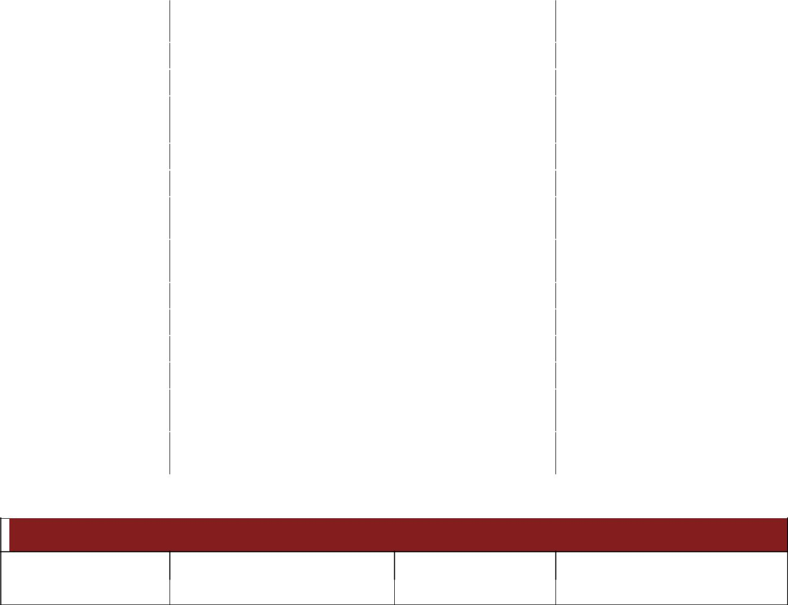

Vendor Contacts

 | Name |  | Company / Role |  | Telephone | E-mail
 | Kevin Runner |  | Runner Technologies |  | +1 877-784-0003 x807 | krunner@runnertechnologies

H:\PMO Templates\Documentation Examples\Address Verification Charter.docx Page 8

Project Charter
Address Verification
Rev. 1.1.0 – 03/03/2009

Appendix B– Risk Ratings
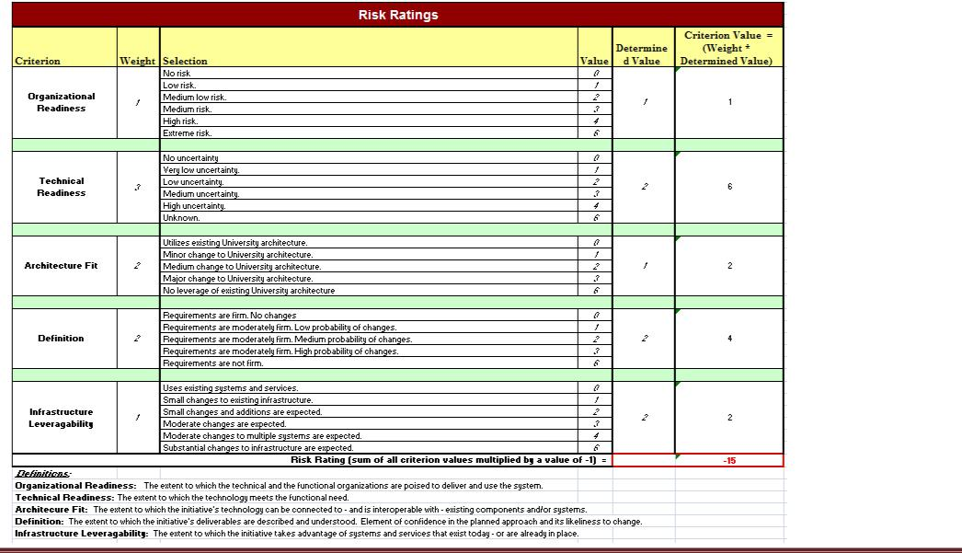

H:\PMO Templates\Documentation Examples\Address Verification Charter.docx Page 9

Project Charter
Address Verification
Rev. 1.1.0 – 03/03/2009

Appendix C– Impact / Benefit (Value) Ratings
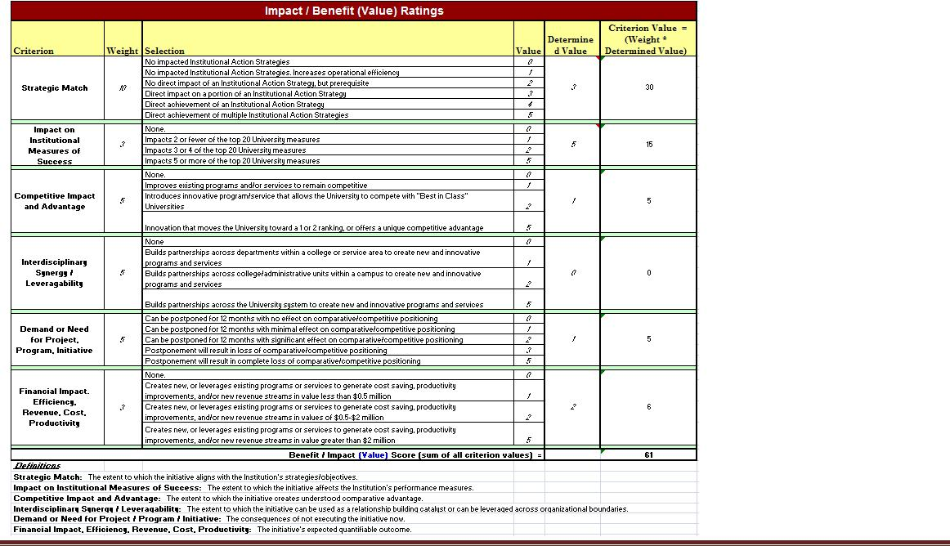

H:\PMO Templates\Documentation Examples\Address Verification Charter.docx Page 10

Project Charter
Address Verification
Rev. 1.1.0 – 03/03/2009

Appendix D– Estimated Cost of Bad Addresses for Selected Departments
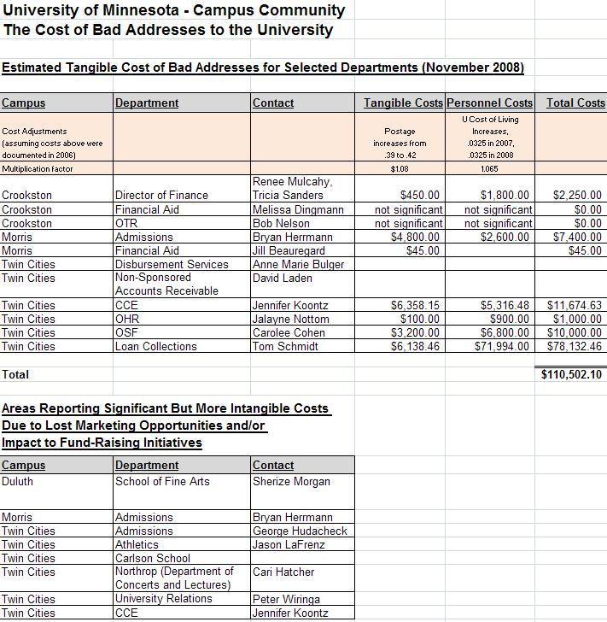

H:\PMO Templates\Documentation Examples\Address Verification Charter.docx Page 11

