Project Charter

CONTOSO, LTD MICROSOFT DYNAMICS CRM

IMPLEMENTATION FOR CALL CENTER

Prepared for
Contoso, Ltd

Prepared by
Jonathan Haas, Proseware, Inc. Sr Project Manager
Proseware, Inc.

Table of Contents

1 INTRODUCTION 1

2 PROJECT SCOPE 2

BUSINESS OBJECTIVES 2

PROJECT OBJECTIVES 2

RELEASE 1 SCOPE 2

PROJECT DEPENDENCIES 3

OUT OF SCOPE 3

3 PROJECT GOVERNANCE MODEL 5

KEY STAKEHOLDERS 5

PROSEWARE, INC. ROLES AND RESPONSIBILITIES 6

CONTOSO, LTD ROLES AND RESPONSIBILITIES 7

PROJECT TEAM STRUCTURE 9

REPORTING 10

COMMUNICATIONS 11

4 PROJECT APPROACH 12

CONSTRAINTS AND ASSUMPTIONS 12

ISSUES AND RISKS 12

HIGH-LEVEL SCHEDULE 13

Release Roadmap 13

Release 1 Schedule 13

KEY MILESTONES AND DELIVERABLES 13

5 SUCCESS CRITERIA AND METRICS 16

BENEFITS 16

- INTRODUCTION

Contoso, Ltd is among the largest providers of private post-secondary education in Brazil, based on student enrollment and revenue, with 83 locations. Headquartered in Rio de Janerio, Contoso, Ltd employs approximately 21,000 full-time, part-time and adjunct faculty and staff and Fall 2007 enrollment of 116,000 students.

Contoso, Ltd’s education institutions offer a broad range of academic programs concentrated in the creative and applied arts, behavioral sciences, education, health sciences and business fields, culminating in the award of associate's through doctoral degrees as well as non-degree programs. Contoso, Ltd faculty are skilled instructors and trained professionals in their fields. Many faculty have extensive industry experience as well as the necessary academic qualifications.

- PROJECT SCOPE

BUSINESS OBJECTIVES

- Increase Admissions staff productivity and drive consistency of Admissions staff performance.

- Provide effective communications with the student through the student life cycle

- Increase the weekly completed applications by 16% per ADA

- Improve the application to start rate by 45%

- Improve employee satisfaction by decreasing ramp up time by providing an intuitive easy to use system

- Improve the predictability and consistency of key business metrics

- Improve data access for real-time access to management and monitoring

PROJECT OBJECTIVES

Release 1

- Establish Microsoft Dynamics CRM as the system of record for Contoso, Ltd lead information

- Design and implement a solution for the Contoso, Ltd Lead to Application new and re-entry student processes using an integrated solution

- Design and implement a solution for the Contoso, Ltd Application to Enrollment new processes using an integrated solution

- Integrate the solution with the existing Leads and Siebel applications

- Test and deploy the integrated solution to the Contoso, Ltd user base

Release 2

- Design and implement a solution for the Lead to Application new and re-entry student processes using an integrated solution

- Integrate the solution with the existing Leads and Siebel applications

- Test and deploy the integrated solution to the user base

- Design and implement dashboard reporting for the entire user base

RELEASE 1 SCOPE

- Microsoft Dynamics CRM Modules

  - Microsoft Dynamics CRM Sales

  - Microsoft Dynamics CRM Marketing

- Business Processes

  - Lead to Application Student processes

  - Application to Enrollment Student processes

  - New and Re Entry Student processes

- Microsoft Dynamics CRM Entities

  - Account

  - Contact

  - Activity

  - Opportunity

  - Campaign

- Integration

  - Microsoft Dynamics CRM Siebel (Student Information System) interface for unidirectional or bidirectional (if necessary) for the dynamic synchronization of Contacts and Opportunities

  - Leads Microsoft Dynamics CRM interface for unidirectional synchronization of Contacts and Opportunities

- Other Integration Components (primary responsibility of Contoso, Ltd)

  - Online Application Microsoft Dynamics CRM for student account information

  - Campus Portal Microsoft Dynamics CRM for student account information

  - Microsoft Dynamics CRM Responsys for outbound email campaigns

- Training

  - Assist with the development of training materials for Train the Trainer

  - Provide train the trainer training

- Knowledge Transfer

  - Functional

  - Microsoft Dynamics CRM Administration

  - Microsoft Dynamics CRM Installation

  - Systems Architecture

  - Configurations and Customizations

  - Reports

- Reporting

  - Perform training for users to create ad hoc reports on data in Microsoft Dynamics CRM

  - Develop up to 10 custom reports using standard reports included in Microsoft Dynamics-Microsoft Dynamics CRM 4.0 as templates.

- Deployment

  - Configure, stabilize (test) and deploy the solution to the Contoso, Ltd (Release 1) , AUO and SUO (Release 2) for 1,201 users distributed among the communities as follows:
Contoso, Ltd | 600
Others | 601
Total | 1,201
- Locations – Rio de Janerio, Buenos Aires

- Mode – Microsoft Dynamics CRM 4.0 Web Client

PROJECT DEPENDENCIES

Migration of Contoso, Ltd student information system to Siebel is in progress and expected to be completed by the end of May 2008. Contoso, Ltd will be responsible for ensuring cross project communications take place to ensure there are no schedule impacts.

OUT OF SCOPE

1. Student Alumni processes are out of scope for both releases of the project

- Future state business process definition or re-engineering beyond the processes impacted by the Microsoft Dynamics CRM solution for Release 1 and 2

- Microsoft Dynamics CRM Workflows or multiple sales processes and\or methodologies (except for Lead to Enrollment)

- Modifications to the core Microsoft Dynamics CRM SDK or coding/scripting on third party applications

- Integration or interface to any third-party or legacy systems the systems identified in the scope section

- Preparation/formatting, data cleansing, de-duplication and export of legacy data for the migration to Proseware, Inc. provided template

- Validation of migrated data

- Hardware and software procurement and installation

- Remote connectivity infrastructure (Except for CITRIX and Desktop)

- End-user training beyond train the trainer

- Creation of end-user training collateral. Proseware, Inc. will provide a template to Contoso, Ltd who will be responsible for customizing it for their needs.

- Organizational Change Management

- Support documentation, as this comes with the Proseware, Inc. Microsoft Dynamics CRM 4.0 Software

- Creating Mail merge word documents or email templates

- Desktop, OS upgrades or service pack maintenance to meet minimum product operating requirements

- Deployment of the solution to mobile users

- PROJECT GOVERNANCE MODEL

KEY STAKEHOLDERS

Group |  | Name |  | Title
Executive Steering
Committee
 |  | Hadaya, Sagiv |  | President
 |  | Abolrous, Hazem |  | VP Operations
 |  | Iallo, Lucio |  | VP Education
 |  | Jacob, Sanjay |  | CIO
 |  | Bator, Tomasz |  | Proseware, Inc. Practice Manager
 |  | Rasmussen,
 |  | Morten |  | Proseware, Inc. Engagement Manager
 |  | Kerle, Michael |  | Proseware, Inc. Sr. Project Manager
Executive Sponsors
 |  | Cabatana, Reina |  | President
 |  | Lachance, Joel |  | VP Operations
 |  | Makovec, Tina |  | CIO
Stakeholders
 |  | Eamsiri, Krittiya |  | VP, Student Applications
 |  | Hamilton, James R. |  | CIO

 |  |  | Harel, Eran | Director, Technology
 |  |  | Hao, Junmin | VP
 |  |  | Hanson, Mark | VP
 |  |  | Oğuz, Göktuğ | AVP, Systems Integration
 |  |  | Grauner, Torleif | Proseware, Inc. Engagement Manager
 |  |  |  | Proseware, Inc. Practice Manager and
 |  |  | Xie, Ming-Yang | Proseware, Inc.’s Project Sponsor
 |  |  |  | Ownership and Accountability
 |  |  | Yang, Chen | Proseware, Inc. Account Manager
 |  |  | Dan Richards | Proseware, Inc. Public Sector Sales
 |  |  |  | Director
 |  |  | Ownership and Accountability Matrix
PROSEWARE, INC. ROLES AND RESPONSIBILITIES
 | Role |  |  | Responsibilities
Project Manager |  | The Project Manager is responsible for ensuring that all aspects of the project
 |  | are planned and executed in a manner that will lead to meeting the
 |  | implementation goals within the established timeframe and budget to a high
 |  | degree of customer satisfaction
Engagement Manager |  | During the implementation, the Engagement Manager has overall
 |  | responsibility for ensuring quality and timeliness in the delivery of services
 |  | and maintaining a healthy relationship with the customer.
Solution Architect |  | The Solution Architect is the primary resource for determining the approach
 |  | to be utilized in an implementation. The Solution Architect will also assist in
 |  | scoping and documenting customizations the project may require. The
 |  | Solution Architect should possess a thorough understanding of the product
 |  | from both a functional and technical perspective.

Application Consultant The Application/Functional Consultant will participate in every aspect of the implementation from analyzing the customer’s business requirements to configuring the Proseware, Inc. Microsoft Dynamics application to meet the customer’s needs. The Application/Functional Consultant communicates with the customer’s organization on many levels to obtain the necessary understanding of the business processes.

Development The Development Consultant is responsible for the design and development Consultant of modifications to the standard Proseware, Inc. Microsoft Dynamics

application.

Technology Consultant The Technology Consultant is tasked with solving issues that relate to implementing Proseware, Inc. Microsoft Dynamics and related software in the customer's current IT environment.

CONTOSO, LTD ROLES AND RESPONSIBILITIES

Role | Responsibilities
Executive Sponsor | The Customer Executive Sponsor is a senior level executive who has accepted
 | ownership of investigating and investing in a business system initiative and
 | will promote funding and staffing of the project.
Business Decision | Business Decision Makers are management level individuals within the
Maker | customer's organization responsible for a specific aspect of the organizational
 | process that will be impacted by the implementation.
Customer Project | The Customer Project Manager is responsible for ensuring all customer
Manager | requirements are planned and executed in a manner that will meet the
 | implementation goals for the project.
IT Manager | The IT Manager is responsible for the customer’s entire IT environment
 | including both hardware and software setup in all locations, or the person
 | filling this role may be accountable for assembling the resources who can be
 | responsible for these technologies.

Organizational Change | The Organization Change Manager is responsible for ensuring that the change
Manager | introduced by the new Microsoft Dynamics CRM system is introduced and
 | communicated to the stakeholders and users. These activities including
 | mobilizing the leadership, managing communications and ensuring that
 | training is planned and executed.
QA Manager | The QA Manager is responsible for managing and coordinating the Systems
 | and Integration Test, Performance Test and User Acceptance Test activities.
 | These activities include ensuring the availability of test users, test resources
 | and scheduling the test activities.
Key Users | Key Users (or Subject Matter Experts) represent a functional area or
 | department within the customer organization, for example, marketing or
 | inside sales. They are typically a more experienced user who has in-depth
 | knowledge of the business processes and procedures currently being used in
 | their functional area or department.
End Users | End Users are the individuals from various functional areas or departments
 | who will use the new solution to perform their daily activities.

PROJECT TEAM STRUCTURE

 |  |  |  |  |  | Role |  |  |  |  |  |  |  |  |  |  |  |  |  |  | Name |  |  |  |  |  |  |  |  |  |  |  | Organization
 |  |  |  | Project Manager(s) |  |  |  |  |  |  |  |  |  | Numadutir, Inga |  |  |  |  |  |  |  |  |  |  |  |  |  |  |  |  | Proseware, Inc.
 |  |  |  |  |  |  |  |  |  |  |  |  |  | Øby, Sidsel |  |  |  |  |  |  |  |  |  |  |  |  |  |  |  |  | Contoso, Ltd
 |  |  | Engagement Manager |  |  |  |  |  |  |  |  |  |  | Gornozhenko, Dmitry |  |  |  |  |  |  |  |  |  |  |  |  |  |  |  |  | Proseware, Inc.
 |  |  |  | Solution Architect(s) |  |  |  |  |  |  |  |  |  | Noriega, Fabricio |  |  |  |  |  |  |  |  |  |  |  |  |  |  |  |  | Proseware, Inc.
 |  |  |  |  |  |  |  |  |  |  |  |  |  | Xylaras, Ioannis |  |  |  |  |  |  |  |  |  |  |  |  |  |  |  |  | Contoso, Ltd
 |  | Application Consultant(s) |  |  |  |  |  |  |  |  |  |  |  | Miller, Ben |  |  |  |  |  |  |  |  |  |  |  |  |  |  |  |  | Proseware, Inc.
 |  |  |  |  |  |  |  |  |  |  |  |  |  | Fitzmaurice, Mike
 |  |  |  |  |  |  |  |  |  |  |  |  |  | Frank, Jill

Development Consultant(s) | Valverde, Eva | Proseware, Inc.
 | Li, Yan
 | Czernek, Pawel
Technical Support Account | TBD | Proseware, Inc.
Manager
Services Executive | Stammler, Jeff | Proseware, Inc.
Organization Change Manager | Lang, Eric | Contoso, Ltd
and Business Process Manager
Business Process Analysis | Clark, Molly | Contoso, Ltd
Manager
QA Manager | Barbariol, Angela | Contoso, Ltd
CRM Administrator | Ræbild, Jesper | Contoso, Ltd
Infrastructure and Operations | Ptak-Małysiak, Urszula | Contoso, Ltd
Manager
Integration and Interface | Hughes, Christine | Contoso, Ltd
Manager
Key Users / Business Owners |  | Contoso, Ltd

REPORTING

- Proseware, Inc. team status reports from the Functional Lead and Technical Lead are due to the Proseware, Inc. Project Manager by Thursday every week at 9:00am EST

- Proseware, Inc. Project Status Report from Proseware, Inc. Project Manager due to Contoso, Ltd Project Manager by Thursday every week at 4:00pm EST

- Steering Committee Report from the Proseware, Inc. and Contoso, Ltd Project Managers due every Friday at 10:00am EST

COMMUNICATIONS

- Proseware, Inc. team internal status meeting will occur every Friday at 8:00am EST

- Proseware, Inc. and Contoso, Ltd project status meeting will occur every Thursday at 03:00pm EST. Meeting attendees will include all team leads and project leads.

- Proseware, Inc. and Contoso, Ltd Steering Committee update will occur every Thursday at 01:00pm

EST

- Phase Tollgate review meetings will be scheduled at the end of every phase completion

- Change control board meetings will be scheduled on a weekly basis upon completion of the Design phase

- PROJECT APPROACH

Proseware, Inc. will leverage the Sure Step Methodology to execute this implementation. Sure Step provides a structured approach to implementing Proseware, Inc. Microsoft Dynamics products. The Sure Step Methodology provides detailed guidance on roles required to perform activities and proven best practices. Flowchart diagrams within this implementation methodology point to tools and templates that can be used at different phases of an implementation project.

Sure Step Methodology organizes the approach into five distinct phases during the implementation project lifecycle
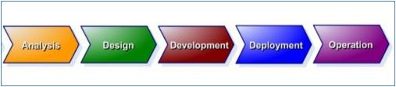

CONSTRAINTS AND ASSUMPTIONS

None identified

ISSUES AND RISKS

None identified

HIGH-LEVEL SCHEDULE

 |  | RELEASE ROADMAP
 |  |  |  |  |  |  |  |  |  |  |  | Sales |  |  |  |  |  |  | Marketing |  |  |  |  |  |  |  | Service
 |  | Contoso, Ltd |  |  |  |  |  |  |  |  |  | Release 1
 |  | Contoso, Ltd |  |  |  |  |  |  |  |  |  |  |  |  |  |  |  |  |  |  |  |  |  |  |  |  | Release
 |  | 2
 |  |  |  |  |  |  |  |  |  |  |  | Adm. V2 |  |  |  |  |  |  | CM V2 |  |  |  |  |  |  |  | Future
 |  |  |  |  |  |  |  |  |  |  |  | Release 2 |  |  |  |  |  |  | Release 3
 |  | Contoso, Ltd
 |  | 3
 |  | RELEASE 1 SCHEDULE
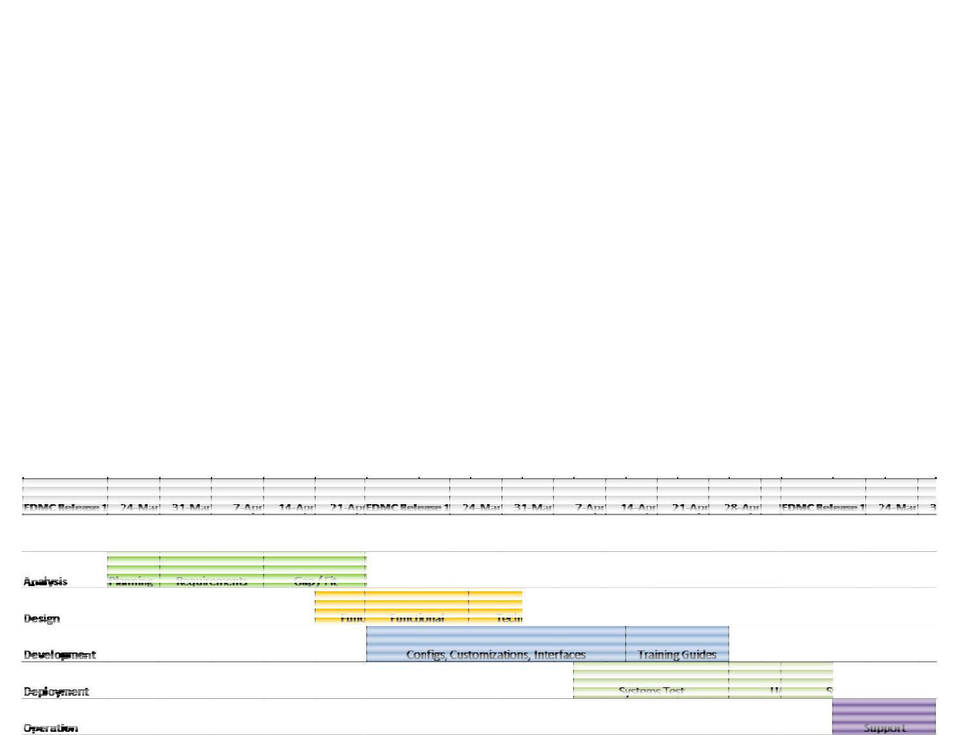

KEY MILESTONES AND DELIVERA BLES

R – Responsible, A – Accountable, I – Inf ormed, C – Consulted

All dates are draft and to be finalized ba sed on the project plan.

Functional | Deliverable/ Miles | tone | Date | Proseware | , Inc. | Contoso,
Area |  |  |  |  |  | Ltd
Analysis | Phase Tollgate Review |  | 04/30/2008
 | Project Charter |  | 3/26/2008 - 4/1/2008 | R, A, C, I |  | R, A, C, I

 | Project Plan | 4/1/2008 - 4/7/2008 | R, A, C, I | R, A, C, I
 | Business Requirements | 3/31/2008 - | R | A, C, I
 |  | 4/11/2008
 | Solution Architecture | 3/31/2008 - | R, A | C, I
 |  | 4/11/2008
 | Gap Fit Analysis | 4/7/2008 - 4/18/2008 | R, A | C, I
 | Dev / Sandbox Environments | 4/18/2008 | R, A | C, I
Design | Phase Tollgate Review | 5/30/2008
 | Functional Design | 4/21/2008 - 5/2/2008 | R, A | C, I
 | Technical Design | 5/2/2008 - 5/16/2008 | R, A | C, I
 | Training / Test Environments | 5/23/2008 | R | A, C, I
 | Test Plan | 5/30/2008 | R | A, C, I
 | System Test Scripts | 5/30/2008 | R, A | C, I
 | Training Plan | 5/30/2008 | R | A, C, I
Developmen | Phase Tollgate Review | 6/30/2008
t
 | Configuration and | 4/28/2008 - | R, A | C, I
 | Development | 5/23/2008
 | Systems and Integration Test | 5/26/2008 - | R | A, C, I
 |  | 6/13/2008
 | Performance Test | 6/2/2008 - 6/13/2008 | R | A, C, I
 | Production Environment | 6/6/2008 | C, I | R, A
 | Training Documentation | 6/12/2008 | R | A, C, I
Deployment | Phase Tollgate Review | 7/11/2008
 | Deployment Plan | 6/9/2008 | R | A, C, I
 | Train the Trainer | 6/9/2008 – 6/12/2008 | R, A | C, I
 | User Acceptance Test | 6/16/2008 - | C, I | R, A
 |  | 6/27/2008
 | Go / No Go Decision | 6/27/2008 | C, I | R, A
 | Go Live | 6/30/2008 | C, I | R, A

Operation | Phase Tollgate Review | 7/25/2008
 | End User Training | 7/1/2008 – 7/11/2008 | C, I | R, A
 | Transition to Support | 7/1/2008 – 7/11/2008 | R, A | C, I

Key Milestones and Deliverables

- SUCCESS CRITERIA AND METRICS

BENEFITS

Increase productivity of Admissions Support by standardizing and automating staff’s daily activities: O Increase talk times of Admissions on a weekly basis.

O Reduce the “paperwork” and low-value add activities O Increase the average completed applications per week

O Increase sub-processes rates (i.e. lead-to-contact, lead-to-application, lead-to-interview and lead-
to-start rates)

Improve Admissions support staff job satisfaction and morale by reducing the amount of human middleware :

O Reduce “paperwork” and lower value-add activities

Improve campaign management ROI on all types of leads (including re-entry students) Improve visibility into and drive consistency of Admissions performance

