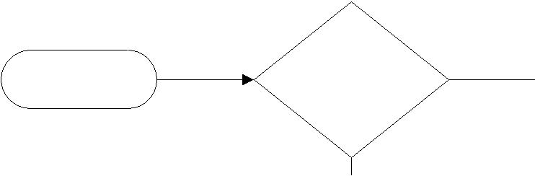

Start | 1 To IFOP | No
 | Active

Yes
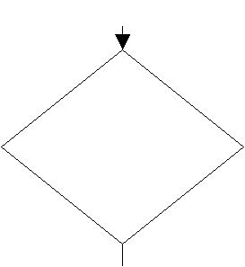

2 From IFOP
No
Valid

Yes
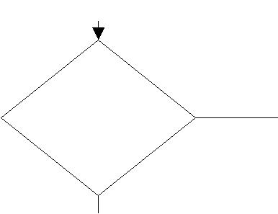

3 Total EPETs
More than Orig _{Yes}

and Pending Trans

No
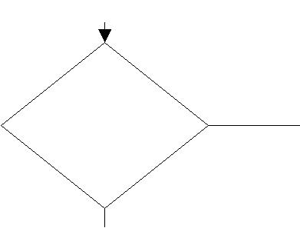

4 From Index

and To Index is No not the same

Yes
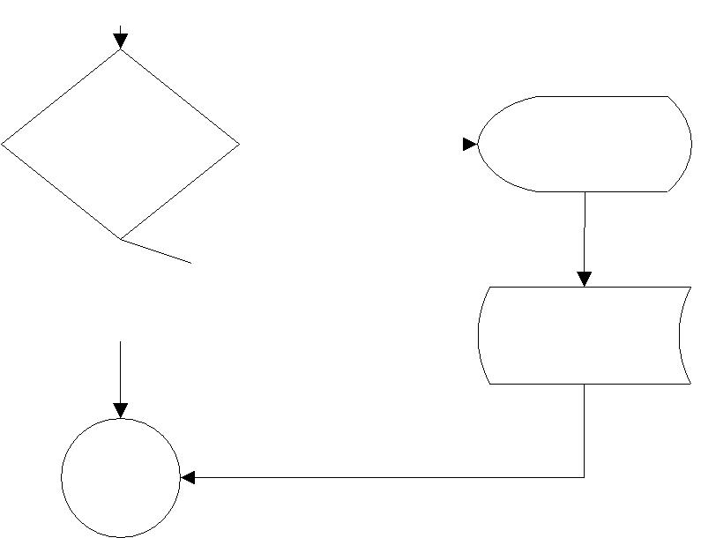

6 Is EPET cost
Yes
shared?
IsCostShared
No

To Page

2
Risk Assessment Decision Tree
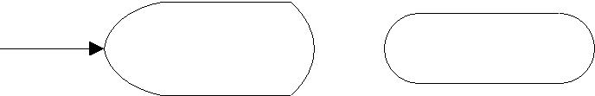

Prompt #E Stop

Prompt #F Stop
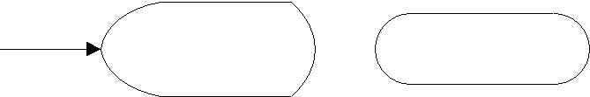

Prompt #H Stop

Prompt #M Stop

Prompt #Q

PTO template

Page 1

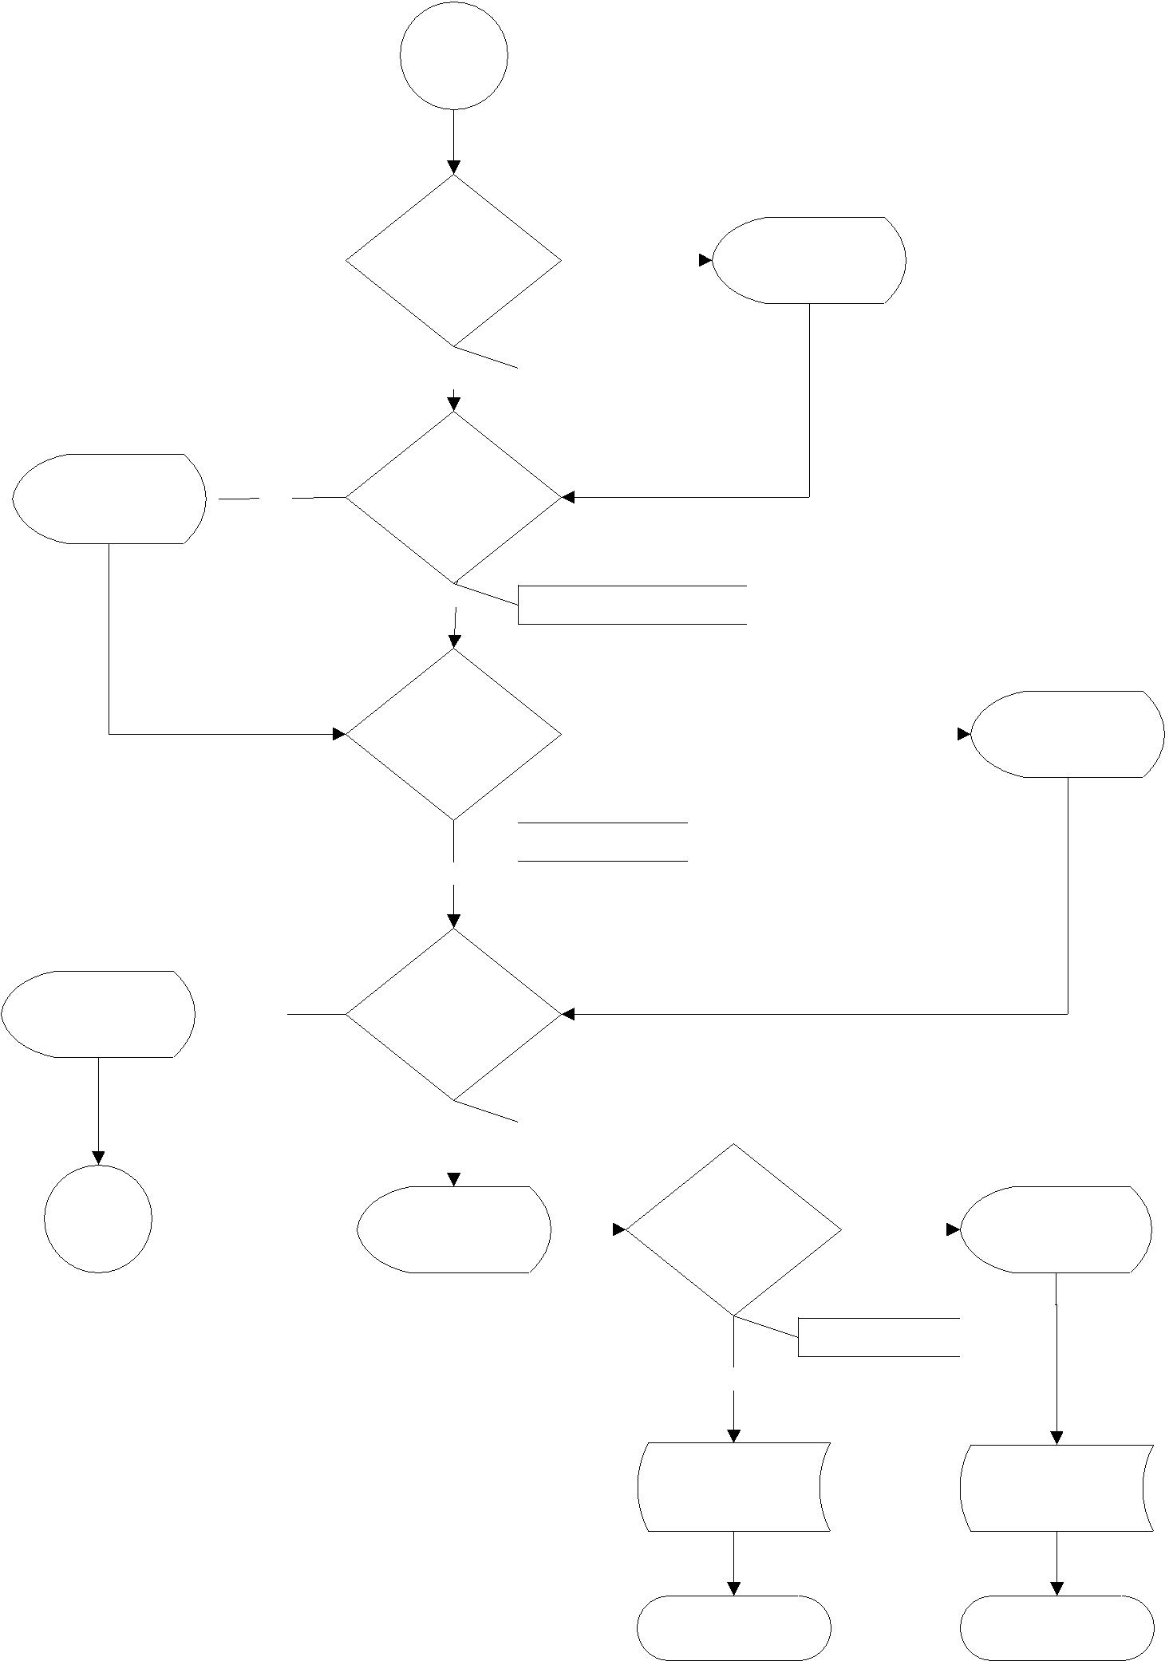
From

Page 1
Risk Assessment Decision Tree

Prompt #O Yes

Prompt #L Yes

To Page

3

8 Is To Org = |  |  |  |  |  |  |  |  |  | Prompt #P
 |  |  |  |  |  | No
From Org
 |  |  |  | IsToOrgFromOrg
 | Yes

9 Past Early

Inactive Date

^{No} IsToPastEarlyInactiveDate

12 > 3 Ledger |  |  |  | Prompt #B
 |  | Yes
Periods

IsTxDateOut4Mos

No

11 Is To Fund

EMF

 |  |  |  | IsToEmf
 | No |  |  |  |  |  | 13 Is From
Prompt #G |  |  |  |  |  |  |  |  |  |  | Prompt #L
 |  |  |  |  |  |  |  |  | No
 |  |  |  |  |  | Fund No EMF

IsFromNotEmf

Yes

PTG template PTG template

Stop Stop

Page 2

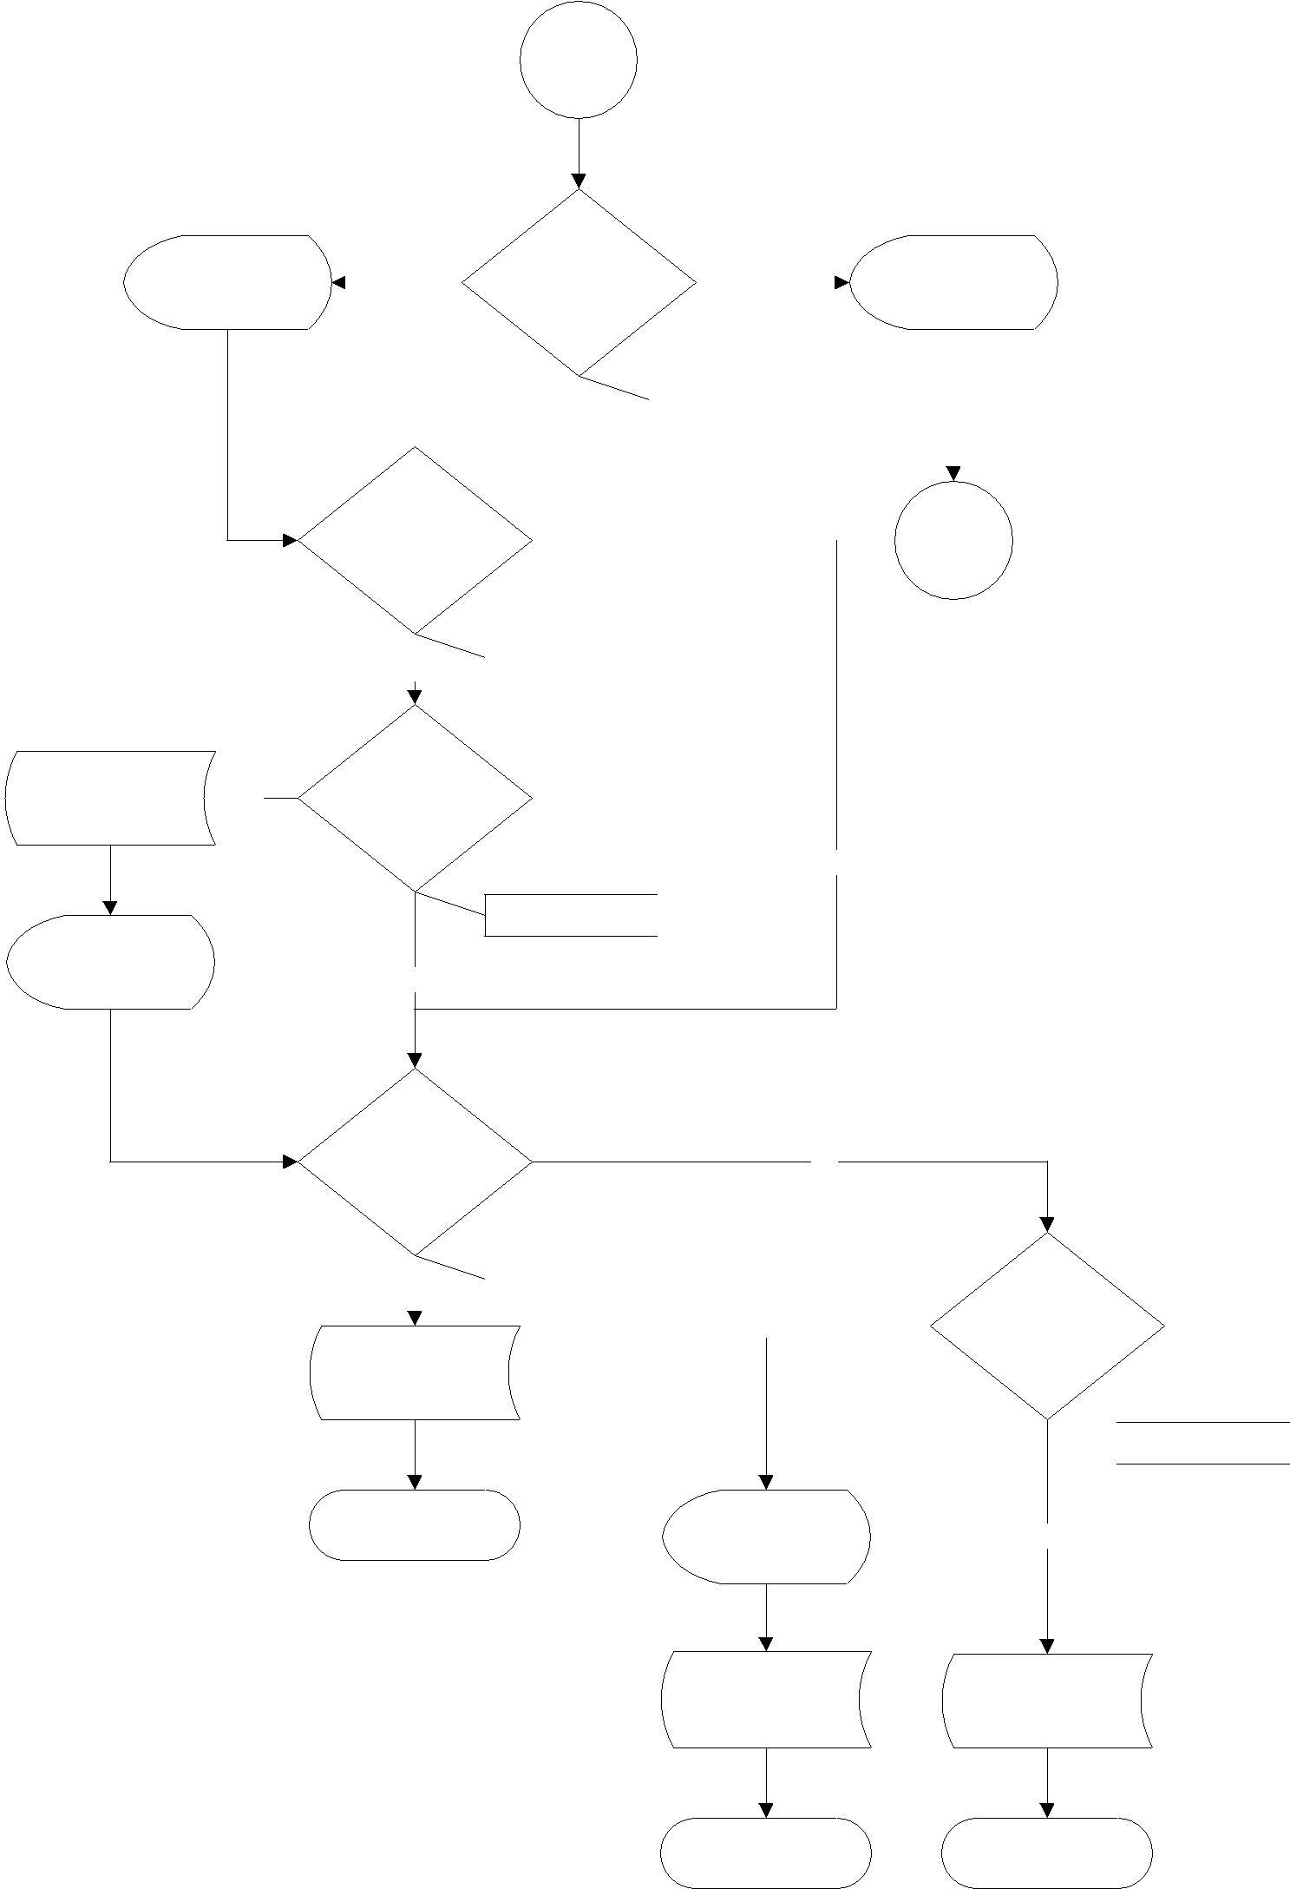
From

Page 2
Risk Assessment Decision Tree

Prompt #G

PTO template No

Prompt #A

 |  |  |  |  |  |  | 14 Is To Fund
 |  |  |  |  |  |  | Private & Not |  |  |  |  |  |  |  | Prompt #K
 |  | Yes |  |  |  |  |  |  |  |  | No
 |  |  |  |  |  |  | Fed FloThru
 |  |  |  |  |  |  |  |  | IsToPrivateNotFft
15 Is To Fund
 |  |  |  |  |  |  |  |  |  |  |  |  |  |  | To Page
 | A Contract/
 |  |  |  |  |  |  |  |  |  |  |  |  |  |  | 4
 |  | Grant
 |  |  |  |  |  |  | IsToPrivCG
 |  |  | Yes

16 Is Trans In

Proj Period

No

IsTxDateInToProjPrd

Yes

17 IntraFund

Transfer No (same level 4)

 |  |  |  | IsIntraFund
 | Yes |  |  |  |  |  |  | 18 Is To Fund
 |  |  |  |  |  | Yes
PTG template |  |  |  |  |  |  |  | in OD

IsToPrivOverDraft

Stop | Prompt #C | No

PTO template PTG template

Stop Stop

Page 3

From

Page 3

19 Trans Date w/in Proj Per on To Fund 90 days for FDP
Risk Assessment Decision Tree
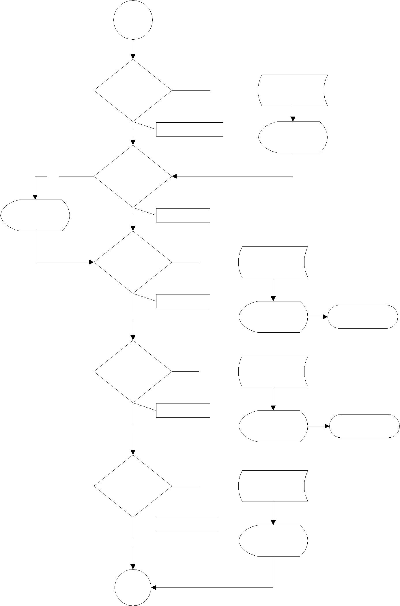

No PTO template

Yes

Prompt #W

Yes | IsTxDateInToProjPrdFdp
 | Prompt #A

20 Delegation

of Authority

_{No} hasDelegAuth

21 IntraFund

Transfer

(same level 4) Yes PTG template & Not Fed

FloThru

IsIntraFundNotFft

No | Prompt #G | Stop

22 Is To Fund

Renewal of Yes PTG template

From

IsToRenewal

No | Prompt #G | Stop

23 Untimely (3 ledger periods

PHS 4 ledger Yes PTO template period other

Fed)

IsTxDateOut4MosNih
_{No} Prompt #B

To Page

5

Page 4

PTO template Yes

Prompt #C

PTO template Yes

Prompt #I
Risk Assessment Decision Tree
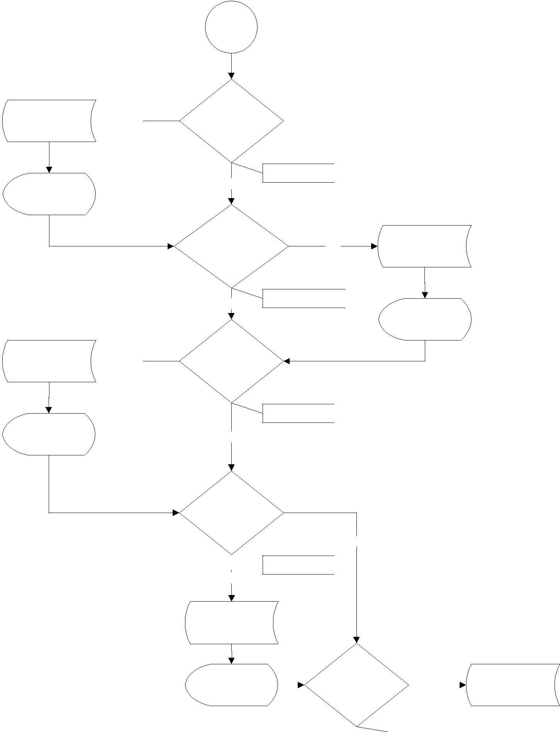
From

Page 4

24 Is to Fund in OD

IsToOverDraft
No
25 Non-Fed to | Yes | PTO template
Fed

_{No} IsFromNonEmfToFed

Prompt #Z

26 Is this Trans an EPET

IsFromEpet

No

27 From Fund

in OD

No

IsFromOverDraft

Yes

PTO template

Prompt #D |  | 28 Non-Effort |  |  |  |  |  |  |  |  | PTO template
 |  |  |  |  |  |  |  | Yes
 |  | DOS Code
 |  |  |  |  |  | IsNonEffortDosCode
 |  |  | No
 |  |  |  |  |  |  |  |  |  |  | Prompt #S
To Page

6

Page 5

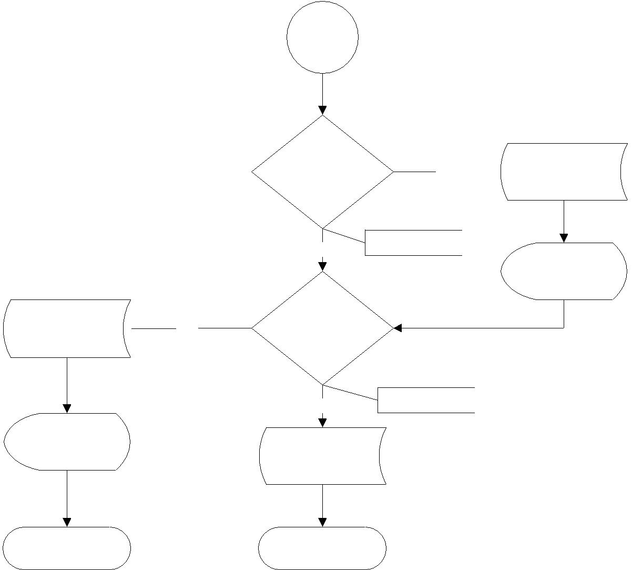
From

Page 5
Risk Assessment Decision Tree

PTO template

Prompt #J

Stop

29

Administrative Yes PTO template Title code

_{No} IsAdminTitleCode

Prompt #T

30 To or From Fund is a

^{Yes} Terminating Award

_{No} IsTermAward

PTG template

Stop

Page 6

This document describes each EPET Decision Tree node in brief sentences and lists the prompt messages.

Risk Assessment Decision Tree

# | Node | Description | True | False
6 | IsCostShared | Check if the From index cost shared. Check From | EMF, | Cont 7
 |  | fund’s doc number, seq number, rule class, | PrmQ,
 |  | account period, index has been cost shared in an | Cont 7
 |  | existing cost share budget.
8 | IsToOrgFromOrg | Check if a transfer is going from one department | Cont 14 | Prm P,
 |  | to another. |  | Cont 14
9 | IsToPastEarlyInactiveDate | Check if To index’s ead (early inactive date?) is | Prm O, | Cont 15
 |  | before or on the next available post date. | Cont 15
11 | IsToEmf | Check if To IFOAP involves EMF or level hierarchy | ExplL, | Expl G,
 |  | is “J11002” or “J11005”. If yes, explain basis if | Cont 8 | Cont 18
 |  | any transactions are being partially transferred.
 |  | If no, explain reason for EPET.
12 | IsTxDateOut4Mos | Check if GA transaction account period is later | Expl B, | Cont 16
 |  | than transaction period by more than 3 periods. | Cont 16
 |  | If yes, explain this transfer does not meet the
 |  | university standards for timeliness. Note, it’s 120
 |  | days after the posting period.
13 | IsFromNotEmf | Check if From IFOAP does not involves EMF. If | GEN, | Expl L,
 |  | not, explain basis if any transactions are being | Stop | Low,
 |  | partially transferred. |  | Stop
14 | IsToPrivateNotFft | Check if TO fund involves private funds. | Prm G, | Prm K,
 |  |  | Cont 9 | Cont 19
15 | IsToPrivCG | Check if TO fund involves private contracts or | Cont 10 | Cont 11
 |  | grants.
16 | IxTxDateInToProjPrd | Check if next available post date is inside the TO | Cont 11 | EMF,
 |  | IFOAP grant start and end date. If not within the |  | Prm A,
 |  | dates, this transaction is considered a high risk |  | Cont 11
 |  | and requires OPAFS review.
17 | IsIntraFund | Check if the transfer is within the same fund (is | GEN, | Cont 12
 |  | intrafund?). And if it is, check if the fund | Stop
 |  | hierarchy code is not equal to “J11010” (is not
 |  | fed flow though?). This is low risk.
18 | IsToPrivOverDraft | Check if TO IFOAP level 3 fund hierarchy equal to | EMF, | GEN,
 |  | “J11040” (is private contract?) If so, use the | Expl C, | Stop
 |  | IFOAP balance. If the balance is less than the | Stop
 |  | transaction amount, the TO fund is over drafted.
 |  | If TO IFOAP level 3 fund hierarchy not equals to
 |  | “J11040” (is not private contract?), then use the
 |  | level 4 fund hierarchy code to get distinct level 5
 |  | codes. If the total of all level 5 balances is less
 |  | than the transaction amount, the TO fund is over
 |  | drafted. If over drafted, explain reason To fund

# | Node | Description | True | False
 |  | is in overdraft.
19 | IxTxDateInToProjPrdFdp | Get To IFOAP grant from date. Check if To IFOAP | Cont 20 | EMF,
 |  | has FDP. If yes, move the grant from date 90 |  | Prm A,
 |  | days earlier. Then check if the GA next available |  | Cont 20
 |  | post date is within the from date and the to date
 |  | (To IFOAP grant to date).
20 | hasDelegAuth | Check if both To and From funds are Fed FDP. | Cont 21 | Cont 21
 |  | Check if To fund involves private fund. Check if
 |  | To and From funds are the same (intra fund).
 |  | Check if transaction is renew. Check if To fund
 |  | does not involve EMF. If any of the above is true,
 |  | then true.
 |  | Lyle noted that there is no way to check if
 |  | someone actually has a delegation of authority.
 |  | The node exists simply to record the answer (a
 |  | check box and pi admin email) for future
 |  | auditing. The check box and email address
 |  | prompt should only appear if delegAuth returns
 |  | false.
21 | IsIntraFundNotFft | Check if the transfer is within the same fund (is | Expl G, | Cont 22
 |  | intrafund?). And if it is, check if the fund | GEN,
 |  | hierarchy code is not equal to “J11010” and | Stop
 |  | “J11011” (is not fed flow though?). This is the
 |  | same logic as #11 IntraFundNotFFT2. If true,
 |  | explain the reason of EPET.
22 | IsToRenewal | Check if transaction is renewal. If true, explain | Expl G, | Cont 23
 |  | the reason of EPET. | GEN,
 |  |  | Stop
23 | IsTxDateOut4MosNih | Check if To or From IPOAF involves level 3 NIH | EMF, | Cont 24
 |  | fund. If so, check if GA transaction account | Expl B,
 |  | period is later than transaction period by more | Cont 24
 |  | than 4 periods (3 periods otherwise). If yes,
 |  | explain this transfer does not meet the federal
 |  | standards for timeliness.
24 | IsToOverDraft | Check if the To fund balance is less than the | EMF, | Cont 25
 |  | transaction amount. If so, the TO fund is over | Expl C,
 |  | drafted. If over drafted, explain reason To fund | Cont 25
 |  | is in overdraft.
25 | IsFromNonEmfToFed | Check if From fund does not involve EMF and if | EMF, | Cont 26
 |  | To fund top level equals “G10000” and level 3 | Prm Z,
 |  | equals “J11010” and “J11011”. | Cont 26
26 | IsFromEpet | Check if transaction is previously an EPET or PET. | EMF, | Cont 27
 |  |  | Prm I,
 |  |  | Cont 27
27 | IsFromOverDraft | Check if From fund balance is less than zero. If | EMF, | Cont 28

# | Node | Description | True | False
 |  | so, explain the basis for the transfer directly | Expl D,
 |  | supporting the project. | Cont 28
28 | IsNonEffortDosCode | DOS codes describe the kind of pay that was | EMF, | Cont 29
 |  | given out (IAP = Incentive Award Program, REG = | Prm S,
 |  | Regular, BYA = By Agreement) Some DOS codes | Cont 29
 |  | like REG or OT are related directly to effort or
 |  | hours worked, others like BYA and IAP have no
 |  | direct correlation to effort. OPAFS decided that
 |  | payroll payments that are not related to effort
 |  | are riskier to move.
29 | IsAdminTitleCode | Administrative Title code is there because there | EMF, | Cont30
 |  | are restrictions on putting administrative time | Prm T ,
 |  | onto federal awards. It is not prohibited, but it is | Cont 30
 |  | not generally allowed either.
30 | IsTermAward | Check if today is between 60 days before the end | EMF, | GEN,
 |  | grant date and the end grant date. Do this for | Expl J, | Stop
 |  | both To and From fund. | Stop

Prompt Messages

# | Screen Text | Journal Text
A | The next available post date on the cost being transferred is not within the | Next available post
 | project period of the TO FUND. This is considered a high risk transaction | date is outside of
 | requiring OPAFS review. | To Fund project
 |  | period
B | This transfer does not meet the university standards for timeliness. Please | Transaction is not
 | explain why this transfer exceeds the allowable time limit for transferring | timely
 | expenses
C | This transaction is being transferred to a fund in overdraft (costs incurred | To Fund is in
 | exceed allocations). Please provide an explanation. If the overdraft fund is | overdraft
 | an extramural fund (external sponsor ‐ federal, private, not‐for‐profit) the
 | condition is considered high risk and will be reviewed by OPAFS for
 | adequacy.
D | This cost is being transferred from a fund in overdraft to an extramural | From Fund is in
 | fund (external sponsor ‐ federal, private, not‐for‐profit). This condition is | overdraft. To Fund
 | considered high risk and will be reviewed by OPAFS for adequacy. Please | is an extramural
 | provide an explanation of the basis for the transfer directly supporting the | fund
 | project.
E | You have selected an inactive IFOP or account code to receive this transfer. | To An Inactive IFOP
 | Any one of the elements, Index‐Fund‐Organization‐Program or the account
 | code may be inactive. Select an active IFOP and account code to receive
 | this transfer. Use the Chart of Account Queries on
 | http://financiallink.ucsd.edu for detailed information.
F | The transaction you have selected was charged to an IFOP that is no longer | From An Inactive
 | active. Transfers from an inactive IFOP are not allowed. You can reactivate | IFOP
 | the Index number or contact General Accounting or OPAFS if the Fund,

# | Screen Text | Journal Text
 | Organization or Program has been inactivated. To look up information
 | about the chart of accounts see the Chart Query Report at
 | http://financiallink.ucsd.edu under reports.
G | Please explain reason for EPET | EPET reason
H | An amount greater than the dollar value of the original transaction cannot | Total EPETs More
 | be transferred. If this dollar value is not greater than the original and | Than Original
 | pending transactions. See notes on the DOPE Reviewer for information on | Transaction
 | previous EPETs.
I | The transaction being transferred is either an EPET or a PET. This type of | Transfer of an EPET
 | transfer is considered high risk and will be reviewed by OPAFS.
J | The To or From fund for this transaction involves a terminating award. This | Terminating award
 | condition is considered high risk and will be reviewed by OPAFS for | is involved
 | adequacy. Please provide an explanation supporting the need for this
 | transfer and how it directly supports the TO FUND.
K | Please explain how this error occurred, what the benefit to the fund being | EPET justification
 | charged is and what is being done to prevent a similar event in the future.
L | If any transactions are being partially transferred please explain the basis | Proration basis of
 | for the proration or split. | partial transfer
M | To Index is same as From Index. | To Index is same as
 |  | From Index
O | The Early Inactivation Date for the Index number you are transferring to is | The Early
 | in the past. | Inactivation Date
 |  | for the To Index
 |  | number is in the
 |  | past.
P | The Org codes are different which may indicate a transfer between | Possible transfer
 | departments. Please provide email address of secondary department in | between
 | the cc: field. | departments.
Q | Epet has been cost shared. | Epet has been cost
 |  | shared.
S | The DOS code for this transaction is considered high risk because no effort | Non effort DOS
 | is attached to the payroll being received. Please explain why this salary is | code transferred to
 | being transferred onto a federal funding source. | federal award.
T | Federal regulations restrict charging administrative salary to federal | Admin salary
 | awards in most situations. Please explain why administrative salary is | transferred to
 | being transferred onto this federally sponsored funding source. | federal award.
U | PI e‐mail address
V | Fund Manager and CC e‐mail address
W | I have delegation of authority. Please provide your e‐mail address in the
 | cc: e‐mail address field.
X | Remember to make corresponding funding changes in UCSD PPS to reflect
 | the payroll expense transfer.

# Screen Text Journal Text

- The ancillary transactions must be moved via a journal entry in IFIS before submission.

- This transaction is being transferred involves a federal fund. This is considered a high risk transaction requiring OPAFS review.

