Mossel Bay Municipality

FORMAL WRITTEN QUOTATION

C21-02/14: REPAIRS, RENOVATIONS AND GENERAL BUILDING WORK TO THE HAVEN HOMELESS SHELTER, MATFIELD STREET, MOSSEL BAY – PHASE 3

 | CLOSING DATE: 14 MARCH 2014 |  | CLOSING TIME: 12:00
 | NAME OF BIDDER* | : ..........................................................................................................................
 | ADDRESS* | : ..........................................................................................................................
 |  | : ..........................................................................................................................
 |  | : ..........................................................................................................................
 |  | : ..........................................................................................................................
 | TEL NUMBER* | : ..........................................................................................................................
 | FAX NUMBER* | : ..........................................................................................................................
 | MBM DATABASE REG NO* | : ..........................................................................................................................
 | B-BBEE LEVEL OF CONTRIBUTION* | : ..........................................................................................................................
 | QUOTATION AMOUNT (VAT INCLUDED)* | :.......................................................................................................................
 |  | Prepared by:
 |  | Mossel Bay Municipality
 |  | PO Box 25
 |  | Mossel Bay
 |  | 6500

 | INDEX
SECTION 1 |  | PAGE
1.1 | INVITATION TO QUOTE | 2
1.2 | CONDITIONS AND INFORMATION | 3
SECTION 2
2.1 | SPECIFICATIONS | 9
SECTION 3
3.1 | MBD1: BID FOR THE REQUIREMENTS OF THE MUNICIPALITY OF MOSSEL BAY | 12
SECTION 4
4.1 | MBD4: DECLARATION OF INTEREST | 15
4.2 | MBD6.1: PREFERENCE POINTS CLAIM FORM IN TERMS OF THE PREFERENTIAL | 18
 | PROCUREMENT REGULATIONS, 2011
4.3 | MBD8: DECLARATION OF BIDDER’S PAST SUPPLY CHAIN MANAGEMENT | 27
 | PRACTICES
4.4 | MBD9: CERTIFICATE OF INDEPENDENT BID DETERMINATION | 29
SECTION 5 | DECLARATION | 32
SECTION 6 | CONTRACT FORM | 33
 | ANNEXURES | 36

1

SECTION 1.1: INVITATION TO QUOTE

CLOSING DATE: 14 MARCH 2014 CLOSING TIME: 12:00

C21-02/14: REPAIRS, RENOVATIONS AND GENERAL BUIDLING WORK AT THE HAVEN HOMELESS SHELTER, MATFIELD STREET, MOSSEL BAY – PHASE 3

Formal written quotations are hereby invited from contractors with a 1GB or higher CIDB grading for repairs, renovations and general building work at the Haven Homeless Shelter, Matfield Street, Mossel Bay.

The specifications can be obtained at the compulsory information meeting that will be held at 09:00 on Thursday, 6 March 2014, at the Haven Homeless Shelter, Matfield Street, Mossel Bay.

Formal written quotations must be submitted on original documents and remain valid for 90 days after the closing date of the quotation. Enquiries about the quotation can be addressed to Mr. Joubert Coetzee at telephone (044) 606-5100.

Documentation can be obtained from Mr. Duane Scholtz at telephone (044) 606-5196 at the Supply Chain Management offices, Plaza Aquada, 55 Marsh Street, Mossel Bay. A set of quotation documents can also be obtained free of charge on our website at www.mosselbay.gov.za (follow the Procurement link on the left hand side).

Complete formal written quotations, together with such additional documentation as requested, must be placed in a sealed envelope and deposited in the tender box on the Lower Ground Floor (seaside) at the Municipality, Marsh Street 101, Mossel Bay, by not later than 12:00 on Friday, 14 March 2014 or be mailed to reach the Tender Box, Mossel Bay Municipality, PO Box 25, Mossel Bay, 6500 before the specified closing date and time. The envelope must be endorsed clearly with the name, number and closing date of the quotation as shown above.

The formal written quotations will be evaluated on the 80/20 Preference Points system as prescribed by the Preferential Procurement Regulations, 2011.

Receipts will be issued at request only for documents handed in during office hours from Mondays to Fridays.

Receipts will not be issued for documents placed in the tender box after hours or which are received by mail.

The tender box will be emptied just after 12:00 on the closing date, after which all quotations will be opened in public.

Late quotations or quotations submitted by e-mail or fax will under no circumstances be accepted.

The Municipality reserves the right to withdraw any invitation to quote and/or to re-advertise or to reject any quotation or to accept a part of it. The Municipality does not bind itself to accepting the lowest quotation.

It is expected of all prospective service providers who are not yet registered on the Municipality's Accredited Supplier Database to register without delay on the prescribed form. The Municipality reserves the right not to accept quotations from prospective suppliers who are not registered on the Database.

DR M GRATZ

MUNICIPAL MANAGER

2

SECTION 1.2: CONDITIONS AND INFORMATION

1.2.1 General and Special Conditions of Contract

The General Conditions of Contract (GCC) available on the National Treasury website www.treasury.gov.za will be applicable to this closed quotation as well as Special Conditions of Contract (SCC) (if applicable) forming part of this set of quotation documents in addition to the conditions and information. Where the GCC and SCC are in conflict with one another, the stipulations of the SCC will prevail.

1.2.2 Completion of Documents

- The original document must be completed fully in black ink and signed by the authorised signatory to validate the quotation. Section 5: DECLARATION must be completed and signed by the authorised signatory and returned. Failure to do so will result in the disqualification of the quotation.

- Documents may not be retyped. Retyped documents will result in the disqualification of the quotation.

- The complete original document must be returned. Missing pages will result in the disqualification of the quotation.

- No unauthorised alteration of this set of documents will be allowed. Any unauthorised alteration will disqualify the quotation automatically. Any ambiguity has to be cleared with contact person for the quotation before the closure date and time.

1.2.3 Compulsory Documentation

1.2.3.1 Tax Clearance Certificate

- A valid original Tax Clearance Certificate must accompany the bid documents unless the bidder is registered on the Accredited Supplier Database of the Municipality and the Municipality has a valid original Tax Clearance Certificate for the bidder on record. The onus is on the bidder to ensure that the Municipality has an original Tax Clearance Certificate on record. If the South African Revenue Services (SARS) cannot provide a valid original Tax Clearance Certificate; the bidder must submit a letter from SARS on an original SARS letterhead that their tax matters are in order.

(b) In the case of a Consortium/Joint Venture every member must submit a separate Tax Clearance Certificate with the bid documents unless the member is registered on the Accredited Supplier Database of the Municipality and the Municipality has a valid original Tax Clearance Certificate for the member on record.

- If a bid is not supported by a valid original Tax Clearance Certificate, either as an attachment to the bid documents or on record in the case of suppliers registered on the Supplier Database of the Municipality, the Municipality reserves the right to obtain such document after the closing date to verify that the bidder’s tax matters are in order. If no such document can be obtained within a period as specified by the Municipality, the bid will be disqualified.

3

1.2.4 Other Documentation

1.2.4.1 Municipal Rates, Taxes and Charges

- A certified copy of the bidder’s municipal account (for the Municipality where the bidder pays his account) for the month preceding the quotation closure date must accompany the tender documents. If such a certified copy does not accompany the bid document of the successful bidder, the Municipality reserves the right to obtain such documents after the closing date to verify that their municipal accounts are in order.

- Any bidder which is or whose directors are in arrears with their municipal rates and taxes or municipal charges due to any Municipality or any of its entities for more than three months and have not made an arrangement for settlement of same before the bid closure date will be unsuccessful.

- If a bidder rents their premises, proof must be submitted that the rental includes their municipal rates and taxes or municipal charges and that their rent is not in arrears.

1.2.5 Authorised Signatory

- A copy of the recorded Resolution taken by the Board of Directors, members, partners or trustees authorising the representative to submit this bid on the bidder’s behalf must be attached to the Bid Document on submission of same.

- A bid shall be eligible for consideration only if it bears the signature of the bidder or of some
person duly and lawfully authorised to sign it for and on behalf of the bidder.

- If such a copy of the Resolution does not accompany the bid document of the successful bidder, the Municipality reserves the right to obtain such document after the closing date to verify that the signatory is in order.

1.2.6 Quantities of Specific Items

If quotations are called for a specific number of items, Council reserves the right to change the number of such items to be higher or lower. The successful bidder will then be given an opportunity to evaluate the new scenario and inform the Municipality if it is acceptable. If the successful bidder does not accept the new scenario, it will be offered to the second-placed bidder. The process will be continued to the Municipality’s satisfaction.

1.2.7 Site / Information Meetings

- Site or information meetings, if specified, are compulsory. Bids will not be accepted from bidders who have not attended compulsory site or information meetings. Bidders that arrive 15 minutes or more after the advertised time the meeting starts will not be allowed to attend the meeting or to sign the attendance register. If a bidder is delayed, he must inform the contact person before the meeting commence and will only be allowed to attend the meeting if the chairperson of the meeting as well as all the other bidders attending the meeting, give permission to do so.

- All partners or the leading partner of a Joint Venture must attend the compulsory site or information meeting.

4

1.2.8 Submission of Quotation

- The quotation must be placed in a sealed envelope, or envelopes when the two-envelope system is specified, clearly marked with the quotation title as well as closing date and time and

- placed in the tender box on the Lower Ground floor (seaside) at the Municipality by not later than 12:00 on Friday, 14 March 2014.

OR

- be mailed to reach the Tender Box, Mossel Bay Municipality, PO Box 25, Mossel Bay, 6500 before the specified closing date and time.

- Faxed, e-mailed and late quotations will not be accepted. Quotations may be delivered by hand, by courier, or posted at the bidder’s risk and must be received by the deadline specified above, irrespective of how they are sent or delivered.

1.2.9 Expenses Incurred in Preparation of Quotation

The Municipality shall not be liable for any expenses incurred in the preparation and submission of the quotation.

1.2.10 Contact with Municipality after Closure Date

Bidders shall not contact the Mossel Bay Municipality on any matter relating to their bid from the time of the opening of the bid to the time the contract is awarded. If a bidder wishes to bring additional information to the notice of the Mossel Bay Municipality, it should do so in writing to the Mossel Bay Municipality. Any effort by the firm to influence the Mossel Bay Municipality in the bid evaluation, bid comparison or contract award decisions may result in the rejection of the bid.

1.2.11 Opening, Recording and Publications of Quotations Received

- Quotations will be opened on the closing date immediately after the closing time specified in the documents. If requested by any bidder present, the names of the bidders, and if practical, the total amount of each bid and of any alternative bids will be read out aloud.

- Details of quotations received in time will be published on the Municipality’s website as well as recorded in a register which is open to public inspection.

1.2.12 Evaluation of Quotations

Quotations will be evaluated in terms of their responsiveness to the quotation specifications and requirements as well as such additional criteria as set out in this set of documents.

1.2.13 Procurement Policy

Bids will be awarded in accordance with the Preferential Procurement Regulations, 2011 pertaining to the Preferential Procurement Policy Framework Act, No 5 of 2000 as well as the Municipality’s Supply Chain Management Policy.

5

1.2.14 Contract

The successful bidder will be expected to sign an agreement/contract within 7 days of the date of notification by the Mossel Bay Municipality that his/her bid has been accepted. The Municipality, at its discretion, may also request the singing of an additional Service Level Agreement, which, together with the signed quotation document, will constitute the full agreement between the Municipality and the successful bidder.

1.2.15 Stamp and Other Duties

The successful bidder will be liable for all duties and costs on legal documents resulting in the establishment of a contract and for the surety and retentions.

1.2.16 Subcontracting

- The Contractor shall not subcontract the whole of the Contract.

- Except where otherwise provided by the Contract, the Contractor shall not subcontract any part of the Contract without the prior written consent of the Municipality, which consent shall not be unreasonably withheld.

- The contractual relationship between the Contractor and any subcontractors selected by the Contractor in consultation with the Municipality in accordance with the requirements of and a procedure contained within the Scope of Work, shall be the same as if the Contractor had appointed the subcontractor in terms of paragraph (b) above.

- Any consent granted in accordance with paragraph (b) or appointment of a subcontractor in accordance with paragraph (c) shall not imply a contract between the Municipality and the subcontractor, or a responsibility or liability on the part of the Municipality to the subcontractor and shall not relieve the Contractor from any liability or obligation under the Contract and he shall be liable for the acts, defaults and neglects of any subcontractor, his agents or employees as fully as if they were the acts, defaults or neglects of the Contractor, his agents or employees.

- The Contractor shall not be required to obtain such consent for –

  - the provision of labour, or
  - the purchase of materials which are in accordance with the Contract, or
  - the purchase or hire of Construction Equipment.

1.2.17 Wrong Information Furnished

Where a contract has been awarded on the strength of the information furnished by the bidder which, after the conclusion of the relevant agreement, is proved to have been incorrect, the Municipality may, in addition to any other legal remedy it may have, recover from the contractor all costs, losses or damages incurred or sustained by the Municipality as a result of the award of the contract.

6

1.2.18 Past Practices

- The bid of any bidder may be rejected if that bidder or any of its directors have abused the municipality’s supply chain management system or committed any improper conduct in relation to such system.

- The bid of any bidder may be rejected if it is or has been found that that bidder or any of its directors influenced or tried to influence any official or councillor with this or any past closed quotation.

- The bid of any bidder may be rejected if it is or has been found that that bidder or any of its directors offered, promised or granted any official or any of his/her close family members, partners or associates any reward, gift, favour, hospitality or any other benefit in any improper way, with this or any past closed quotation.

1.2.19 Validity of BEE certificates:

- If the certificate was issued by a verification agency the following must be on the face of the certificate:

SANAS logo, unique BVA number, must be an original certificate or certified copy of the original, the name and physical location of the bidder, the registration number and, where applicable, the VAT number of the bidder, the date of issue and date of expiry of the certificate, the certificate number for identification and reference, the scorecard that was used (for example EME, QSE or Generic), the name and / or logo of the Verification Agency, the certificate must be signed by the authorized person from the Verification Agency and the B-BBEE Status Level of Contribution obtained by the bidder.

- If certificate was issued by an Auditor/ Accounting Officers:

The Accounting Officer’s or Registered Auditor’s letter head with full contact details, the Accounting Officer’s or Registered Auditor’s practice numbers, the name and the physical location of the bidder, the registration number and, where applicable, the VAT number of the bidder, the date of issue and date of expiry, the B-BBEE Status Level of Contribution obtained by the measured entity, the total black shareholding and total black female shareholding, the B-BBEE Status Level of Contribution obtained by the bidder and must be an original certificate or certified copy of the original.

- If the certificate was issued by registered auditors approved by IRBA

Clearly identify the B-BBEE approved registered auditor by the auditor’s individual registration number with IRBA and the auditor’s logo, clearly record an approved B-BBEE Verification Certificate identification reference in the format required by the SASAE, reflect relevant information regarding the identity and location of the measured entity, identify the Codes of Good Practice or relevant Sector Codes applied in the determination of the scores, record the weighting points (scores) attained by the measured entity for each scorecard element, where applicable, and the measured entity’s overall B-BBEE Status Level of Contribution, reflect that the B-BBEE Verification Certificate and accompanying assurance report issued to the measured entity is valid for 12 months from the date of issuance and reflect both the issuance and expiry date, and the B-BBEE Status Level of Contribution obtained by the bidder and must be an original certificate or certified copy of the original.

7

(d) Also note:

- Certificates that fail to comply with the abovementioned will result in no preference points being awarded.

- Certificates must be a valid original or certified copy of the original.

- However, in the case where a bidder submitted a B-BBEE Certificate at the closing date and time of the bid but it was not the original or not certified as a true copy of the original, the bidder must be requested to submit the original or certified copy of the original within a specified period of time. If the required certificate is submitted within the specified time, and the certificate complies this the requirements set by National Treasury, the bidder may be awarded the points that they qualify for.

- If a bidder that has a valid original or certified copy of the original on their supplier database file or submitted one with a previous tender, the bidder does not have to submit a certificate or certified copy with every tender.

- The onus is on a bidder to ensure that a valid original or certified copy of the original is on their supplier database file or was submitted one with a previous tender.

1.2.20 Enquiries

Enquiries in connection with this quotation, prior to the closure date, may be addressed to Mr. Joubert Coetzee at telephone (044) 606-5100.

8

SECTION 2.1: SPECIFICATIONS

2.1.1 SCOPE OF WORKS: THE HAVEN - PHASE 3

GROUND FLOOR

- Social Worker Room

  - Repair ceiling and cornice (match existing)
  - Clean window glass and replace broken glass

- Admin

  - Clean window glass
  - Make sure the window can open and close properly
  - Repair ceiling and cornice (match existing)
  - Put in ceiling board in the opening

- Sick Bay

  - Repair ceiling and cornice (match existing)

- Admin

  - Repair ceiling and cornice (match existing)

  - Remove tiles from floor and the tiles in the hallway as well as in front of the toilets and the entrance area

- Open Area

  - Put in ceiling board in the opening (A)

  - Remove two door frames and finish off (B)

- Hallway

  - Repair ceiling (C)

- Family Room

  - Repair ceiling

  - Make sure the window can open and close properly

- Hallway

  - Remove two doorframe and finish off (D)

  - Repair ceiling (E)

- Recreation and Training

  - Repair ceiling
  - Repair wood beams to match existing

9

- Store / Kitchen

  - Repair ceiling
  - Put in ceiling board in the opening

  - Install two 40mm PVC outlets for washing machines and connect to the current system (F)

  - Install two cold water points for washing machines (F)
  - Install new tab at the sink (tap will be supplied) (G)
  - Support zink (G)

- Hall Way

  - Repair ceiling (H)
  - Finish off two arches at the steps ( )

- Bathroom

  - Repair the cupboard in bathroom an cornice to match existing colour (J)

- Balcony

  - Install cold water point at new zink and also a 40mm outlet that must be connected to the current system (K)
  - Clean the windows

- Lounge

  - Clean the windows

- Bathroom A

  - Install new toilet and connect the pipe work (toilet will be supplied)
  - Install two new urinals and connect to pipe work.

  - Install new hand basin and connect the pipe work (only the basin will be supplied). The taps and all the other fittings must be supplied by the contractor.

- Bathroom B

  - Install two new toilets and connect the pipe work (toilet will be supplied)
  - Install hand basin and connect the pipe work (only hand basin will be supplied)

  - Install partitions between the toilets, can use part of the old partitions, but must replace the wood where necessary.

- Bathroom C

  - Install new toilet and connect the pipe work (toilet will be supplied)
  - Install hand basin and connect the pipe work (only hand basin will be supplied)

- Bathroom D

  - Install two new toilets and connect the pipe work (toilet will be supplied)

  - Install two new hand basins and connect the pipe work (only hand basin will be supplied)

10

- Bathroom E

  - Install one new toilet and connect the pipe work (toilet will be supplied)
  - Install one new urinal and connect to pipe work
  - Install one new hand basin and connect the pipe work (only hand basin will be supplied)
  - Blank off the other hand basin pipes

SECOND FLOOR

- Dining Room

  - Build and plaster wall at the steps (A)

  - Finish off old cornice against the roof/wall (B)

- Back Yard

  - Build steel cage with two gates and it must be with diamond mesh and be galvanised and also lockable (4 x 44kg gas bottels) (C)

- Kitchen

  - Install a cold and hot water point at the new zink and install the tap at the zink (the tap will be provided) (D)

  - Move the water pipe to the outside of building (E)
  - Close whole in ceiling with nutec board.

- Store Room

  - Install new window frame (window frame will be supplied)

UPPER FLOOR

- Replace wood on the steps (wood will be provided by the Municipality) (A)
- Repair all the ceilings in the rooms where cupboards were removed. (green on the plan)
- Finish ceiling of with cornice matching the existing where the cupboards were removed
- Ceiling, cornice and walls must be painted matching the same colour as the existing

- Remove all loose and flaking paint on walls and ceiling by sanding or scraping. Finish with two coats Dulux wall and all or similar approved to match existing colour.

THIRD FLOOR

- Repair all the ceilings in the rooms where cupboards were removed (green on the plan)

- Finish ceiling of with cornice matching the existing where the cupboards were removed
- Ceiling, cornice and walls must be painted matching the same colour as the existing

- Remove all loose and flaking paint on walls and ceiling by sanding or scraping. Finish with two coats Dulux wall and all or similar approved to match existing colour.

11

SITE: ON COMPLETION OF CONTRACT

- The site must be left in a clean state with all rubble and other rubbish removed to the entire satisfaction of the Mosselbay Municipality.

- Wherever new materials are used to replace damaged, broken or missing components, these materials shall match the existing in all respects and shall, were applicable, be installed in strict accordance with the manufacturer’s instructions.

SPECIAL CONDITIONS OF CONTRACT

- Time for completion of work (3) weeks.

- Penalties for late completion will be R500 per day.

- Please note that this contract is covered under the General Conditions of Contract for Construction works where necessary.

- All construction work must conform to the standard Civil and Building Industry Code of Practice.

- All safety procedures must be in place at all times during construction. Contractor must have their Occupational Health and Safety plan in order and on site.

- No inferior or defective workmanship of any trade will be accepted.

- Final payment will only be made after the building site has been thoroughly cleaned of all building materials or rubble.

- Only contractors that have successfully completed work of this nature and can produce proof thereof will be considered for this contract. The Municipality reserves the right to request such proof after the quotation has closed.

- The contractor will be held responsible for any damage what so ever to the existing premises and will carry out repairs or repainting to the complete satisfaction of the Municipality at his own cost.
- Only qualified artisans with the necessary tools will be allowed to work on this site.

- Prices must be valid for sixty (60) days.

12

SECTION 3.1: MBD1: BID FOR THE REQUIREMENTS OF THE MUNICIPALITY OF MOSSEL BAY

FORMAL WRITTEN QUOTATION C21-02/14

REPAIRS, RENOVATIONS AND GENERAL BUILDING WORK AT THE HAVEN HOMELESS SHELTER, MATFIELD

STREET, MOSSEL BAY – PHASE 3

CLOSING DATE: 14 MARCH 2014 | CLOSING TIME: 12:00

Bid documents, placed in a sealed envelope and clearly marked with the bid number on the outside, may be posted to:

The Tender Box
Mossel Bay Municipality
Private Bag X29
MOSSEL BAY
6500

Or deposited in the tender box situated on the Lower Ground Floor, Municipal Building, 101 Marsh Street, Mossel Bay

Please note:

- Bidders must ensure that bids are delivered timeously to the correct address. If the bid is late, it will not be accepted for consideration.

- All bids must be submitted on the official forms. Forms may not be retyped.

- This bid is subject to the General Conditions of Contract (GCC) and, if applicable, any other special conditions of contract included in this document.

- The successful bidder will be required to fill in and sign a written Contract Form (MBD7).

THE FOLLOWING PARTICULARS MUST BE FURNISHED. FAILURE TO DO SO MAY RESULT IN YOUR BID NOT BEING ACCEPTED.

MUNICIPAL SUPPLIER DATABASE REGISTRATION NO: .......................................................................................

NAME OF BIDDER: .....................................................................................................................................................

POSTAL ADDRESS: ....................................................................................................................................................

.......................................................................................................................................................................................

STREET ADDRESS : .........................................................................................................................................

......................................................................................................................................................................................

TELEPHONE: AREA CODE: ..................................... NUMBER...............................................................

FACSIMILE: AREA CODE: ....................................... NUMBER...............................................................

13

E-MAIL ADDRESS (IF AVAILABLE): .............................................................................................................................

NAME OF CONTACT PERSON: ..............................................................................................................................

CELL PHONE NUMBER OF CONTACT PERSON: ..................................................................................................

VAT REGISTRATION NUMBER…………………………………………………………………………………………………..

HAS AN ORIGINAL AND VALID TAX CLEARANCE CERTIFICATE BEEN ATTACHED? YES/NO

HAS A VALID ORIGINAL OR A VALID CERTIFIED COPY OF B-BBEE STATUS LEVEL VERIFICATION
CERTIFICATE BEEN SUBMITTED? (MBD 6.1) YES/NO

IF YES, WHO WAS THE CERTIFICATE ISSUED BY?

AN ACCOUNTING OFFICER AS CONTEMPLATED IN THE CLOSE CORPORATION ACT (CCA) L

A VERIFICATION AGENCY ACCREDITED BY THE SOUTH AFRICAN NATIONAL
ACCREDITATION SYSTEM (SANAS) L

A REGISTERED AUDITOR L
(Tick applicable box)

(A B-BBEE STATUS LEVEL VERIFICATION CERTIFICATE MUST BE SUBMITTED IN ORDER TO QUALIFY FOR PREFERENCE POINTS FOR B-BBEE)

ARE YOU THE ACCREDITED REPRESENTATIVE IN SOUTH AFRICA FOR THE GOODS/SERVICES/WORKS
OFFERED? YES/NO (IF YES ENCLOSE PROOF)

SIGNATURE OF BIDDER ……………………………………………………………………………………………………..

DATE………………………………………………………………………………………………………………..

CAPACITY UNDER WHICH THIS BID IS SIGNED ……………………………………………………………………………

TOTAL BID PRICE……………………………………

TOTAL NUMBER OF ITEMS OFFERED …………………………………

14

DELIVERY BASIS:

Is the delivery period firm? | YES / NO
Period required for delivery after receipt of order (days)
Is the price (inclusive of VAT) firm? | YES / NO
Discount offered: | Conditional/Unconditional
If conditional, state condition:
Is offer strictly to specification/terms of reference | YES / NO

If not to specification/terms of reference. Please state deviation(s) if any: ................................................................

..................................................................................................................................................................................

BANK DETAILS (IF APPLICABLE):

BANK NAME:

BRANCH: |  | BRANCH CODE:
ACCOUNT HOLDER:
ACCOUNT NUMBER: |  | ACCOUNT TYPE:
OFFICAL STAMP FROM BANK

………………………………………………………..

AUTHORISED BANK OFFICIAL

AUTHORISED SIGNATURE: ..........................................................................................................................................

NAME: .............................................................................................................................................................................

CAPACITY: .....................................................................................................................................................................

DATE: .............................................................................................................................................................................

15

SECTION 4.1 MBD4: DECLARATION OF INTEREST

- No bid will be accepted from persons in the service of the state∗.

- Any person, having a kinship with persons in the service of the state, including a blood relationship, may make an offer or offers in terms of this invitation to bid. In view of possible allegations of favouritism, should the resulting bid, or part thereof, be awarded to persons connected with or related to persons in service of the state, it is required that the bidder or their authorised representative declare their position in relation to the evaluating/adjudicating authority.

3. | In order to give effect to the above, the following questionnaire must be completed and submitted
 | with the bid.
3.1 | Full Name of bidder or his or her representative: ………………………………………………………….
3.2 | Identity Number:………………………………………………………………………………………………...
3.3 | Position occupied in the Company (director, trustee, shareholder²): | ......................................................
3.4 | Company registration number:…………………………………………………………………………….....
3.5 | Tax Reference Number: …………………………………………………………………………………….
3.6 | VAT Registration Number: ………………………………………………………………………………....
3.7 | The names of all directors / trustees / shareholders members, their individual identity numbers and state
 | employee numbers must be indicated in paragraph 4 below.
3.8 | Are you presently in the service of the state? | YES / NO
3.8.1 | If so, furnish particulars.

……………………………………………………………… ………………………………………………………………

∗ MSCM Regulations: “in the service of the state” means to be –
  - a member of –
    - any municipal council;
    - any provincial legislature; or
    - the national Assembly or the national Council of provinces;

  - a member of the board of directors of any municipal entity;
  - an official of any municipality or municipal entity;

  - an employee of any national or provincial department, national or provincial public entity or constitutional institution within the meaning of the Public Finance Management Act, 1999 (Act No.1 of 1999);
  - a member of the accounting authority of any national or provincial public entity; or
  - an employee of Parliament or a provincial legislature.

3.9 | Have you been in the service of the state for the past twelve months? | YES / NO
3.9.1 | If so, furnish particulars.

………………………………………………………………………………………………………………………………

16

3.10 Do you, have any relationship (family, friend, other) with persons in the service of the state and who may be
YES / NO
involved with the evaluation and or adjudication of this bid? YES / NO

3.10.1 If so, furnish the following particulars:

………………………………………………………………………………………………………………………………

3.11 Are you, aware of any relationship (family, friend, other) between a bidder and any persons in the service of
the state who may be involved with the evaluation and or adjudication of this bid? YES / NO

3.11.1 If so, furnish particulars

…………………………………………………………….…………………………………………………………….

3.11 Are any of the company’s directors, managers, principal shareholders or stakeholders in service of the

state?

3.12.1 If so, furnish particulars.

………………………………………………………………....................................................................................

3.13 Are any spouse, child or parent of the company’s directors, managers, principal shareholders or stakeholders
` in service of the state? YES / NO

3.13.1 If so, furnish particulars.……………………………………………………………………………………………………

3.14. Do you or any of the directors, trustees, managers, principle shareholders, or stakeholders of this company have any interest in any other related companies or business whether or not they are bidding for this contract?
YES / NO

3.14.1 If yes, furnish particulars:………………………………………..…………………………………………………..

- Full details of directors / trustees / members / shareholders.

State Employee
_{Full Name} _{Identity Number} Number ^{Income Tax}
Number

17
State Employee
_{Full Name} _{Identity Number} Number ^{Income Tax}
Number

...................................................................... .........................................................
Signature Date

...................................................................... .........................................................
Position Name of Bidder

18

SECTION 4.2 MDB 6.1: PREFERENCE POINTS CLAIM FORM IN TERMS OF THE PREFERENTIAL PROCUREMENT REGULATIONS 2011

This preference form must form part of all bids invited. It contains general information and serves as a claim form for preference points for Broad-Based Black Economic Empowerment (B-BBEE) Status Level of Contribution

NB: BEFORE COMPLETING THIS FORM, BIDDERS MUST STUDY THE GENERAL CONDITIONS, DEFINITIONS AND DIRECTIVES APPLICABLE IN RESPECT OF B-BBEE, AS PRESCRIBED IN THE PREFERENTIAL PROCUREMENT REGULATIONS, 2011.

1. GENERAL CONDITIONS

1.1 The following preference point systems are applicable to all bids:

- the 80/20 system for requirements with a Rand value of up to R1 000 000 (all applicable taxes included); and

- the 90/10 system for requirements with a Rand value above R1 000 000 (all applicable taxes included).

1.2 | The value of this bid is estimated to not exceed R1 000 000 (all applicable taxes included) and therefore
 | the 80/20 system shall be applicable.
1.3 | Preference points for this bid shall be awarded for:
 | (a) | Price; and
 | (b) | B-BBEE Status Level of Contribution.

1.3.1 | The maximum points for this bid are allocated as follows:
 |  | POINTS
1.3.1.1 | PRICE | 80
1.3.1.2 | B-BBEE STATUS LEVEL OF CONTRIBUTION | MAXIMUM OF 20
 | Total points for Price and B-BBEE must not exceed | 100
1.4 | Failure on the part of a bidder to fill in and/or to sign this form and submit a | valid original or a valid
 | certified copy of a B-BBEE Verification Certificate from a Verification Agency | accredited by the South
 | African Accreditation System (SANAS) or a Registered Auditor approved by the Independent Regulatory
 | Board of Auditors (IRBA) or an Accounting Officer as contemplated in the Close Corporation Act (CCA)
 | together with the bid, will be interpreted to mean that preference points for B-BBEE status level of
 | contribution are not claimed.
1.5. | The purchaser reserves the right to require of a bidder, either before a bid is adjudicated or at any time
 | subsequently, to substantiate any claim in regard to preferences, in any manner required by the purchaser.
.

19

2. DEFINITIONS

2.1 “all applicable taxes” includes value-added tax, pay as you earn, income tax, unemployment insurance fund contributions and skills development levies;

2.2 “B-BBEE” means broad-based black economic empowerment as defined in section 1 of the Broad -Based Black Economic Empowerment Act;

2.3 “B-BBEE status level of contributor” means the B-BBEE status received by a measured entity based

on its overall performance using the relevant scorecard contained in the Codes of Good Practice on Black Economic Empowerment, issued in terms of section 9(1) of the Broad-Based Black Economic Empowerment Act;

2.4 “bid” means a written offer in a prescribed or stipulated form in response to an invitation by an organ of state for the provision of services, works or goods, through price quotations, advertised competitive bidding processes or proposals;

2.5 “Broad-Based Black Economic Empowerment Act” means the Broad-Based Black Economic Empowerment Act, 2003 (Act No. 53 of 2003);

2.6 “comparative price” means the price after the factors of a non-firm price and all unconditional discounts that can be utilized have been taken into consideration;

2.7 “consortium or joint venture” means an association of persons for the purpose of combining their expertise, property, capital, efforts, skill and knowledge in an activity for the execution of a contract;

2.8 “contract” means the agreement that results from the acceptance of a bid by an organ of state;

2.9 “EME” means any enterprise with an annual total revenue of R5 million or less .

2.10 “Firm price” means the price that is only subject to adjustments in accordance with the actual increase or decrease resulting from the change, imposition, or abolition of customs or excise duty and any other duty, levy, or tax, which, in terms of the law or regulation, is binding on the contractor and demonstrably has an influence on the price of any supplies, or the rendering costs of any service, for the execution of the contract;

2.11 “functionality” means the measurement according to predetermined norms, as set out in the bid documents, of a service or commodity that is designed to be practical and useful, working or operating, taking into account, among other factors, the quality, reliability, viability and durability of a service and the technical capacity and ability of a bidder;

2.12 “non-firm prices” means all prices other than “firm” prices;

2.13 “person” includes a juristic person;

2.14 “rand value” means the total estimated value of a contract in South African currency, calculated at the time of bid invitations, and includes all applicable taxes and excise duties;

2.15 “sub-contract” means the primary contractor’s assigning, leasing, making out work to, or employing, another person to support such primary contractor in the execution of part of a project in terms of the contract;

2.16 “total revenue” bears the same meaning assigned to this expression in the Codes of Good Practice on Black Economic Empowerment, issued in terms of section 9(1) of the Broad-Based

20

Black Economic Empowerment Act and promulgated in the Government Gazette on 9 February 2007;

2.17 “trust” means the arrangement through which the property of one person is made over or bequeathed to a trustee to administer such property for the benefit of another person; and

2.18 | “trustee” means any person, including the founder of a trust, to whom property is bequeathed in
 | order for such property to be administered for the benefit of another person.
3. | ADJUDICATION USING A POINT SYSTEM
3.1 | The bidder obtaining the highest number of total points will be awarded the contract.
3.2 | Preference points shall be calculated after prices have been brought to a comparative basis taking into
 | account all factors of non-firm prices and all unconditional discounts;.
3.3 | Points scored must be rounded off to the nearest 2 decimal places.
3.4 | In the event that two or more bids have scored equal total points, the successful bid must be the one
 | scoring the highest number of preference points for B-BBEE.
3.5 | However, when functionality is part of the evaluation process and two or more bids have
 | scored equal points including equal preference points for B-BBEE, the successful bid must
 | be the one scoring the highest score for functionality.
3.6 | Should two or more bids be equal in all respects, the award shall be decided by the drawing of lots.
4. | POINTS AWARDED FOR PRICE
4.1 | THE 80/20 OR 90/10 PREFERENCE POINT SYSTEMS
 | A maximum of 80 or 90 points is allocated for price on the following basis:
 | 80/20 | or | 90/10

 | Pt − P min |  |  |  | Pt − P min
Ps = 80 1 − |  |  | or | Ps = 90 1 −
 | P min |  |  |  | P min

Where
Ps | = | Points scored for comparative price of bid under consideration
Pt | = | Comparative price of bid under consideration
Pmin | = | Comparative price of lowest acceptable bid

- Points awarded for B-BBEE Status Level of Contribution

5.1 In terms of Regulation 5 (2) and 6 (2) of the Preferential Procurement Regulations, preference points must be awarded to a bidder for attaining the B-BBEE status level of contribution in accordance with the table below:

21

B-BBEE Status Level of Contributor | Number of points
B-BBEE Status Level of Contributor | (80/20 system)
1 | 20
2 | 18
3 | 16
4 | 12
5 | 8
6 | 6
7 | 4
8 | 2
Non-compliant contributor | 0

5.2 Bidders who qualify as EMEs in terms of the B-BBEE Act must submit a certificate issued by an Accounting Officer as contemplated in the CCA or a Verification Agency accredited by SANAS or a Registered Auditor. Registered auditors do not need to meet the prerequisite for IRBA’s approval for the purpose of conducting verification and issuing EMEs with B-BBEE Status Level Certificates.

5.3 Bidders other than EMEs must submit their original and valid B-BBEE status level verification certificate or a certified copy thereof, substantiating their B-BBEE rating issued by a Registered Auditor approved by IRBA or a Verification Agency accredited by SANAS.

5.4 A trust, consortium or joint venture, will qualify for points for their B-BBEE status level as a legal entity, provided that the entity submits their B-BBEE status level certificate.

5.5 A trust, consortium or joint venture will qualify for points for their B-BBEE status level as an unincorporated entity, provided that the entity submits their consolidated B-BBEE scorecard as if they were a group structure and that such a consolidated B-BBEE scorecard is prepared for every separate bid.

5.6 Tertiary institutions and public entities will be required to submit their B-BBEE status level certificates in terms the specialized scorecard contained in the B-BBEE Codes of Good Practice.

5.7 A person will not be awarded points for B-BBEE status level if it is indicated in the bid documents that such a bidder intends sub-contracting more than 25% of the value of the contract to any other enterprise that does not qualify for at least the points that such a bidder qualifies for, unless the intended sub-contractor is an EME that has the capability and ability to execute the sub-contract.

5.8 A person awarded a contract may not sub-contract more than 25% of the value of the contract to any other enterprise that does not have an equal or higher B-BBEE status level than the person concerned, unless the contract is sub-contracted to an EME that has the capability and ability to execute the sub-contract.

22

- BID DECLARATION

6.1 Bidders who claim points in respect of B-BBEE Status Level of Contribution must complete the following:

- B-BBEE STATUS LEVEL OF CONTRIBUTION CLAIMED IN TERMS OF PARAGRAPHS 1.3.1.2 AND 5.1

7.1 B-BBEE Status Level of Contribution:........................................ = …………… (maximum of 20 points)

(Points claimed in respect of paragraph 7.1 must be in accordance with the table reflected in paragraph 5.1 and must be substantiated by means of a B-BBEE certificate issued by a Verification Agency accredited by SANAS or a Registered Auditor approved by IRBA or an Accounting Officer as contemplated in the CCA).

- SUB-CONTRACTING

8.1 | Will any portion of the contract be sub-contracted? |  |  | YES / NO (delete which is not applicable)
8.1.1 If yes, indicate:
 | (i) | what percentage of the contract will be subcontracted? |  |  | ............……………….…......%
 | (ii) | the name of the sub-contractor? | …………………………………………………………..
 | (iii) | the B-BBEE status level of the sub-contractor? |  |  | .................................……………........
 | (iv) | whether the sub-contractor is an EME? |  | YES / NO (delete which is not applicable)

- DECLARATION WITH REGARD TO COMPANY/FIRM

9.1 | Name of firm | : ......................................................................................................
9.2 | VAT registration number | : ......................................................................................................
9.3 | Company registration number | :........................................................................................................

9.4 TYPE OF COMPANY/ FIRM

Partnership/Joint Venture / Consortium

One person business/sole propriety

Close corporation

Company

(Pty) Limited
[TICK APPLICABLE BOX]

9.5 DESCRIBE PRINCIPAL BUSINESS ACTIVITIES

………….. .................................................................................................................................................................

……………… .............................................................................................................................................................

…………….................................................................................................................................................................

9.6 COMPANY CLASSIFICATION

Manufacturer

Supplier

Professional service provider

Other service providers, e.g. transporter, etc.

23

[TICK APPLICABLE BOX]

9.7 MUNICIPAL INFORMATION

Municipality where business is situated …………………………………………………………………..
Registered Account Number ……………………………...
Stand Number ………………………………………………....

9.8 TOTAL NUMBER OF YEARS THE COMPANY/FIRM HAS BEEN IN BUSINESS? ……………………

9.9 I/we, the undersigned, who is / are duly authorised to do so on behalf of the company/firm, certify that the points claimed, based on the B-BBE status level of contribution indicated in paragraph 7 of the foregoing certificate, qualifies the company/ firm for the preference(s) shown and I / we acknowledge that:

- The information furnished is true and correct;

- The preference points claimed are in accordance with the General Conditions as indicated in paragraph 1 of this form.

- In the event of a contract being awarded as a result of points claimed as shown in paragraph 7, the contractor may be required to furnish documentary proof to the satisfaction of the purchaser that the claims are correct;

- If the B-BBEE status level of contribution has been claimed or obtained on a fraudulent basis or any of the conditions of contract have not been fulfilled, the purchaser may, in addition to any other remedy it may have –

  - disqualify the person from the bidding process;

  - recover costs, losses or damages it has incurred or suffered as a result of that person’s conduct;

  - cancel the contract and claim any damages which it has suffered as a result of having to make less favourable arrangements due to such cancellation;

  - restrict the bidder or contractor, its shareholders and directors, or only the shareholders and directors who acted on a fraudulent basis, from obtaining business from any organ of state for a period not exceeding 10 years, after the audi alteram partem (hear the other side) rule has been applied; and
  - forward the matter for criminal prosecution

24

WITNESSES:

1. ………………………………………

……………………………………
SIGNATURE(S) OF BIDDER(S)

2. ……………………………………… DATE:……………………………………………………..

ADDRESS:…………………………................................

….……………………………………………....................

.………………………………………………..................

..…………….……………………………………………

25
MUNICIPAL RATES AND SERVICES

Names of | Physical residential address | Residential Municipal Account | Name of Municipality
Directors/Partners/Senior | of the | number(s)
Managers | Director/Partner/Senior | number(s)
 | Manager

NB: Please attach copy/copies of Municipal Account(s)

DECLARATION

I, THE UNDERSIGNED (NAME) ...............................................................................................

CERTIFY THAT THE INFORMATION FURNISHED ABOVE IS CORRECT. I ACCEPT THAT THE STATE MAY ACT AGAINST ME SHOULD THIS DECLARATION PROVE TO BE FALSE.

...................................................................... .........................................................
Signature Date

...................................................................... .........................................................
Position Name of Bidder

AUTHORITY FOR SIGNATORY

26

We, the undersigned, hereby authorize Mr / Mrs ……………………………………… acting in his/her capacity

as …………………………………. of the business trading as ……………………………… to sign all

documentation in connection with Closed Quotation ……………………………….

Note: If bidders attached a copy of their Authorised Signatory is it not necessary to complete this form.

NAME OF MEMBERS / | SIGNATURE | DATE
DIRECTORS | SIGNATURE | DATE

27
SECTION 4.3: MBD8: DECLARATION OF BIDDER’S PAST SUPPLY CHAIN MANAGEMENT PRACTICES

- This Municipal Bidding Document must form part of all bids invited.

- It serves as a declaration to be used by municipalities and municipal entities in ensuring that when goods and services are being procured, all reasonable steps are taken to combat the abuse of the supply chain management system.

- The bid of any bidder may be rejected if that bidder, or any of its directors have:

  - abused the municipality’s / municipal entity’s supply chain management system or committed any improper conduct in relation to such system;

  - been convicted for fraud or corruption during the past five years;

  - wilfully neglected, reneged on or failed to comply with any government, municipal or other public sector contract during the past five years; or

  - been listed in the Register for Tender Defaulters in terms of section 29 of the Prevention and Combating of Corrupt Activities Act (No 12 of 2004).

- In order to give effect to the above, the following questionnaire must be completed and submitted with the bid.

Item | Question |  | Yes |  | No
4.1 | Is the bidder or any of its directors listed on the National Treasury’s database as a |  | Yes |  | No
 | company or person prohibited from doing business with the public sector?

(Companies or persons who are listed on this database were informed in writing of this restriction by the National Treasury after the audi alteram partem rule was applied).

The Database of Restricted Suppliers now resides on the National Treasury’s website(www.treasury.gov.za) and can be accessed by clicking on its link at the bottom of the home page.

4.1.1 If so, furnish particulars:

4.2 | Is the bidder or any of its directors listed on the Register for Tender Defaulters in terms of |  |  | Yes | No
 | section 29 of the Prevention and Combating of Corrupt Activities Act (No 12 of 2004)?
 | The Register Tender Defaulters can be accessed on the National Treasury’s
 | website (www.treasury.gov.za) by clicking on its link at the bottom of the home
 | page.

28

4.2.1 If so, furnish particulars:

4.3 | Was the bidder or any of its directors convicted by a court of law (including a court of | Yes | No
 | law outside the Republic of South Africa) for fraud or corruption during the past five
 | years?
4.3.1 | If so, furnish particulars:

4.4 | Does the bidder or any of its directors owe any municipal rates and taxes or municipal | Yes | No
 | charges to the municipality / municipal entity, or to any other municipality / municipal
 | entity, that is in arrears for more than three months?
4.4.1If so, furnish particulars:

4.5 | Was any contract between the bidder and the municipality / municipal entity or any | Yes | No
 | other organ of state terminated during the past five years on account of failure to
 | perform on or comply with the contract?
4.7.1 | If so, furnish particulars:

CERTIFICATION

I, THE UNDERSIGNED (FULL NAME) …………..……………………………..……CERTIFY THAT THE

INFORMATION FURNISHED ON THIS DECLARATION FORM TRUE AND CORRECT.

I ACCEPT THAT, IN ADDITION TO CANCELLATION OF A CONTRACT, ACTION MAY BE TAKEN AGAINST ME SHOULD THIS DECLARATION PROVE TO BE FALSE.

……………………………………….... …………………………..........
Signature Date

………………………………………... ………………………….........

Position Name of Bidder

SECTION 4.4 MBD 9: CERTIFICATE OF INDEPENDENT BID DETERMINATION

29

- This Municipal Bidding Document (MBD) must form part of all bids¹ invited.

- Section 4 (1) (b) (iii) of the Competition Act No. 89 of 1998, as amended, prohibits an agreement between, or concerted practice by, firms, or a decision by an association of firms, if it is between parties in a horizontal relationship and if it involves collusive bidding (or bid rigging).² Collusive bidding is a pe se prohibition meaning that it cannot be justified under any grounds.

- Municipal Supply Regulation 38 (1) prescribes that measures for the combating of abuse of the supply accounting officer, among others, to:

a supply chain management policy must provide chain management system, and must enable the

  - take all reasonable steps to prevent such abuse;

  - reject the bid of any bidder if that bidder or any of its directors has abused the supply chain management system of the municipality or municipal entity or has committed any improper conduct in relation to such system; and

  - cancel a contract awarded to a person if the person committed any corrupt or fraudulent act during the bidding process or the execution of the contract.

- This MBD serves as a certificate of declaration that would be used by institutions to ensure that, when bids are considered, reasonable steps are taken to prevent any form of bid-rigging.

- In order to give effect to the above, the attached Certificate of Bid Determination (MBD9) must be completed and submitted with the bid:

¹ Includes price quotations, advertised competitive bids, limited bids and proposals.

- Bid rigging (or collusive bidding) occurs when businesses, that would otherwise be expected to compete, secretly conspire to raise prices or lower the quality of goods and / or services for purchasers who wish to acquire goods and / or services through a bidding process. Bid rigging is, therefore, an agreement between competitors not to compete.

30

CERTIFICATE OF INDEPENDENT BID DETERMINATION

I, the undersigned, in submitting the accompanying bid:

(Bid Number and Description)

in response to the invitation for the bid made by:

(Name of Municipality / Municipal Entity)

do hereby make the following statements that I certify to be true and complete in every respect:

I certify, on behalf of: _____________________________________________________ that:

(Name of Bidder)

- I have read and I understand the contents of this Certificate;

- I understand that the accompanying bid will be disqualified if this Certificate is found not to be true and complete in every respect;

- I am authorized by the bidder to sign this Certificate, and to submit the accompanying bid, on behalf of the bidder;

- Each person whose signature appears on the accompanying bid has been authorized by the bidder to determine the terms of, and to sign, the bid, on behalf of the bidder;

- For the purposes of this Certificate and the accompanying bid, I understand that the word “competitor” shall include any individual or organization, other than the bidder, whether or not affiliated with the bidder, who:

  - has been requested to submit a bid in response to this bid invitation;

  - could potentially submit a bid in response to this bid invitation, based on their qualifications, abilities or experience; and

  - provides the same goods and services as the bidder and/or is in the same line of business as the bidder

- The bidder has arrived at the accompanying bid independently from, and without consultation, communication, agreement or arrangement with any competitor. However communication between partners in a joint venture or consortium³ will not be construed as collusive bidding.

- In particular, without limiting the generality of paragraphs 6 above, there has been no consultation, communication, agreement or arrangement with any competitor regarding:

  - prices;

31

  - geographical area where product or service will be rendered (market allocation)

  - methods, factors or formulas used to calculate prices;

  - the intention or decision to submit or not to submit, a bid;

  - the submission of a bid which does not meet the specifications and conditions of the bid; or

  - bidding with the intention not to win the bid.

- In addition, there have been no consultations, communications, agreements or arrangements with any competitor regarding the quality, quantity, specifications and conditions or delivery particulars of the products or services to which this bid invitation relates.

- The terms of the accompanying bid have not been, and will not be, disclosed by the bidder, directly or indirectly, to any competitor, prior to the date and time of the official bid opening or of the awarding of the contract.

- I am aware that, in addition and without prejudice to any other remedy provided to combat any restrictive practices related to bids and contracts, bids that are suspicious will be reported to the Competition Commission for investigation and possible imposition of administrative penalties in terms of section 59 of the Competition Act No. 89 of 1998 and or may be reported to the National Prosecuting Authority (NPA) for criminal investigation and or may be restricted from conducting business with the public sector for a period not exceeding ten (10) years in terms of the Prevention and Combating of Corrupt Activities Act No. 12 of 2004 or any other applicable legislation.

………………………………………… …………………………………………

Signature Date

……………………………………….. …………………………………………

Position Name of Bidder

- Joint venture or Consortium means an association of persons for the purpose of combining their expertise, property, capital, efforts, skill and knowledge in an activity for the execution of a contract.

32

SECTION 5: DECLARATION

- I hereby declare that I have read, understood, agree and comply with all of the sections below, if included, that it shall be deemed to form and be construed as part of this agreement:

- Bidding documents, viz

- Invitation to bid;
- Tax clearance certificate;
- Pricing schedule(s);
- Technical Specification(s);

- Preference claims for Broad Based Black Economic Empowerment Status Level of

Contribution in terms of the Preferential Procurement Regulations, 2011;
- Declaration of interest;
- Declaration of bidder’s past SCM practices;
- Certificate of Independent Bid Determination
-Special Conditions of Contract;

  - General Conditions of Contract; and
  - Other (specify)

- I confirm that I am duly authorised to sign this document.

NAME (PRINT) | ………………………………………….
 |  | WITNESSES
CAPACITY | ………………………………………….
 |  | 1 | …….……………
SIGNATURE | ………………………………………….
 |  | 2. | ……………………
NAME OF FIRM | ………………………………………….
 |  | DATE: …………………….
DATE | ………………………………………….

33

SECTION 6: CONTRACT FORM: PART 1 (TO BE FILLED IN BY THE BIDDER)

BOTH THE SERVICE PROVIDER (PART 1) AND THE PURCHASER (PART 2) MUST FILL THIS FORM IN DUPLICATE. BOTH FORMS MUST BE SIGNED IN THE ORIGINAL SO THAT THE SERVICE PROVIDER AND THE PURCHASER WOULD BE IN POSSESSION OF ORIGINALLY SIGNED CONTRACTS FOR THEIR RESPECTIVE RECORDS.

1. The following documents shall be deemed to form and be read and construed as part of this agreement:

- Bidding documents, viz
- Invitation to bid;
- Tax clearance certificate;
- Pricing schedule(s);
- Technical Specification(s);

- Preference claims for Broad Based Black Economic Empowerment Status Level of Contribution in terms of the Preferential Procurement Regulations, 2011;
- Declaration of interest;

- Declaration of bidder’s past SCM practices;
- Certificate of Independent Bid Determination
-Special Conditions of Contract;

  - General Conditions of Contract; and
  - Other (specify)

- I confirm that I have satisfied myself as to the correctness and validity of my bid; that the price(s) and rate(s) quoted cover all the goods and/or works specified in the bidding documents; that the price(s) and rate(s) cover all my obligations and I accept that any mistakes regarding price(s) and rate(s) and calculations will be at my own risk.

I accept full responsibility for the proper execution and fulfilment of all obligations and conditions devolving on me under this agreement as the principal liable for the due fulfillment of this contract.

- I declare that I have no participation in any collusive practices with any bidder or any other person regarding this or any other bid.

- I confirm that I am duly authorised to sign this contract.

NAME (PRINT)………………………………………….

 |  | WITNESSES
CAPACITY | ………………………………………….
 | 1 |  | …….……………..
SIGNATURE | ………………………………………….
 | 3. |  | ……………………
NAME OF FIRM | ………………………………………….
 |  | DATE: …………………….
DATE | ………………………………………….

34

SECTION 6: CONTRACT FORM: PART 2 (TO BE FILLED IN BY THE PURCHASER)

- I……………………………………… in my capacity as…………………………………………………...….. accept your quotation under reference number ………………dated………………………for the supply of goods/works indicated hereunder and/or further specified in the annexure(s).
- An official order indicating delivery instructions is forthcoming.

- I undertake to make payment for the goods/works delivered in accordance with the terms and conditions of the contract, within 30 (thirty) days after receipt of an invoice accompanied by the delivery note.

 | PRICE (ALL |  |  |  | MINIMUM
ITEM | PRICE (ALL |  |  | B-BBEE STATUS | THRESHOLD FOR
ITEM | APPLICABLE |  | DELIVERY | B-BBEE STATUS | THRESHOLD FOR
ITEM | APPLICABLE | BRAND | DELIVERY | LEVEL OF | LOCAL PRODUCTION
NO | TAXES | BRAND | PERIOD | LEVEL OF | LOCAL PRODUCTION
NO | TAXES |  | PERIOD | CONTRIBUTION | AND CONTENT (if
NO | INCLUDED) |  |  | CONTRIBUTION | AND CONTENT (if
 | INCLUDED) |  |  |  | applicable)

- I confirm that I am duly authorized to sign this contract.

SIGNED AT ………………………………………ON………………………………..

NAME (PRINT) | …………………………………….
SIGNATURE | …………………………………….
OFFICIAL STAMP
OFFICIAL STAMP |  |  |  | WITNESSES
 |  |  |  | 1. | ………………………
 |  |  |  | 2. | ………………………
 |  |  |  | DATE | ……………………….

35

ANNEXURES
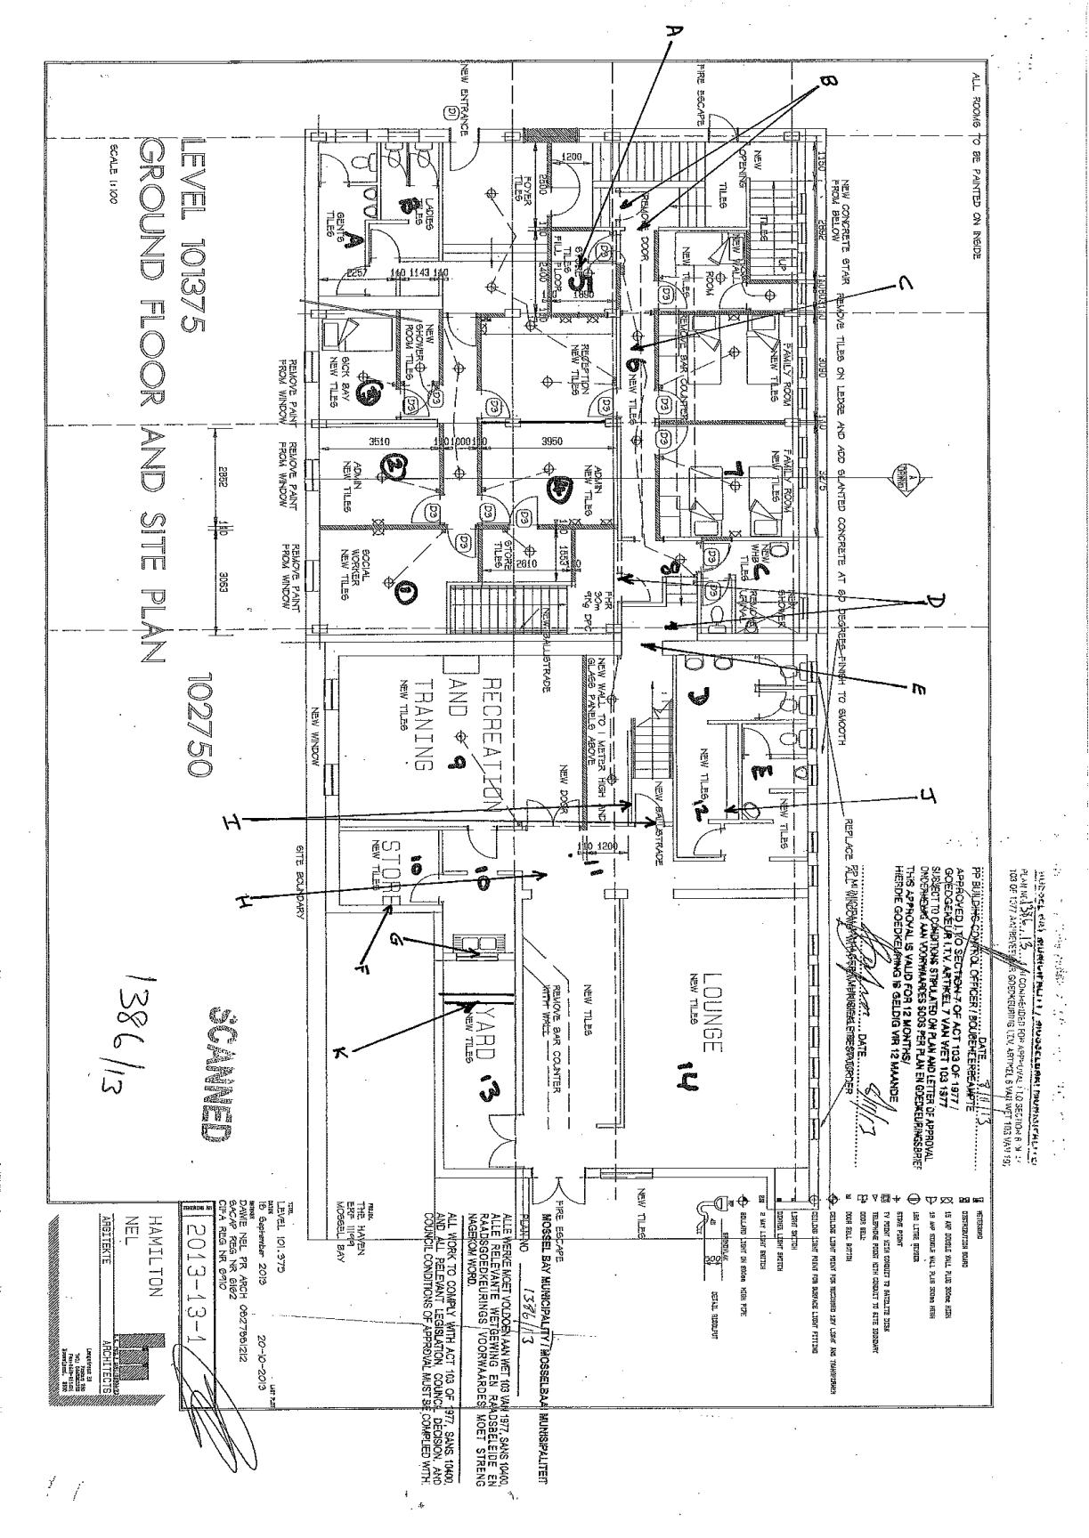

36

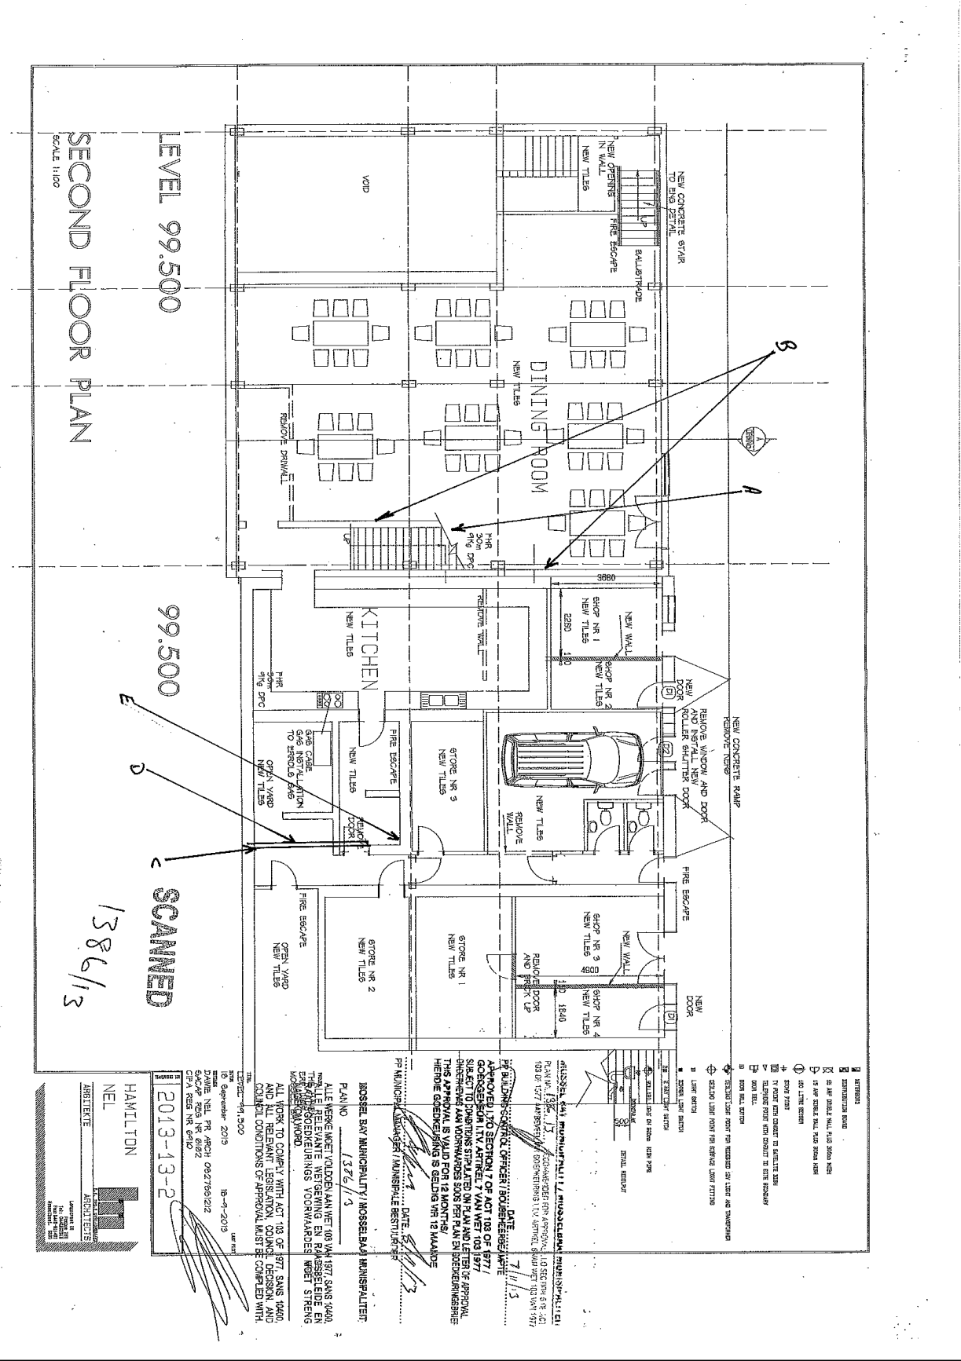

37
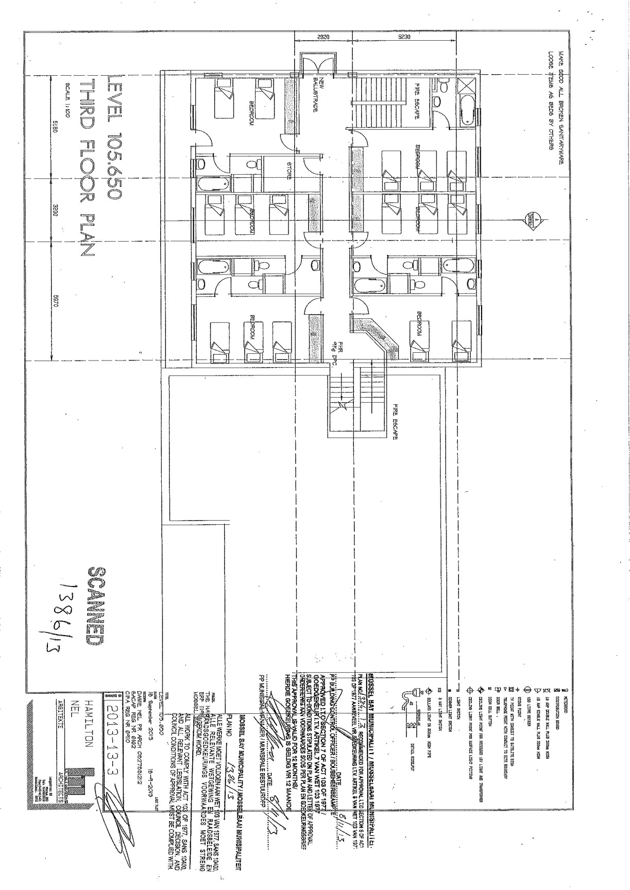

38
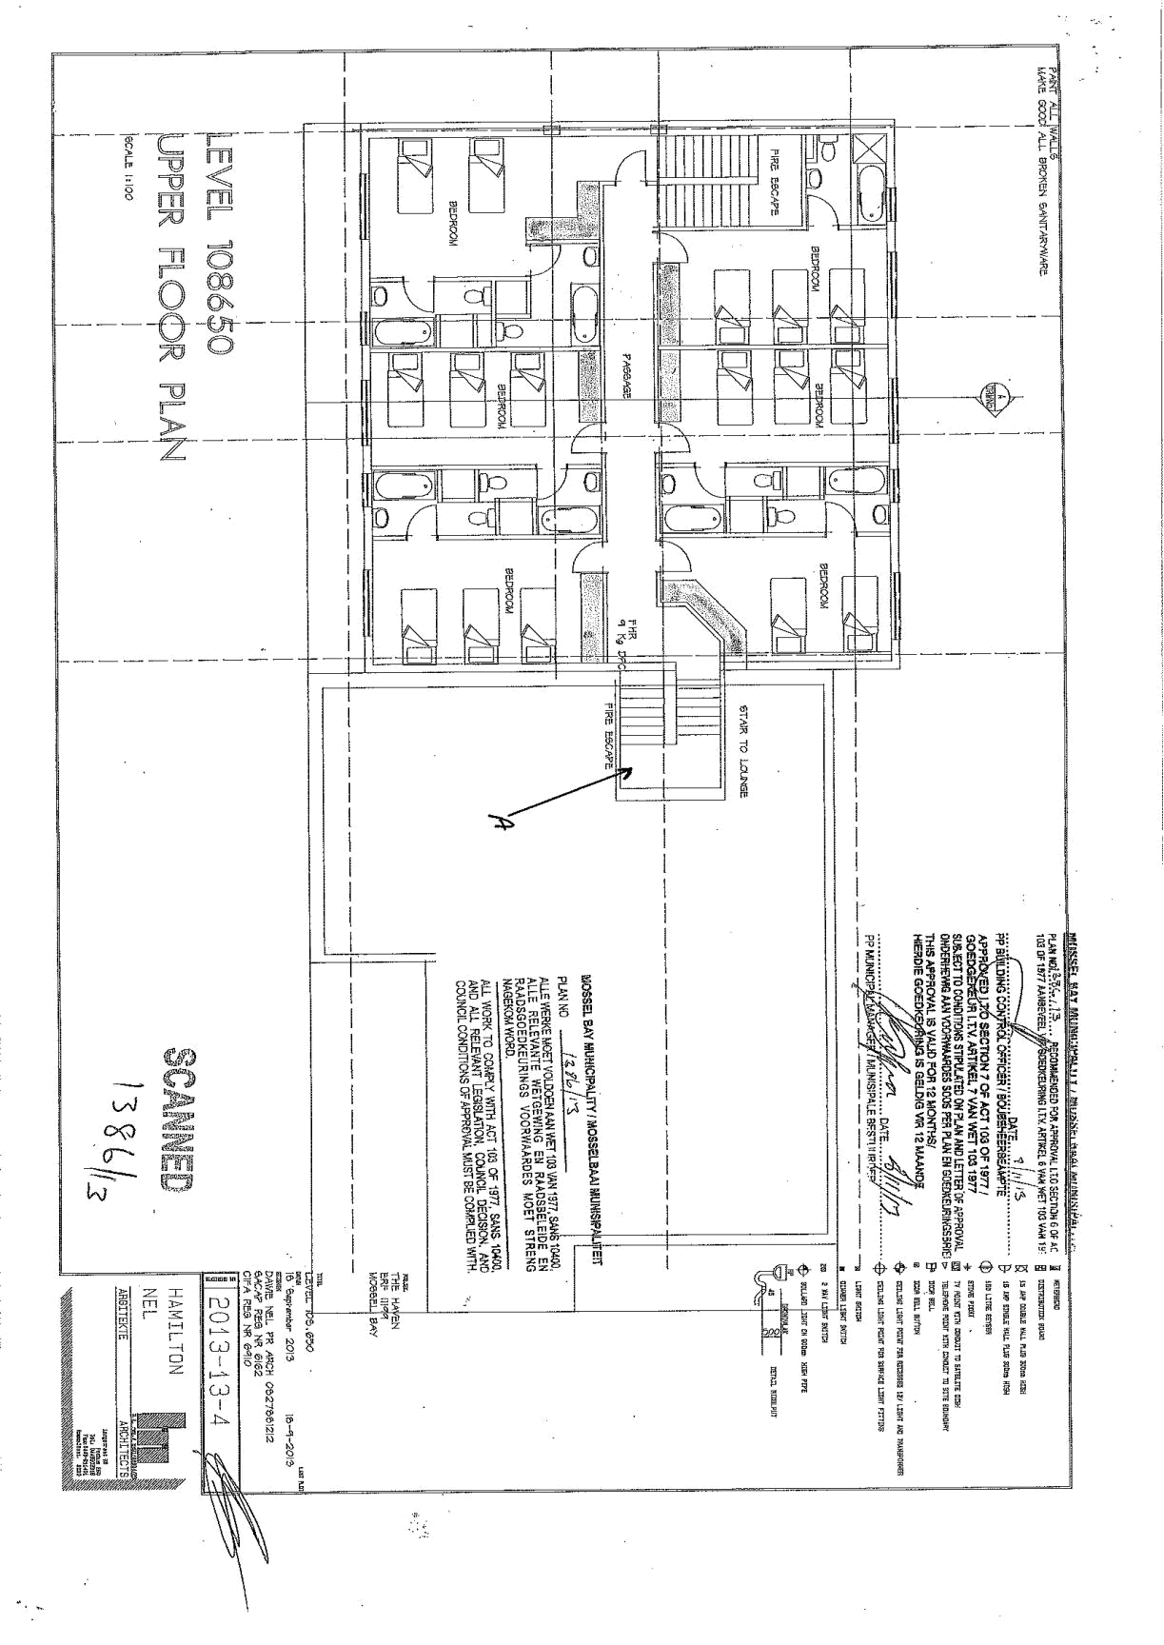

39

